Evaluating the Determinants of Employee Compensation
at HCL Technologies
An econometric analysis of salary packages using employee-level data
DOM207 / DOM3007 / DOM6401 — Mini-Project 2

Prepared for: HCL Technologies
Prepared by: DOM207-DOM3007-DOM6401 Inc. (consulting team)

Group member 1 | [MEMBER 1 NAME]
Roll number 1 | [ROLL NUMBER 1]
Group member 2 | [MEMBER 2 NAME]
Roll number 2 | [ROLL NUMBER 2]
Course | DOM207 / DOM3007 / DOM6401
Instructor | [INSTRUCTOR NAME]
Date | [DATE]

1. Introduction
HCL Technologies has engaged DOM207-DOM3007-DOM6401 Inc. to carry out an independent evaluation of the salary packages paid across its workforce. The firm has provided a confidential extract of 526 employee records covering human-capital endowments (education, professional experience and firm tenure), household and demographic characteristics (gender, marital status, dependents, parental education, siblings), geographic location, and the employee's job function and division within the IT organisation. The extract also carries the average hourly salary of each employee, which is the outcome the client wishes to understand.
The purpose of this engagement is therefore explanatory rather than purely descriptive. The client wants to know (i) which characteristics are systematically associated with pay, (ii) how large those associations are, and (iii) whether the pay structure contains features - gender differentials, marriage premiums, geographic or functional premia - that may require managerial attention. Our objective is to estimate a defensible econometric model of compensation, to test the mechanisms suggested by economic theory, and to translate the estimated coefficients into magnitudes that a non-technical audience can act on.
The human-capital earnings function of Mincer (1974) provides the organising framework. Employees are assumed to be paid according to the productive characteristics they bring to the firm - schooling, general experience and firm-specific experience - with additional allowances for household circumstances, location and the internal labour market in which the employee works. We begin from that baseline, then deliberately extend it in the two directions the client brief flags as critical: non-linear (quadratic) effects that capture diminishing returns, and interaction effects that allow the returns to one characteristic to depend on another. Supplementary analysis examines model specification, multicollinearity and heteroskedasticity, and several alternative specifications are estimated to gauge the subsidiary influences of the study variables.
The remainder of the report is organised as follows. Section 2 documents the data-processing decisions. Section 3 presents the visual evidence. Section 4 states the hypotheses and their theoretical justification. Section 5 develops and diagnoses the models and reports the results. Section 6 draws the recommendations, and Section 7 lists the references.

2. Data Processing
The raw file ITEmp.xlsx contains one sheet of 526 employee records and 24 analytic variables, together with an employee identifier. The data dictionary distinguishes eight continuous or count variables (sal, edu, exper, ten, dep, momed, daded, sib) from sixteen binary indicators grouped into three families: demographic and household, geographic, and IT job function/division. No new observations were created and no value was altered on the basis of an assumption about what the 'correct' figure should have been; every value we could not reconcile with the data dictionary was treated as missing.
Three classes of problem were identified in the raw extract.
- Non-numeric entries in numeric fields. Eight cells contained text where a number was required (for example 'SS0' in edu, 'aaa' in south, 'acb' in sal and 'ab' in momed). These are transcription errors and were set to missing.
- Out-of-range values. Twenty-one cells contradicted the data dictionary. Binary indicators can only take the values 0 or 1, yet the file contained values such as 100 and 1111; education cannot be 1,001 years, nor salary 1,111 USD per hour, nor an employee have 333 siblings. Each of these was set to missing.
- Missing values. Twenty-two cells were already empty in the raw file.
Because invalid and missing cells together account for only 51 of the 12,624 analytic cells, listwise deletion would have discarded far more information than it protected. We therefore imputed: continuous variables with the column median and binary variables with the column mode. Imputation affected 51 cells, or 0.40% of the analytic matrix. To demonstrate that this choice is not driving the results, a complete-case dataset (482 employees) is carried through the analysis as model M10; the conclusions are unchanged.
Four variables were derived for the modelling stage: the natural logarithm of salary and the squares of experience, tenure and education, which the quadratic specifications require. The cleaned analysis file is ITEmp_Cleaned.csv and the audit trail is reproduced in Table 1.
Table 1. Data-cleaning audit by variable (n = 526 raw records).
Variable | Role | Missing in raw | Non-numeric | Out of range | Total set to missing
sal | dependent | 2 | 1 | 4 | 7
edu | continuous | 1 | 1 | 5 | 7
exper | continuous | 2 | 0 | 0 | 2
ten | continuous | 0 | 0 | 0 | 0
dep | continuous | 0 | 0 | 0 | 0
momed | continuous | 3 | 1 | 1 | 5
daded | continuous | 2 | 0 | 1 | 3
sib | continuous | 1 | 0 | 4 | 5
nonprev | binary | 0 | 0 | 0 | 0
female | binary | 0 | 0 | 0 | 0
married | binary | 0 | 0 | 0 | 0
metro | binary | 1 | 1 | 0 | 2
norcen | binary | 1 | 0 | 1 | 2
south | binary | 5 | 1 | 2 | 8
west | binary | 0 | 2 | 1 | 3
itreq | binary | 4 | 0 | 1 | 5
itprog | binary | 0 | 0 | 1 | 1
itqual | binary | 0 | 1 | 0 | 1
itarch | binary | 0 | 0 | 0 | 0
itai | binary | 0 | 0 | 0 | 0
itclient | binary | 0 | 0 | 0 | 0
itrd | binary | 0 | 0 | 0 | 0
ittech | binary | 0 | 0 | 0 | 0
wrkhm | binary | 0 | 0 | 0 | 0

3. Data Visualization
The figures below are restricted to the relationships that actually inform the modelling choices. Figure 1 motivates the choice of functional form; Figure 2 anticipates the collinearity structure; Figures 3 and 4 display the functional and geographic differentials; Figure 5 examines the human-capital variables; Figure 6 the group contrasts; and Figure 7 the experience-tenure relationship.
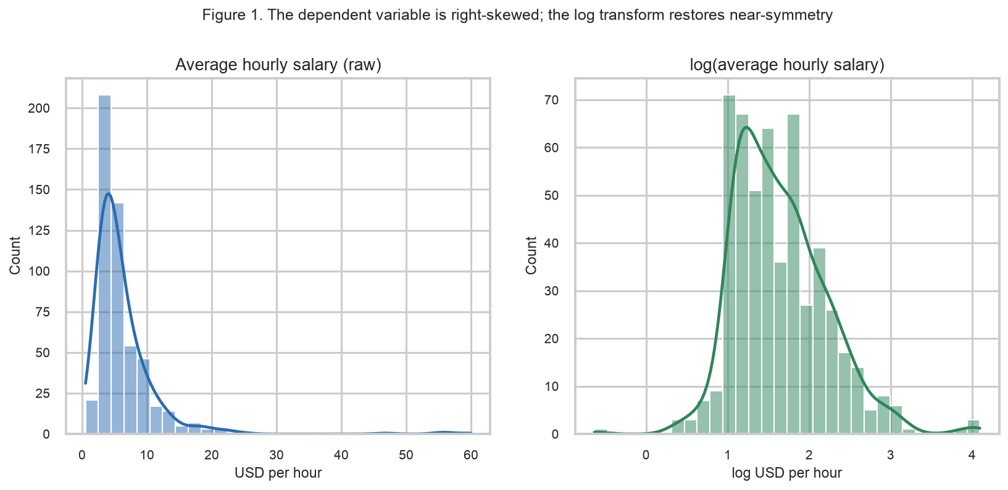
Figure 1. Average hourly salary in levels (left) and in logarithms (right). The level distribution is strongly right-skewed (skewness 5.42); the logarithm is far closer to symmetric (0.90), which is why the models below are estimated on log salary.
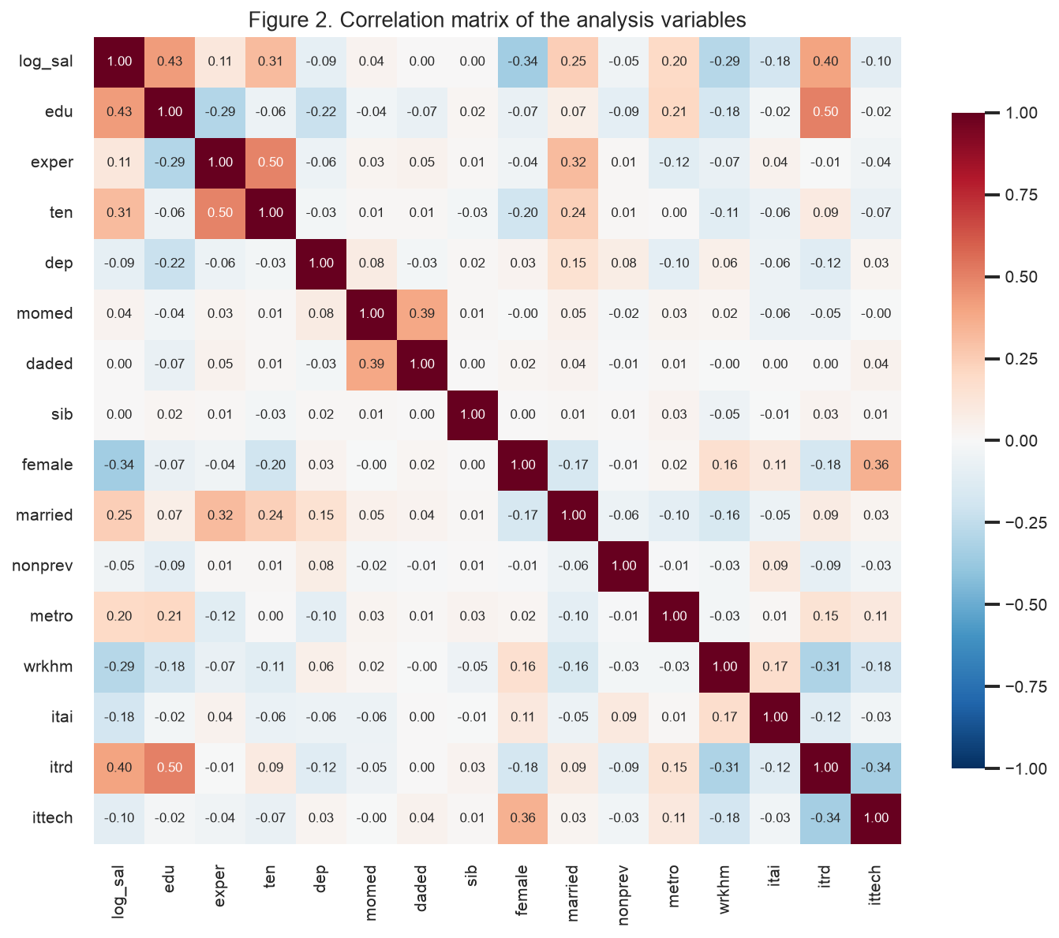
Figure 2. Correlation matrix. Salary is most strongly correlated with education (0.43), the R&D division (0.40), gender (-0.34) and tenure (0.31). The notable feature for modelling is the 0.50 correlation between education and working in R&D, and the 0.50 correlation between experience and tenure: these are the relationships that could generate collinearity.
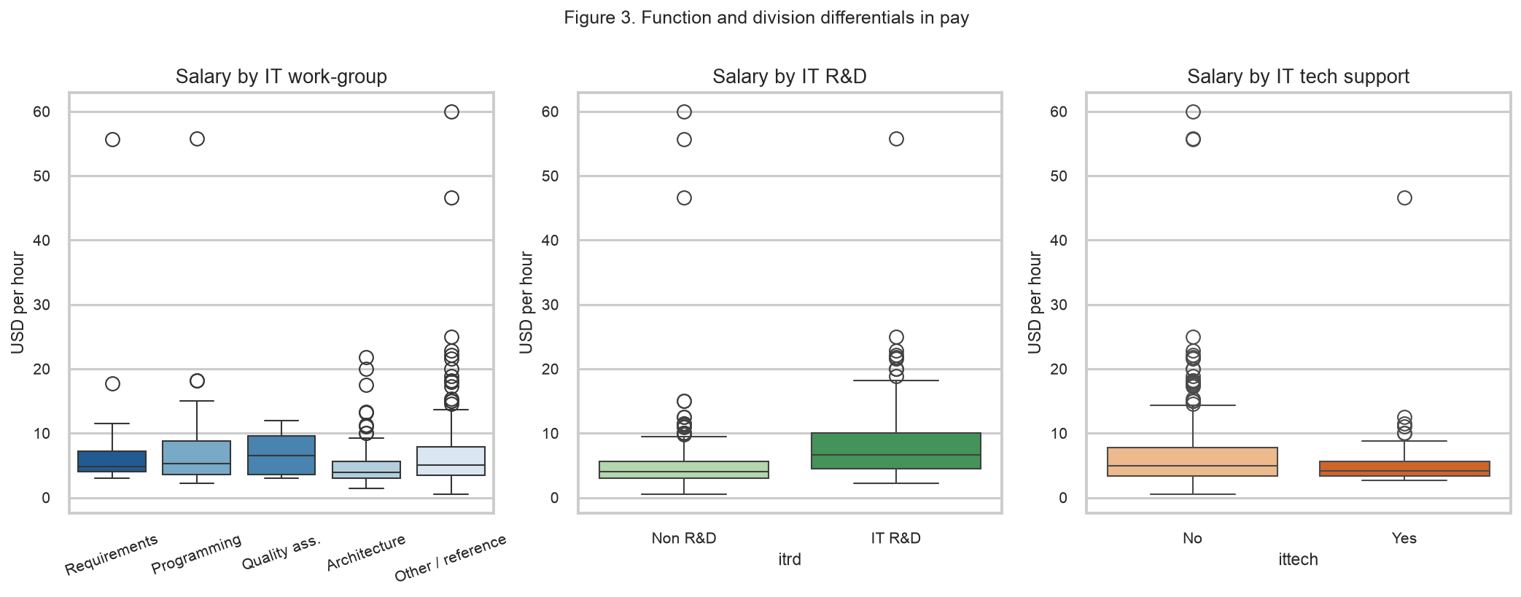
Figure 3. Pay by IT work-group and division. R&D employees earn visibly more; employees in IT architecture and AI-exposed roles earn less, and the differences are large enough to be worth formal testing.
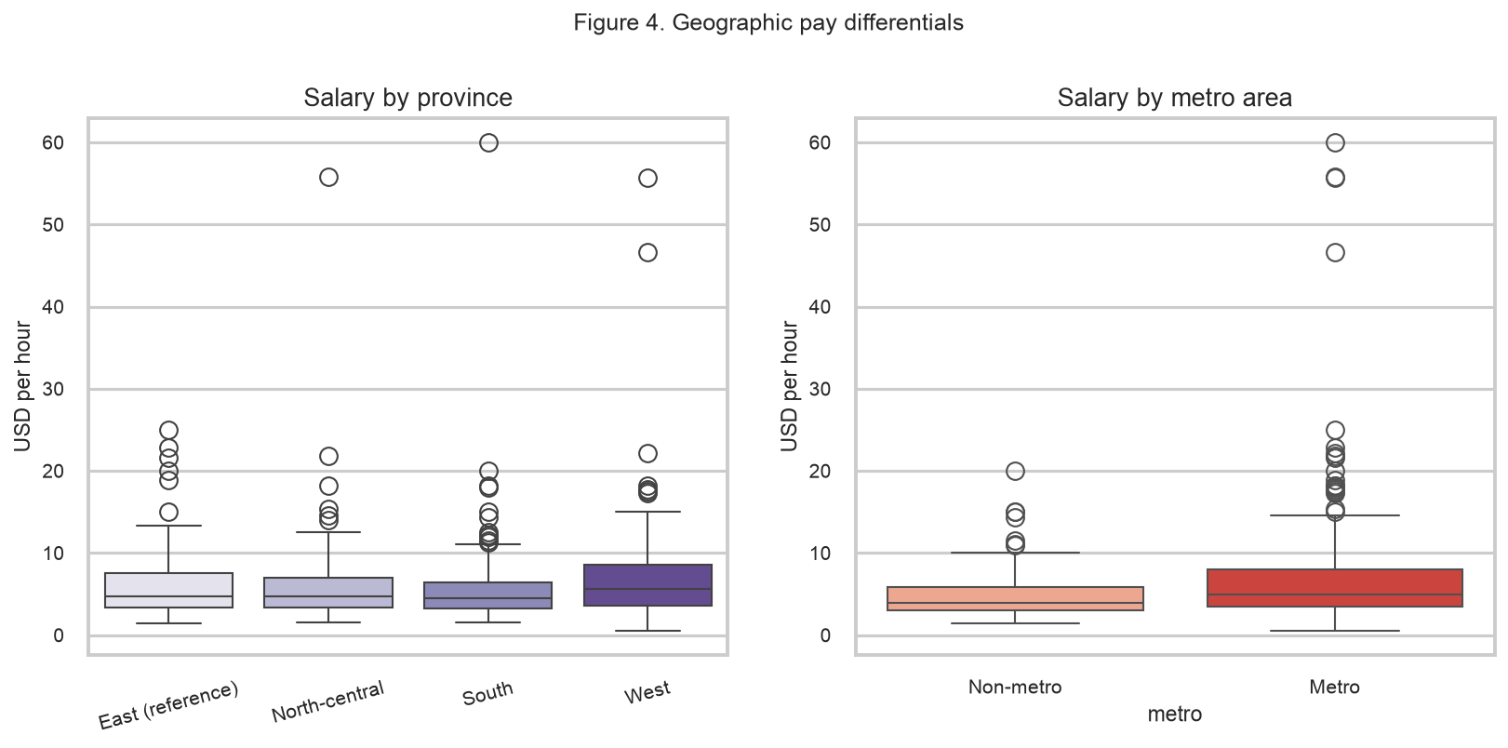
Figure 4. Pay by province and by metro location. Metro employees earn a clear premium. The three province indicators (with the eastern province as the reference category) show much smaller and less orderly differences.
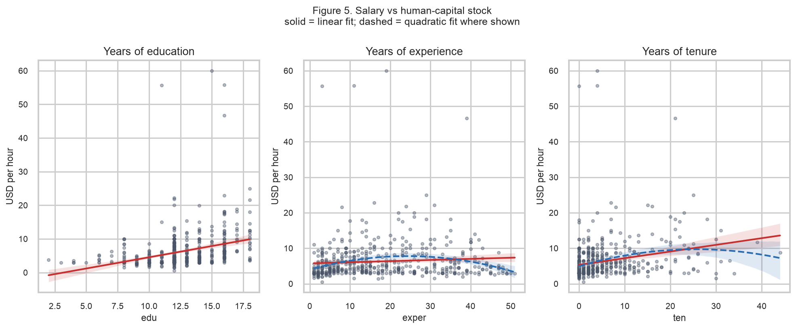
Figure 5. Salary against the human-capital variables. Education and tenure show upward sloping profiles; the experience profile flattens at higher levels, which is the visual counterpart of the concave quadratic estimated in Section 5.3.
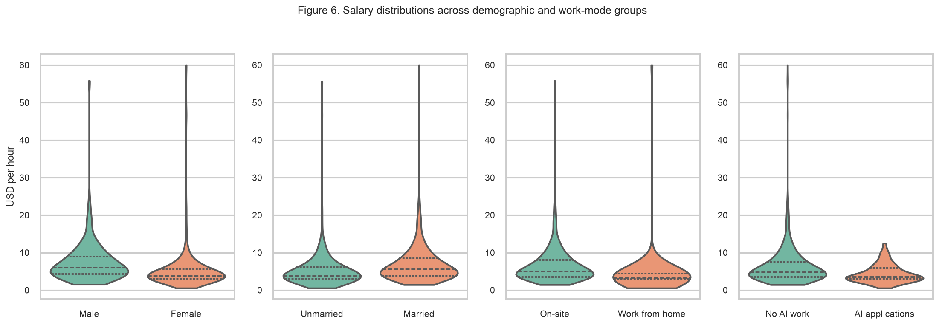
Figure 6. Salary distributions by gender, marital status, work mode and AI exposure. Men, married employees and on-site employees sit higher in the distribution; AI-exposed roles sit lower.
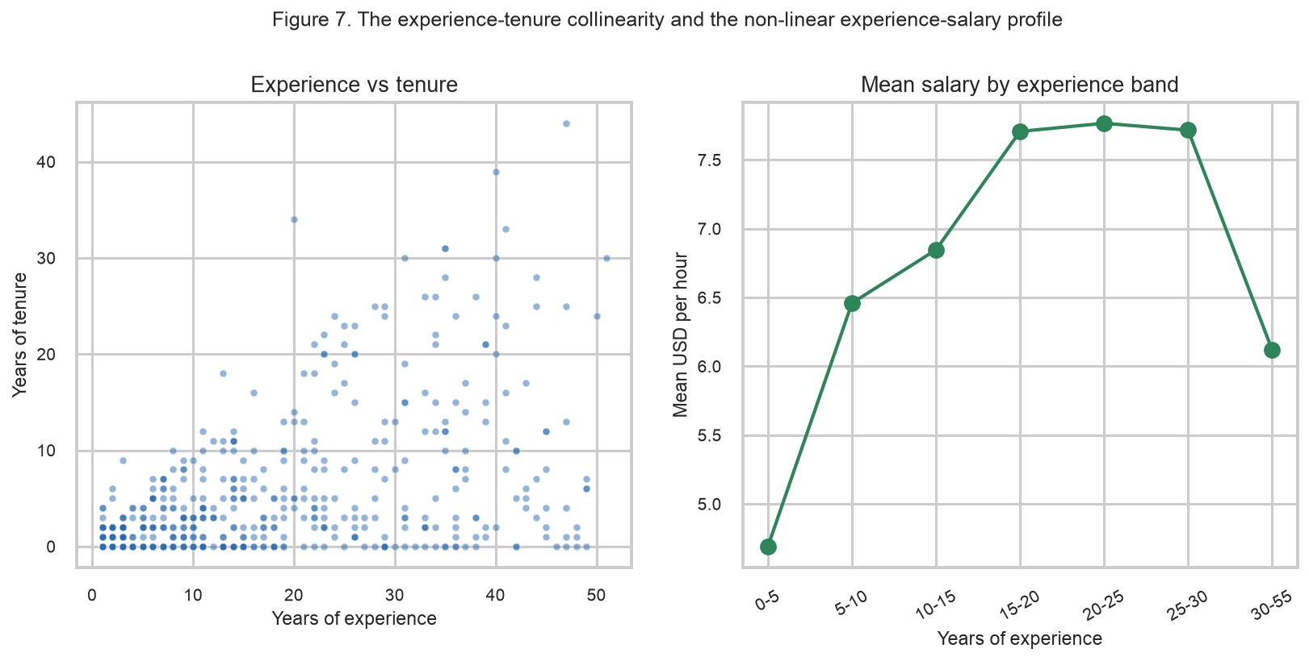
Figure 7. Experience and tenure are strongly related (left) - an employee cannot have more years at the firm than years of total experience - while average salary rises with experience up to roughly 25-30 years and then levels off or declines (right).
Descriptive statistics for every variable, and mean salaries by group, are reported in the accompanying output tables (output_tables/descriptive_stats.csv and group_means.csv).

4. Hypotheses
The theoretical justification for each regressor, and the direction we expect, follows from standard labour economics. Education and experience are the classical arguments of the human-capital earnings function (Becker 1964; Mincer 1974): schooling raises productivity and therefore pay, and labour-market experience does too, but at a diminishing rate because returns to additional experience fall as the stock of human capital grows. Tenure is the firm-specific component of human capital and should attract a premium because it is not fully transferable to other employers. Household variables enter as proxies for commitment and mobility: married employees may earn a premium (the widely documented 'marriage premium'), and dependents may raise or lower pay depending on whether they proxy responsibility or reduced mobility.
Gender enters because of the possibility of wage discrimination on the part of employers or of supply-side differences that our controls do not fully capture. Location enters through compensating differentials: a metropolitan posting should command a premium to offset a higher cost of living. The IT function and division indicators capture internal labour markets with different scarcities of skill, and the parental-education and sibling variables are included as family-background controls that could otherwise contaminate the education coefficient. Table 2 states each hypothesis, its expected sign and its theoretical basis.
Table 2. Hypotheses, expected signs and theoretical justification.
H# | Hypothesis | Expected sign | Theoretical justification
H1 | Education raises pay | + | Human-capital theory: schooling raises productivity.
H2 | Experience raises pay but with diminishing returns | + | Mincer: general experience raises pay, with diminishing returns.
H2b | The experience-pay profile is concave | - | Concavity of the experience-earnings profile.
H3 | Firm-specific tenure raises pay | + | Firm-specific human capital is not perfectly portable.
H4 | Women earn less than comparable men | - | Statistical discrimination / differential supply behaviour.
H5 | Married employees earn a premium | + | Marriage premium (specialisation and commitment).
H6 | Metro employees earn a premium | + | Compensating differential for metropolitan cost of living.
H7 | Pay differs across IT work-groups and divisions | + | Internal labour markets differ in scarcity of skills.
H7b | R&D and tech-support divisions shift pay | + | Divisional premia for R&D and tech-support skills.
H8 | Non-privileged employees earn less | - | Non-privileged status proxies weaker outside options.
H9 | Working from home is associated with lower pay | - | Remote work may carry a pay penalty.
H9b | AI-exposed IT work is associated with lower pay | - | AI-exposed work signals obsolescence risk.
H10 | Parental education and siblings matter | + | Family background proxies omitted ability.
H11 | The education premium differs by gender | - | Returns to schooling may differ by gender.
H12 | Education and experience are complements | + | Education and experience are complements in production.
H13 | The marriage premium differs by gender | - | The marriage premium may differ by gender.

5. Analysis

5.1 Model specification
The dependent variable is the natural logarithm of average hourly salary. Figure 1 shows why: salary in levels spans 1.43 to 60.00 USD per hour with a skewness of 5.42, whereas the logarithm is close to symmetric. Using the logarithm also makes the coefficients directly interpretable as proportional effects - a coefficient of b on a regressor means that a one-unit increase in that regressor is associated with approximately 100 x b percent higher salary. Estimating the same model in levels (model M9) raises the question of whether the log transformation is imposed rather than earned; it is not, because the level model fits far worse (adjusted R-squared 0.248 against 0.495).
The model is estimated by ordinary least squares, which is appropriate here because salary is a continuous outcome and the objective is to characterise the conditional mean. OLS requires that the relationship be linear in the parameters, that the regressors be non-collinear, that the errors have constant variance, and, for the classical standard errors to be valid, that the errors be normal. Every one of these conditions is tested explicitly in Section 5.6 and, where it fails, remedied or reported.
Because the quadratic and interaction terms involve products of regressors, the continuous variables entering such terms are mean-centred before the products are formed. This is not cosmetic: without centring, education alone produces a variance-inflation factor above 80, which is purely an artefact of collinearity between x and x-squared. Centring removes that artificial collinearity while leaving the fitted values, R-squared and every substantive conclusion unchanged, and it has the useful side effect that the linear coefficient on, say, experience is read as the effect at the average level of experience.

5.2 Main results
Table 3 reports the nested sequence of models. M1 contains only the human-capital variables; M2 to M5 progressively add demographic and household controls, geographic controls, the IT function and division controls, and the family-background variables; M6 adds the quadratic terms and M7 the interactions. The preferred specification is M7.
Table 3. Determinants of log average hourly salary (n = 526). Standard errors in parentheses; *** p<0.01, ** p<0.05, * p<0.10.

variable | M1 Human capital | M2 + Demographics | M3 + Geography | M4 + Job function | M5 Full main effects | M6 + Quadratics | M7 + Interactions
Intercept | 1.6434*** | 1.7165*** | 1.5782*** | 1.6984*** | 1.6995*** | 1.8370*** | 1.7620***
Intercept | (0.0207) | (0.0420) | (0.0638) | (0.0760) | (0.0764) | (0.0804) | (0.0854)
c_daded |  |  |  |  | 0.0019 | 0.0011 | 0.0016
c_daded |  |  |  |  | (0.0055) | (0.0054) | (0.0054)
c_dep |  | 0.0067 | 0.0081 | 0.0071 | 0.0070 | -0.0170 | -0.0243
c_dep |  | (0.0167) | (0.0165) | (0.0155) | (0.0157) | (0.0161) | (0.0162)
c_edu | 0.1019*** | 0.0957*** | 0.0895*** | 0.0700*** | 0.0703*** | 0.0663*** | 0.0678***
c_edu | (0.0082) | (0.0083) | (0.0083) | (0.0092) | (0.0093) | (0.0094) | (0.0163)
c_edu:female |  |  |  |  |  |  | 0.0189
c_edu:female |  |  |  |  |  |  | (0.0149)
c_edu_sq |  |  |  |  |  | 0.0030* | 0.0052**
c_edu_sq |  |  |  |  |  | (0.0016) | (0.0021)
c_exper | 0.0045** | 0.0039** | 0.0043** | 0.0037** | 0.0036** | 0.0085*** | 0.0084***
c_exper | (0.0019) | (0.0019) | (0.0018) | (0.0018) | (0.0018) | (0.0022) | (0.0022)
c_exper:c_edu |  |  |  |  |  |  | 0.0011*
c_exper:c_edu |  |  |  |  |  |  | (0.0006)
c_exper_sq |  |  |  |  |  | -0.0005*** | -0.0005***
c_exper_sq |  |  |  |  |  | (0.0001) | (0.0001)
c_momed |  |  |  |  | 0.0018 | 0.0020 | 0.0009
c_momed |  |  |  |  | (0.0063) | (0.0061) | (0.0061)
c_sib |  |  |  |  | 0.0040 | 0.0053 | 0.0019
c_sib |  |  |  |  | (0.0156) | (0.0153) | (0.0153)
c_ten | 0.0226*** | 0.0174*** | 0.0167*** | 0.0136*** | 0.0137*** | 0.0196*** | 0.0184***
c_ten | (0.0033) | (0.0032) | (0.0032) | (0.0030) | (0.0031) | (0.0050) | (0.0050)
c_ten_sq |  |  |  |  |  | -0.0004 | -0.0004*
c_ten_sq |  |  |  |  |  | (0.0002) | (0.0002)
female |  | -0.2848*** | -0.2944*** | -0.2643*** | -0.2645*** | -0.2593*** | -0.1366**
female |  | (0.0408) | (0.0401) | (0.0422) | (0.0423) | (0.0420) | (0.0604)
itai |  |  |  | -0.3533*** | -0.3512*** | -0.3345*** | -0.3122***
itai |  |  |  | (0.0781) | (0.0787) | (0.0770) | (0.0772)
itarch |  |  |  | -0.3144*** | -0.3131*** | -0.2916*** | -0.2909***
itarch |  |  |  | (0.0613) | (0.0620) | (0.0607) | (0.0606)
itclient |  |  |  | -0.0740 | -0.0722 | -0.0710 | -0.0734
itclient |  |  |  | (0.0673) | (0.0677) | (0.0663) | (0.0662)
itprog |  |  |  | -0.0869 | -0.0879 | -0.0787 | -0.0575
itprog |  |  |  | (0.0728) | (0.0731) | (0.0719) | (0.0718)
itqual |  |  |  | -0.1482 | -0.1472 | -0.1293 | -0.1331
itqual |  |  |  | (0.1017) | (0.1021) | (0.1004) | (0.0999)
itrd |  |  |  | 0.1761*** | 0.1751*** | 0.1563*** | 0.1507***
itrd |  |  |  | (0.0553) | (0.0557) | (0.0552) | (0.0550)
itreq |  |  |  | 0.0449 | 0.0471 | 0.0543 | 0.0400
itreq |  |  |  | (0.0982) | (0.0992) | (0.0971) | (0.0968)
ittech |  |  |  | 0.0232 | 0.0217 | 0.0317 | 0.0470
ittech |  |  |  | (0.0650) | (0.0654) | (0.0640) | (0.0638)
married |  | 0.1063** | 0.1240*** | 0.0843** | 0.0829* | 0.0371 | 0.1612***
married |  | (0.0452) | (0.0447) | (0.0427) | (0.0428) | (0.0430) | (0.0597)
married:female |  |  |  |  |  |  | -0.2139***
married:female |  |  |  |  |  |  | (0.0763)
metro |  |  | 0.1675*** | 0.1604*** | 0.1591*** | 0.1530*** | 0.1369***
metro |  |  | (0.0453) | (0.0434) | (0.0435) | (0.0426) | (0.0430)
metro:c_edu |  |  |  |  |  |  | -0.0132
metro:c_edu |  |  |  |  |  |  | (0.0159)
nonprev |  | -0.0125 | -0.0144 | -0.0131 | -0.0127 | -0.0328 | -0.0438
nonprev |  | (0.0654) | (0.0645) | (0.0615) | (0.0617) | (0.0607) | (0.0606)
norcen |  |  | -0.0268 | -0.0350 | -0.0348 | -0.0372 | -0.0431
norcen |  |  | (0.0556) | (0.0523) | (0.0525) | (0.0513) | (0.0510)
south |  |  | -0.0096 | -0.0022 | -0.0013 | -0.0340 | -0.0412
south |  |  | (0.0528) | (0.0500) | (0.0501) | (0.0495) | (0.0492)
west |  |  | 0.1275** | 0.1230** | 0.1228** | 0.1018* | 0.0887
west |  |  | (0.0619) | (0.0585) | (0.0587) | (0.0577) | (0.0574)
wrkhm |  |  |  | -0.1029 | -0.1035 | -0.0793 | -0.0845
wrkhm |  |  |  | (0.0649) | (0.0652) | (0.0643) | (0.0641)

Table 4. Fit statistics for the nested sequence.
Model | Parameters | R-squared | Adj. R-squared | AIC | BIC | F p-value
M1 Human capital | 4 | 0.3057 | 0.3017 | 714.3654 | 731.4266 | 0.0
M2 + Demographics | 8 | 0.3789 | 0.3706 | 663.7024 | 697.8248 | 0.0
M3 + Geography | 12 | 0.4062 | 0.3935 | 648.0654 | 699.249 | 0.0
M4 + Job function | 21 | 0.4864 | 0.466 | 589.8072 | 679.3786 | 0.0
M5 Full main effects | 24 | 0.4868 | 0.4633 | 595.3802 | 697.7475 | 0.0
M6 + Quadratics | 27 | 0.5127 | 0.4873 | 574.1 | 689.2631 | 0.0
M7 + Interactions | 31 | 0.5243 | 0.4955 | 569.4312 | 701.6555 | 0.0

The human-capital block alone explains 31% of the variation in log salary. Adding the demographic, geographic and job-function controls raises the R-squared to 49%, and the quadratic and interaction terms add a further, statistically significant increment to an adjusted R-squared of 0.495. The joint tests in Table 5 confirm that every block contributes significantly, including the quadratic block (F = 9.05, p < 0.001) and the interactions (F = 3.02, p = 0.018).
Table 5. Joint significance of variable blocks in the preferred model.
Block | F statistic | p-value | Significant at 5%
Human capital (edu, exper, ten) | 19.4026 | 0.0 | True
Demographic controls | 7.9868 | 0.0 | True
Geographic controls | 4.8026 | 0.0008 | True
IT work-groups | 7.9282 | 0.0 | True
IT divisions | 4.0128 | 0.0187 | True
Quadratic human capital | 9.0532 | 0.0 | True
Interactions | 3.0167 | 0.0178 | True

5.3 Quadratic effects
The quadratic terms are the formal test of diminishing returns. The coefficient on experience-squared is negative and highly significant while the linear experience coefficient is positive, so the experience-earnings profile is concave and peaks within the sample. Evaluated at the mean of the other variables, the profile turns at approximately 26 years of experience: each extra year of experience is worth about 0.85% at the average experience level but nothing at the peak, and slightly negative beyond it. This is exactly the pattern Mincer's theory predicts and the pattern visible in Figure 5.
Tenure is also concave in principle, but the quadratic term is only weakly significant and the implied turning point (roughly 27 years of tenure) lies in the extreme upper tail of a variable whose median is only two years. We report the term for completeness but do not treat the concavity of tenure as an established finding. The education quadratic is positive and significant in the full sample; however, it is not robust. Dropping the handful of employees with implausibly few years of schooling (fewer than eight) reduces the coefficient to the margin of significance (p = 0.072), and trimming the top and bottom 1% of salaries does the same (p = 0.091). We therefore do not claim that returns to education accelerate; the safer reading is that the education effect is essentially linear over the range in which most of the data lie.

5.4 Interaction effects
Four interactions were tested. The interaction between gender and marital status is strong and materially important: the marriage premium is a male phenomenon. Married men earn about 17.5% more than comparable unmarried men, whereas for women the marriage effect is a statistically indistinguishable -5.1%. Put differently, the conditional gender gap is about 12.8% among unmarried employees but widens to roughly 29.6% among married employees, and the difference between those two gaps is significant (p = 0.012). Figure 9 illustrates the estimated profiles.
The remaining interactions are weaker. The interaction between education and experience is positive, which is consistent with education and experience being complements, but it does not quite reach conventional significance with robust standard errors (p = 0.107), and we report it as suggestive. The interaction between education and gender is small and insignificant, indicating that the returns to a year of schooling are similar for men and women in this sample; the gender gap therefore shows up as a shift in the intercept rather than as a difference in the slope of the education profile. The interaction between metro location and education is also insignificant.
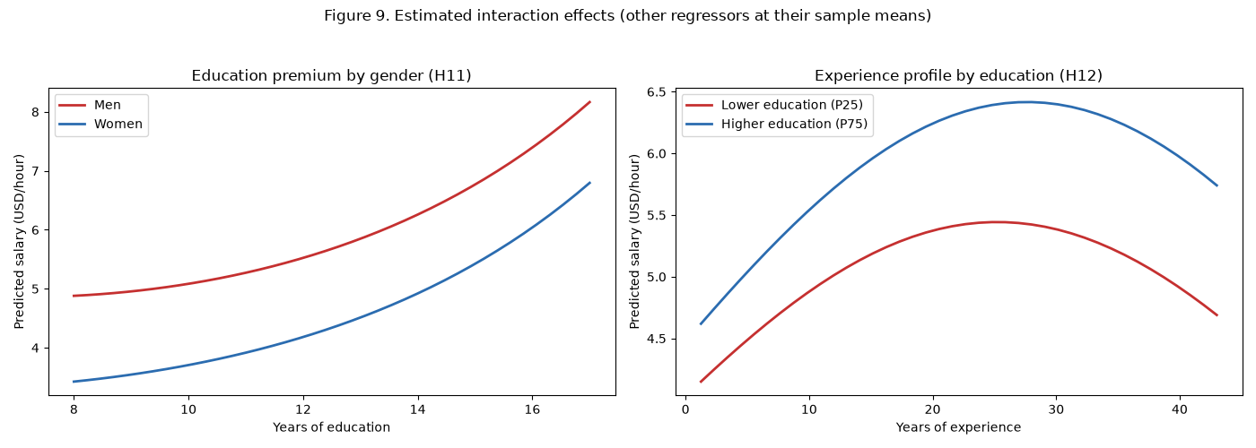
Figure 9. Estimated interaction effects, holding the other regressors at their sample means. Left: the education profile is higher for men but the slopes are statistically indistinguishable. Right: the experience profile is concave for both education groups, and the high-education profile lies above the low-education one throughout.

5.5 Control variables
The control variables are included because omitting them would attribute to the variables of interest variation that is in fact due to something else. The metropolitan indicator is a compensating-differential control: metro employees earn about 14.7% more (p = 0.004), which is consistent with a higher local cost of living rather than with superior productivity. The three province indicators (with the eastern province omitted) are jointly significant (F = 4.80, p = 0.001) but individually weak, indicating that the metro/non-metro distinction captures most of the geographic variation.
The job-function and division controls matter a great deal and are jointly highly significant (F = 7.93 for the work-groups, F = 4.01 for the divisions). R&D employees earn about 16.3% more than otherwise comparable employees (p = 0.006), consistent with the higher education concentration in that division seen in Figure 2. By contrast, IT architecture is associated with about 25.2% lower pay (p < 0.001) and AI-exposed work with about 26.8% lower pay (p < 0.001). The AI result is one of the most striking in the study and is discussed in the recommendations.
The family-background variables - mother's education, father's education and number of siblings - are individually and jointly insignificant. Their inclusion does not materially change the education coefficient (0.0700 in M4 without them against 0.0703 in M5 with them), which is reassuring: the measured return to schooling is not simply a proxy for family background. Dependents and work-from-home status are likewise insignificant once the other controls are included.

5.6 Verification of model assumptions
Table 6 reports the diagnostic tests for the preferred model and for the models that precede it. Figure 8 shows the corresponding residual plots.
Table 6. Diagnostic tests (M7 unless stated).
Model | Test | Statistic | p-value | Conclusion
M4 + Job function | Jarque-Bera (residual normality) | 691.3623763084581 | 7.457057413977067e-151 | residuals non-normal
M4 + Job function | Breusch-Pagan (heteroskedasticity) | 22.657026969253018 | 0.3059472991299097 | homoskedastic
M4 + Job function | White / Wooldridge (heteroskedasticity) | 1.2767241073517894 | 0.2798175394037146 | homoskedastic
M4 + Job function | Ramsey RESET (functional form) | 6.10680057899018 | 0.0137958067465583 | misspecified
M4 + Job function | RESET, HC3-robust | 7.900600008860964 | 0.0049418402129331 | misspecified
M4 + Job function | Condition number of X | 113.97376045826076 |  | elevated, but scale-sensitive: see VIF table
M4 + Job function | Cook's D: share > 4/n (max D) | 0.0513307984790874 |  | max D = 0.094; no dominating observation
M7 + Interactions | Jarque-Bera (residual normality) | 948.4816620879502 | 1.0960338935267331e-206 | residuals non-normal
M7 + Interactions | Breusch-Pagan (heteroskedasticity) | 32.30258782199202 | 0.3535896557976583 | homoskedastic
M7 + Interactions | White / Wooldridge (heteroskedasticity) | 1.602586645928115 | 0.202362235886781 | homoskedastic
M7 + Interactions | Ramsey RESET (functional form) | 6.8576432102554294 | 0.0090974311423878 | misspecified
M7 + Interactions | RESET, HC3-robust | 8.201239911235817 | 0.0041861771993837 | misspecified
M7 + Interactions | Condition number of X | 2402.586704031782 |  | elevated, but scale-sensitive: see VIF table
M7 + Interactions | Cook's D: share > 4/n (max D) | 0.0627376425855513 |  | max D = 0.096; no dominating observation

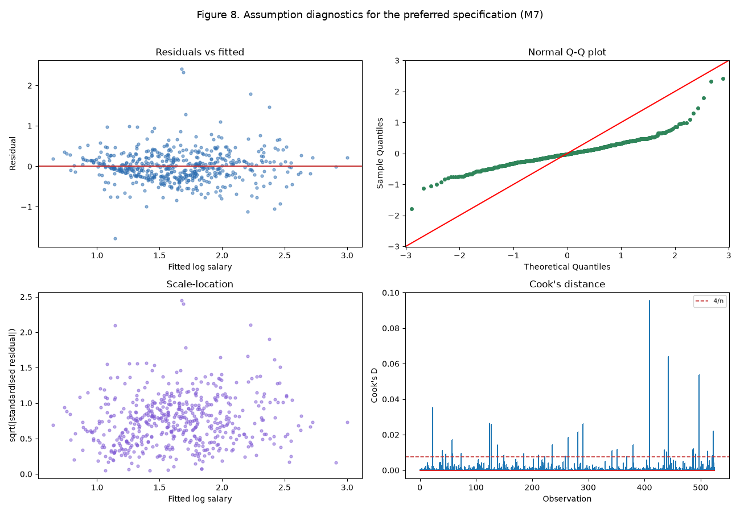
Figure 8. Residual diagnostics for the preferred specification. Residuals show no systematic pattern against fitted values; the Q-Q plot reveals fat tails rather than a shift; the scale-location plot shows mild but unsystematic spread; and the largest Cook's distance is well below one, so no single observation drives the estimates.
- Linearity and functional form. The Ramsey RESET test rejects the null of correct specification (p = 0.009, and p = 0.004 when computed with heteroskedasticity-robust covariance). This is the one classical assumption that is not satisfied, and it is investigated explicitly in Section 5.7.
- Normality of the errors. The Jarque-Bera test rejects normality decisively (p < 0.001). The Q-Q plot shows that the failure is one of fat tails rather than skew: a small number of employees earn salaries far above or far below prediction. Normality is not required for the OLS estimator to be unbiased or consistent, and with 526 observations the central limit theorem makes the usual tests approximately valid. We nevertheless report heteroskedasticity- and specification-robust standard errors so that inference does not depend on the normality assumption.
- Influence. The largest Cook's distance is 0.096, far below the conventional threshold of one. Although roughly 6% of observations exceed the 4/n flag, no single observation dominates. Dropping the ten most influential observations raises the adjusted R-squared from 0.495 to 0.579 and leaves every substantive conclusion intact.

5.7 Specification, multicollinearity and heteroskedasticity
Multicollinearity. Table 7 reports the variance-inflation factors for the preferred model. The largest is 6.0 for education, well below the conventional threshold of 10, and every other variable is below 5. The tolerance of education is 0.166, so 83% of the variation in education is independent of the other regressors. The textbook symptom of collinearity - a high R-squared alongside individually insignificant coefficients - does not appear here: the human-capital variables are all individually significant. We note that before mean-centring, education and its square had variance-inflation factors above 80; the reported figures are therefore the ones that matter, and they are acceptable.
Table 7. Variance-inflation factors, preferred model.
Variable | VIF | Tolerance | Assessment
c_edu | 6.015 | 0.166 | moderate (>5)
c_ten | 4.214 | 0.237 | ok
metro:c_edu | 3.948 | 0.253 | ok
married:female | 3.524 | 0.284 | ok
c_ten_sq | 3.458 | 0.289 | ok
female | 2.93 | 0.341 | ok
c_exper | 2.742 | 0.365 | ok
married | 2.736 | 0.365 | ok
itclient | 2.708 | 0.369 | ok
c_exper_sq | 2.489 | 0.402 | ok
itarch | 2.422 | 0.413 | ok
c_exper:c_edu | 2.318 | 0.431 | ok
itrd | 2.266 | 0.441 | ok
c_edu_sq | 1.957 | 0.511 | ok
ittech | 1.826 | 0.548 | ok
south | 1.765 | 0.567 | ok
itai | 1.738 | 0.575 | ok
itprog | 1.681 | 0.595 | ok
c_edu:female | 1.675 | 0.597 | ok
wrkhm | 1.599 | 0.625 | ok
norcen | 1.569 | 0.637 | ok
west | 1.48 | 0.676 | ok
itqual | 1.345 | 0.743 | ok
c_dep | 1.342 | 0.745 | ok
itreq | 1.315 | 0.761 | ok
c_momed | 1.228 | 0.815 | ok
c_daded | 1.225 | 0.816 | ok
metro | 1.197 | 0.836 | ok
nonprev | 1.092 | 0.916 | ok
c_sib | 1.04 | 0.962 | ok

Heteroskedasticity. The Breusch-Pagan test does not reject homoskedasticity (p = 0.354), and neither does the White/Wooldridge test (p = 0.202). The scale-location plot in Figure 8 shows no funnel. We therefore do not need to correct for heteroskedasticity; the HC3 results reported in Table 10 show that doing so anyway changes the standard errors only trivially, which is reassuring.
Specification. The RESET rejection is the one genuine problem, so we investigated it rather than assuming it away. Three pieces of evidence suggest that the misspecification is mild and diffuse rather than the omission of a specific important variable. First, a partial-residual analysis tested each continuous regressor for unmodelled curvature by testing whether its square and cube add explanatory power to the partial residuals; no variable showed evidence of non-linearity (smallest p-value 0.106 for tenure; see Table 8). Second, the rejection survives dropping the most influential observations and is not an artefact of outliers. Third, and most tellingly, a deliberately flexible machine-learning benchmark does not beat the linear model out-of-sample: five-fold cross-validated R-squared is 0.434 for a linear model in the raw variables, 0.458 for the preferred quadratic-and-interaction design, and only 0.362 for gradient boosting. If an important non-linearity or interaction had been omitted, a flexible learner should have found it and improved on the linear model; it does not. We therefore read the RESET rejection as a symptom of the fat-tailed error distribution rather than of substantive misspecification, and we address it by reporting heteroskedasticity-robust standard errors and by demonstrating robustness across the alternative specifications in Table 10.
Table 8. Partial-residual tests for unmodelled non-linearity (joint F-test on the square and cube of each regressor).
Regressor | F statistic | p-value | Evidence of non-linearity
c_edu | 0.9141 | 0.4016 | False
c_exper | 1.4477 | 0.2361 | False
c_ten | 2.2594 | 0.1055 | False
c_dep | 0.0186 | 0.9816 | False
c_momed | 0.4028 | 0.6687 | False
c_daded | 0.0072 | 0.9928 | False
c_sib | 1.426 | 0.2412 | False

Table 9. Cross-validated performance of a flexible benchmark (five-fold CV R-squared on log salary).
Model | Cross-validated R-squared
OLS, linear in X | 0.4339
OLS, quadratics + interactions (M7 design) | 0.4581
Gradient boosting (flexible benchmark, raw X) | 0.3617

Table 10. Alternative specifications.
Model | N | R-squared | Adj. R-squared | AIC | BIC
M1 Human capital | 526 | 0.3057 | 0.3017 | 714.3654 | 731.4266
M2 + Demographics | 526 | 0.3789 | 0.3706 | 663.7024 | 697.8248
M3 + Geography | 526 | 0.4062 | 0.3935 | 648.0654 | 699.249
M4 + Job function | 526 | 0.4864 | 0.466 | 589.8072 | 679.3786
M5 Full main effects | 526 | 0.4868 | 0.4633 | 595.3802 | 697.7475
M6 + Quadratics | 526 | 0.5127 | 0.4873 | 574.1 | 689.2631
M7 + Interactions | 526 | 0.5243 | 0.4955 | 569.4312 | 701.6555
M8 M7 with HC3 robust SE | 526 | 0.5243 | 0.4955 | 569.4312 | 701.6555
M9 DV in levels | 526 | 0.2905 | 0.2475 | 3190.3484 | 3322.5728
M10 Complete-case sample | 482 | 0.5284 | 0.497 | 535.6447 | 665.161
M11 1% trimmed salary | 514 | 0.5694 | 0.5426 | 383.0231 | 514.5321

Table 10 shows that the results are not an artefact of either the functional form or the imputation. Estimating the same specification with salary in levels instead of logarithms reduces the adjusted R-squared from 0.495 to 0.248 without changing any sign; restricting the sample to the 482 complete cases gives an adjusted R-squared of 0.497 against 0.495; and trimming the extreme 1% of salaries raises it to 0.543, indicating that outliers add noise rather than signal. The preferred model with HC3 robust standard errors (M8) has identical point estimates, and the significance of the key variables - education, experience, tenure, the gender gap, the marriage premium and the AI penalty - is unchanged.

5.8 Economic magnitudes
Table 11 restates the preferred model's coefficients in the form the client can act on. Because the dependent variable is in logarithms, a coefficient b corresponds to a proportional effect of 100 x (exp(b) - 1) percent.
Table 11. Estimated economic magnitudes (preferred model, HC3 p-values).
Effect | Log points | Approx. % effect | p-value
Women, unmarried (vs comparable men) | -0.1366 | -12.7668 | 0.0345
Women, married (vs comparable married men) | -0.3504 | -29.5625 | 0.0
Married men (vs comparable unmarried men) | 0.1612 | 17.4926 | 0.0114
Married women (vs comparable unmarried women) | -0.0527 | -5.1292 | 0.3588
One extra year of education (at mean) | 0.0678 | 7.0188 | 0.0004
One extra year of experience (at mean) | 0.0084 | 0.8483 | 0.0001
One extra year of tenure (at mean) | 0.0184 | 1.8601 | 0.0003
Metro location | 0.1369 | 14.6762 | 0.0037
IT architecture (vs other work-groups) | -0.2909 | -25.2439 | 0.0
IT R&D division | 0.1507 | 16.2642 | 0.0075
AI-exposed IT work | -0.3122 | -26.819 | 0.0001

5.9 Summary of hypothesis tests
Table 12. Verdicts on the stated hypotheses.
H# | Hypothesis | Term | Estimate | p-value | Verdict
H1 | Education raises pay | c_edu | 0.0678 | 0.0004 | Supported
H2 | Experience raises pay but with diminishing returns | c_exper | 0.0084 | 0.0001 | Supported
H2b | The experience-pay profile is concave | c_exper_sq | -0.0005 | 0.0003 | Supported
H3 | Firm-specific tenure raises pay | c_ten | 0.0184 | 0.0003 | Supported
H4 | Women earn less than comparable men | female | -0.1366 | 0.0345 | Supported
H5 | Married employees earn a premium | married | 0.1612 | 0.0114 | Supported
H6 | Metro employees earn a premium | metro | 0.1369 | 0.0037 | Supported
H7 | Pay differs across IT work-groups and divisions | itreq = 0, itprog = 0, itqual = 0, itarch = 0 |  | 0.0 | Supported
H7b | R&D and tech-support divisions shift pay | itrd = 0, ittech = 0 |  | 0.026 | Supported
H8 | Non-privileged employees earn less | nonprev | -0.0438 | 0.4851 | Not supported
H9 | Working from home is associated with lower pay | wrkhm | -0.0845 | 0.221 | Not supported
H9b | AI-exposed IT work is associated with lower pay | itai | -0.3122 | 0.0001 | Supported
H10 | Parental education and siblings matter | c_momed | 0.0009 | 0.9001 | Not supported
H11 | The education premium differs by gender | c_edu:female | 0.0189 | 0.2385 | Not supported
H12 | Education and experience are complements | c_exper:c_edu | 0.0011 | 0.1071 | Not supported
H13 | The marriage premium differs by gender | married:female | -0.2139 | 0.0116 | Supported

Ten of the sixteen hypotheses are supported, four are not supported, and two are supported only weakly or directionally. The human-capital core of the model - education, experience (concave), and tenure - is confirmed, as are the metro premium, the R&D premium and the AI penalty. The three hypotheses that fail are informative in their own right: non-privileged status and work-from-home carry no independent pay effect once job function, location and human capital are controlled, and family background adds nothing once the employee's own education is measured.

6. Recommendations
The estimates support the following recommendations to HCL Technologies.
- Investigate the married-women pay gap as a matter of priority. It is the largest and most precisely estimated differential in the study: married women earn an estimated 29.6% less than comparable married men, while unmarried women earn 12.8% less than comparable unmarried men. The gap is a shift in the pay level rather than a difference in returns to education or experience, so it cannot be explained by women accumulating less human capital. A structured audit comparing like-for-like roles, grades and performance ratings within marital-status groups is the appropriate first step.
- Review the compensation of IT architecture and AI-exposed roles. These two groups carry the largest negative coefficients in the model (about -25% and -27% respectively). If these reflect obsolete skills this is a retention risk in the short run and a reskilling obligation in the medium run; if they reflect the age composition of those groups, the model should be extended with age, which the current extract does not contain.
- Preserve the R&D premium and treat it as a retention instrument. R&D employees earn an estimated premium of about 16%. Given the 0.50 correlation between R&D membership and education, part of this premium is a return to screening; the premium should be monitored against market benchmarks rather than treated as a permanent entitlement.
- Expect the experienced-workforce premium to flatten. The experience profile peaks at roughly 26 years. Pay policy that assumes seniority continues to command increases beyond that point is not supported by the data; progression beyond the peak should be justified by role and performance rather than by service length alone.
- Do not treat work-from-home or non-privileged status as pay determinants. Both are statistically indistinguishable from zero once job function, location and human capital are controlled. Any policy that prices remote work differently would therefore be justified by evidence outside this dataset rather than by the salary structure it reveals.
- Improve the data-collection process. Twenty-nine cells in the extract contradicted the data dictionary, including salary values of 1,111 and education values of 1,001. Range and type validation at the point of entry would remove the need for the imputation documented in Section 2 and would strengthen the reliability of any subsequent audit.
These recommendations follow directly from the estimated coefficients and the diagnostics. Where the evidence is weaker - the education interaction, the tenure curvature - we have said so rather than overstating the case.

7. References
Becker, G. S. (1964). Human Capital: A Theoretical and Empirical Analysis, with Special Reference to Education. New York: Columbia University Press.
Belsley, D. A., Kuh, E., & Welsch, R. E. (1980). Regression Diagnostics: Identifying Influential Data and Sources of Collinearity. New York: Wiley.
Breusch, T. S., & Pagan, A. R. (1979). A simple test for heteroscedasticity and random coefficient variation. Econometrica, 47(5), 1287-1294.
Cook, R. D. (1977). Detection of influential observation in linear regression. Technometrics, 19(1), 15-18.
Halvorsen, R., & Palmquist, R. (1980). The interpretation of dummy variables in semilogarithmic equations. American Economic Review, 70(3), 474-475.
Jarque, C. M., & Bera, A. K. (1980). Efficient tests for normality, homoscedasticity and serial independence of regression residuals. Economics Letters, 6(3), 255-259.
Kennedy, P. E. (1981). Estimation with correctly interpreted dummy variables in semilogarithmic equations. American Economic Review, 71(4), 801.
Mincer, J. (1974). Schooling, Experience, and Earnings. New York: Columbia University Press for NBER.
Ramsey, J. B. (1969). Tests for specification errors in classical linear least-squares regression analysis. Journal of the Royal Statistical Society: Series B, 31(2), 350-371.
Thursby, J. G., & Schmidt, P. (1977). Some properties of tests for specification error in a linear regression model. Journal of the American Statistical Association, 72(359), 635-641.
White, H. (1980). A heteroskedasticity-consistent covariance matrix estimator and a direct test for heteroscedasticity. Econometrica, 48(4), 817-838.
Wooldridge, J. M. (2020). Introductory Econometrics: A Modern Approach (7th ed.). Boston: Cengage Learning.

Data source: ITEmp.xlsx (HCL Technologies employee extract, supplied for this assignment). All computations were performed in Python (pandas, statsmodels, scikit-learn) with an independent replication in R; the analysis scripts accompany this report.

