SALARY DETERMINANTS AT A MULTINATIONAL IT COMPANY
MP2 — DOM207 / DOM3007 / DOM6401
A quantitative analysis of employee salary data
Prepared by: [Your name] | Collaborator: [Name]
Roll number(s): [Insert roll number(s)]
Course: [Insert course name and number]
Instructor: [Insert instructor name]
Date: 19 October 2026

Introduction
This report evaluates the association between employee characteristics, human-capital measures, job assignments, work arrangements, and average hourly salary in the supplied ITEmp.xlsx dataset. The objective is to identify which observed factors are statistically associated with salary, assess whether simple linear specifications are adequate, and translate the empirical evidence into cautious, data-grounded recommendations. The analysis is associational rather than causal: the dataset is observational and does not establish that changing a characteristic would cause salary to change.
The original Salary worksheet contains 526 employee records and 25 columns. Employee ID is used only for record tracking and excluded from the regression predictors. The report uses only the supplied data and does not add employee observations.

Data processing
The original workbook was preserved. A separate cleaned copy was created for analysis. Columns were converted to numeric values; non-numeric entries in numeric fields were treated as missing. Binary indicators were restricted to 0/1. Implausible values outside conservative ranges were set to missing rather than guessed or silently recoded. Salary values above 100 were flagged as likely data-entry anomalies and set to missing; this rule excludes three extreme recorded values (1111, 435.67 and 333.334) while retaining values up to 60. Education values below one year, negative experience/tenure, and out-of-range binary codes were also treated as missing. These rules are transparent, conservative cleaning choices and should be confirmed with the data owner if original records can be checked.
After cleaning, 519 salary observations remain. Each regression uses listwise deletion for variables included in that model; consequently sample sizes vary across specifications. The cleaned workbook and data_cleaning_log.csv are included in the project package. No values were imputed.
Important limitation: the codebook has inconsistent names for the non-privileged indicator (nonprev in the data versus noprev in the description) and describes some indicators only briefly. Geographic indicators and IT-role indicators are therefore interpreted as recorded 0/1 indicators; the omitted/reference categories cannot be given a more specific substantive label than the coding supports.

Data visualization
The salary distribution is right-skewed even after obvious extreme data-entry anomalies are removed, so a log-salary model is included as a robustness specification. The scatterplot suggests substantial dispersion in salary at similar experience levels, indicating that experience alone cannot explain pay differences. The gender-indicator chart is descriptive and is not adjusted for education, job assignment, tenure, or other covariates.
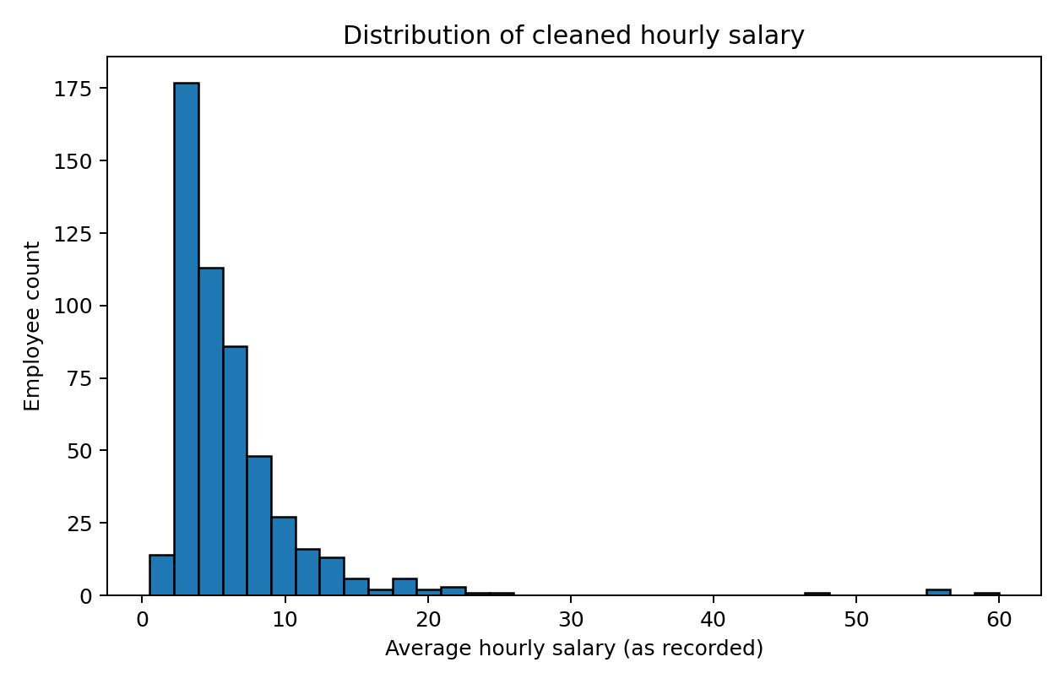
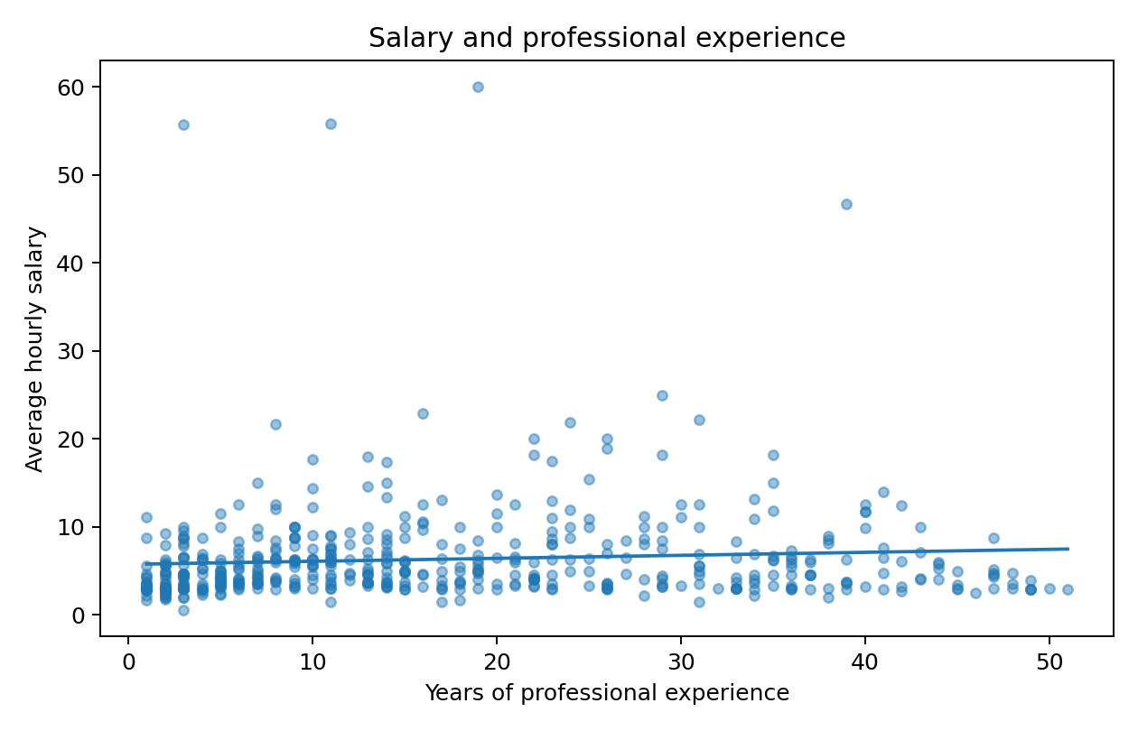
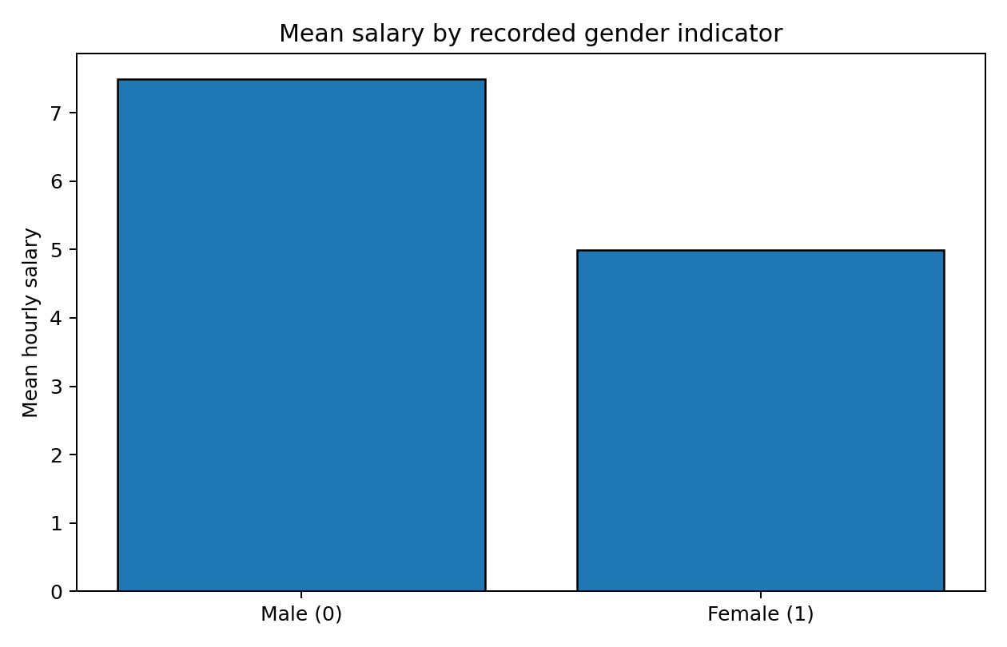

Hypotheses
- H1 — Education: Years of formal education are positively associated with salary, holding other observed factors constant.
- H2 — Experience: Professional experience is positively associated with salary, although the marginal association may diminish at higher experience levels.
- H3 — Tenure: Years with the current company are positively associated with salary, conditional on overall experience.
- H4 — Gender indicator: The recorded female indicator is associated with salary after controlling for observed human-capital, role, geography, family-background and work-arrangement variables. The test is two-sided; no causal interpretation is assumed.
- H5 — Work context: Salary differs across recorded IT role, geographic and work-from-home indicators, conditional on the other model covariates.
- H6 — Nonlinearity and interaction: A quadratic experience/tenure specification and an education-by-experience interaction may improve fit relative to a purely linear model.

Analysis

Method and model strategy
Ordinary least squares (OLS) regression is used because salary is continuous. HC3 heteroskedasticity-robust standard errors and confidence intervals are reported for inference. Four specifications are compared: Model 1 includes human-capital measures and controls; Model 2 adds IT-role, geography and work-from-home indicators; Model 3 adds centered squared experience and tenure terms plus a centered education-by-experience interaction; Model 4 repeats the nonlinear specification with log salary as the dependent variable. Centering makes lower-order coefficients easier to interpret and reduces nonessential collinearity between polynomial and interaction terms.
Control variables include gender indicator, marital status, dependents, non-privileged status, location, parental education and siblings. They are included to reduce omitted-variable bias from observed differences that may be related to salary and the primary predictors. IT assignment indicators and work-from-home status are added to represent job context. Their coefficients are conditional associations, not necessarily causal effects.

Model comparison
Model | N | R² | Adjusted R² | AIC
M1: Human capital and controls | 488 | 0.218 | 0.195 | 3007.4
M2: Add role and work-location indicators | 482 | 0.256 | 0.219 | 2964.9
M3: Quadratic and interaction terms | 482 | 0.267 | 0.225 | 2963.7
M4: Log-salary robustness model | 482 | 0.515 | 0.487 | 541.4
Model 2 improves adjusted R² over Model 1, suggesting that job-context indicators add explanatory information. Model 3 improves fit only modestly over Model 2. Model 4's R² is not directly comparable with the raw-salary models because the dependent variable is on the log scale. AIC values should only be compared across models fit to the same dependent variable and sample.

Key results: Model 3
Term | Coefficient | HC3 SE | p-value | Interpretation at 5%
edu_c | 0.542 | 0.143 | 0.0002 | Statistically significant
exper_c | 0.060 | 0.023 | 0.0079 | Statistically significant
ten_c | 0.160 | 0.063 | 0.0118 | Statistically significant
female | -1.834 | 0.473 | 0.0001 | Statistically significant
metro | 1.293 | 0.501 | 0.0099 | Statistically significant
itqual | -1.691 | 0.649 | 0.0092 | Statistically significant
itarch | -2.272 | 0.509 | 0.0000 | Statistically significant
itai | -2.416 | 0.681 | 0.0004 | Statistically significant
I(exper_c ** 2) | -0.003 | 0.001 | 0.0379 | Statistically significant
I(ten_c ** 2) | -0.002 | 0.002 | 0.3132 | Not significant
edu_c:exper_c | 0.007 | 0.007 | 0.3169 | Not significant
nonprev | -0.359 | 0.562 | 0.5231 | Not significant
wrkhm | 0.641 | 0.870 | 0.4618 | Not significant
In Model 3 (N=482, adjusted R²=0.225), education is positively associated with salary (coefficient 0.542, p=0.0002). The female indicator has a negative conditional association (coefficient -1.834, p=0.0001056); this is an adjusted association and should not be interpreted as proof of discrimination or as a causal effect. Metro residence is positively associated with salary (coefficient 1.293, p=0.0099). Recorded IT quality-assurance, architecture, and AI indicators have negative coefficients relative to the implicit reference coding, conditional on other included variables; interpretation is limited because the role indicators may overlap and the codebook does not fully define their mutual exclusivity.
The centered quadratic experience term is negative and statistically significant (coefficient -0.0028, p=0.0379), consistent with a concave experience-salary relationship in this specification. The tenure-squared term and education-by-experience interaction are not significant at 5% (p=0.313 and p=0.317). Thus, the data provide evidence for nonlinear experience association, but not clear evidence for a tenure quadratic or education-experience interaction.
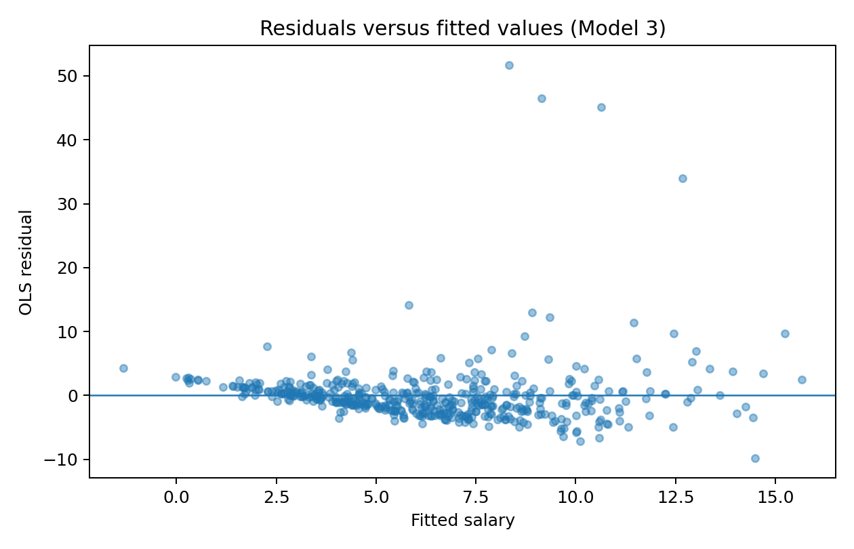

Model diagnostics and assumptions
Breusch–Pagan test: LM=21.22, p=0.731; this test does not indicate statistically significant heteroskedasticity at 5% for the Model 3 residuals. HC3 robust standard errors are nevertheless retained as a prudent safeguard. Ramsey RESET test: F=16.27, p=0.00006; this rejects the null of no omitted nonlinear functional form at 5%, indicating that some misspecification may remain. The Jarque–Bera test is highly significant, indicating non-normal residuals; with a sample of roughly 480, robust inference is preferable, but outliers and model form should still be reviewed.
After centering the variables used in polynomial and interaction terms, the largest non-intercept VIF is 4.38 (ten_c). This is below the common heuristic threshold of 5 for the non-intercept predictors in this model, though VIF is a diagnostic heuristic rather than a formal pass/fail test. The residuals-versus-fitted plot and RESET result suggest the model is not a complete representation of salary formation. Other limitations include possible omitted variables (e.g., grade, performance, location-specific cost of living, and job seniority), unclear units for salary, possible overlapping job indicators, and the observational nature of the data.

Recommendations
- Use education, experience, tenure, job assignment and location as inputs to a more complete pay-equity review, but do not use these estimates alone to set individual salaries. Validate salary units, job grades, and role definitions with the data owner first.
- Investigate the adjusted gender association through a formal pay-equity audit that includes job level, performance, role seniority, hours, and location-specific compensation factors if available. The present dataset supports further investigation, not a definitive causal conclusion.
- Review salary records with implausible values and confirm the flagged values against source records before any operational use. The current analysis excludes obvious extreme salary anomalies rather than guessing their intended values.
- Use a nonlinear experience term in future modeling, but avoid claiming a specific optimal experience level without calculating and validating the marginal-effect turning point within the observed range.
- Improve model specification by collecting relevant job-level and performance variables, clarifying whether role indicators can overlap, and validating geographic reference categories. Re-run diagnostics and validate predictions on held-out data before using a model for compensation decisions.
- Treat work-from-home and family-background coefficients cautiously. Their lack of statistical significance in this specification does not establish that these factors never matter; it only means this model does not detect clear conditional associations.

References
1. DOM207-DOM3007-DOM6401: MP2 project specification, supplied PDF, pp. 1–3.
2. ITEmp.xlsx, supplied workbook, Salary and Data Description worksheets.
3. White, H. (1980). A heteroskedasticity-consistent covariance matrix estimator and a direct test for heteroskedasticity. Econometrica, 48(4), 817–838.
4. Breusch, T. S., & Pagan, A. R. (1979). A simple test for heteroscedasticity and random coefficient variation. Econometrica, 47(5), 1287–1294.

Appendix: reproducibility
Run analysis.py in an environment with pandas, numpy, matplotlib, statsmodels, scipy, openpyxl, and python-docx installed. Keep ITEmp.xlsx in the same directory as the script. The script recreates the cleaned dataset, figures, model-comparison table, coefficient table, VIF output and diagnostic summary.

