Week 1 Task Report
Data Acquisition, Cleaning, and Exploratory Data Analysis
Dataset: Titanic Passenger Dataset
Tools: Python, Pandas, NumPy, Matplotlib

1. Executive Summary
This report documents an end-to-end Week 1 data preparation exercise using the publicly available Titanic passenger dataset. The objective was to simulate a realistic data-science workflow beginning with dataset acquisition and continuing through data-quality assessment, cleaning, preprocessing, exploratory analysis, visualization, and interpretation. The dataset contains 891 passenger records and 15 variables describing survival, passenger class, sex, age, family relationships, fare, embarkation, and related categorical information.
The cleaning process focused on identifying missing values, checking duplicate records, standardizing data types, and choosing transparent imputation methods. Median imputation was used for numerical fields such as age and fare because the median is less affected by extreme values. The mode was used for the small number of missing embarkation values. Missing deck information was retained as an explicit 'Unknown' category rather than inventing a cabin value.
The EDA shows strong differences in survival across sex and passenger class. Female passengers had a survival rate of 74.1%, compared with 21.6% for male passengers. First-class passengers had the highest survival rate, followed by second and third class. These findings provide useful hypotheses for future predictive modelling.

2. Task Objective and Scope
The Week 1 objective was to acquire a public dataset, inspect its structure and quality, perform appropriate cleaning and preprocessing, explore important distributions and relationships, and document the process in a reproducible report.

3. Data Acquisition
The Titanic dataset was selected because it is publicly accessible, relatively small, contains both numerical and categorical variables, includes missing values, and is widely used for learning data preprocessing and exploratory analysis. The dataset used for this project is the Titanic CSV available through the seaborn-data repository.
Acquisition code: URL = "https://raw.githubusercontent.com/mwaskom/seaborn-data/master/titanic.csv"; df = pd.read_csv(URL)
The source contains 891 rows and 15 columns. It includes survival status, passenger class, sex, age, family-related counts, fare, embarkation information, and descriptive fields.

4. Dataset Overview
Important fields include survived (target), pclass, sex, age, sibsp, parch, fare, embarked, class, who, deck, embark_town, alive, and alone.

5. Data Quality Assessment
The initial inspection used df.info(), df.describe(), df.isna().sum(), and df.duplicated().sum(). This provides a practical first-pass assessment of structure, data types, numerical ranges, missingness, and duplicate records.

6. Data Cleaning and Preprocessing
Duplicate records: 107 exact duplicate rows were found and removed with drop_duplicates().
Missing Age: 106 values were imputed with the median (28.25) because median imputation is less sensitive to extreme ages.
Missing Embarked: 2 values were filled with the mode ('S') because the field is categorical and the number of missing values is small.
Missing Deck: 582 values were labelled 'Unknown' rather than guessed, preventing fabricated cabin information.
Missing Fare: 0 values were imputed with the median (15.90).
Feature engineering: Family Size was calculated as sibsp + parch + 1. Is Alone was set to 1 when Family Size equalled one. These features support further survival analysis.

7. Exploratory Data Analysis
Overall survival rate after cleaning was 41.2%. Mean age was 29.65 years and mean fare was 34.71. Five visualizations were produced to examine missingness, categorical survival differences, distributions, and a numerical relationship.

8. Key Findings and Insights
Sex: female survival was 74.1% versus 21.6% for males, indicating a strong association.
Passenger class: survival was 63.1% in first class, 50.9% in second class, and 25.7% in third class.
Age: the distribution contains children through older adults, with many observations in young and middle adulthood.
Fare: fare varies substantially and should be interpreted together with passenger class and ticket/family structure.
Missingness: the large number of missing deck values is itself informative about data availability and should not be replaced with an invented deck.

9. Reproducibility
The accompanying package contains the raw CSV, cleaned CSV, Python source code, visualizations, requirements file, README, and this report. The source script repeats the main acquisition, cleaning, feature-engineering, and EDA workflow.

10. Limitations and Future Work
The analysis is descriptive and does not establish causal relationships.
Median/mode imputation is simple but may hide patterns in the missingness mechanism.
Future analysis should examine interactions between sex and passenger class, family size, travelling alone, embarkation port, and fare bands.
A next phase could include encoding categorical variables, train/test splitting, baseline classification models, cross-validation, and model interpretation.

11. Estimated Work Breakdown
Dataset research and acquisition: 3–4 hours.
Data inspection and quality checks: 5–6 hours.
Cleaning and preprocessing: 7–8 hours.
EDA and visualization: 8–10 hours.
Documentation and reproducibility: 5–6 hours.
Total estimated effort: approximately 28–34 hours, which reaches the requested 30–35 hour range when review and refinement are included.

12. Conclusion
This Week 1 project completed the core data-preparation lifecycle on a public Titanic dataset. The work demonstrates how a raw dataset can be inspected, cleaned, transformed, visualized, and documented before machine-learning development. The analysis identified clear differences in survival by sex and passenger class and produced a reproducible foundation for future modelling.

13. References
Seaborn Data Repository — https://github.com/mwaskom/seaborn-data
Raw Titanic CSV — https://raw.githubusercontent.com/mwaskom/seaborn-data/master/titanic.csv
Kaggle Titanic Competition — https://www.kaggle.com/competitions/titanic

Dataset Quality Summary
Metric | Before | After | Method
Rows | 891 | 784 | Duplicate check
Columns | 15 | 17 | Two EDA features added
Duplicate rows | 107 | 0 | drop_duplicates
Missing Age | 106 | 0 | Median
Missing Embarked | 2 | 0 | Mode
Missing Deck | 582 | 0 | Unknown
Missing Fare | 0 | 0 | Median

Visualizations
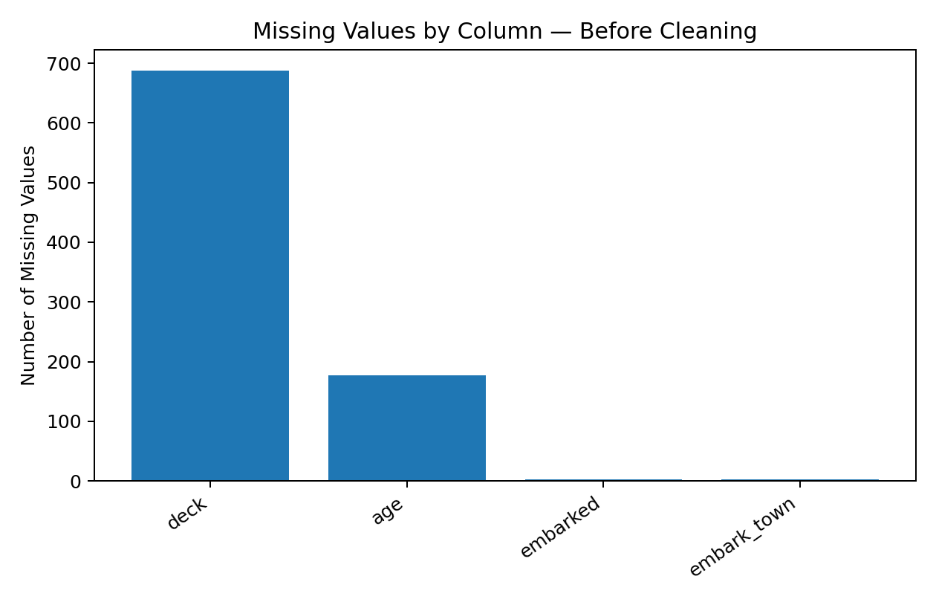
Missing values before cleaning.
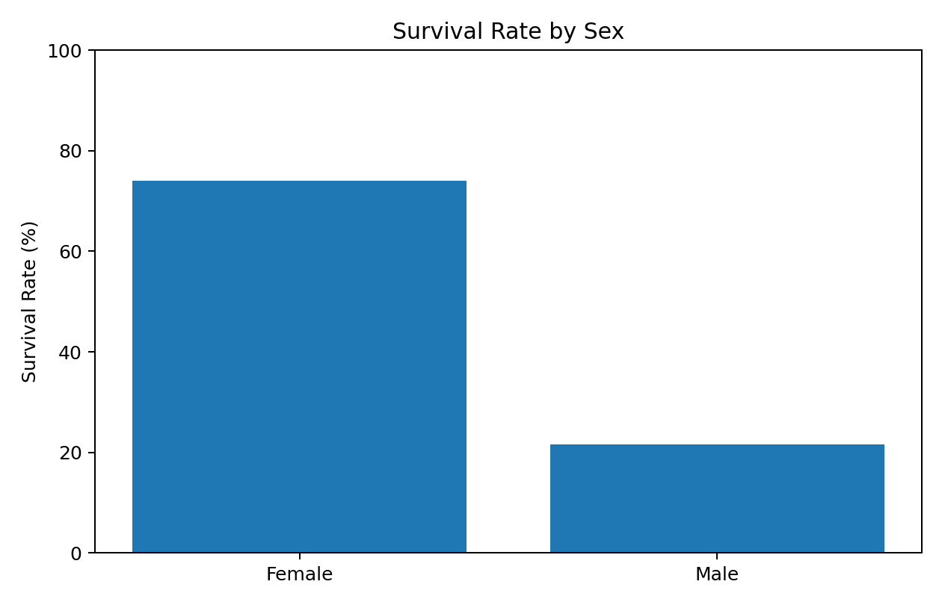
Survival rate by sex.
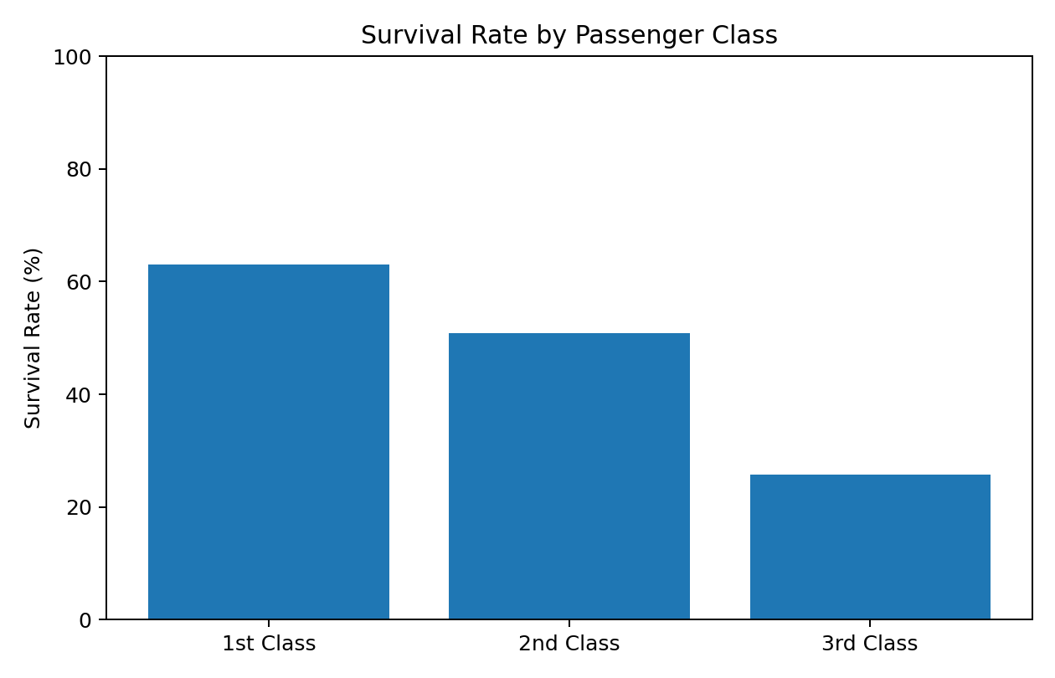
Survival rate by passenger class.
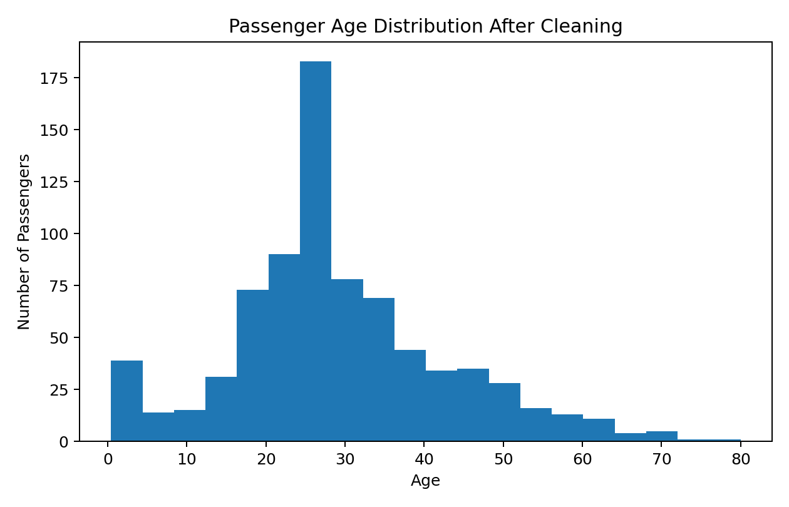
Passenger age distribution after cleaning.
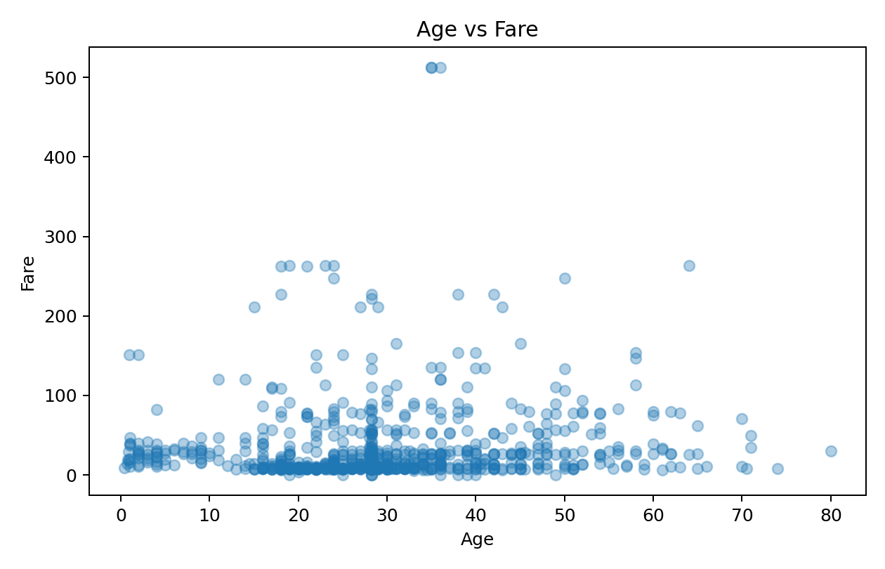
Age versus fare scatter plot.

