WEEK 4 / AI EVALUATION

Customer Support Agent Evaluation
Project Report
A practical review of a five-intent e-commerce classifier, its prompt revision, LangSmith observability, and an optional LLM-as-a-judge pilot.
KEY RESULT
92%  Baseline accuracy | 97%  Revised prompt accuracy | +5 pp  Accuracy change
Executive summary
The improved classifier prompt raised accuracy from 92 to 97 correct predictions on a 100-ticket synthetic evaluation set. Each ticket run is observable through an OpenTelemetry span and LangSmith trace, making individual errors easier to inspect and connect to prompt versions.
The optional judge experiment is promising but still partial. On 12 completed Refund_Missed cases, both Qwen-only and the Nebius Jev-style hybrid agreed with the human labels on all 12. Seventeen of the 29 labeled failure rows remain unjudged, so these pilot scores are not full-set results.
Project repository github.com/navya504/Customer-Support-Agent-Evaluation
Models Nebius Qwen3 for classification and judging, with GLM-5.3-Flash for the Jev-style decision leg.

System design
The notebook uses a small LangGraph workflow to classify a customer message into one of five intents. The classifier returns the selected category and reasoning. The evaluation harness records the input, label, prediction, prompt version, and correctness so results can be compared ticket by ticket.
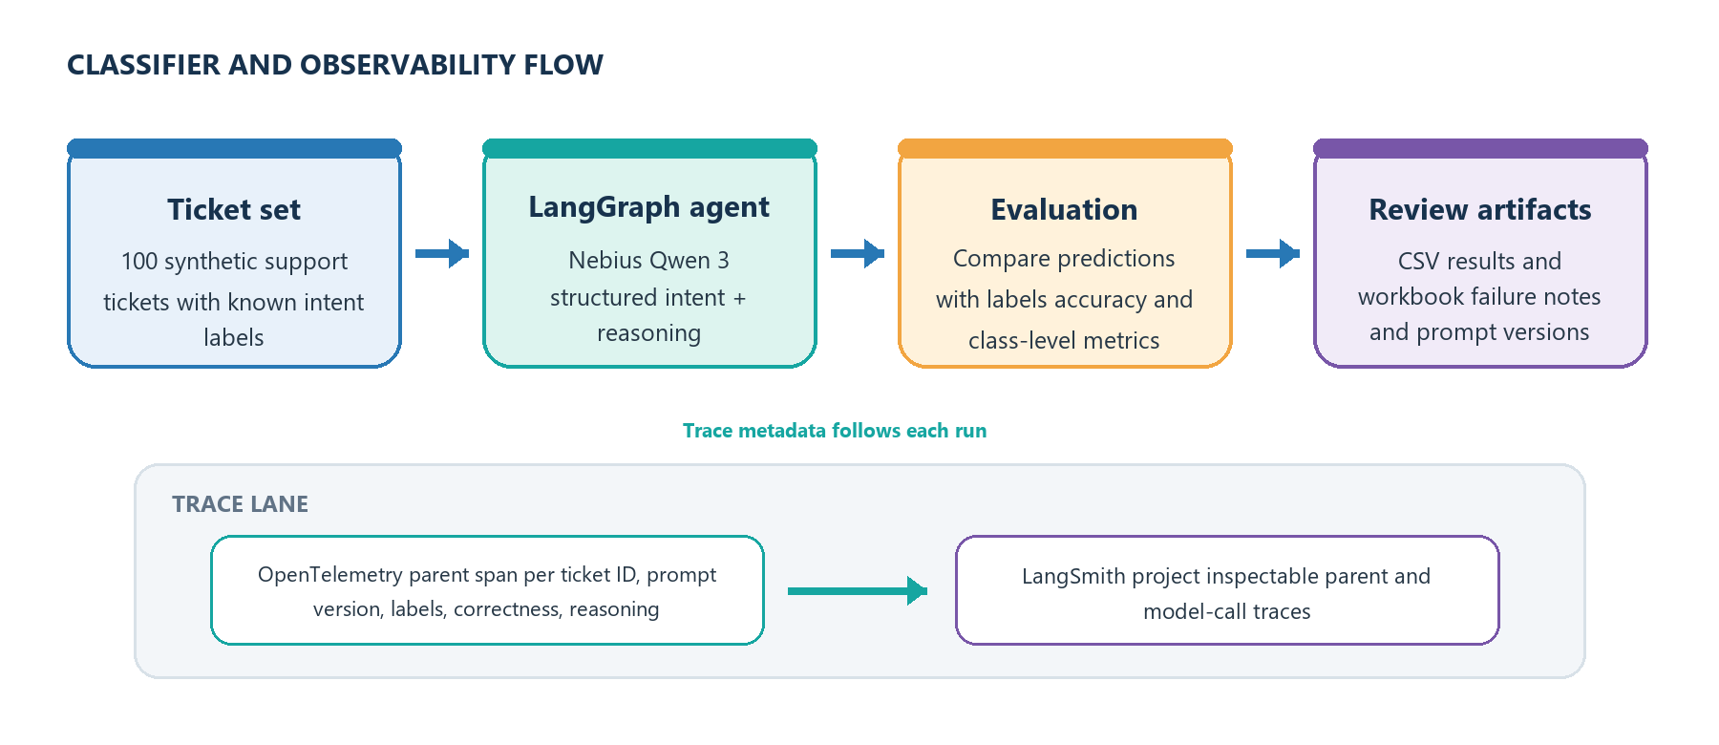
Figure 1. Classifier evaluation and trace flow.

Intent categories
Intent | What the classifier routes here
order_status | Tracking, delivery progress, or an order status question.
refund_request | A customer asking for money back or a refund.
product_issue | A damaged, wrong, defective, or inaccurately described item.
account_help | Account access, profile, payment-method, or related support.
other | General questions, feedback, or messages outside the other intents.

Evaluation setup
The synthetic set starts from 25 seed tickets and uses three generated variations per seed, yielding 100 labeled examples. The seeds include ambiguous and deliberately tricky messages, such as a delivery complaint that also mentions a refund. The notebook compares a baseline prompt with a focused revision and reports accuracy, precision, recall, and a confusion matrix.
OpenTelemetry adds a ticket-level parent span while LangChain and LangGraph provide child spans for the model work. The trace metadata includes the ticket ID, run and prompt versions, true and predicted categories, correctness, and reasoning. This makes a spreadsheet row traceable to the corresponding LangSmith record.

Classifier results and failure analysis
The prompt revision improved aggregate routing accuracy by five percentage points on the 100-ticket set. That is 5 more correct predictions in this evaluation. Accuracy is useful as a headline, while class-level precision, recall, and the confusion matrix show which intents still need attention.
Run | Accuracy | Correct | Interpretation
Baseline prompt | 92% | 92 / 100 | Starting classifier prompt.
Improved prompt | 97% | 97 / 100 | Focused revision targeting a selected failure pattern.
Change | +5 percentage points | +5 correct | Observed on this synthetic test set.

Labeled failure categories
Step 3 groups the 29 classifier failures into four categories. These labels create a human reference for targeted prompt work and for scoring the optional judge.
Failure category | Labeled rows | What the category captures
Refund_Missed | 12 | Refund or price-adjustment intent routed to another intent.
Topic_Cue_Overroute | 7 | A prominent topic or keyword pulls the prediction toward an unrelated intent.
Product_Description_Missed | 1 | A mismatch between a product's stated features and the received item is missed.
Account_Help_Misrouted | 9 | An account, app, checkout, promo-code, or account-history issue is routed elsewhere.

Interpreting the accuracy result
The 97% result supports the revised prompt on this dataset. It does not establish performance on live customer traffic. The examples are synthetic, and the reported comparison does not include confidence intervals or a separate external test set.

LLM as a Judge Pilot
The judge answers one binary question for a selected failure category. The model receives the customer message, the classifier's predicted intent, and the category rubric. Human Step 3 labels stay outside the model input and are used afterward to calculate agreement.
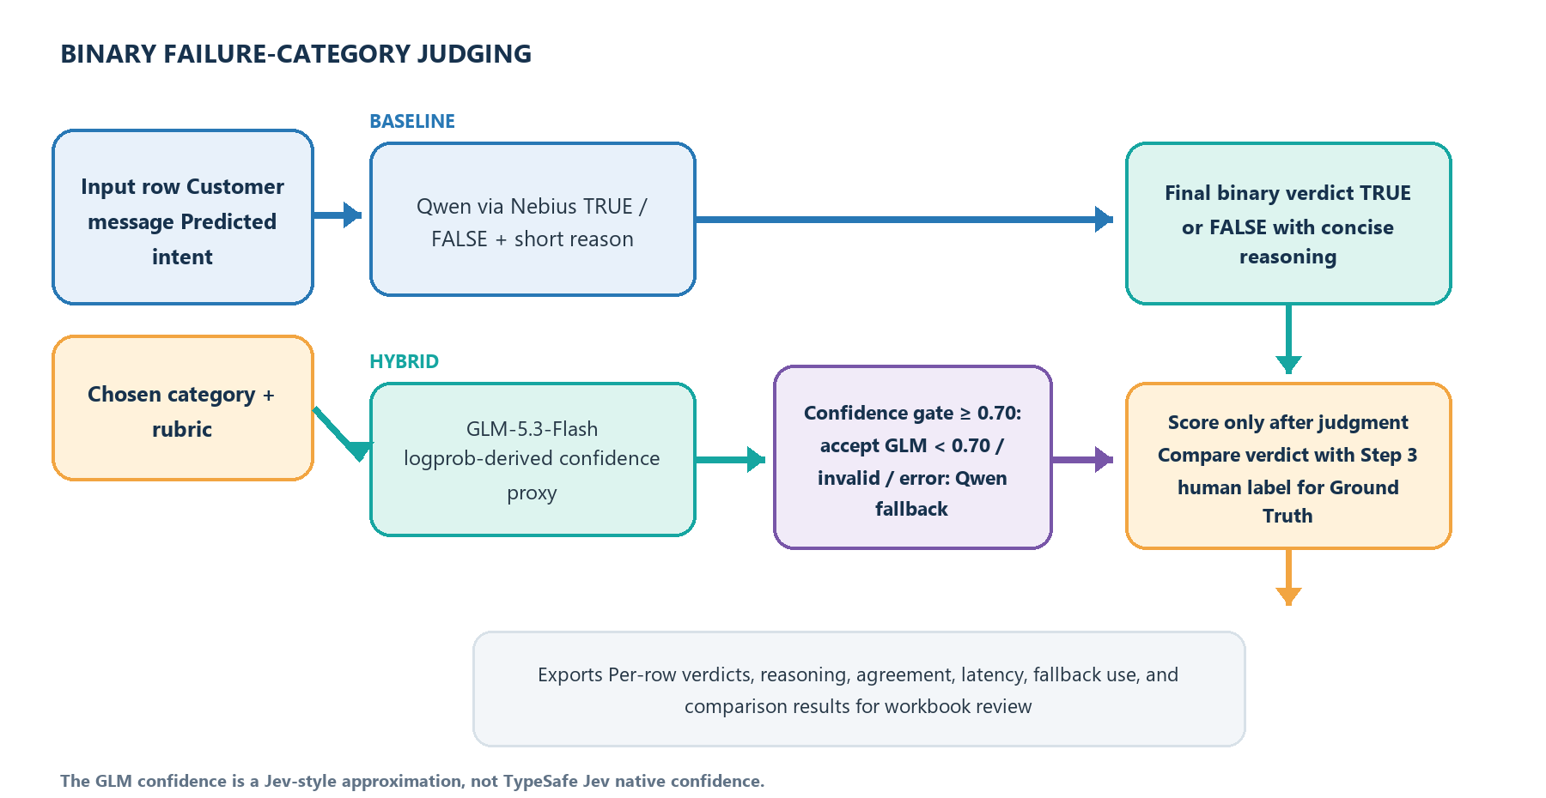
Figure 2. Binary judge paths and post-hoc scoring.

Pilot comparison
Approach | Judge result | Agreement | Mean latency | Notes
Qwen-only baseline | 12 resolved | 12 / 12 | 1.65 sec | Qwen returned TRUE/FALSE and reasoning.
Nebius Jev-style hybrid | 12 resolved | 12 / 12 | 37.24 sec | GLM proxy accepted at ≥0.70; 4 of 12 rows used Qwen fallback.
The hybrid uses GLM-5.3-Flash log probabilities to derive a two-option confidence proxy, 2 × P(top choice) − 1. This is a Jev-style approximation; it is not TypeSafe Jev's native confidence. The hybrid processed 12 of 29 labeled failures (41.4% coverage). Its 100% agreement applies only to those 12 completed Refund_Missed rows.
Usage and cost The GLM decision calls reported 4,266 input tokens and 24 output tokens. Qwen token usage and provider prices were unavailable, so total token usage and cost remain blank.

Project Conclusion
The classifier prompt revision raised accuracy from 92% to 97% on the 100-ticket synthetic test set. The judge pilot improved the failure-review workflow by applying an explicit rubric to each case and returning a binary category decision with a concise explanation. On the completed Refund_Missed pilot, both Qwen-only and the Nebius Jev-style hybrid agreed with the human labels in all 12 cases. This demonstrates consistent category-level review; it does not show higher agreement for the hybrid than for Qwen-only.

Project files and references
- Project repository
- Evaluation spreadsheet
Artifact | Use
week4_customer_support_evals.ipynb | Classifier evaluation and LangSmith tracing workflow.
llm_as_judge_jev.ipynb | Qwen-only and Nebius Jev-style judge workflow.
llm_j_llm_only_results.csv | Per-row Qwen-only predictions and reasoning.
llm_j_jev_hybrid_results.csv | Per-row hybrid decisions, confidence proxy, fallback, and latency.
llm_j_approach_comparison.csv | Approach-level comparison summary.
Week 4 AI evaluation workbook | Human labels, failure analysis, and judge review tabs.
outputs folder | LangSmith trace screenshots for run evidence.

