VISUALIZATION TOOL FOR ELECTRIC VEHICLE CHARGE AND RANGE ANALYSIS
A Data Visualization Project Using Tableau
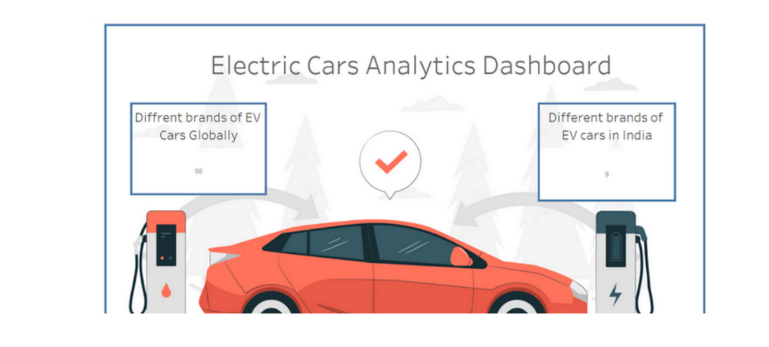
Submitted By:
• T. Navya Gopika
• Sd. Asha Sulthana
• V. Uday Sai
• Sk. Nagulmeera

ABSTRACT

Electric Vehicles (EVs) are rapidly transforming the automotive industry due to growing environmental concerns and increasing demand for sustainable transportation solutions. The development of efficient charging infrastructure and the analysis of vehicle performance metrics play a crucial role in the successful adoption of EVs.
The “Electric Vehicle Charge and Range Analysis” project focuses on analyzing EV charging infrastructure, brand and model distribution, performance metrics, efficiency levels, pricing trends, and powertrain distribution in India. The objective of this project is to provide meaningful insights into the current EV ecosystem through interactive data visualization techniques.
The dataset used for this project includes information on global and Indian EV brands, charging station regions and types, vehicle top speed, efficiency (Wh/Km), price range, body styles, and powertrain types. The data was cleaned and structured using Microsoft Excel, and interactive dashboards were developed using Tableau. Geographic mapping was implemented using OpenStreetMap integration.
Key findings from the analysis reveal that India currently has 12 active EV brands compared to 32 globally. The NDMC region shows the highest concentration of charging stations. Luxury brands such as Porsche and Audi dominate in performance metrics, while Tata and MG provide more affordable EV options. Efficiency levels vary significantly across brands.
This project provides a comprehensive analytical overview of EV infrastructure and performance trends, supporting data-driven understanding of market distribution and infrastructure readiness in India.

Contents

- Introduction
- Problem Statement
- Objectives
- Data and Methodology
- Dashboard Analysis
5.1 Overall Dashboard Overview
5.2 Charging Infrastructure Analysis
5.3 Brand and Model Distribution
5.4 Performance and Efficiency Analysis
5.5 Powertrain Analysis
5.6 Price Analysis
- Key Findings
- Limitations
- Conclusion
- Future Scope

CHAPTER 1

INTRODUCTION
Electric Vehicles (EVs) are emerging as a sustainable alternative to conventional fuel-based vehicles. Increasing environmental pollution, rising fuel prices, and government initiatives promoting clean energy have accelerated the adoption of EVs worldwide.
In India, the EV market is expanding steadily, supported by policy initiatives and improvements in charging infrastructure. However, the growth of EV adoption depends significantly on charging availability, vehicle efficiency, pricing affordability, and technological advancements.
Data visualization plays a crucial role in understanding market trends and infrastructure readiness. By analyzing charging station distribution, brand presence, performance metrics, and pricing segmentation, meaningful insights can be derived regarding the EV ecosystem.
This project aims to analyze and visualize electric vehicle data to provide a structured and comprehensive overview of EV charge and range analysis in India.

CHAPTER 2

PROBLEM STATEMENT
The rapid growth of Electric Vehicles (EVs) has created a strong need for structured analysis of charging infrastructure, vehicle performance, and market distribution. Although data about EV brands, charging stations, and vehicle specifications is available, it is often scattered and not presented in a consolidated analytical format.
The major problems identified are:
• Lack of centralized visualization of EV charging infrastructure across regions
• Limited comparative analysis of EV brands and models
• Insufficient performance comparison based on efficiency and top speed
• Absence of structured price segmentation analysis
• Limited insight into powertrain distribution across brands
Without proper visualization and analysis, it becomes difficult to understand infrastructure readiness, brand competitiveness, and affordability segments within the EV market.
This project addresses these gaps by creating an interactive dashboard that integrates charging infrastructure data, vehicle specifications, and pricing trends into a single analytical platform.

CHAPTER 3

OBJECTIVES
The primary objectives of this project are:
• To analyze the distribution of EV charging stations across different regions in India
• To compare global EV brands with brands available in India
• To study the distribution of EV models across different body styles
• To analyze performance metrics such as average top speed and efficiency (Wh/Km)
• To evaluate price segmentation of electric vehicles in India
• To examine powertrain distribution across EV brands
• To generate meaningful insights using interactive data visualization techniques
These objectives help in understanding infrastructure readiness, brand competition, performance variation, and affordability within the EV ecosystem.

CHAPTER 4

DATA AND METHODOLOGY
4.1 Methodology
The methodology followed in this project includes data collection, data cleaning, transformation, visualization development, and insight extraction.
Data Collection
The dataset was obtained from publicly available EV data sources containing brand specifications, infrastructure information, and pricing details.
Data Cleaning
• Removed null values
• Standardized brand names
• Formatted numerical fields
• Categorized vehicle body styles
Data Transformation
• Calculated average top speed per brand
• Computed average efficiency values
• Grouped charging stations by region
• Segmented price categories
Dashboard Development
The cleaned dataset was imported into Tableau to create interactive visualizations including charging infrastructure analysis, performance comparison, pricing segmentation, and powertrain distribution.

CHAPTER 5

DASHBOARD ANALYSIS
5.1 Overall Dashboard Overview
The overall dashboard provides a consolidated visualization of electric vehicle infrastructure, performance metrics, brand distribution, and pricing trends. The dashboard integrates multiple analytical sections into a single interactive platform, allowing comprehensive understanding of the EV ecosystem in India.
The layout is structured to present infrastructure analysis at the top, followed by brand distribution, performance metrics, and price segmentation.
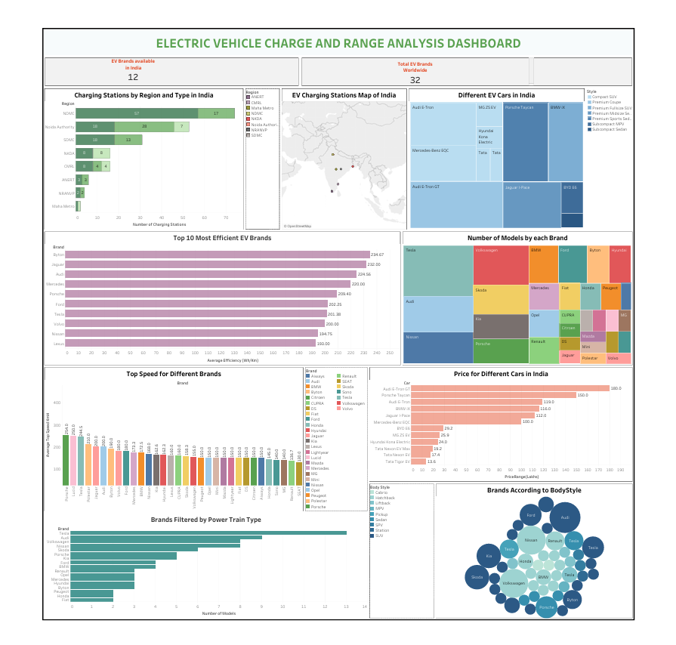

5.2 Charging Infrastructure Analysis

This section examines the distribution of electric vehicle charging stations across various regions in India. Charging stations are categorized by region and charging type, including AC and DC charging formats.
The NDMC region shows the highest number of charging stations, indicating stronger infrastructure readiness. Regions such as Noida Authority and SDMC also demonstrate moderate charging availability.
The comparison between AC and DC charging types helps evaluate infrastructure balance and accessibility.
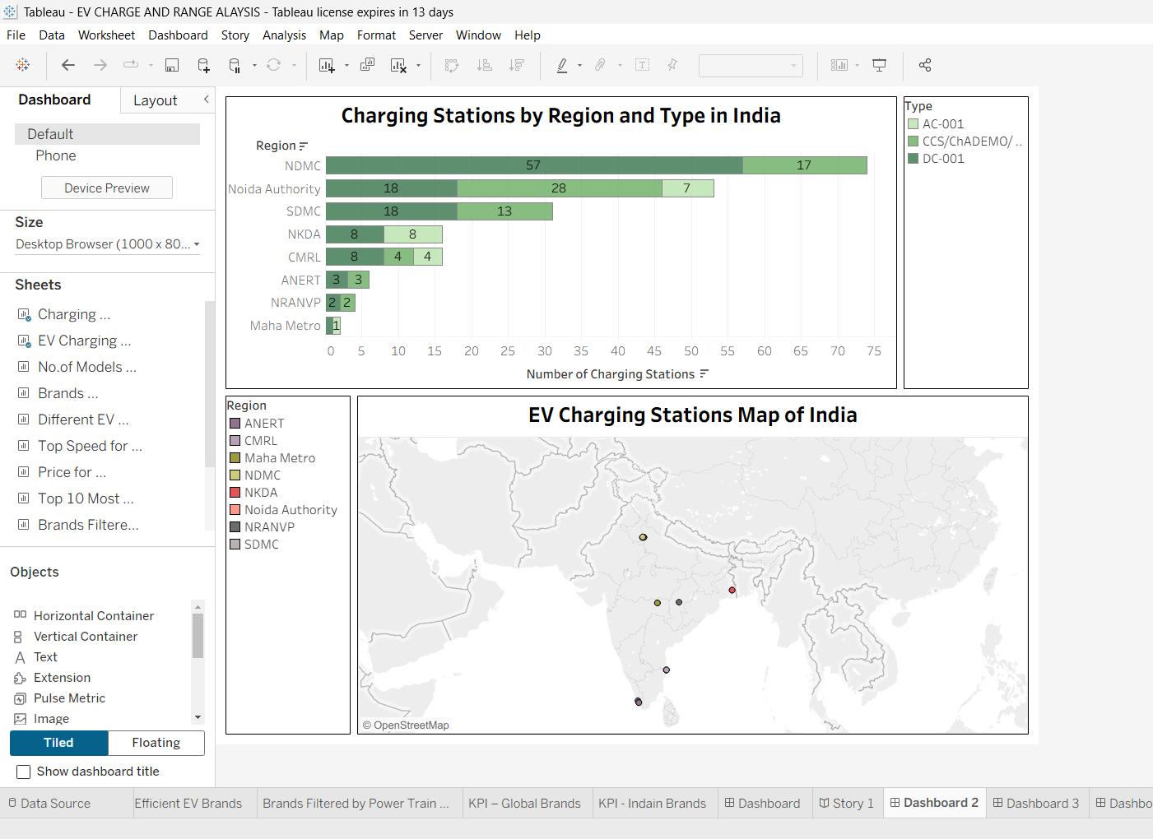

5.3 Brand and Model Distribution

This section analyzes the distribution of EV brands and the number of models offered by each brand. It also categorizes vehicles based on body style, such as SUV, Sedan, Hatchback, and other segments.
Brands such as Tesla, Audi, and Volkswagen show higher model availability, reflecting stronger market presence. The visualization highlights the dominance of SUV and premium vehicle segments in the EV market.
This analysis provides insights into brand competitiveness and product diversity.
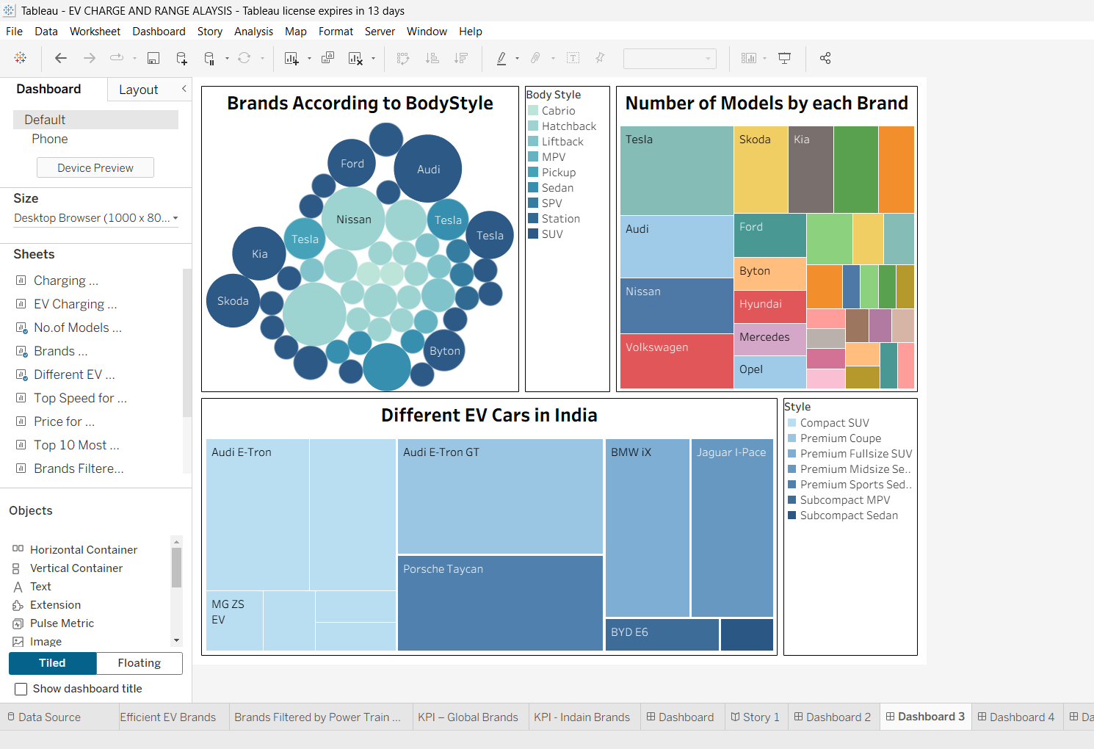

5.4 Performance and Efficiency Analysis

The performance and efficiency section compares EV brands based on average top speed and energy efficiency measured in Wh/Km.
Luxury brands such as Porsche and Lucid demonstrate higher top speed values, indicating performance-focused engineering. Efficiency analysis shows that brands like Byton and Jaguar maintain competitive energy consumption levels.
The variation across brands reflects differences in battery technology, engineering design, and market positioning.
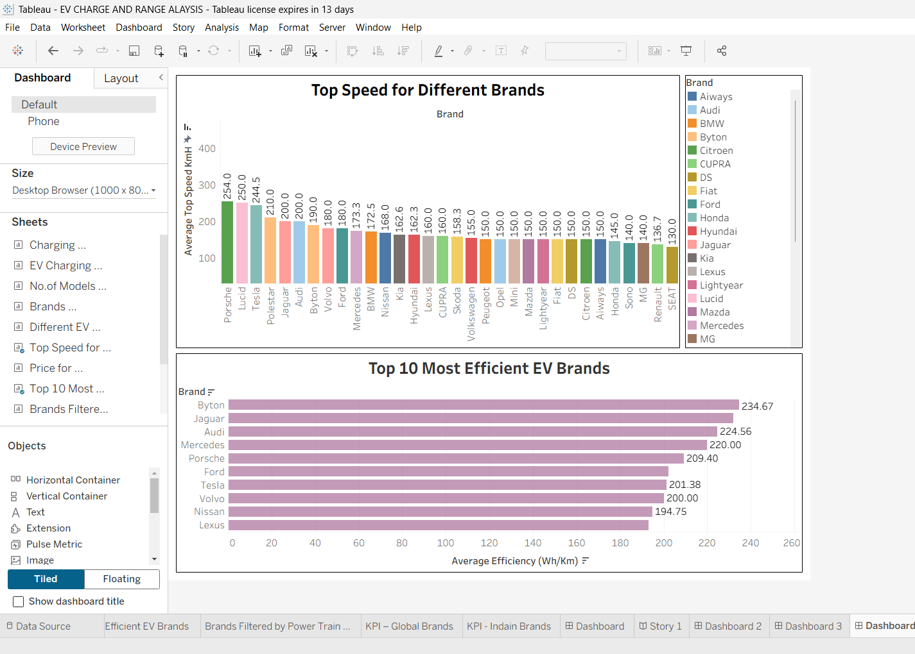

5.5 Powertrain Analysis

The powertrain analysis evaluates the number of EV models offered by each brand across different powertrain configurations.
Brands such as Tesla and Audi show a higher number of models, indicating broader product portfolios. This analysis helps understand technological diversity and brand investment in EV development.
Powertrain distribution plays a key role in performance capabilities and efficiency outcomes.
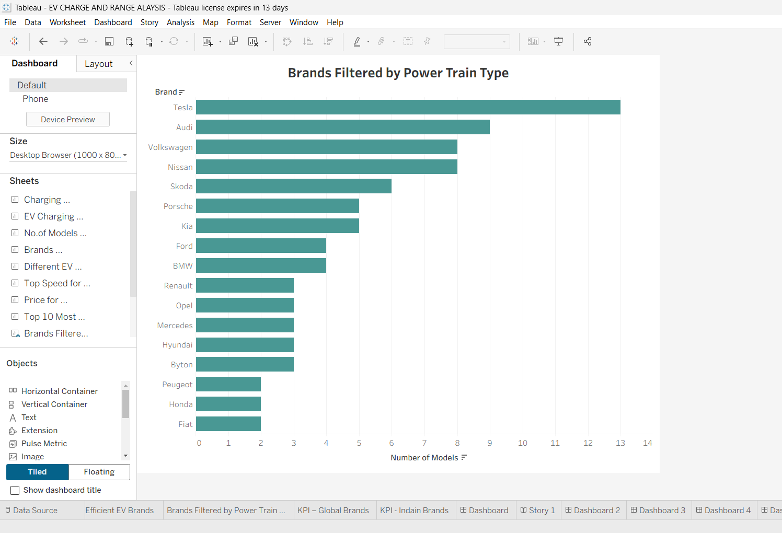

5.6 Price Analysis

The price analysis examines the pricing structure of EV models available in India. Luxury vehicles such as Audi E-Tron GT and Porsche Taycan occupy the higher price range.
In contrast, Tata Nexon EV and MG ZS EV provide more affordable options, making EV ownership accessible to a wider segment of consumers.
The visualization clearly highlights market segmentation between premium and affordable EV categories.
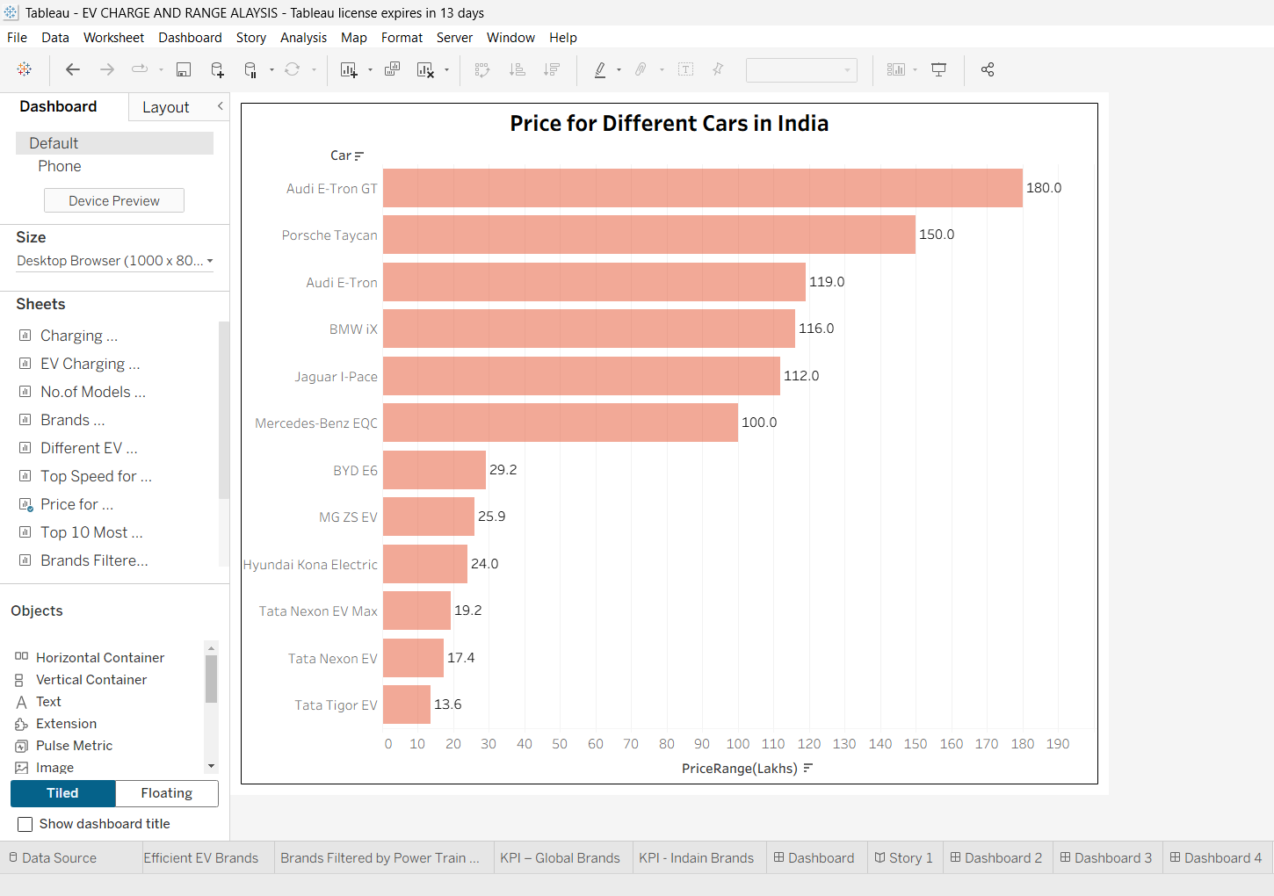

KEY FINDINGS

The major findings derived from the dashboard analysis are:
• India currently has 12 active EV brands compared to 32 globally, indicating growing but still developing market presence.
• The NDMC region has the highest concentration of EV charging stations, showing stronger infrastructure readiness compared to other regions.
• Charging infrastructure is more concentrated in urban and administrative regions than in semi-urban areas.
• Luxury EV brands such as Porsche and Lucid demonstrate higher top speed performance metrics.
• Brands such as Byton and Jaguar show strong efficiency values in terms of energy consumption (Wh/Km).
• EV pricing in India is clearly segmented into premium and affordable categories.
• Tata Nexon EV and MG ZS EV offer relatively affordable options compared to high-end luxury models.
• Tesla and Audi show a larger number of models, indicating stronger brand portfolio presence.

LIMITATIONS

The project has certain limitations:
• The dataset is limited to publicly available information.
• Real-time updates of charging station data are not included.
• Market prices may change over time due to policy changes and economic factors.
• The analysis does not include customer preference or adoption behavior.
• Battery degradation and charging time factors were not analyzed.

CONCLUSION

The Electric Vehicle Charge and Range Analysis project provides a comprehensive visualization-based study of EV infrastructure, performance, pricing, and brand distribution in India.
Through structured data analysis and interactive dashboard design, the project highlights infrastructure concentration patterns, performance differences across brands, and pricing segmentation within the EV market.
The findings indicate that while EV adoption is increasing in India, infrastructure expansion remains regionally concentrated. Luxury brands dominate performance metrics, while affordable models are gradually increasing accessibility.
Overall, this project demonstrates how data visualization tools like Tableau can transform raw EV data into meaningful and actionable insights.

FUTURE SCOPE

The project can be extended in the following ways:
• Integration of real-time charging station data.
• Predictive analysis using machine learning models.
• State-wise EV adoption trend analysis.
• Battery charging time and degradation analysis.
• Customer preference and behavioral analytics.
• Integration of government policy impact analysis.

