PROJECT REPORT
on
“Cross-Cohort Generalization of Self-Supervised Learning for Alzheimer’s Disease MRI Classification”
By
Navya
NN25MCA076
To
Mr. Arhath
Assistant Professor Gd.II
Department of MCA
(An off-Campus Institution of Nitte (Deemed to be University), MANGALORE)
Nitte Mahalinga Adyanthaya Memorial Institute of Technology
Nitte – 574110, Karkala, Udupi District
2025-26

(An off-Campus Institution of Nitte (Deemed to be University), MANGALORE)
Nitte Mahalinga Adyanthaya Memorial Institute of Technology
Department of MCA
BONAFIDE CERTIFICATE
Certified that this project report “Cross-Cohort Generalization of Self-Supervised Learning for Alzheimer’s Disease MRI Classification” is the bonafide work of “Navya (NN25MCA076)” who carried out the project work under my supervision.

SIGNATURE | SIGNATURE
Head of the department | Project In charge
Dr. Mamatha Balipa | Mr. Arhath
Professor & Head | Assistant Professor Gd.II
Department of MCA | Department of MCA
NMAMIT, Nitte | NMAMIT, Nitte

Table of Contents
Serial No. | Title | Page No
1 | Abstract | 1
2 | Chapter 1: Introduction | 2
3 | Chapter 2: Literature Survey and Research Gap | 3
4 | Chapter 3: Methodology | 4-5
5 | Chapter 4: Procedures and System Setup | 6
6 | Chapter 5: Results & Discussion | 7-8
7 | Chapter 6: Future Enhancements | 9
8 | Conclusion | 10
9 | References | 11-12

Abstract
Alzheimer’s disease (AD) is a progressive neurodegenerative disorder affecting millions of people, and structural brain magnetic resonance imaging (MRI) plays a central role in its diagnosis and in planning treatment. Machine learning models trained on one neuroimaging dataset, however, often fail on data from other imaging protocols, scanners or patient populations, a problem known as distribution shift or domain gap. This project investigates whether self-supervised learning (SSL) with contrastive pretraining improves cross-dataset generalization compared with conventional supervised learning for AD classification from structural MRI.
Two approaches are compared on the same ResNet-18 backbone: a supervised baseline trained directly on labelled data, and an SSL pipeline that uses SimCLR contrastive pretraining followed by supervised fine-tuning. Both are evaluated with subject-level training, validation and test splits to prevent data leakage, and with predictions aggregated across all MRI slices of a subject. The source dataset is the Alzheimer’s Disease Neuroimaging Initiative (ADNI), of which 398 subjects have been downloaded, to be classified as cognitively normal (CN), mild cognitive impairment (MCI) or Alzheimer’s disease. Performance is measured by subject-level accuracy, precision, recall, F1 score and ROC-AUC, and generalization by the cross-cohort generalization gap: the difference between accuracy on the ADNI test set and accuracy on the held-out OASIS cohort.
The complete pipeline has been implemented and verified end to end on synthetic data. Preparing the real data showed that the diagnosis labels must be taken from the ADNI records before training, and the OASIS cohort has yet to be obtained; the experiments on real scans are therefore prepared but not yet run, and no accuracy on real MRI is reported.
Keywords: Alzheimer’s disease, MRI, deep learning, ResNet-18, SimCLR, self-supervised learning, cross-dataset generalization.
Chapter 1: Introduction
Clinical Context and Motivation Alzheimer’s disease accounts for 60–80% of dementia cases worldwide. Structural brain MRI is a standard diagnostic tool that reveals the atrophy characteristic of AD, particularly in the hippocampus and the temporal lobes. Automated classification of MRI could help clinicians detect the disease early and monitor its progression. Deploying such models across clinical sites remains difficult, however, because scanner hardware, acquisition parameters, preprocessing and patient populations vary from one site to the next.
The Generalization Problem Supervised deep learning models achieve high accuracy on the dataset they are trained on but often fail on data from other sources. This failure, known as domain shift or distribution shift, is a critical barrier to clinical use. A model trained on ADNI may perform poorly on OASIS, UK Biobank or other cohorts because of differences in scanner hardware and magnetic field strength, MRI pulse sequences and acquisition protocols, image preprocessing pipelines, and the demographics of the patient populations.
Data Leakage in Prior Work Many neuroimaging studies split their data by image or by slice, so slices of the same subject can appear in both the training and the test set. The model then learns features of the individual rather than of the disease, and its accuracy is inflated. Proper evaluation requires subject-level splitting, in which all data of a subject belong to exactly one partition, and care when combining the predictions for the slices of one subject.
Research Questions and Objectives The primary research question is: does self-supervised contrastive pretraining improve cross-dataset generalization for Alzheimer’s disease classification from structural MRI compared with supervised learning? The secondary objectives are to quantify the within-dataset and cross-dataset performance of the supervised and SSL models; to measure the generalization gap and test its statistical significance; to implement strict subject-level data splitting and prediction aggregation; and to evaluate robustness with several metrics beyond accuracy.
The project builds a reproducible pipeline in approximately 2,100 lines of Python in seven modules. It reads ADNI T1-weighted scans from their original DICOM files (113,100 images from 398 subjects), converts them into normalised 2D slices, splits subjects into training, validation and test sets, trains both models under identical conditions and compares them over repeated runs with a statistical test. No number is reported in this document unless a file produced by the project contains it.
Chapter 2: Literature Survey and Research Gap
Alzheimer’s Disease and Public Cohorts Frisoni et al. (2010) and Scheltens et al. (2016) describe atrophy of the medial temporal lobe, and of the hippocampus in particular, as a marker of AD that is visible on routine T1-weighted MRI. ADNI (Jack et al., 2008) provides standardised MPRAGE scans of CN, MCI and AD participants from many sites and is the most widely used training source in this field. OASIS (Marcus et al., 2007; LaMontagne et al., 2019) provides MRI and clinical ratings of ageing adults with and without dementia collected independently of ADNI, which makes it a suitable unseen target cohort.
Deep Learning and Self-Supervised Learning Residual networks (He et al., 2016) made deep convolutional networks trainable through shortcut connections; ResNet-18 is small enough for modest datasets and CPU training. Representation learning aims to learn features that capture the underlying factors of variation in data (Bengio et al., 2013). SimCLR (Chen et al., 2020) learns such features without labels by pulling together two random augmentations of the same image and pushing apart other images under the NT-Xent loss, building on the InfoNCE objective of Oord et al. (2018). Azizi et al. (2021) showed that self-supervised pretraining improves medical image classification and robustness to distribution shift in dermatology and chest X-ray imaging.
Evaluation Practice Wen et al. (2020) found that many AD classification studies suffered from data leakage, most often because one subject’s scans appeared in both training and test sets, and Yagis et al. (2021) showed on brain MRI that a slice-level split can yield high accuracy even when a subject-level split of the same data falls to chance.
Research Gap Four gaps motivate this project. First, few studies systematically compare SSL pretraining with supervised baselines on AD neuroimaging data, and fewer still evaluate cross-dataset generalization. Second, prior cross-dataset AD studies often use image-level splits, which inflate accuracy and obscure true generalization; subject-level splitting and subject-level aggregation of slice predictions are required. Third, there is no standard leakage-free protocol for cross-cohort studies, and most works report within-dataset accuracy without formally measuring the generalization gap or testing its significance. Fourth, it is unknown whether SSL features give more consistent predictions across the slices of one subject, which would improve robustness in clinical settings.
Chapter 3: Methodology
The system processes the MRI scans of each subject in five stages, shown in Figure 3.1: preprocessing, subject-level splitting, supervised baseline training, self-supervised pretraining with fine-tuning, and subject-level evaluation. Each stage is described below with the reasoning behind it.
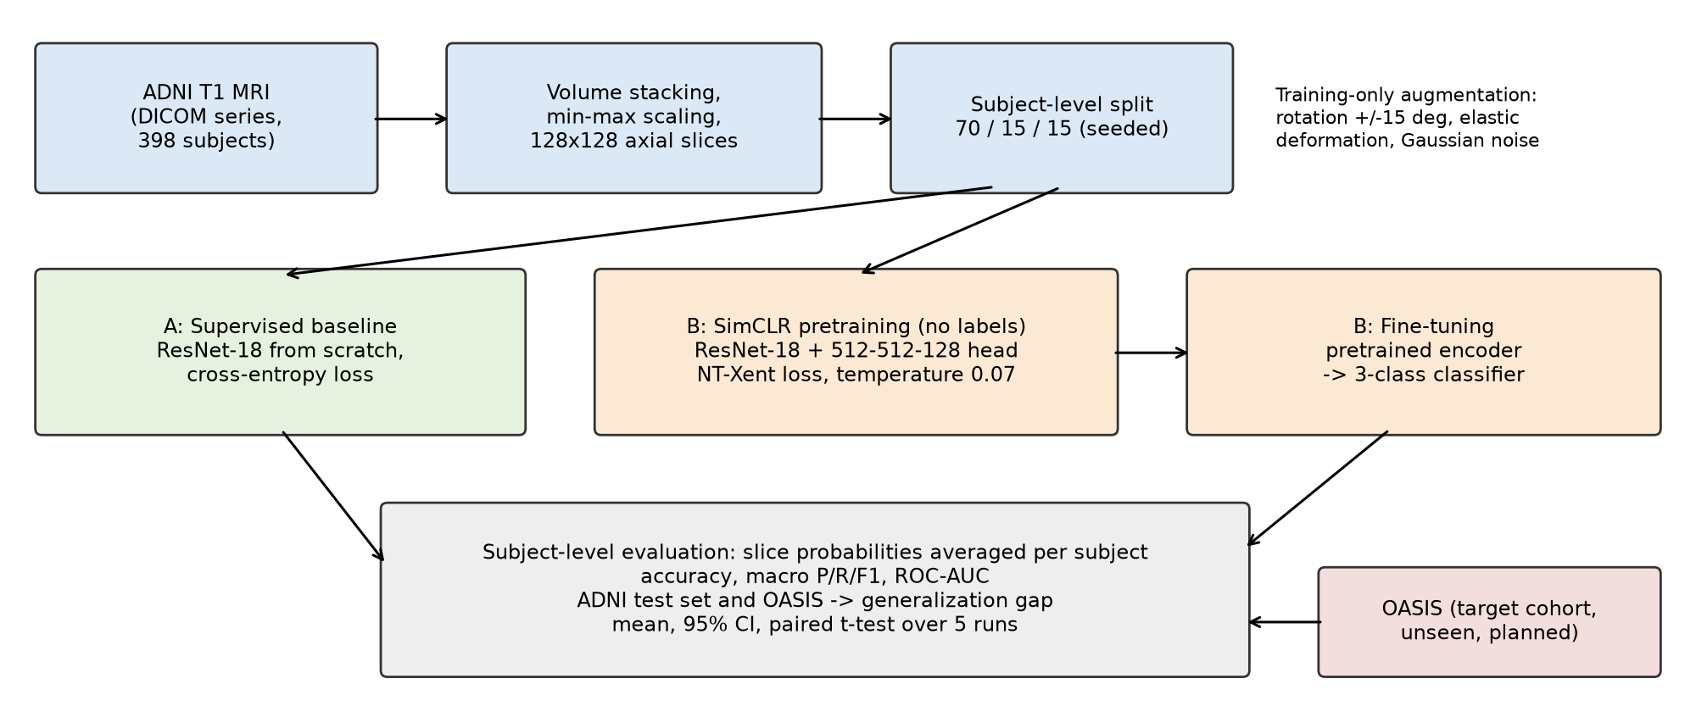
Figure 3.1: Architecture of the supervised vs. self-supervised comparison pipeline
Preprocessing The DICOM images of one scan are read with pydicom and stacked into a 3D volume. Intensities are scaled to the range 0 to 1 using the minimum and maximum of that volume, so that differences between scanners do not dominate, and every axial slice is resized to 128 × 128 pixels. Each grayscale slice is copied into three channels because ResNet-18 expects colour input.
Subject-Level Splitting Subjects, not slices, are divided into 70% training, 15% validation and 15% test, with the class proportions kept similar in each set and a fixed random seed. All slices of a subject stay in the subject’s set, so the test set contains only people the network has never seen.
Augmentation Training slices receive random rotation of up to 15 degrees, elastic deformation and Gaussian noise, using the Albumentations library. Validation and test slices are only normalised, because evaluation must reflect real scans rather than altered ones.
Supervised Baseline A ResNet-18 with its final layer replaced by a three-class output (CN, MCI, AD) is trained from random initialisation with the Adam optimiser at a learning rate of 0.001, cross-entropy loss and a batch size of 16 for up to 50 epochs, stopping early when validation accuracy has not improved for ten epochs.
Self-Supervised Pretraining and Fine-Tuning The same ResNet-18, without its classification layer, serves as an encoder that produces a 512-dimensional feature vector. A projection head of two linear layers (512 to 512 to 128, with ReLU between them) maps it to the space in which the NT-Xent loss is computed with a temperature of 0.07. Pretraining runs for up to 100 epochs and uses no labels. The pretrained encoder layers are then copied into a fresh classifier, which is fine-tuned on the labelled slices at a lower learning rate of 0.0001 for up to 50 epochs with the same early stopping. Both models therefore have identical architectures and differ only in how their weights were initialised.
Subject-Level Evaluation For every test subject, the class probabilities of all its slices are averaged and the class with the highest mean probability becomes the subject’s prediction. Accuracy, macro-averaged precision, recall and F1 score, one-vs-rest ROC-AUC and the confusion matrix are computed on these subject-level predictions. Macro averaging gives each class equal weight, which matters because AD subjects are fewer than CN and MCI subjects.
Repeated Runs and Significance Testing The complete experiment is repeated five times with different seeds (43 to 47), each with a new split. For each metric the mean, standard deviation and 95% confidence interval over runs are reported, and a paired t-test over the runs decides whether the difference between the self-supervised and supervised models is significant at p < 0.05.
Cross-Cohort Evaluation ADNI is the source cohort, on which both models are trained, and OASIS is the target cohort, which neither model sees during training, pretraining or model selection. After training, each model is applied unchanged to the OASIS subjects, with the same preprocessing and subject-level aggregation. OASIS grades dementia by the Clinical Dementia Rating (CDR) rather than by ADNI’s research groups, so the planned mapping is CDR 0 to CN, CDR 0.5 to MCI and CDR 1 or above to AD; because this mapping is approximate, the two-class comparison of CN against AD will also be reported. For each model the generalization gap is the in-cohort ADNI score minus the OASIS score. The hypothesis is supported if the self-supervised model has a significantly smaller gap, or a significantly higher OASIS score, than the supervised baseline over the five runs.
Chapter 4: Procedures and System Setup
Development Environment The project was developed in Python 3.13 with PyTorch and torchvision for the networks, pydicom and nibabel for reading medical images, NumPy, SciPy and pandas for data handling, scikit-learn for metrics, Albumentations for augmentation and Matplotlib with seaborn for plots. The development laptop has no GPU, so all settings are chosen to make training feasible on a CPU: 128-pixel slices, the small ResNet-18 and a batch size of 16. The dependencies are listed in requirements.txt and installed in a virtual environment.
Configuration Every adjustable value, including paths, split ratios, image size, learning rates, epochs, the SimCLR temperature, augmentation strengths, the number of runs and the random seed, is kept in config.py so that experiments can be changed and repeated without editing code. Each run sets the NumPy and PyTorch random seeds for reproducibility.
Data Acquisition The ADNI T1 collections were downloaded as ZIP archives from the ADNI image repository and unpacked with extract_adni.py into one folder per subject, giving 398 subjects and 113,100 DICOM images. The scans come from several scanner protocols and generations of ADNI, which appear as differently named series (Figure 5.2). The XML metadata files downloaded with the images were stored separately and record each subject’s research group.
Code Organisation The code is divided into seven modules: dataset.py reads scans and labels, splitter.py performs the subject-level split and saves it to split_assignments.json, dataloader.py builds the PyTorch data loaders with augmentation, models.py defines the classifier, encoder, projection head and SimCLR model, train.py contains the supervised and contrastive training loops and the NT-Xent loss, evaluate.py performs subject-level aggregation and computes metrics, and experiment.py runs the complete comparison and writes experiment_results.json and statistics.json.
Testing Every module except dataset.py contains a self-test that runs when the file is executed directly. Before any real scan is used, the whole pipeline can be run on a mock dataset of synthetic subjects, which checks that loading, splitting, both training paths, evaluation and the statistics are connected correctly in minutes rather than hours.
Running the System The complete comparison is started with a single command, python src/experiment.py, which trains and evaluates both models for every run and saves all subject-level predictions and summary statistics to outputs/results.
Chapter 5: Results and Discussion
The software pipeline is complete and has been run end to end on synthetic data. The comparison of supervised and self-supervised training on real ADNI scans is implemented but has not yet been run; no accuracy on real MRI is reported for it. This chapter reports what has been measured: the verification run, the composition of the local data and the problems found while preparing it.
Pipeline Verification The mock experiment completed two runs, each training the supervised baseline, pretraining and fine-tuning the SimCLR model and evaluating both on three held-out synthetic subjects. Because the synthetic slices are random noise, no model can learn anything from them, and both models correctly scored at chance: an accuracy of 0.333 and a macro F1 score of 0.167 in both runs, with every test subject assigned to the same class. These numbers confirm only that the pipeline runs and that the subject-level evaluation produces one prediction per subject; they say nothing about either method. The run also showed that with nine mock subjects the validation set was empty, and that identical scores in every run make the t-test undefined, so the real experiment needs enough subjects for non-empty validation sets and enough runs for the test to be meaningful.
Diagnosis Labels The labels used so far in data/raw/ADNI_diagnoses.csv were produced by create_diagnoses.py as placeholders: the 398 subjects were randomly assigned 50% CN, 30% MCI and 20% AD so that the pipeline could be exercised. A check against the research group recorded in the ADNI XML metadata showed that 237 of the 398 subjects have a recorded group: 78 CN, 124 MCI (82 MCI, 27 early MCI and 15 late MCI), 25 AD and 10 with significant memory concern. Of the 227 subjects whose recorded group maps to CN, MCI or AD, the placeholder label agrees in only 79 cases (34.8%), roughly what random assignment predicts. Any model trained on the placeholder labels would therefore learn nothing about the disease, and the labels must be replaced by those from the ADNI records before real results are produced. Figure 5.1 compares the two.
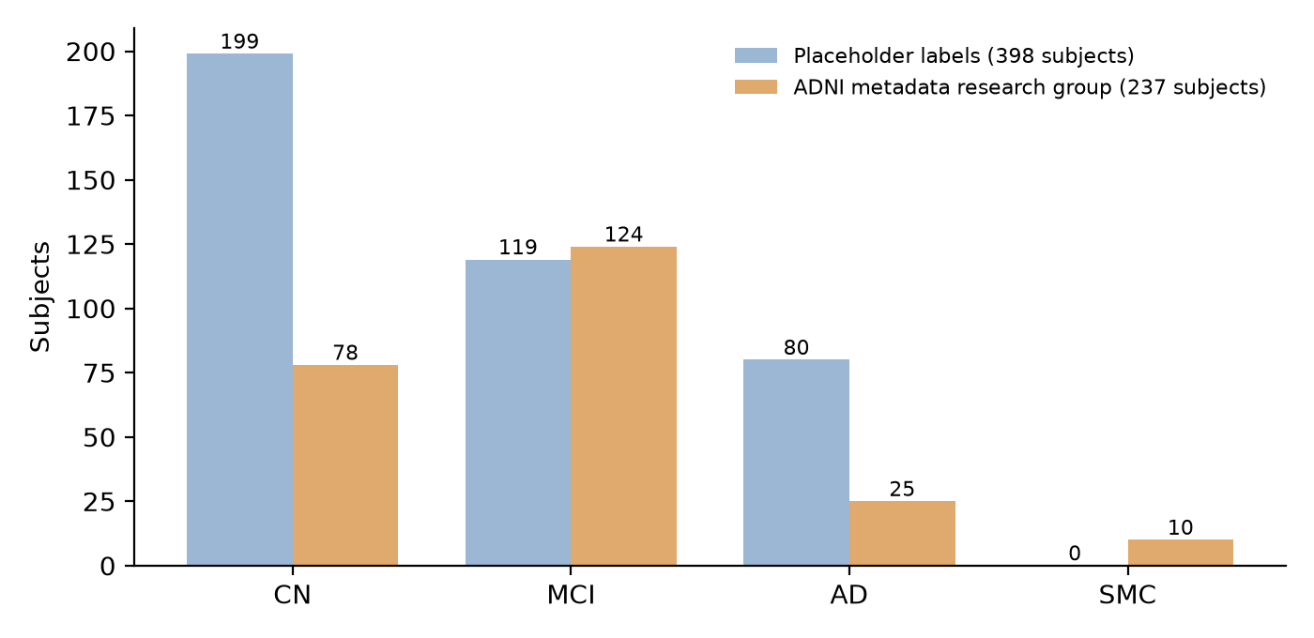
Figure 5.1: Placeholder labels compared with the research group recorded in the ADNI metadata
Class Balance The recorded groups are imbalanced, with five times as many MCI as AD subjects, which supports the use of macro-averaged metrics and suggests class weighting during training. The 161 subjects without a metadata record need their diagnosis taken from the ADNI clinical tables, and the 10 subjects with significant memory concern must either be excluded or grouped explicitly.
Acquisition Protocols Figure 5.2 shows that the scans of the 398 subjects are stored under many different series names. The loader currently reads only series named exactly MPRAGE, which exist for 159 subjects, so more than half of the downloaded subjects would be skipped. Recognising the other MPRAGE variants, and choosing one scan per subject consistently, will more than double the usable data.
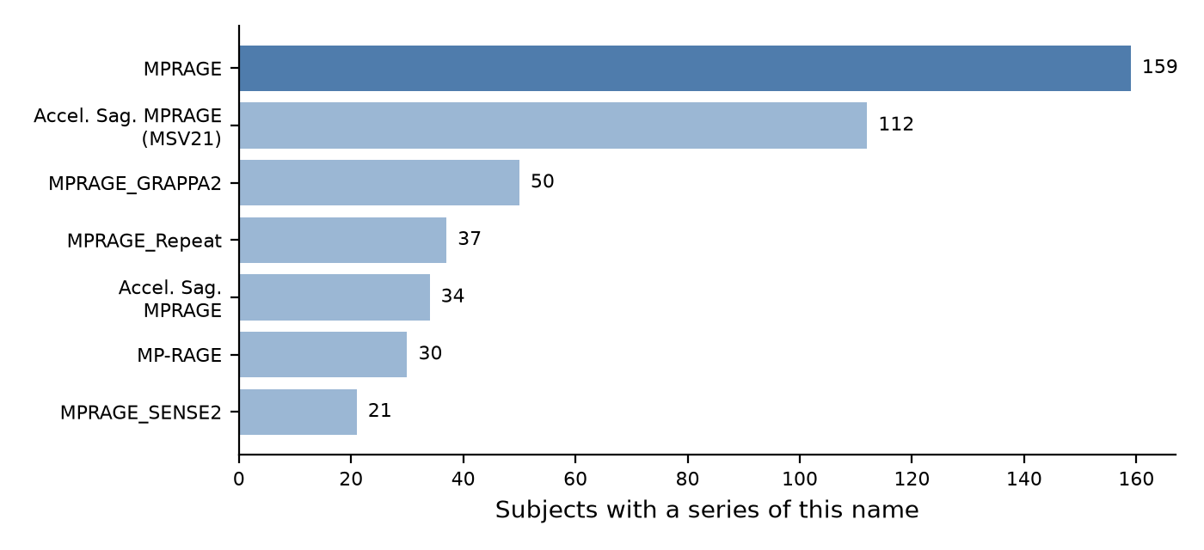
Figure 5.2: Number of subjects per MRI series name (the series the loader currently reads is highlighted)
Observations from Development Preparing the pipeline for real data revealed several defects that the mock run could not expose, and each is to be corrected before the ADNI experiment. The per-slice access method of the dataset still returns synthetic images in place of the stored slices, and two methods the data loader calls exist only in an earlier version of the dataset module. In SimCLR pretraining, the second view of each slice is produced by adding very slight noise rather than by an independent random augmentation, which makes the contrastive task too easy for the encoder to learn useful features. In the evaluator, the true labels are collected in the order subjects are first seen, while predictions are listed in sorted order of subject identifier, so the two can be misaligned when these orders differ.
Limitations No result on real MRI exists yet. The OASIS cohort has not been downloaded, so the cross-cohort evaluation, which is the central experiment of the project, has not been run, and the mapping from CDR to the three ADNI classes is approximate. The model uses 2D slices, which ignore the 3D structure of the brain, includes slices outside the brain that carry no diagnostic information, and does not apply skull stripping or registration to a standard template. The development laptop has no GPU, which limits the number of epochs and runs that can be completed in reasonable time.
Chapter 6: Future Enhancements
Multi-Cohort Evaluation Evaluation will be extended beyond OASIS to further large neuroimaging datasets, including AIBL (Australian Imaging, Biomarkers and Lifestyle Study) and UK Biobank. Testing on several cohorts strengthens the evidence for generalization and shows which differences between datasets cause the largest loss of accuracy.
Explainability and Interpretability Gradient-weighted Class Activation Mapping (Grad-CAM; Selvaraju et al., 2017) and related methods will show which brain regions contribute most to each prediction. This is essential for clinical acceptance and can confirm whether the learned features match known AD pathology, such as hippocampal atrophy.
Uncertainty Estimation Bayesian deep learning or Monte Carlo dropout will provide an uncertainty estimate with each prediction, so that clinicians can rely on high-confidence cases and review ambiguous ones manually.
Domain Adaptation and Transfer Learning Domain adaptation techniques such as adversarial training, maximum mean discrepancy (MMD) and self-training will be investigated to improve cross-cohort performance further, and compared with SSL pretraining.
Clinician-Friendly Research Prototype A web-based research prototype will allow clinicians and researchers to upload MRI scans and obtain an automated AD risk prediction with its confidence score and Grad-CAM visualisation, and to contribute data for future refinement of the model.
Conclusion
The project has produced a complete, reproducible pipeline for measuring whether self-supervised contrastive pretraining improves the cross-cohort generalization of Alzheimer’s disease classification from structural MRI. It reads ADNI scans from their original DICOM files, splits the data by subject to prevent leakage, trains a ResNet-18 baseline and a SimCLR-pretrained ResNet-18 under identical conditions, aggregates slice predictions into one prediction per subject, and compares the two models over repeated runs with confidence intervals and a paired t-test. An end-to-end run on synthetic data confirmed that every stage is connected and that the evaluation correctly reports chance performance when there is nothing to learn.
The most useful lesson came from checking the data before trusting any result. The placeholder diagnosis labels agree with the ADNI records for only 34.8% of subjects, the loader would have used fewer than half of the downloaded scans, and several defects were invisible on synthetic data. Had the experiment been run without these checks, it would have produced numbers that looked like findings but measured nothing.
Future work will take diagnosis labels from the ADNI records, read all MPRAGE variants, correct the dataset, augmentation and evaluation defects, replace the second SimCLR view with an independent random augmentation, run the five-run comparison on ADNI, add class weighting, restrict slices to the brain, download OASIS and measure the generalization gap of both models on it, report effect sizes alongside the significance tests, vary the fraction of labelled data to measure where pretraining helps most, and train on a GPU.
References
1. C. R. Jack Jr., M. A. Bernstein, N. C. Fox, P. Thompson, G. Alexander, D. Harvey et al., The Alzheimer’s Disease Neuroimaging Initiative (ADNI): MRI methods, Journal of Magnetic Resonance Imaging, vol. 27, no. 4, pp. 685-691, 2008.
2. D. S. Marcus, T. H. Wang, J. Parker, J. G. Csernansky, J. C. Morris and R. L. Buckner, Open Access Series of Imaging Studies (OASIS): Cross-sectional MRI data in young, middle aged, nondemented, and demented older adults, Journal of Cognitive Neuroscience, vol. 19, no. 9, pp. 1498-1507, 2007.
3. P. J. LaMontagne, T. L. Benzinger, J. C. Morris, S. Keefe, R. Hornbeck, C. Xiong et al., OASIS-3: Longitudinal neuroimaging, clinical, and cognitive dataset for normal aging and Alzheimer disease, medRxiv, 2019.
4. G. B. Frisoni, N. C. Fox, C. R. Jack, P. Scheltens and P. M. Thompson, The clinical use of structural MRI in Alzheimer disease, Nature Reviews Neurology, vol. 6, no. 2, pp. 67-77, 2010.
5. P. Scheltens, K. Blennow, M. M. Breteler, B. de Strooper, G. B. Frisoni, S. Salloway and W. M. Van der Flier, Alzheimer’s disease, The Lancet, vol. 388, no. 10043, pp. 505-517, 2016.
6. K. He, X. Zhang, S. Ren and J. Sun, Deep Residual Learning for Image Recognition, IEEE CVPR, pp. 770-778, 2016.
7. Y. Bengio, A. Courville and P. Vincent, Representation learning: A review and new perspectives, IEEE Transactions on Pattern Analysis and Machine Intelligence, vol. 35, no. 8, pp. 1798-1828, 2013.
8. A. van den Oord, Y. Li and O. Vinyals, Representation Learning with Contrastive Predictive Coding, arXiv:1807.03748, 2018.
9. T. Chen, S. Kornblith, M. Norouzi and G. Hinton, A Simple Framework for Contrastive Learning of Visual Representations, ICML, pp. 1597-1607, 2020.
10. S. Azizi et al., Big Self-Supervised Models Advance Medical Image Classification, IEEE/CVF ICCV, 2021.
11. J. Wen et al., Convolutional neural networks for classification of Alzheimer’s disease: Overview and reproducible evaluation, Medical Image Analysis, vol. 63, 101694, 2020.
12. E. Yagis et al., Effect of data leakage in brain MRI classification using 2D convolutional neural networks, Scientific Reports, vol. 11, 22544, 2021.
13. R. R. Selvaraju, M. Cogswell, A. Das, R. Vedantam, D. Parikh and D. Batra, Grad-CAM: Visual explanations from deep networks via gradient-based localization, IEEE ICCV, pp. 618-626, 2017.
14. I. Goodfellow, Y. Bengio and A. Courville, Deep Learning, MIT Press, 2016.
15. D. P. Kingma and J. Ba, Adam: A Method for Stochastic Optimization, ICLR, 2015.
16. A. Buslaev et al., Albumentations: Fast and Flexible Image Augmentations, Information, vol. 11, no. 2, 125, 2020.
17. A. Paszke et al., PyTorch: An Imperative Style, High-Performance Deep Learning Library, NeurIPS, 2019.

