DENSITY BASED TRAFFIC SIGNAL SYSTEM

Requirements

Nowadays, controlling the traffic becomes major issue because of rapid increase in automobiles and also because of large time delays between traffic lights. So, in order to rectify this problem, we will go for density based traffic lights system.

In this system, IR sensors to measure the traffic density. To arrange one IR sensor for each road; these sensors always sense the traffic on that particular road. All these sensors are interfaced to the microcontroller. Based on these sensors, controller detects the traffic and controls the traffic system.

* Atmega8 Controller
* PCB board
* IR sensors-4
* LED’s-12(4-red,4-green,4-yellow)
* 12v Battery or adaptor
* Serial cable
* Connecting wires

High Level Requirements:

ATMEGA8 AVR Microcontroller

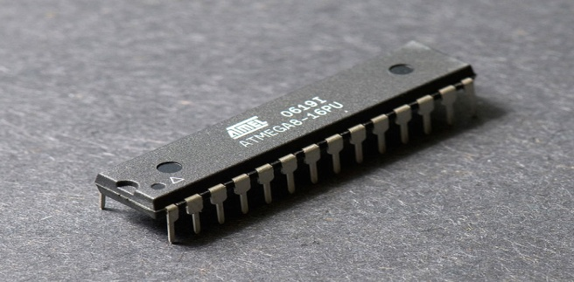 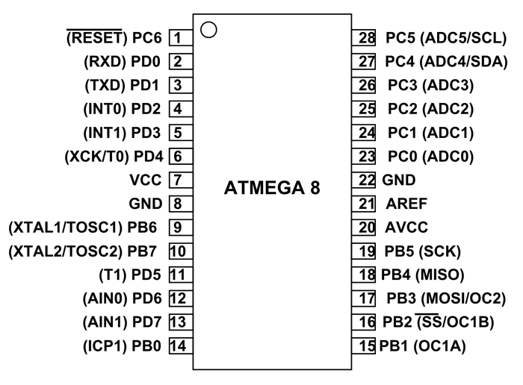

**ATMEGA8 is a 28 pin AVR microcontroller**. Although we have many similar [microcontrollers](https://components101.com/tags/avr-microcontroller), ATMEGA8 is popular because it is one of the cheapest microcontroller and provides many features in lesser pins. With program memory of 8Kbytes, ATMEGA8 application is very versatile. With various POWER SAVING modes, it can work on MOBILE EMBEDDED SYSTEMS. With its compact size, it can be put in many small boards. With Watchdog timer to reset under error, it can be used on systems with minimal human interference. These features added together in one controller make the ATMEGA8 popular.

Using ATMega8 is similar to other ATMega microcontrollers, such as [ATMega32](https://components101.com/microcontrollers/atmega32-8-bit-avr-microcontroller). Similarly, the micro-controller need to be programmed and added appropriate peripherals to get the output. Without programming the controller is an empty chip.

For working of ATMEGA8, first we need to burn the appropriate program file in the **ATMEGA8 FLASH memory**. After dumping this program code, the controller executes this code and provides appropriate response.

PCB Board

A printed circuit board, or PCB, is used to mechanically support and electrically connect electronic components using conductive pathways, tracks or signal traces etched from copper sheets laminated onto a non-conductive substrate.

When the board has only copper tracks and features, and no circuit elements such as capacitors, resistors or active devices have been manufactured into the actual substrate of the board, it is more correctly referred to as printed wiring board (PWB) or etched wiring board.

IR Sensor

IR sensor is an electronic device, that emits the light in order to sense some object of the surroundings. An [**IR sensor**](https://robu.in/product-category/sensor/ir-and-pir-sensor/) can measure the heat of an object as well as detects the motion. Usually, in the [**infrared spectrum**](https://en.wikipedia.org/wiki/Infrared_spectroscopy), all the objects radiate some form of thermal radiation. These types of radiations are invisible to our eyes, but infrared sensor can detect these radiations.

The emitter is simply an IR LED [**(Light Emitting Diode**](https://robu.in/product-category/display-boards/led/)) and the detector is simply an IR photodiode . Photodiode is sensitive to IR light of the same wavelength which is emitted by the IR LED. When IR light falls on the photodiode, the resistances and the output voltages will change in proportion to the magnitude of the IR light received.

There are five basic elements used in a typical infrared detection system: an infrared source, a transmission medium, optical component, infrared detectors or receivers and signal processing. Infrared lasers and Infrared LED’s of specific wavelength used as infrared sources.

The three main types of media used for infrared transmission are vacuum, atmosphere and optical fibers. Optical components are used to focus the infrared radiation or to limit the spectral response.

Adapter

An **adapter** or **adaptor**[[1]](https://en.wikipedia.org/wiki/Adapter" \l "cite_note-1) is a device that converts attributes of one electrical device or system to those of an otherwise incompatible device or system. Some modify [power](https://en.wikipedia.org/wiki/Electric_power) or [signal](https://en.wikipedia.org/wiki/Signal_processing) attributes, while others merely adapt the physical form of one [connector](https://en.wikipedia.org/wiki/Electrical_connector) to another

Serial Cable

A **serial cable** is a [cable](https://en.wikipedia.org/wiki/Electrical_cable) used to transfer information between two devices using a [serial communication](https://en.wikipedia.org/wiki/Serial_communication) protocol. The form of connectors depends on the particular [serial port](https://en.wikipedia.org/wiki/Serial_port) used. A cable wired for connecting two [DTEs](https://en.wikipedia.org/wiki/Data_terminal_equipment) directly is known as a [null modem](https://en.wikipedia.org/wiki/Null_modem) cable.

Low Level Requirements:

1. Traffic lights

Traffic lights are also called in different ways like traffic lamps, signal lights, traffic semaphore, and traffic control signals. Commonly, traffic lights have three colors. Green means go, red means stop and the yellow or orange means that the signal is about to switch into green or red. Other roads and highways only use red and green traffic light signals which bear the same meaning.

Traffic lights play a vital and crucial role in the flow of traffic every day. It prevents or at least reduces the cases of car crash and collisions in the roads especially in intersections. It provides a safe and orderly flow of cars on the roads and highways.

In addition, traffic lights also ensure the safety of pedestrians crossing the road. It ensures that pedestrians also get the same share of the road without worrying about their safety. There are probably millions of lives saved by those drivers who follow traffic lights.

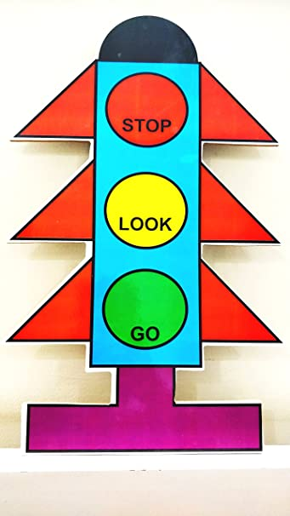 Traffic Signal

## **2. Road signs**

There are three main types of road signs in the Philippines. Each of it bears significance that every driver should remember and follow.

### ****Warning signs****

### Road signs and traffic signs promote safe driving conditions. Warning signs tell if the road ahead has curves and turns. It also indicates if there will be merge and lane transition, intersections, pedestrian crossing, hill warning, divided highway, speed bump notices, narrowed road, roundabout, and advance traffic control. Not following warning signs can cause great danger especially when the warning signsindicates that there are an ongoing construction work or hazard ahead. Examples are slippery road and falling rocks.

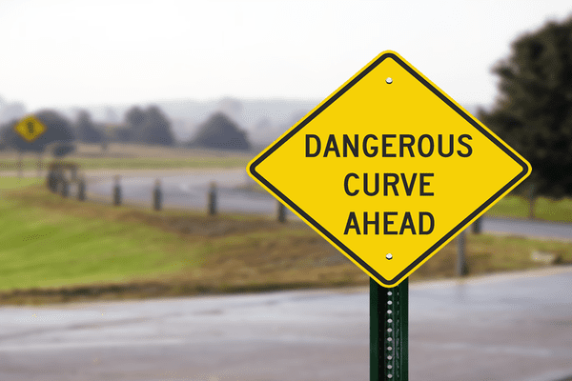

### ****Advisory or regulatory signs****

Advisory signs are those that indicate the right and maximum speed in a particular road, it also shows if the road is one way only, even those signs we often see before we cross bridges that indicates the weight capacity of the bridge.

Other examples of regulatory signs are no overtaking, no entry, no parking, no blowing of horns, and no U-turn. It is important to take note and follow advisory signs for your own safety and for the safety of other drivers as well. It should also be followed if you don’t want to get caught and ticketed by a traffic enforcer.

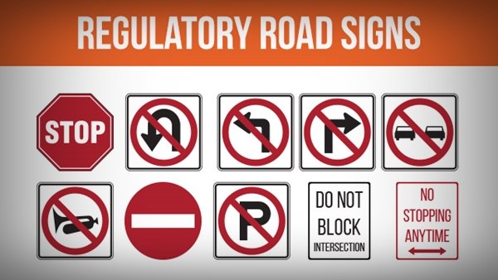

### ****Information road signs****

Information road signs are signs that provide important information for the drivers. It tells if there is a nearby hospital, airport or hotel. It also tells the distance of the next city or town as well as the right loading and unloading area. It can also give directions to drivers in the right place to park their vehicles.

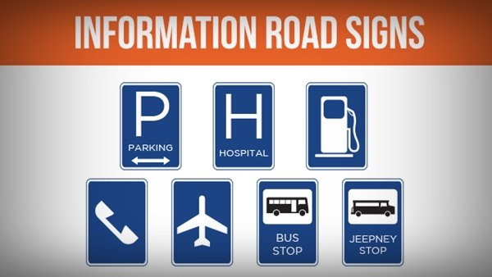

Information road signs are signs that provide important information for the drivers. It tells if there is a nearby hospital, airport or hotel. It also tells the distance of the next city or town as well as the right loading and unloading area.

## **3. Why should we follow the road signals and traffic lights?**

### ****Safety****

First and foremost, we follow traffic lights and road signals for safety – the safety of ourselves and the safety of all the people on the road. Without traffic lights, the number of accidents and fatalities will significantly increase especially on road intersections. It has contributed so much in lessening car accidents and collision and saving millions of lives.***.***

Traffic lights also help pedestrians to safely cross the roads. If we don't follow the traffic lights, our roads will be dangerous. Accidents will happen every minute and the safety of each individual will be at risk.

Road signs are also very helpful in keeping us safe. It tells us if there are dangers and hazards ahead. It provides us warnings on what’s ahead, be it heavy traffic, sharp curves and turns, road constructions and many more. Road signs keep us aware of any imminent danger so that we can protect ourselves.

If a driver will not abide or follow road signs, he/she is putting himself/herself to danger together with his/her passengers. It will also make driving a very dangerous activity.

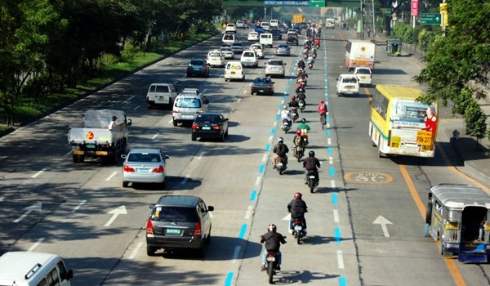

### **Order**

Imagine a road without traffic lights or road signs, we would have very dangerous and chaotic roads. The same goes when we don’t follow road signs and traffic lights. Our roads will be in total chaos and traffic will be at its worst. Office workers and students will be late in their respective classes and jobs.

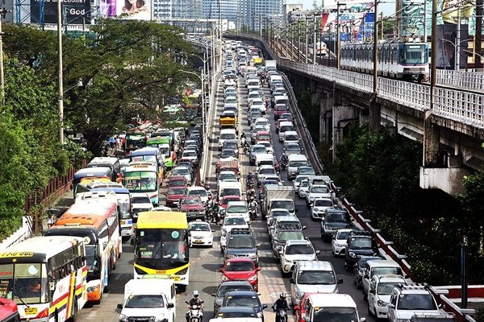

Imagine a road without traffic lights or road signs, we would have very dangerous and chaotic roads

There will be total gridlock. We will have disorderly and chaotic roads and highways. The main purpose of road signs is to make the run of transportation in the road’s smooth and systematic. That is why, following them is very important, to keep our roads in order.

### **Fines and Penalties**

Of course, if a person did not follow the road signs and traffic lights, he or she will have to face corresponding [fines and penalties](https://philkotse.com/safe-driving/7-most-expensive-fines-for-traffic-violations-in-the-philippines-mmda-3167) if caught by a traffic enforcer. That is if only caught violating.

However, if the violation of the rule resulted in an accident that leads to an injury of another individual – driver or pedestrian – he or she will have to face filed charges against him on top of the fines and penalties he/she has to pay.

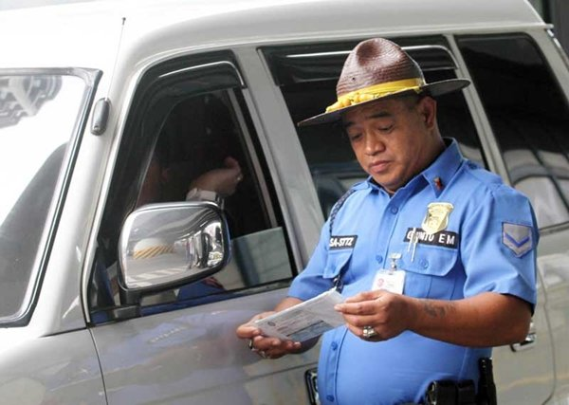

There will be corresponding fines and penalties if caught by a traffic enforcer

The same goes when the [violation of traffic rules](https://philkotse.com/safe-driving/10-most-common-traffic-violations-in-the-philippines-respective-fines-2770) resulted in damage to property. Your license might also be subjected for suspension or revocation, depending on the damage or injury caused by the violations of traffic rules.

Lots of road crash and accidents happen because drivers didn’t follow traffic rules. This is one of the main reasons why abiding road signs and traffic lights are very important. Road signs and traffic lights are there for a reason. It is there for us to abide and follow.

They are very important because they promote safety and order on our roads and highways. They also serve as warnings of dangers ahead. They make our driving experience better and safer.