DESIGN

Structural Diagram

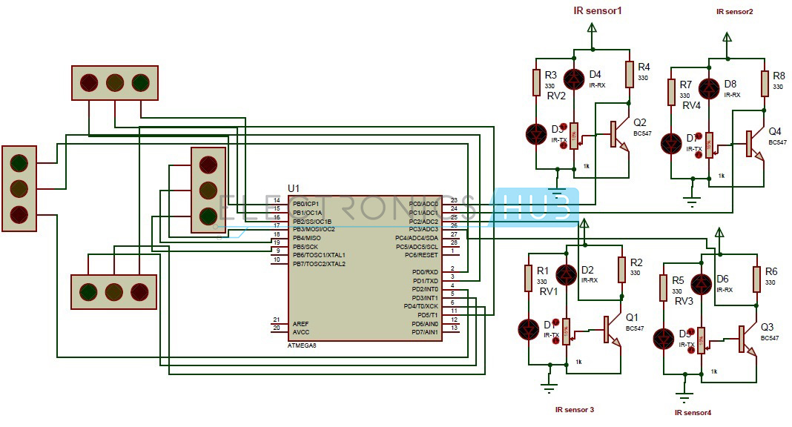

**Density Based Traffic Lights System Circuit Diagram**

## Block Diagrams

## Block diagram of the Density Based Traffic Light Control System. | Download Scientific Diagram

