DATA ANALYSIS INTERNSHIP REPORT
Exploratory Data Analysis on Student Dataset

Introduction
Data analysis plays an important role in understanding patterns and extracting insights from datasets. The objective of this project is to analyze a student dataset containing demographic and enrollment details. Using Python, SQL, and visualization techniques, the dataset was explored to understand the distribution of students across courses, gender, cities, and academic years.
Exploratory Data Analysis (EDA) techniques were applied to summarize the dataset and identify meaningful patterns that can assist in decision-making and institutional planning.
Dataset Overview
The dataset contains 1000 student records with the following attributes:
Column Name | Description
Student_ID | Unique identifier for each student
Name | Student name
Date_of_Birth | Student birth date
Gender | Gender of student
Course | Enrolled course
Year | Academic year
City | Student city
Email | Student email address

Data Preparation
Before performing analysis, the dataset was cleaned and prepared.
Steps performed:
- Imported dataset into Python using Pandas
- Checked for missing values
- Converted Date_of_Birth column to datetime format
- Created Age column from Date_of_Birth
- Verified dataset structure using info() and describe()
Visualizations
The following visualizations were created:
- Gender Distribution Bar Chart
- Course Enrollment Distribution
- City-wise Student Distribution
- Academic Year Distribution
- Age vs Academic Year Scatter Plot

Descriptive Statistics & Univariate Analysis
Descriptive statistics help summarize key characteristics of the dataset.
Numerical Analysis
The numerical variables include:
- Age
- Year
df[['Age','Year']].describe()
Insights:
- The average age of students falls within the typical college age range.
- Academic years are distributed across multiple levels.

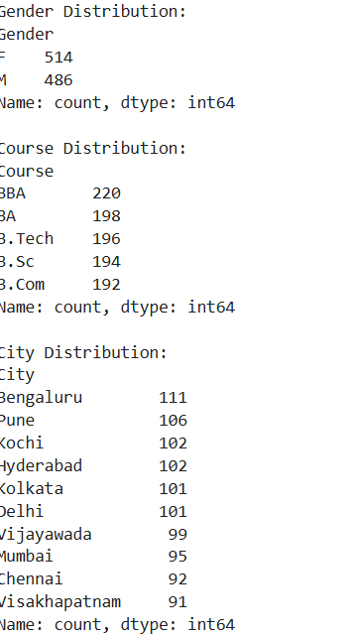
Gender Distribution
print("Gender Distribution:")
print(df['Gender'].value_counts())
print("\nCourse Distribution:")
print(df['Course'].value_counts())
print("\nCity Distribution:")
print(df['City'].value_counts())

Course Distribution
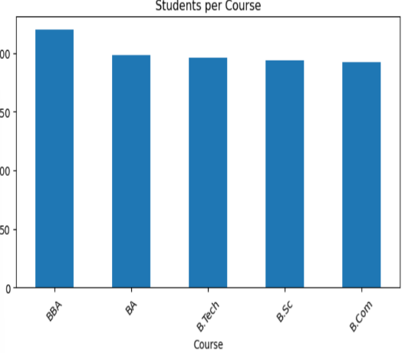
df['Course'].value_counts()
plt.figure(figsize=(8,4))
df['Course'].value_counts().plot(kind='bar')
plt.title("Students per Course")
plt.xticks(rotation=45)
plt.show()
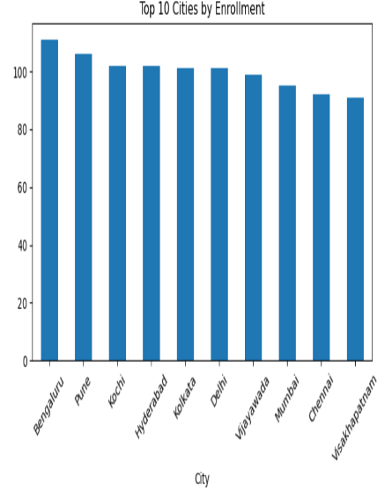
City Distribution
df['City'].value_counts().head(10)
plt.figure(figsize=(8,4))
df['City'].value_counts().head(10).plot(kind='bar')
plt.title("Top 10 Cities by Enrollment")
plt.xticks(rotation=45)
plt.show()
SQL for Business Questions
What is the total number of students?
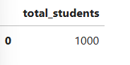
SELECT COUNT(*) AS total_students
FROM students;

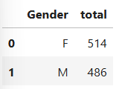
What is the gender distribution?
SELECT Gender, COUNT(*) AS total
FROM students
GROUP BY Gender;

Which course has the highest enrollment?
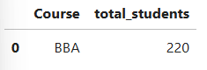
SELECT Course, COUNT(*) AS total_students
FROM students
GROUP BY Course
ORDER BY total_students DESC
LIMIT 1;

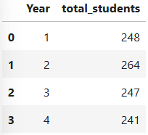
How many students are in each academic year?
SELECT Year, COUNT(*) AS total_students
FROM students
GROUP BY Year
ORDER BY Year;

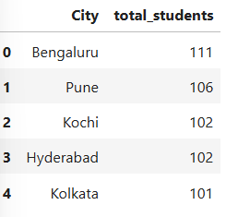
Top 5 cities by student enrollment
SELECT City, COUNT(*) AS total_students
FROM students
GROUP BY City
ORDER BY total_students DESC
LIMIT 5;

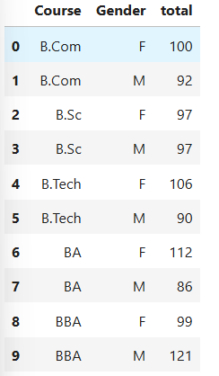
Course-wise gender distribution
SELECT Course, Gender, COUNT(*) AS total
FROM students
GROUP BY Course, Gender
ORDER BY Course;

Multivariate Analysis & Correlation
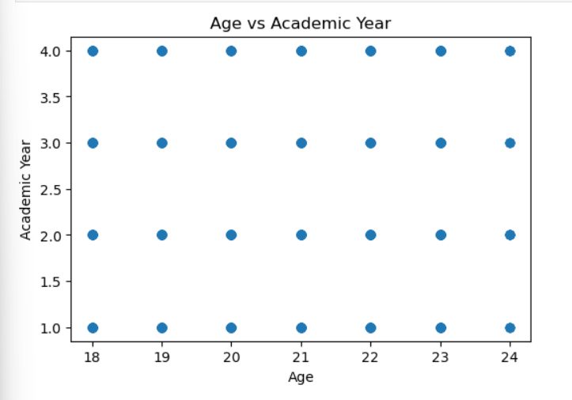
🔹 Age vs Year Scatter Plot
plt.figure(figsize=(6,4))
plt.scatter(df['Age'], df['Year'])
plt.xlabel("Age")
plt.ylabel("Academic Year")
plt.title("Age vs Academic Year")
plt.show()

🔹 Course vs Gender (Stacked Bar)
pd.crosstab(df['Course'], df['Gender']).plot(kind='bar', stacked=True)
plt.xticks(rotation=45)
plt.title("Course vs Gender Distribution")
plt.show()
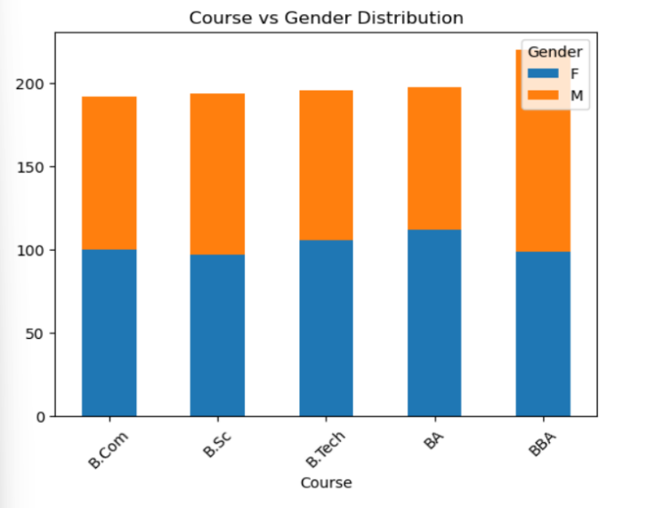

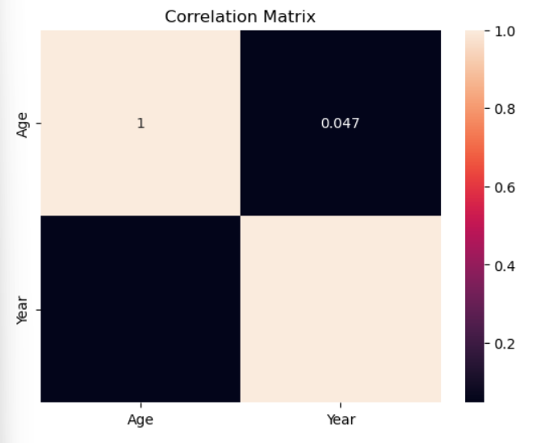
🔹 Correlation Matrix
corr = df[['Age','Year']].corr()
sns.heatmap(corr, annot=True)
plt.title("Correlation Matrix")
plt.show()

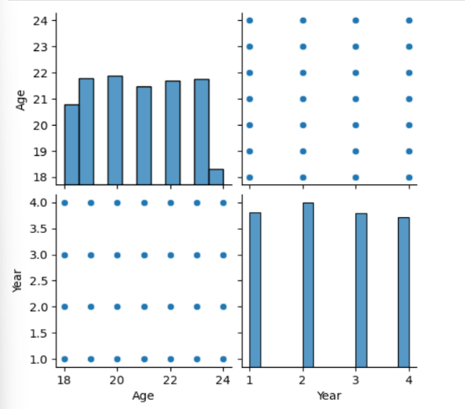
🔹 Pair Plot
sns.pairplot(df[['Age','Year']])
plt.show()

Conclusion
The analysis of the student dataset provided valuable insights into enrollment patterns and student demographics. The study revealed variations in course popularity, gender distribution, and city-wise enrollment. Age distribution aligns with academic progression across years.
These insights can help institutions understand student demographics and support academic planning and resource allocation.

