1. Define Smart Objects with its Characteristics and also Discuss about the trends in smart objects.
Smart Objects: A Definition
Historically, the definition of a smart object has been a bit nebulous because of the different interpretations of the term by varying sources. To add to the overall confusion, the term smart object, despite some semantic differences, is often used interchangeably with terms such as smart sensor, smart device, IoT device, intelligent device, thing, smart thing, intelligent node, intelligent thing, ubiquitous thing, and intelligent product. In order to clarify some of this confusion, we provide here the definition of smart object as we use it in this book. A smart object, as described throughout this book, is a device that has, at a minimum, the following four defining characteristics (see Figure 3-7):
Processing unit: A smart object has some type of processing unit for acquiring data, processing and analyzing sensing information received by the sensor(s), coordinating control signals to any actuators, and controlling a variety of functions on the smart object, including the communication and power systems. The specific type of processing unit that is used can vary greatly, depending on the specific processing needs of different applications. The most common is a microcontroller because of its small form factor, flexibility, programming simplicity, ubiquity, low power consumption, and low cost.
Sensor(s) and/or actuator(s): A smart object is capable of interacting with the physical world through sensors and actuators. As described in the previous sections, a sensor learns and measures its environment, whereas an actuator is able to produce some change in the physical world. A smart object does not need to contain both sensors and actuators. In fact, a smart object can contain one or multiple sensors and/or actuators, depending upon the application.
Communication device: The communication unit is responsible for connecting a smart object with other smart objects and the outside world (via the network). Communication devices for smart objects can be either wired or wireless. Overwhelmingly, in IoT networks smart objects are wirelessly interconnected for a number of reasons, including cost, limited infrastructure availability, and ease of deployment. There are myriad different communication protocols for smart objects. In fact, much of this book is dedicated to how smart objects communicate within an IoT network, especially Chapter 4, ―Connecting Smart Objects,‖ Chapter 5, ―IP as the IoT Network Layer,‖ and Chapter 6, ―Application Protocols for IoT.‖ Thus, this chapter provides only a high-level overview and refers to those other chapters for a more detailed treatment of the subject matter.
Power source: Smart objects have components that need to be powered. Interestingly, the most significant power consumption usually comes from the communication unit of a smart object. As with the other three smart object building blocks, the power requirements also vary greatly from application to application. Typically, smart objects are limited in power, are deployed for a very long time, and are not easily accessible. This combination, especially when the smart object relies on battery power, implies that power efficiency, judicious power management, sleep modes, ultra-low power consumption hardware, and so on are critical design elements. For long-term deployments where smart objects are, for all practical purposes, inaccessible, power is commonly obtained from
scavenger sources (solar, piezoelectric, and so on) or is obtained in a hybridized manner, also tapping into infrastructure power.
Figure

2. Explain how Wireless sensor network can be able to connect smart objects.
Wireless Sensor Networks (WSNs)
Wireless sensor networks are made up of wirelessly connected smart objects, which are sometimes referred to as motes. The fact that there is no infrastructure to consider with WSNs is surely a powerful advantage for flexible deployments, but there are a variety of design constraints to consider with these wirelessly connected smart objects. Figure 3-8 illustrates some of these assumptions and constraints usually involved in WSNs
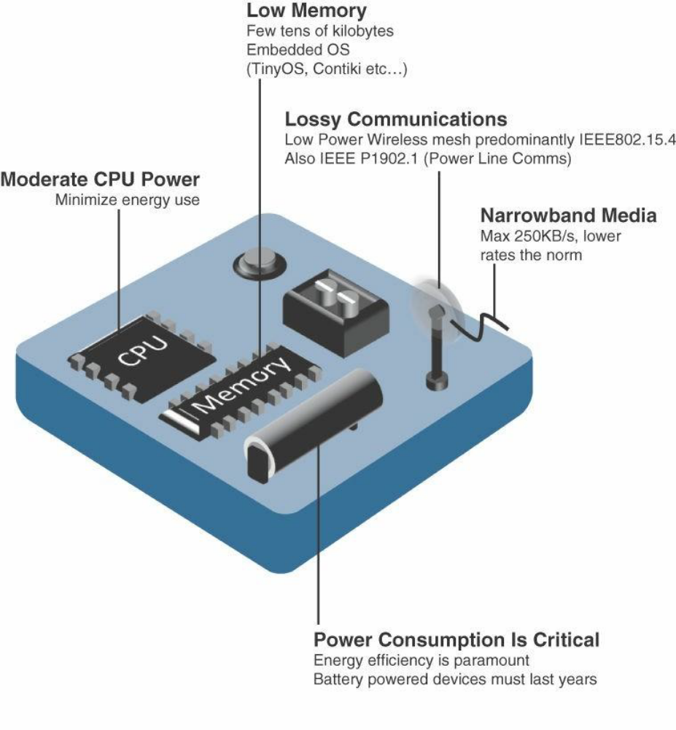

Design Constraints for Wireless Smart Objects

The following are some of the most significant limitations of the smart objects in WSNs: Limited processing power
Limited memory
Limited processing power
Limited memory
Lossy communication Limited transmission speeds Limited power
Note Smart objects with limited processing, memory, power, and so on are often referred to as
constrained nodes. Constrained nodes are discussed in more detail in Chapter 5.
These limitations greatly influence how WSNs are designed, deployed, and utilized. The fact that individual sensor nodes are typically so limited is a reason that they are often deployed in very large numbers. As the cost of sensor nodes continues to decline, the ability to deploy highly redundant sensors becomes increasingly feasible. Because many sensors are very inexpensive and correspondingly inaccurate, the ability to deploy smart objects redundantly allows for increased accuracy.
Such large numbers of sensors permit the introduction of hierarchies of smart objects. Such a hierarchy provides, among other organizational advantages, the ability to aggregate similar sensor readings from sensor nodes that are in close proximity to each other. Figure 3-9 shows an example of such a data aggregation function in a WSN where temperature readings from a logical grouping of temperature sensors are aggregated as an average temperature reading

Figure
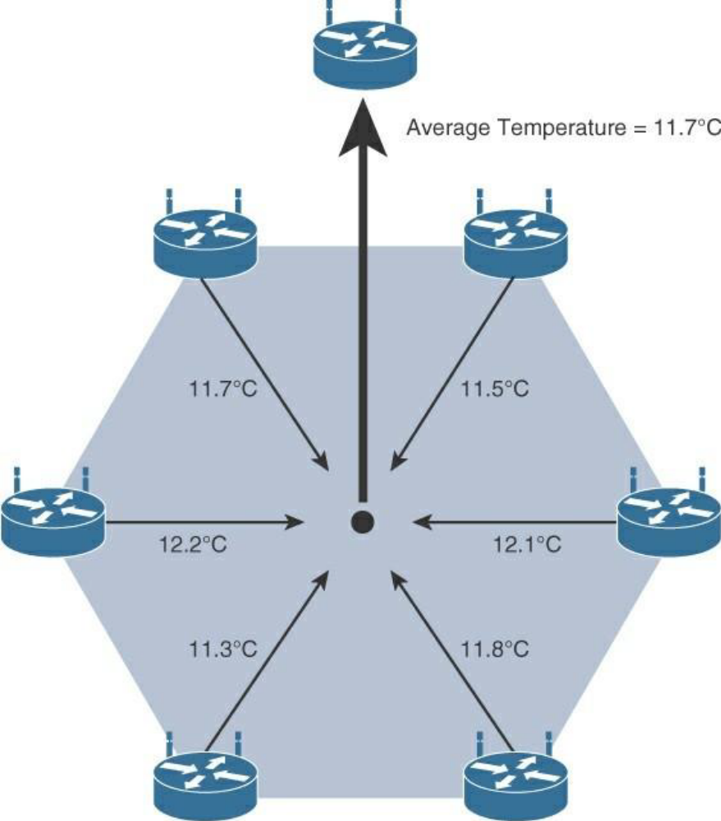 These data aggregation techniques are helpful in reducing the amount of overall traffic (and energy) in WSNs with very large numbers of deployed smart objects. This data aggregation at the network edges is where fog and mist computing, discussed in Chapter 2, ―IoT Network Architecture and Design,‖ are critical IoT architectural elements needed to deliver the scale and performance required by so many IoT use cases. While there are certain instances in which sensors continuously stream their measurement data, this is typically not the case. Wirelessly connected smart objects generally have one of the following two
communication patterns:
Event-driven: Transmission of sensory information is triggered only when a smart object detects a particular event or predetermined threshold.
Periodic: Transmission of sensory information occurs only at periodic intervals. The decision of which of these communication schemes is used depends greatly on the specific application. For example, in some medical use cases, sensors periodically send postoperative vitals, such as temperature or blood pressure readings. In other medical use cases, the same blood pressure or temperature readings are triggered to be sent only when certain critically low or high readings are measured. As WSNs grow to very large numbers of smart objects, there is a trend toward ever-increasing levels of autonomy. For example, manual configuration of potentially thousands of smart objects is impractical and unwieldy, so smart objects in a WSN are typically self-configuring or automated by an IoT management platform in the background. Likewise, additional levels of autonomous functions are required to establish cohesive communication among the multitudinous nodes of large-scale WSNs that are often ad hoc deployments with no regard for uniform node distribution and/or density. For example, there is an increasing trend toward ―smart dust‖ applications, in which very small sensor nodes (that is, MEMS) are scattered over a geographic area to detect vibrations, temperature, humidity, and so on. This technology has practically limitless capabilities, such as military (for example, detecting enemy troop movement), environmental (for example, detecting earthquakes or forest fires), and industrial (for example, detecting manufacturing anomalies, asset tracking). Some level of self-organization is required for networking the scads of wireless smart objects such that these nodes autonomously come together to form a true network with a common purpose. This capability to self-organize is able to adapt and evolve the logical topology of a WSN to optimize communication (among nodes as well as to centralized wireless controllers), simplify the introduction of new smart objects, and improve reliability and access to services. Additional advantages of being able to deploy large numbers of wireless low-cost smart objects are the inherent ability to provide fault tolerance, reliability, and the capability to extend the life of a WSN, especially in scenarios where the smart objects have limited battery life. Autonomous techniques, such as self-healing, self-protection, and self-optimization, are often employed to perform these functions on behalf of an overall WSN system. IoT applications are often mission critical, and in large-scale WSNs, the overall system can’t fail if the environment suddenly changes, wireless communication is temporarily lost, or a limited number of nodes run out of battery power or function improperly.

3. Mention any six sensor types are measuring physical phenomenon and summarize each of them with suitable examples.

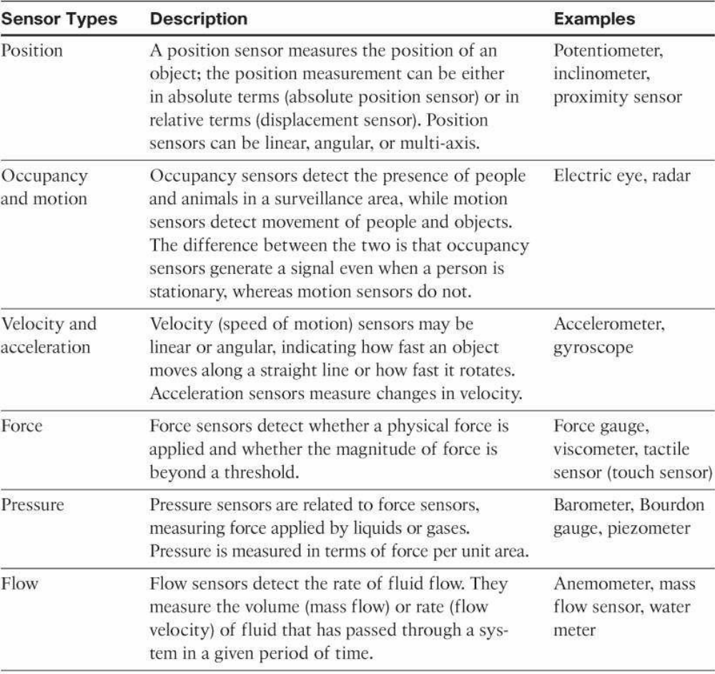
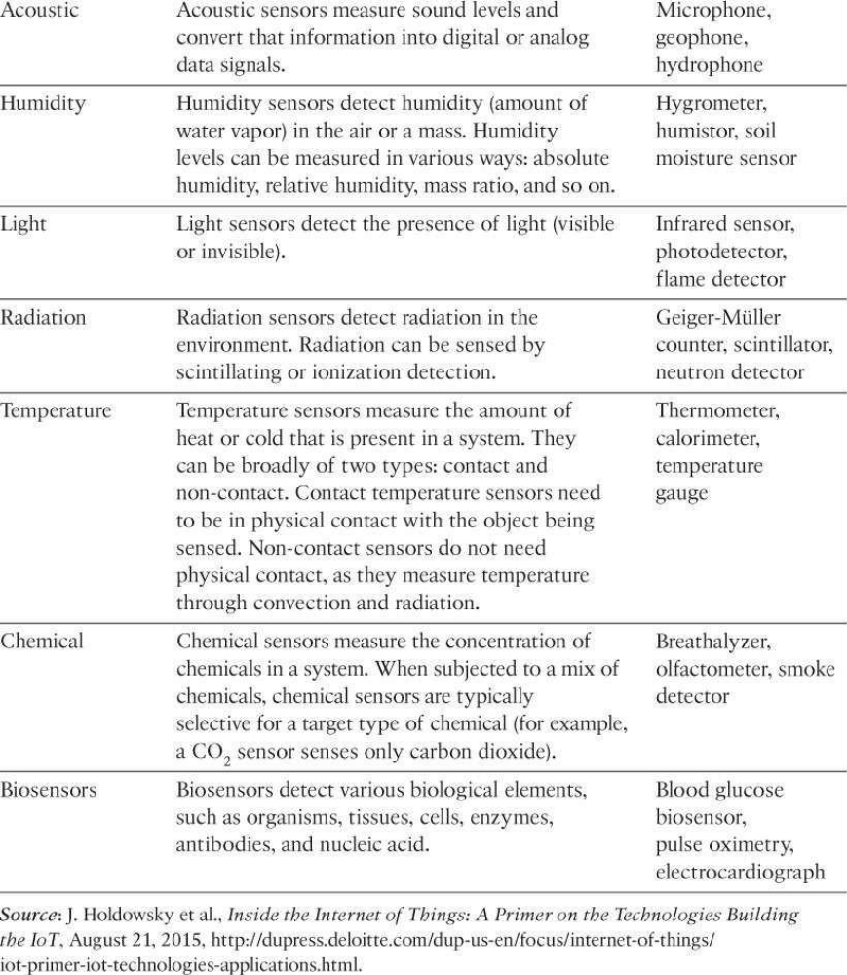

4. Explain various communication criteria’s that are important for Smart Objects communication.

5. Present number of ways to group and cluster sensors into different categories

Active or passive: Sensors can be categorized based on whether they produce an energy output and typically require an external power supply (active) or whether they simply receive energy and typically require no external power supply (passive).
Invasive or non-invasive: Sensors can be categorized based on whether a sensor is part of the environment it is measuring (invasive) or external to it (non-invasive).
Contact or no-contact: Sensors can be categorized based on whether they require physical contact with what they are measuring (contact) or not (no-contact).
Absolute or relative: Sensors can be categorized based on whether they measure on an absolute scale (absolute) or based on a difference with a fixed or variable reference value (relative).
Area of application: Sensors can be categorized based on the specific industry or vertical where they are being used.
How sensors measure: Sensors can be categorized based on the physical mechanism used to measure sensory input (for example, thermoelectric, electrochemical, piezoresistive, optic, electric, fluid mechanic, photoelastic).
What sensors measure: Sensors can be categorized based on their applications or what physical variables they measure.

6. Describe the advantages and disadvantages of Sensor Actuator Network (SANET).
following are some advantages and disadvantages that a wireless-based solution offers: Advantages:
Greater deployment flexibility (especially in extreme environments or hard-to-reach places)
Simpler scaling to a large number of nodes Lower implementation costs
Easier long-term maintenance
Effortless introduction of new sensor/actuator nodes Better equipped to handle dynamic/rapid topology changes
Disadvantages:
Potentially less secure (for example, hijacked access points) Typically lower transmission speeds
Greater level of impact/influence by environment

7. Explain how Wireless sensor network can be able to connect smart objects and design constraints and also explain concept of Data Aggregation

Wireless Sensor Networks (WSNs)
Wireless sensor networks are made up of wirelessly connected smart objects, which are sometimes referred to as motes. The fact that there is no infrastructure to consider with WSNs is surely a powerful advantage for flexible deployments, but there are a variety of design constraints to consider with these wirelessly connected smart objects. Figure 3-8 illustrates some of these assumptions and constraints usually involved in WSNs.

The following are some of the most significant limitations of the smart objects in WSNs:
Limited processing power
Limited memory
Lossy communication
Limited transmission speeds
Limited power

These limitations greatly influence how WSNs are designed, deployed, and utilized. The fact that individual sensor nodes are typically so limited is a reason that they are often deployed in very large numbers. As the cost of sensor nodes continues to decline, the ability to deploy highly redundant sensors becomes increasingly feasible. Because many sensors are very inexpensive and correspondingly inaccurate, the ability to deploy smart object redundantly allows for increased accuracy.
Such large numbers of sensors permit the introduction of hierarchies of smart objects. Such a hierarchy provides, among other organizational advantages, the ability to aggregate similar sensor readings from sensor nodes that are in close proximity to each other. Figure 3-9 shows an example of such a data aggregation function in a WSN where temperature readings from a logical grouping of temperature sensors are aggregated as an average temperate reading.

These data aggregation techniques are helpful in reducing the amount of overall traffic (and energy) in WSNs with very large numbers of deployed smart objects. This data aggregation at the network edges is where fog and mist computing, discussed in Chapter 2, ―IoT Network Architecture and Design,‖ are critical IoT architectural elements needed to deliver the scale and performance required by so many IoT use cases. While there are certain instances in which sensors continuously stream their measurement data, this is typically not the case. Wirelessly connected smart objects generally have one of the following two communication patterns:
Event-driven: Transmission of sensory information is triggered only when a smart object detects a particular event or predetermined threshold.
Periodic: Transmission of sensory information occurs only at periodic intervals. The decision of which of these communication schemes is used depends greatly on the specific application. For example, in some medical use cases, sensors periodically send postoperative vitals, such as temperature or blood pressure readings. In other medical use cases, the same blood pressure or temperature readings are triggered to be sent only when certain critically low or high readings are measured. As WSNs grow to very large numbers of smart objects, there is a trend toward ever-increasing levels of autonomy. For example, manual configuration of potentially thousands of smart objects is impractical and unwieldy, so smart objects in a WSN are typically self-configuring or automated by an IoT management platform in the background. Likewise, additional levels of autonomous functions are required to establish cohesive communication among the multitudinous nodes of large-scale WSNs that are often ad hoc deployments with no regard for uniform node distribution and/or density. For example, there is an increasing trend toward ―smart dust‖ applications, in which very small sensor nodes (that is, MEMS) are scattered over a geographic area to detect vibrations, temperature, humidity, and so on. This technology has practically limitless capabilities, such as military (for example, detecting enemy troop movement), environmental (for example, detecting earthquakes or forest fires), and industrial (for example, detecting manufacturing anomalies, asset tracking). Some level of self-organization is required for networking the scads of wireless smart objects such that these nodes autonomously come together to form a true network with a common purpose. This capability to self-organize is able to adapt and evolve the logical topology of a WSN to optimize communication (among nodes as well as to centralized wireless controllers), simplify the introduction of new smart objects, and improve reliability and access to services. Additional advantages of being able to deploy large numbers of wireless low-cost smart objects are the inherent ability to provide fault tolerance, reliability, and the capability to extend the life of a WSN, especially in scenarios where the smart objects have limited battery life. Autonomous techniques, such as self-healing, self-protection, and self-optimization, are often employed to perform these functions on behalf of an overall WSN system. IoT applications are often mission critical, and in large-scale WSNs, the overall system can’t fail if the environment suddenly changes, wireless communication is temporarily lost, or a limited number of nodes run out of battery power or function improperly.

