**Github**

**Introduction:**

GitHub is a code hosting platform. It lets you and others work together on projects from anywhere.

The code we write in our local system can be pushed to git. Also the code we want from others can get it through git by pulling the code into our local repository. Also the git repository should be initialized while working with the git.

The following the steps to use git

**Step 1: Repository:**

A repository is usually used to organize a single project. Repositories can contain folders and files, images, videos, spreadsheets, and data sets – anything your project needs. We recommend including a README, or a file with information about your project.

Steps to create a new repository:

* In the upper right corner, next to your avatar or identification, click and then select New repository.
* Name your repository hello_world.
* Write a short description.
* Select Initialize this repository with a README.

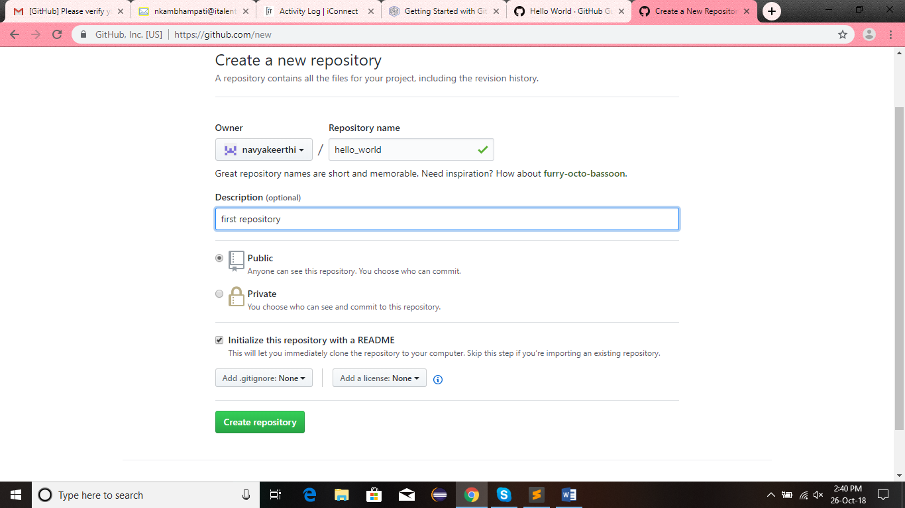

* Click on create repository

**Step 2: Change directory:**

Create a folder in your system on the name of the repository (say daily_activities_by_navya)

Next copy the path of your folder. Go to git bash and change directory to your path as follows

cd path.

In my scenario my directory is E:\daily_activities_by_navya. So my command is

cd E:\daily_activities_by_navya

now we are in the required directory.

**Step 3: Git initialization:**

In our local system we should initialize the git first to make use of it. The git in the local system could be initialized by the following command

git init

we will get the following

Initialized empty Git repository in E:/daily_activities_by_navya/.git/

**Step 4: Git origin:**

**Step 5: Accessing the git repository:**

Now we are required to access our git repository by providing email and password in the form of commands as follows.

git config --global user.email “[navya4343@gmail.com](mailto:navya4343@gmail.com)”

git config --global user.password "ammulu43"

**step 6: Branch creation:**

now we are required to create a branch in our repository (daily activities by navya). This can be done using the following command.

git checkout -b oct26

This creates the branch and switches to that branch automatically.

**Basic git commands**

|  |  |
| --- | --- |
| **Command** | **Description** |
| 1. Git inti | 1. Initializes the git local repository |
| 1. git config --global user.name "your name" | 1. telling git local repository about you |
| 1. git config --global user.email “your email” | 1. telling git your mail id |
| 1. git clone url | 1. cloning means pulling the entire repository to your local folder. |
| 1. git add <filename> | 1. to add a particular folder to the git local repository |
| 1. git add * | 1. to add all the files to the git local repository |
| 1. git commit -m "changes in message" | 1. displays the message in double quotes in the repository at the file name for identification purpose |
| 1. git commit –a | 1. commits the files add to the git local repository or the files which are modified |
| 1. git push origin branch | 1. now the committed files will be sent to the branch specified in the command of your remote repository |
| 1. git status | 1. List the files you've changed and those you still need to add or commit |
| 1. git checkout -b <branchname> | 1. Create a new branch and switch to it |
| 1. git checkout <branchname> | 1. Switch from one branch to another |
| 1. git branch | 1. List all the branches in your repo, and also tell you what branch you're currently in |