# **WEB AND SOCIAL ANALYTICS PROJECT REPORT**

**HUNT**

Gabrielle Zhou Navya Manepalli Meghana Rega

# Contents

Executive Summary: 2

Company Background: 2

Current Capabilities: 2

Business Model: 3

Financial Metrics and Market Share: 4

Customer Demographics: 4

Key Performance Indicators for the current model: 4

Target Customers: 5

Factors being considered: 5

Services Analysis: 6

Launching a One Stop App – a Competitive Environment Analysis 8

Features of the app: 8

Recommendations: 10

Marketing Analysis and Strategy 11

Target Audience Analysis 11

Before launching the app 13

Launch the app and continue marketing effort 13

KPIs for Marketing Strategy 13

Online Marketing Strategy 15

Company Website Design Recommendation 15

Tools and Analysis Recommendation 15

SEO Strategy 16

Social Media Strategy 16

Mobile Strategy 17

Web Analytics Implementation 17

Appendix: 19

Works Cited 26

# Executive Summary

**MNG Inc.** is a major stake holder and a market leader in retail and hospitality industry. It operates under the brand name OYO with a hospitality franchise model in Asia. With a wide range of experience and market capitalization in the hospitality industry MNG is excited to enter the US market with an application (app) named HUNT.

Hunt enables users to make online reservations for restaurants, hotels, reviews and compare prices. It is an approach to aim business and leisure travelers with a ‘one stop shop’ approach to service. Customers will be able to make restaurant reservations, book hotel rooms and manage expenses from the same window. The main goal is to target the Business travelers.

# Company Background

OYO is India’s largest hospitality company consisting mainly of budget Hotels. It was founded in 2012 by Ritesh Agarwal and has since shown a potential growth with 12,000 hotels in 337 cities in India, Malaysia, UAE, China and Indonesia. OYO launched OYO Home at the end of 2017, an Airbnb like market place for short-term rentals. It is present in more than 10 Indian leisure destinations including Goa, Shimla, Pondicherry, Udaipur, Kerala so far. Its first International OYO home was launched in Dubai in April 2018. It is one of the top funded business start-ups in India. (Exhibit 5)

Growth Story: From a single room in May 2013 there was an amazing growth with more than 8500 hotels at present. Currently it has 300,000 daily active users. Number of hotels in the OYO chain is increasing towards 10,000. The number of App downloads is reaching 10 million.

### Current Capabilities:

OYO has very grand plans to become a leader of hospitality through a great blend of technology and a proven business model. In its first year of its setup OYO revenue reached an impressive $4.8 million. The main objective of OYO is to provide standard rooms at very reasonable prices and it turned out to be a great mantra for their success. Standardization,

Affordability and usage of Technology are OYO’s greatest strengths. It strives to provide the same facilities and amenities to all the customers to maintain its brand value. Providing high quality customer experience at a very affordable price is its greatest asset to generate revenue. According to its Annual report 2018

* OYO Hotels & Homes completed its transition to becoming a 100% leased and franchised hotel chain.
* More than 13 million customers have used OYO Hotels & Homes until December 2018.
* It is already among the top 10 Hotel chains in the world and growing exponentially.
* It is the 3rd largest Hotel brand in CHINA with 271,000 rooms by Dec 2018
* South Asia’s largest Hotel chain which offers quality service at a very affordable price.

With a multi-brand strategy OYO launched several new products like Silver Key- Corporate Apartments, OYO Living (millennial housing) , Palette (Resorts) and OYO Homes(Vacation Rentals) . There’s a significant increase in the number of new products being launched.

According to the Red Seer Report the brand has a strong in-house technology platform which makes the brand stand out. It is very successful that other players are spending 3-4% of their top line to compete with OYO’s technological capabilities.(Exhibits 1,2,3)

### Business Model:

Providing quality living spaces to customers is their main goal. OYO uses technology and talent by targeting the asset and home owners to transform substandard and unbranded hotels to affordable and quality living spaces. To on board a partner OYO uses a franchise signing app (ORBIS) which promotes significant operational efficiencies. After on boarding the transformation time for the property is 3 to 14 days. Then OYO uses a Property management platform to manage revenue, pricing, food , procurement and Inventory with the help of data driven algorithms. OYO uses many communication channels to increase demand and revenue in business. The partnered hotels provide standardized service to the customers.

The bookings are made through the OYO rooms website and the OYO mobile application.

### Financial Metrics and Market Share:

Revenue increased from $17 million to $60 million showing a 3.5 times growth in the financial year 2017-2018. Revenue for the financial year 2018-2019 saw an exponential growth of $200 million. According to the OYO’s Annual report the majority of the demand is by word of mouth customers who account for 93% of the revenues in Q4 2018. OYO dominates with 68.4% of Market share the next being Trivago and Roomstonite with 13.6% and 6.6% respectively. (Exhibit 3)

### 

### Customer Demographics:

OYO’s objective is to deliver quality spaces to the customers at very affordable prices. Star hotels deliver predictable, reliable services but budget hotels don’t. The main target of OYO is to provide standardized , reliable hotel experience on a budget. All the customer categories like the business travelers, leisure ,people travelling for religious purposes, tourists are the target customers. The target customer behavior is very predictable. The customers look for the best quality service and they are always willing to pay for that quality service. They seek immediate response and they need all the services on time and seek convenience. Keeping this in mind OYO is striving to make the affordable quality hotel space experience very efficient and enjoyable by all its customers.

### Key Performance Indicators for the current model:

**Occupancy Percentage:**

This is the most critical measure of performance for OYO hotels. It is measured as the percentage of available rooms occupied over a specific period.

**Customer Satisfaction:**

This is a key performance indicator which is linked with the online rating. Reviews are very important as most of the customers select the hotels based on quality of reviews.

**Revenue per available room:**

REVPAR is a very useful measure of OYO hotels. It is measured by the average daily room revenue generated by available room.

REVPAR = Total Room Revenue /Total rooms available

### Target Customers:

Coming from a customer centric industry, when done an analysis on which is making the most contribution to the economy, we concluded that “Travel and Tourism” industry plays a major role. In 2017, this industry contributed 2.57 trillion US dollars directly to the GDP worldwide with the total contribution of 8.27 trillion US dollars (Exhibit 6). Among the Travel and Tourism domain, when done an analysis on the type of customers, we can see that, there are majorly two types of customers, business travelers and leisure travelers. Here, from the Exhibit 7, we can see that, there is a study growth in leisure travelers, where as there is the same amount of business travelers. However, there is also a potential for steady growth in business travelers provided their journey, stay and ease of booking is made easier.

According to the survey conducted in 2017 asking what is it that the business travelers are looking for, 86.7% answered a better management of the trip and stay. Therefore, we set the customer base to Business travelers as we see a great scope of improvement there.

### Factors being considered:

The business travelers’ growth is forecasted to increase in the coming years.

Number of IT companies are increasing quarter by quarter and having multiple branches all over the US. Hence, the chance of travelling will increase. (Exhibit 8)

Number of airlines and feasible schedules are increasing with lesser travel time, which directly encourages more business trips. (Exhibit 9)

Companies are promoting change of work location and meetings with clients in person style which again increases the travels. (Exhibit 10)

Also, above all, leisure travelers have enough resources in place to take care of the trip. Targeting them may not pivot to huger profits as another app in the market would just be there.

According to a survey conducted by the Global Business Travel Association the top concerns of the Business Travelers are

• 54% of travelers identified the process of flight and hotel booking is taking too long.

• 48% identified delayed flight and train departures as concerns

• 67% said keeping track of the receipts and expenses is a real headache

• 37% said local attractions updates come vey late

• Airport Security hassles

Why is the targeted customer dissatisfied?

These delays, cancellations and mechanical issues are very unpredictable. These reasons also affect the Hotel reservations and leads to commute concerns and disturbances in the carefully laid -plans.

What are they currently doing to solve the problem? The problem that HUNT is trying to solve is that, offering a one stop service to make the business travelers experience hassle free.

About 43% increase is expected of the business travelers by 2019. The medium of booking for these business travelers is direct airline websites for 76% of them. 70% look at multiple websites and other Online travel agencies to compare fares and then make a booking. Each booking on an average takes about 5-6 business days for closure. Therefore, its appropriate to build something exclusively for business users.

### Services Analysis:

When looking at the aids/services the business travelers have in hand for the travel, there is no specific one point to go to fulfil their services. This is because, as per **Exhibit 11** the type of hotels the business travelers stay, and most other leisure travelers stay are very different. Same for flight choice, restaurants etc.

For the general tours and eatery, there are many apps, websites to help like trivago.com, kayak.com, expedia.com that were top in 2018. For restaurants selection, they have yelp app, grub hub for delivery services etc. However, there is no such facility for business travelers.

Also, the time spent by business travelers during the trip on eatery, places to see is very less since their focus would be either meetings/office work. They need quick decisions to make in the limited time of stay. Therefore, we can focus on making an app exclusive for the business travelers for their travel management. At present, the top apps in the category of “TRAVEL and LOCAL” are “Trip Advisor” for booking hotels, flights and Yelp for local restaurants. Considering the factors of tor ratings of 4.5+, installs of 1,00,000 + and size of the app being minimum and free of cost apps.

Table1 : *Top apps from Appstore*

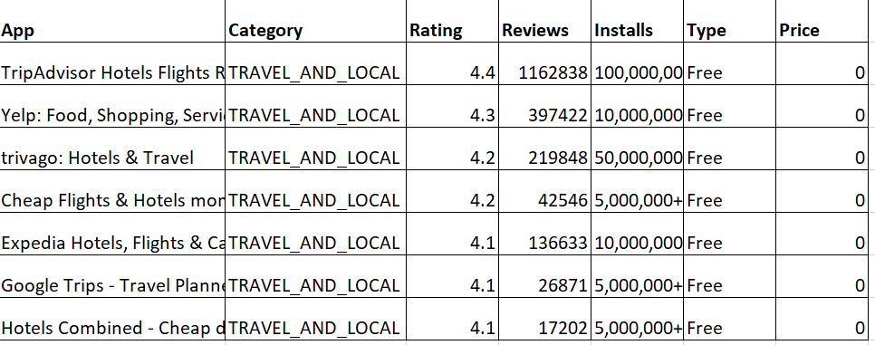

# Launching a One Stop App – a Competitive Environment Analysis

In order to make an app, it should be in such a way that it serves their needs the best. An idea is to combine the features of “Trip Advisor” app and “Yelp” app. But, will we get enough attention to it? Is it targeting the business users the right way? No, it does not. We need to include features that are most useful at the same time not redundant in functions with the already existing apps.

### Features of the app:

**Size:**

Size of the app should be minimal as business travelers already have so many business-related apps on their phone.

According to the mobile phone purchases data summary, business users prefer phones with more battery power useful for travelling and minimal features with EMAIL and other business specific apps being downloaded the most. They already have too many apps downloaded. Hence, we need to design an app which occupied less space. Also, because we have many features being developed in the app, we should make sure to include just the important, non-fancy options and clear flow of app design.

**Travel booking:**

Flights / hotels / its status updates ease of cancelling etc.

According to the survey by the Global Business Travel Association, business users say they get so many options that their company doesn’t allow to book. It consumes time to apply a lot of filers and then compare with other websites.

The first most important feature would be the details of best flights for the dates of travel along with hotels booking at one place. There can be two tabs one for booking flights and the other for stay. This way they need not go to too many places to compare and two different times to book and two different payments.

Also, the app should incorporate the most frequently booked flights, hotels for stay based on the historical data of business travelers which will be different from leisure travelers. This will reduce the space of the app since not all will be displayed.

**Restaurants for eatery:**

The business customers do not have the time to ask around people for tasting the local food but good rated restaurants etc. These features are included in “Yelp” top rated local app for finding restaurants.

There should be another tab including local restaurants available picked based on the location they are in by taking preference from the customer to see if they want the nearest/authentic local food again based on ratings and reviews as business users want top notch quality.

It should also show options and be able to order online through app and get it delivered or picked up. Payment should be allowed to do from the app.

**Places to visit:**

It will a limited time that the business travelers will have. The app should be able to suggest nearby tourist attractions based on their schedule so that they can decide to go immediately. If any booking or purchase of tickets are allowed, the booking could be availed with in the app.

**Receipt management:** One stop payment through app

As per the survey mentioned earlier, managing all the receipts if taken in multiple places is difficult for them. Also, they should scan them and apply for reimbursements and takes a lot of time to process. And the payment details need to be entered too many times that also confuses and sometimes they tend to forget, and the prices may go up within that time.

By creating the app and incorporating a company gateway for paying their employees payments all at once would make it better manageable. Also, the user can add everything into cart for both booking hotels and flights and the payment details can be entered just once.

**Push Notifications:** Crossing budget allowance meter.

There can be notifications and reminders feature incorporated to alert the user if he/she is using the allocated budget allowance too much or notifications letting them know how much is left etc.

Also, the app can pop up notifications based on the schedule if there is time to visit any place or try a new restaurant etc.

### 

### Recommendations:

Since **OYO** is already a leadingsuccessful company in India and is planning to move to the US Market, it can start building up its brand by tying up with the top Business Class hotels like the ones in Exhibit U.

It can have them incorporate their payment gateway into their app. At the same time, it can also shake hands with some Top Business users used Travel agencies. It could incorporate the payments through the app for them too.

Above all, OYO can come in contract with the companies like consulting where there are more business travelers. The app can be exclusive for just the companies with more business users, in that way we could get profits by charging the company per install.

# Marketing Analysis and Strategy

It is crucial to develop a marketing plan that can attract users and build awareness. Since OYO is building a new app, namely HUNT, how to make users download and actively use the app will be important to the the app’s success. Before launching the app to the market, it is needed to build awareness and increase downloads on the launch day, monitor KPIs and continue to build awareness and promote the app will go a long way. There are outbound marketing strategies such as advertising on newspapers, television, direct mail that OYO can employ to push its app to its users. It can also consider using inbound marketing strategies to draw users to it, such approaches include social media, blog, online video, etc.

### Target Audience Analysis

HUNT’s primary competitor is Yelp and Trip advisor, so we use these two websites to perform our market and customer analysis. Yelp provides recommendations on many different business categories, the biggest category is restaurant, it takes up 19% across all reviewed business category. (See figure 1, source: <https://www.yelp.com/factsheet>), it has an average of 164 million unique visitors to its website and app (See appendix), indicating the market size is potentially very big. Yelp is being used by all age groups and all income levels, but people with college and above education background have formed most Yelp’s users. TripAdvisor is the largest online travel site, recording nearly 300 million unique visitors in July 2016, its users also range from different age groups, with almost half of the users between age 18-34. Younger users are also more likely to rely on recommendations on Trip advisor (see appendix). Since HUNT is primarily focused on business travelers, targeting on younger user group is also more effective because we can build a customer foundation in younger users who are current business professionals or will be business professionals. Based on the analysis above, we plan our marketing strategy to primarily use inbound marketing to cater to the need to younger and more educated internet users since they are more likely to accept valuable information and recommendations and mix outbound marketing strategies to support the promotion. We also will employ social media outreach because we are targeting on younger internet users, and according to trip advisor, younger users are more inclined to use social media such as Facebook and Instagram to get recommendations (see figure 2).

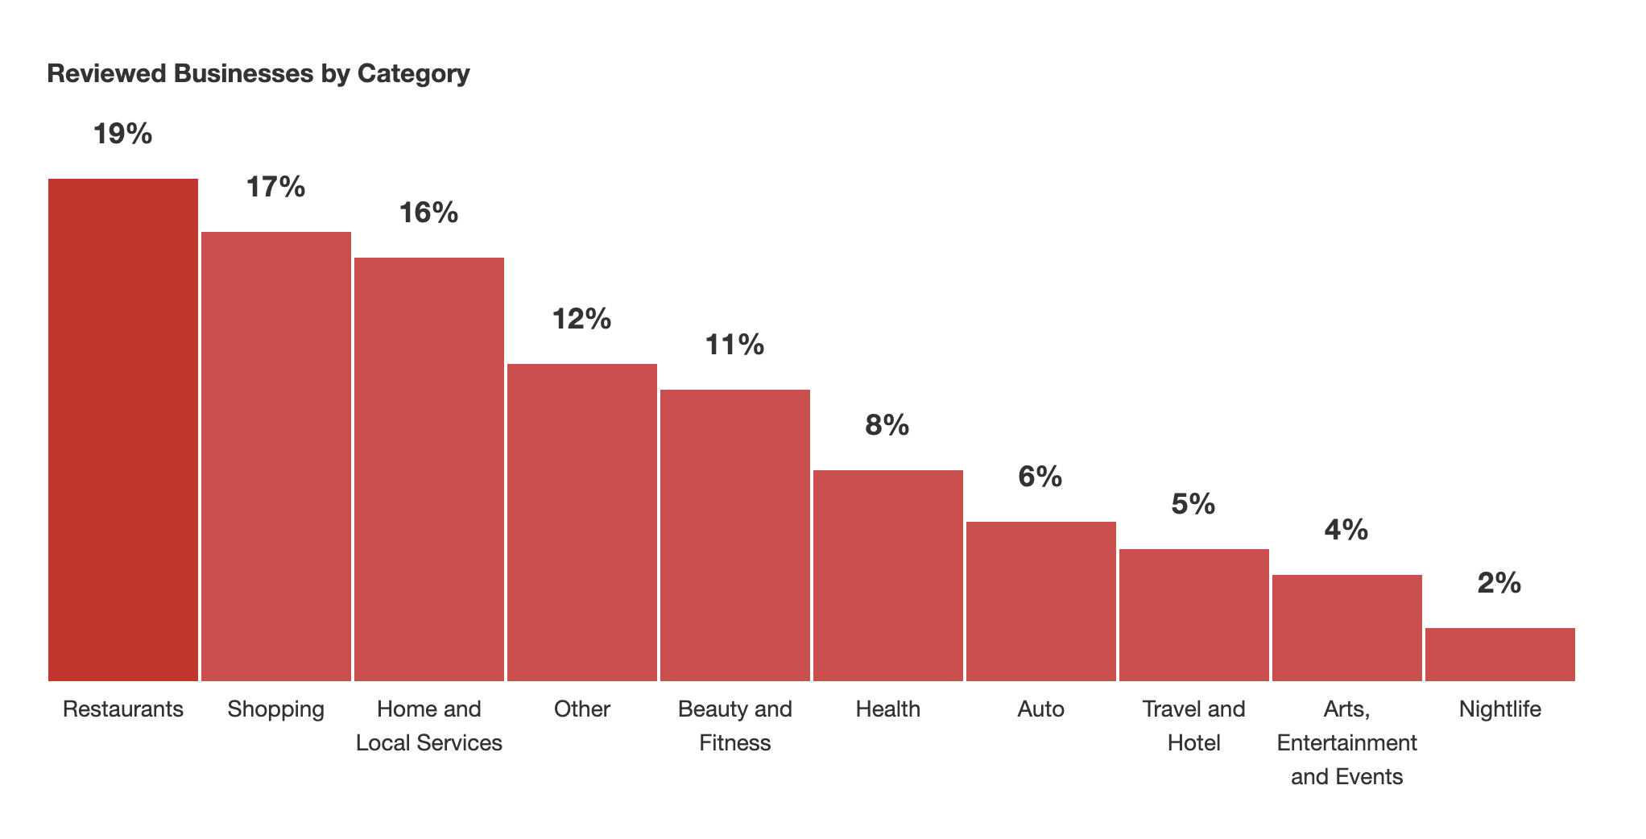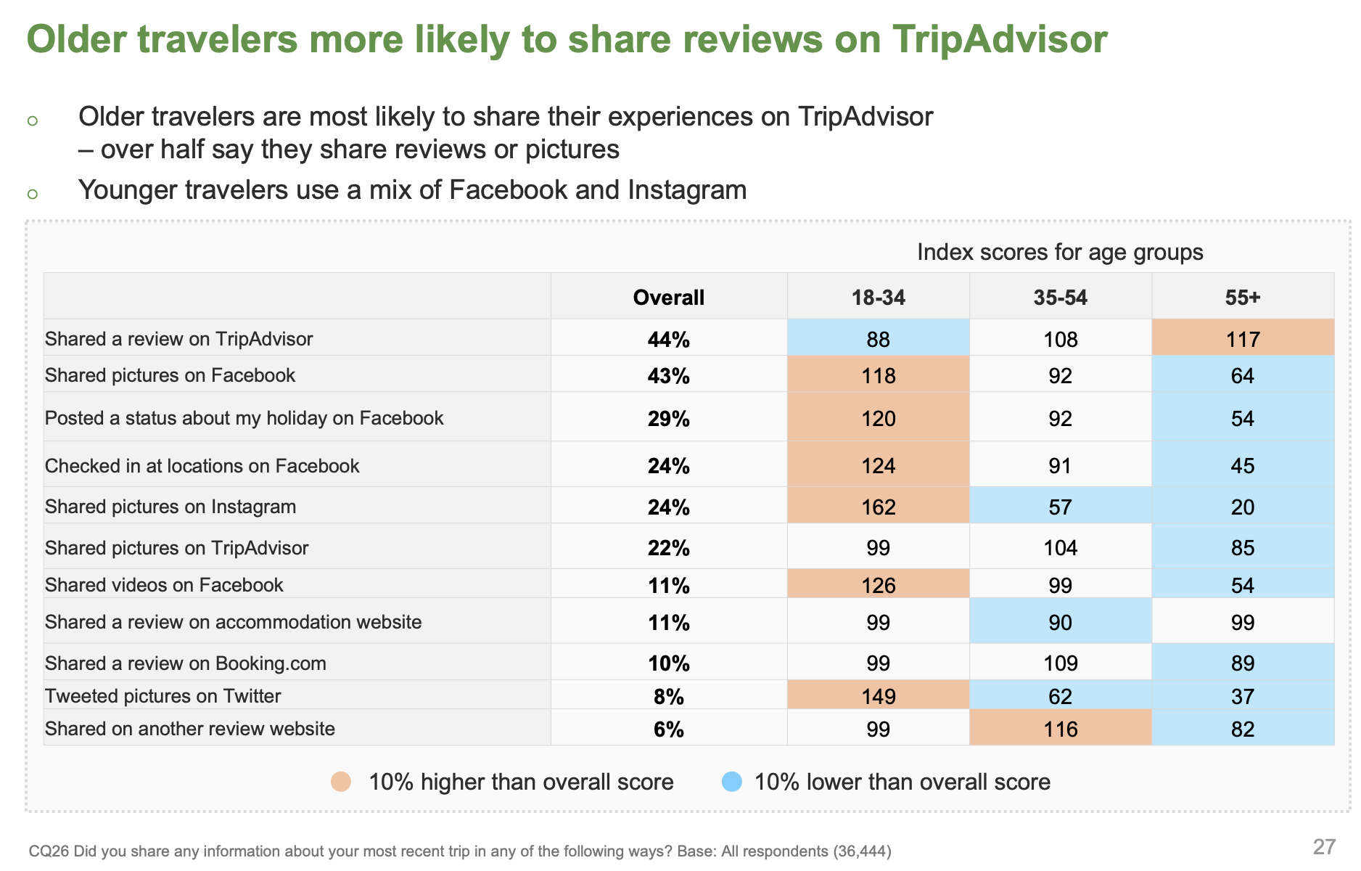

The marketing strategies are divided into two categories, before launching the app which is focusing on the short term promotion of the app, and after launching the app, we will keep employing our marketing strategy for the long term goal of the app, to increase both downloads and active user.

### Before launching the app

Building awareness takes time, the first step to OYO’s success is to plan early and push its app to the market as early as possible. There are several things to develop awareness before it launch its app to the market.

* Create a website for its new app: to expand online presence, it can host content and display its app to potential users by publishing expert blogs to create value for visitors, drive web traffic.
* Encourage email signups to enable email marketing.
* Start a blog to attract new users as well as build fan base.
* Outreach to social media users, set up social media account on major platforms such as Facebook, Twitter, Instagram. Keep updating social media and actively interacting with users.

### Launch the app and continue marketing effort

* Keep updating content on its website, conduct analysis on page views, bounce rate, referral sites, and employ SEO strategy on its website.
* Monitor email campaigns, email click-through rate, bounce rate and optimize email campaigns accordingly.
* Continue to develop interesting and valuable content on its blog to attract users.
* Continue to update on social media, interact with users.
* Monitor app downloads on each app store, make promotions at the early stage and monitor active user number.
* Optimize app store listing. Use app description to tell its story, use visuals such as screenshots, preview videos, app icons to entice users to download. Use keyword optimization to target users that use search engine to search for apps.

### KPIs for Marketing Strategy

Having KPIs will help OYO monitor its progress, make data-driven decision, analyze marketing expense and calculate return on investments. We have the following metrics we consider are the most crucial parts to OYO’s marketing campaigns.

|  |  |
| --- | --- |
| KPI | Description |
| Visits/Visitors | The KPI is used to measure its website, to track how many new users visit its website, how many users keep coming back to its website to view content they are interested in. This metric is used to measure the success of its website. The large the number is, the better the result. |
| Depth of visit | This metric is to measure whether people are willing to spend time on its website, whether the content in its website is attractive enough to keep users from leaving. We will use bounce rate and exit rate to measure this metric. |
| Unique visitors rate | We use this metric to identify the healthiness of its website. While obtaining new users are important to its website, we also want to keep old users to stay with it. The initial rate will be high, since there are not many old users, but while the website keeps developing itself, this rate ideally will remain stable, indicating it is obtaining a large number of new users and keeping old users. |
| Session time | We intend to use it website as a tool to promote its app, so the content in its website is supposed to attract users to read articles on its website, or watch videos on its website. The longer the average session time, the better the website is performing. |
| Email subscription number | We will also employ email marketing campaigns to promote the app, people who subscribe to its email list are perspective users, so a large number of email subscribers is a good indicator. |
| Social media followers | Much the same with email subscription, a large number of followers expose it to a large number of potential users, it measures the healthiness of its social media accounts. |

# Online Marketing Strategy

### Company Website Design Recommendation

The first and foremost step toward OYO’s marketing campaign is to build a website for its company. A good website design can go a long way for its business. Here are three things HUNT can do when building up its website.

1. Be concise and clear: the audience of its website is people who are looking for great advice for restaurants and hotels, keep the content and design concise and clear can help users easy to navigate to the content they are looking for, and thus increase their willingness to visit its website again in the future. Users are also more willing to pay for its app because it is able to provide the content they are looking for without making them taking a huge amount of effort.
2. Engage the audience: While providing useful information is critical for the website’s success, engage the audience and ultimately lead them to become its app users is our goal. It should provide clear instruction on how to download and try out its app, allow them to contact it and ask any question if they should have any.
3. Optimize its website for mobile: 80% of internet users own smartphones, and Google announced more search happened on mobile than on desktop in 2015. A mobile specific design will help mobile or tablet users have good user experience when they browse our website on mobile devices.

### Tools and Analysis Recommendation

With the help of the right tools and data analysis, it can generate insights and use these insights to improve its website for better user engagement. Currently, our marketing KPI focuses on three different campaigns, and each campaign needs a specific tool to help analyze data.

* Company website, we recommend using Google Analytics to analyze website data. Google analytics can provide insights about its landing page quality, visit/visitors, session time, referral websites, bounce rate, user geolocation, and user visit time during a day. Using WordPress to deploy its website is recommended, and it can use Monster Insight, a tool that is based on Google analytics but is simpler to use.
* Email campaign: use a vendor that provide basic data analytics. Vendors such as MailChimp can provide campaign performance analytics such as bounce rate, click through rate, unsubscribe rate. Use these metrics to measure the performance of its email campaigns, and aid in designing future email campaign.
* Social media: Currently it is only measuring followers on social media, it is a metric it can directly view from its account.

# SEO Strategy

SEO is an ongoing process for every website, and it takes time to see results. For the success of its website, we recommend employing the following strategies for the SEO of its website:

* Add key phrases to its website’s meta tag. This approach allows google crawler to find its website, and index it with relevant key phrases.
* Add inbound and outbound links to its website
* Ensure the website has a consistent style, easy to navigate, does not have factual errors and other low-quality indicators.
* Use image and optimize image alt attribute to increase SEO score.

### Social Media Strategy

Social media is a good resource to build brand awareness and engage with users. We recommend the following strategies for social media outreach:

* Make sure it has social media accounts in major popular social media platform, such as Facebook, Twitter, Instagram
* Update frequently. Social media use a different method to rank content, time decay is an important factor among other factors, updating content frequently can constantly increase our exposure.

### Mobile Strategy

More and more people start their search journey from their mobile devices, having a mobile friendly website is important. The following strategies are recommended for mobile optimization:

* Use a reliable server to deploy its website, make sure the website does not load exceed 10 seconds.
* Contents fit in the screen size without having users to scroll from side to side. To that end, it can use adaptive and responsive design, both designs can provide a mobile-friendly website.
* Identify mobile users and serve them content for them to easily navigate to the app store and download the app with just one click.

### Web Analytics Implementation

With the discussed strategies above, we have several steps to implement web analytics into its marketing strategies.

1. Set up its website and register Google Analytics account, link the website to Google Analytics account. Pull data from the Google Analytics at least once a month, examine page views, visitors, session time, bounce rate and other KPIs, perform analysis toward key landing pages and their performance, implement SEO strategies to improve the website’s organic search rank.
2. Employ several paid search campaign to observe search engine marketing performance, develop ad copy and do A/B testing on ad copies. Select winning ad copies in future campaign.
3. Perform social media advertising campaign and analyze click-through rate and conversion rate. Analyze social media’s impact on search engine result, allocate and adjust campaign fund based on social media and search engine performance.

# Appendix

Exhibit 1: OYO in Numbers

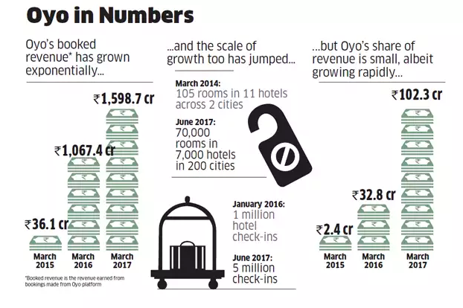

Exhibit 2

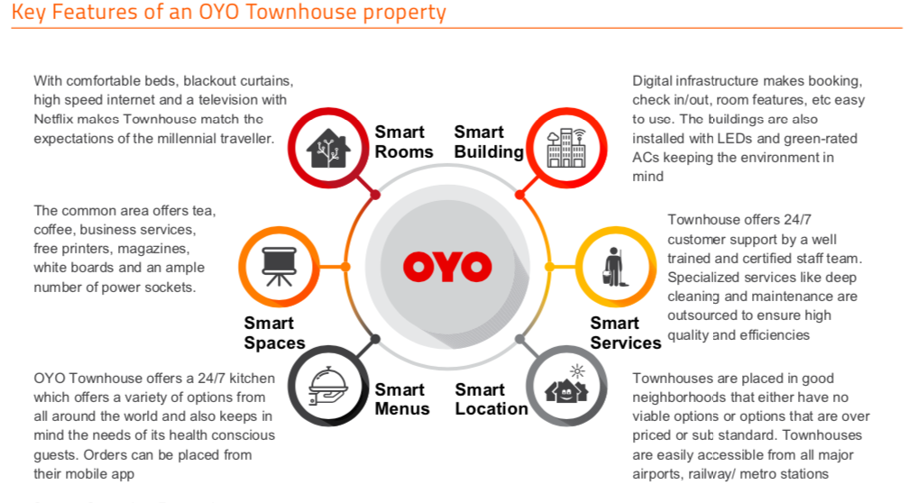

(Source: Red Seer Report)

Exhibit 3

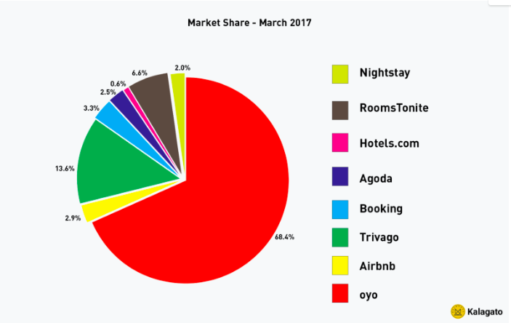

Exhibit 4

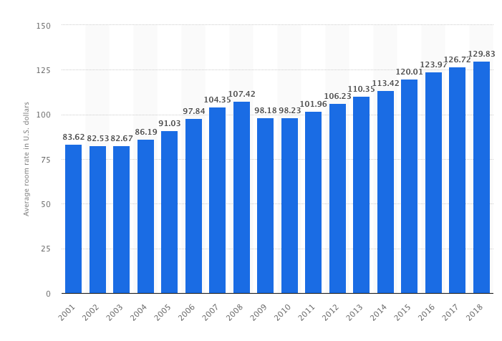

Exhibit 5: The Most funded Startups

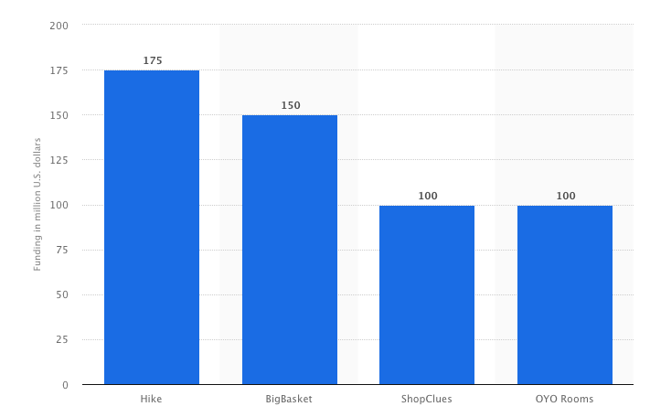

Exhibit 6:

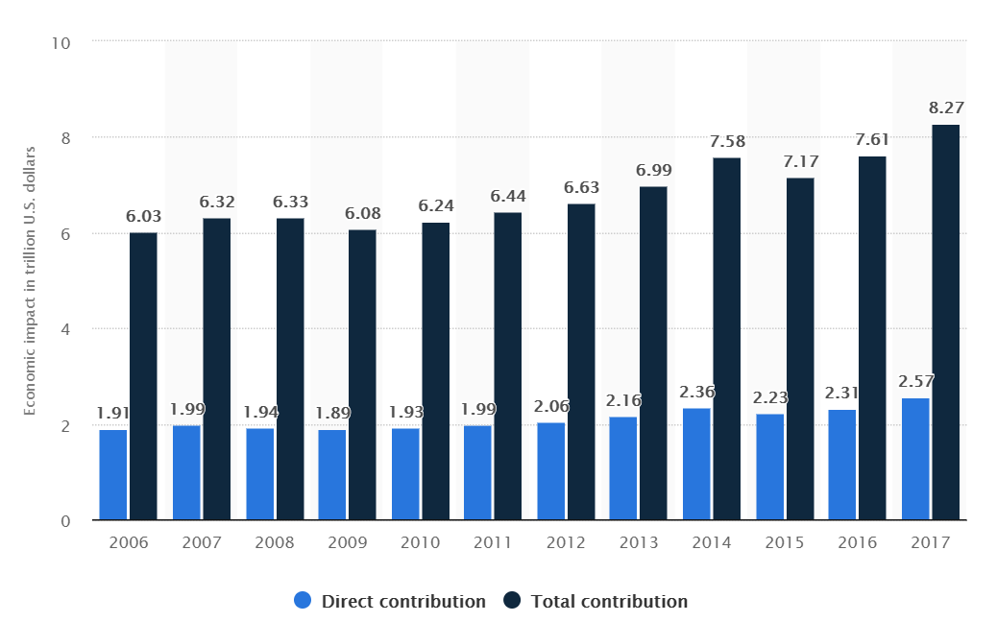

Exhibit 7:

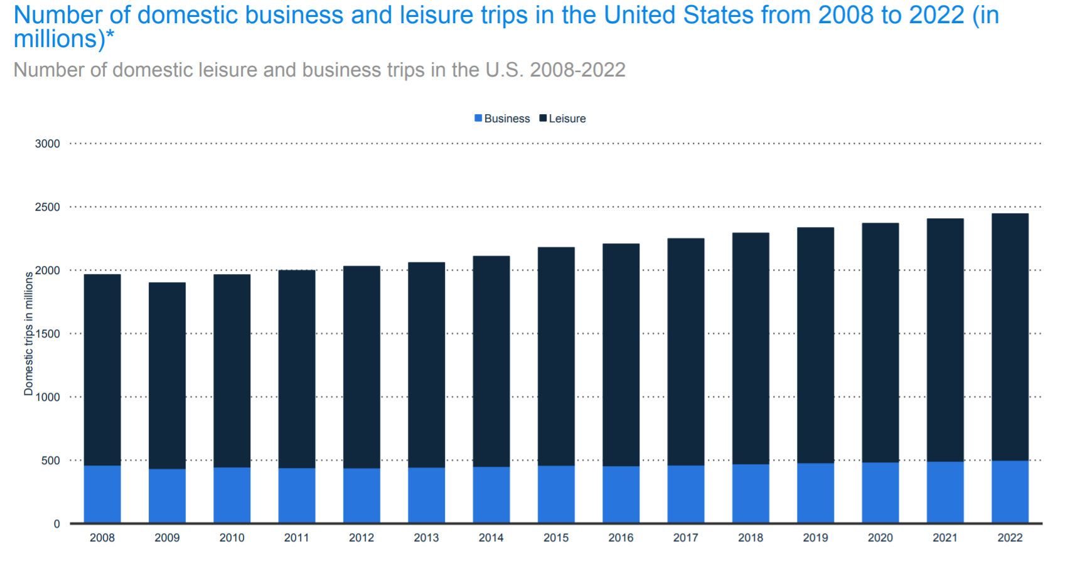

Exhibit 8: (r=0.8372) Flight booking versus IT Business Users

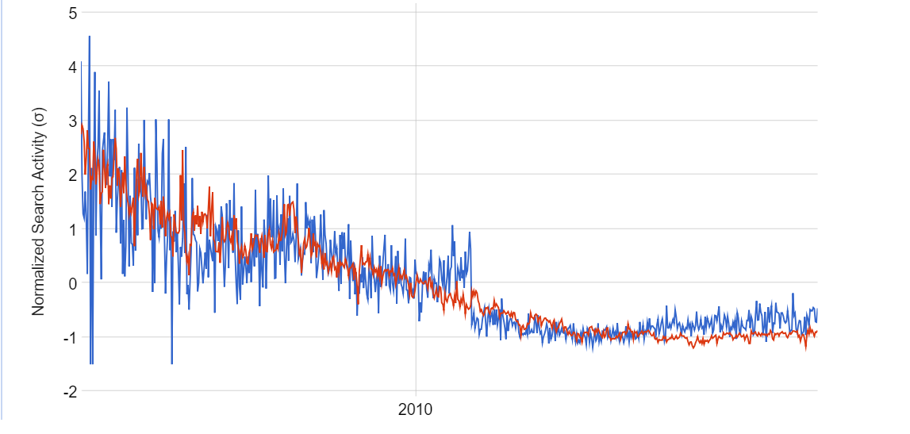

Exhibit 9: Number of Airlines increase over years

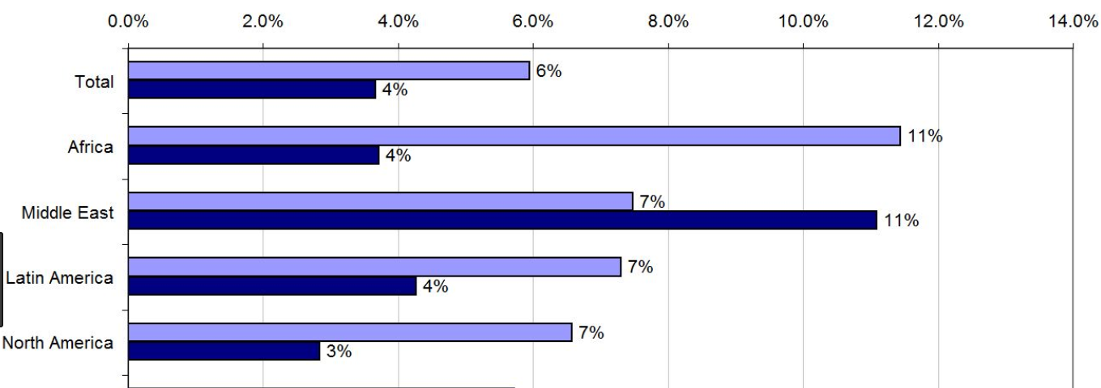

Exhibit 10: Scatter Plot (Video conferencing converting into Business travels)

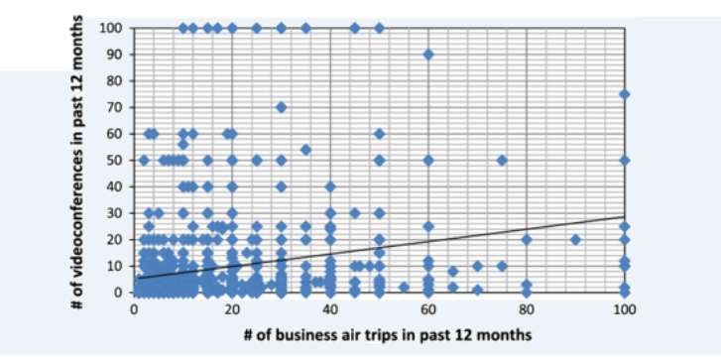

Exhibit 11:

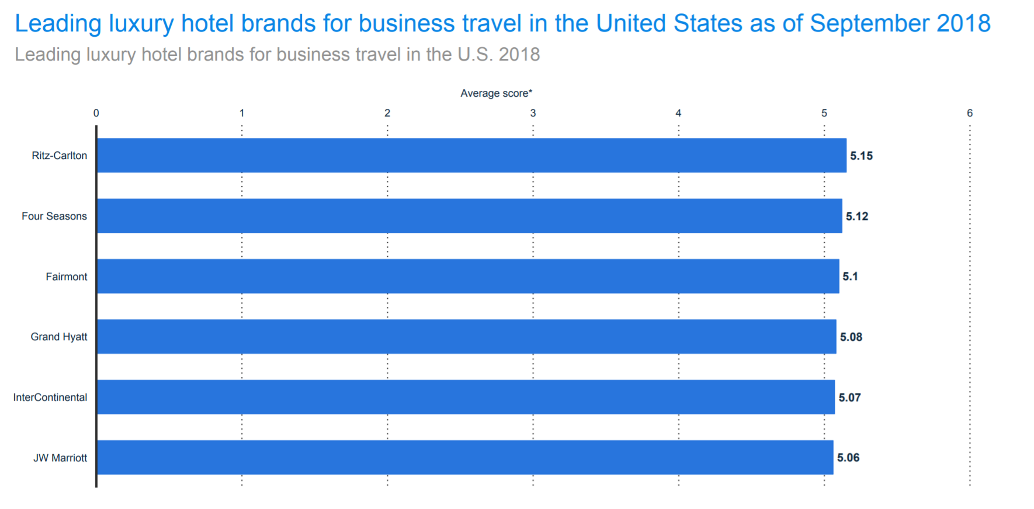

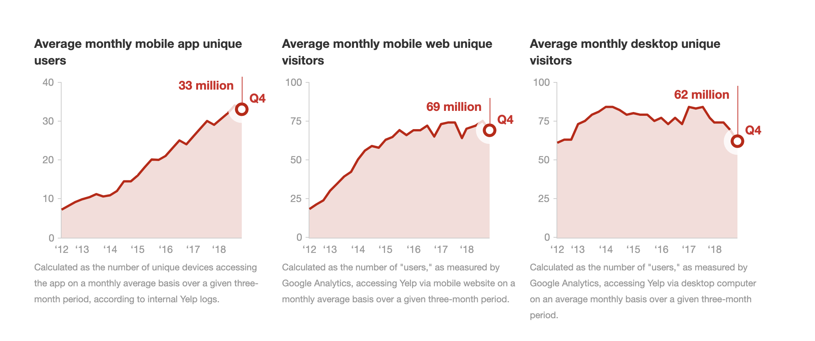

Source: <https://www.yelp.com/factsheet>

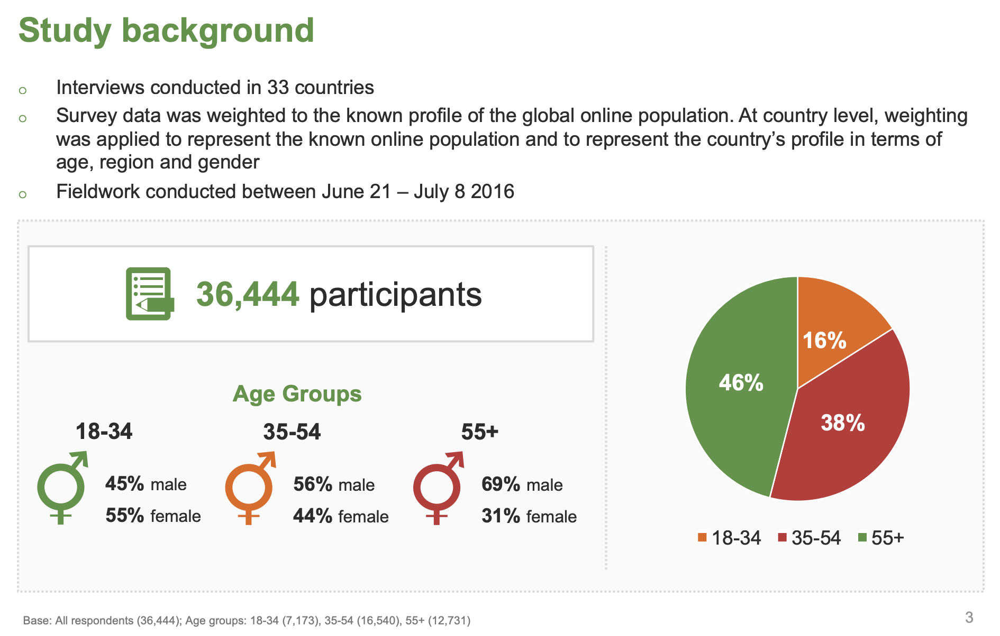

Source: <https://www.tripadvisor.com/TripAdvisorInsights/wp-content/uploads/2018/01/TripBarometer-2016-Traveler-Trends-Motivations-Global-Findings.pdf>

# Works Cited

Oyorooms.com Analytics - Market Share Stats &amp; Traffic Ranking www.similarweb.com

[Case Study] Oyo Rooms : Business Model, The Success Mantra, and Journey to top

New Research and Ideas , December 18, 2018- HBS Working Knowledge.

https://hbswk.hbs.edu

OYO Official Blog, Annual Report FY2018, www.oyorooms.com

OYO, www.slidshare.net

https://www.statista.com/statistics/233223/travel-and-tourism--total-economic-

contribution-worldwide/

https://www.google.com/trends/correlate/search?e=Business+Travel&amp;t=weekly&amp;p=us#

https://www.kaggle.com/ramamet4/app-store-apple-data-set-10k-apps#appleStore_description.csv

https://www.researchgate.net/figure/Scatter-plot-of-business-trips-and-of-video-

meetings-in-the-past-12-months_fig1_257429828