Hackerearth Roy and Profile Picture
https://www.hackerearth.com/practice/basic-programming/input-output/basics-of-input-output/practice-problems/algorithm/roy-and-profile-picture/
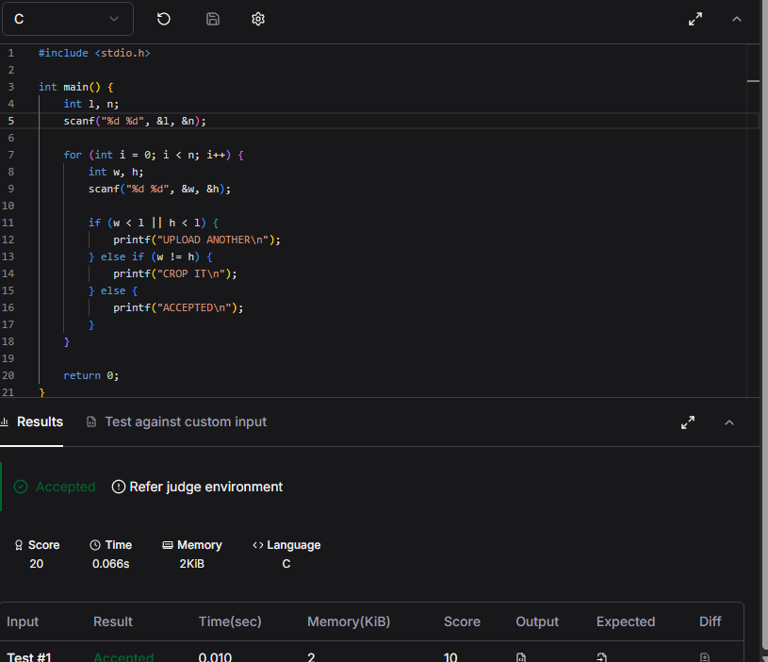
#include <stdio.h>

int main() {
int l, n;
scanf("%d %d", &l, &n);

for (int i = 0; i < n; i++) {
int w, h;
scanf("%d %d", &w, &h);

if (w < l || h < l) {
printf("UPLOAD ANOTHER\n");
} else if (w != h) {
printf("CROP IT\n");
} else {
printf("ACCEPTED\n");
}
}

return 0;
}

