Hackerearth factorial!
https://www.hackerearth.com/practice/basic-programming/input-output/basics-of-input-output/practice-problems/algorithm/find-factorial/
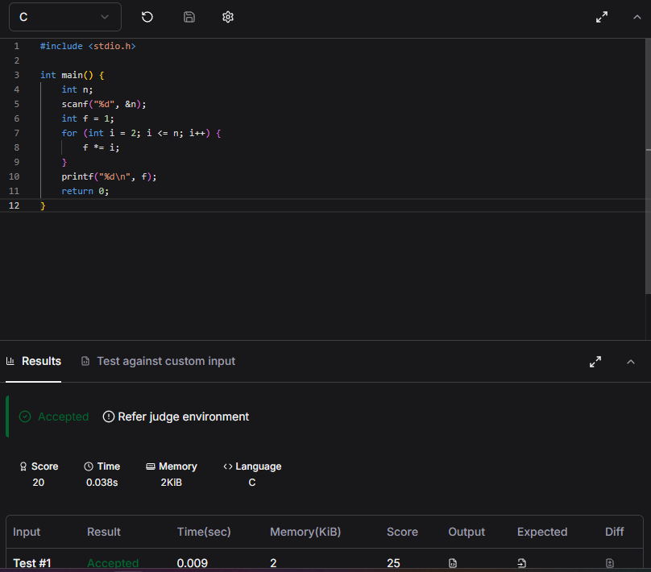
#include <stdio.h>

int main() {
int n;
scanf("%d", &n);
int f = 1;
for (int i = 2; i <= n; i++) {
f *= i;
}
printf("%d\n", f);
return 0;
}

