NAVYA PANDEY
SEC G
26CSU296
Read from STDIN, Write to STDOUT
https://www.hackerearth.com/practice/basic-programming/input-output/basics-of-input-output/practice-problems/algorithm/io-exercise/
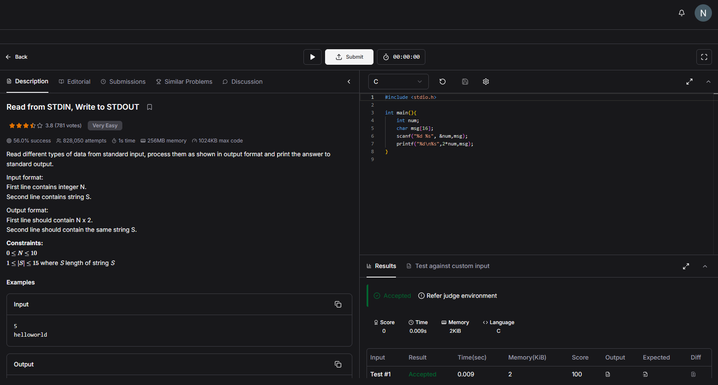#include <stdio.h>

int main(){
int num;
char msg[16];
scanf("%d %s", &num,msg);
printf("%d\n%s",2*num,msg);
}

