Hackerrank For loop in C
https://www.hackerrank.com/challenges/for-loop-in-c/problem
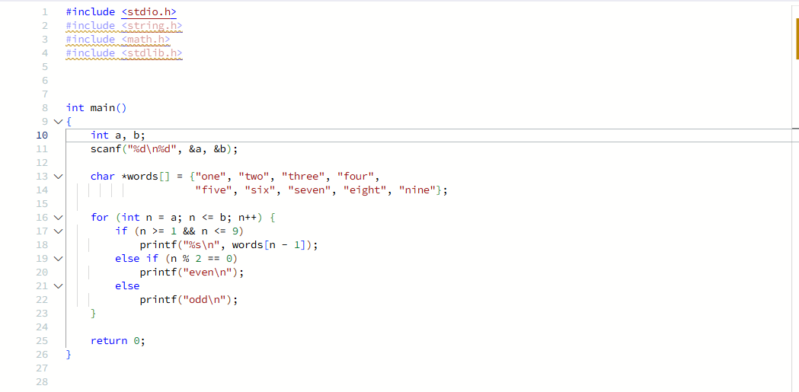
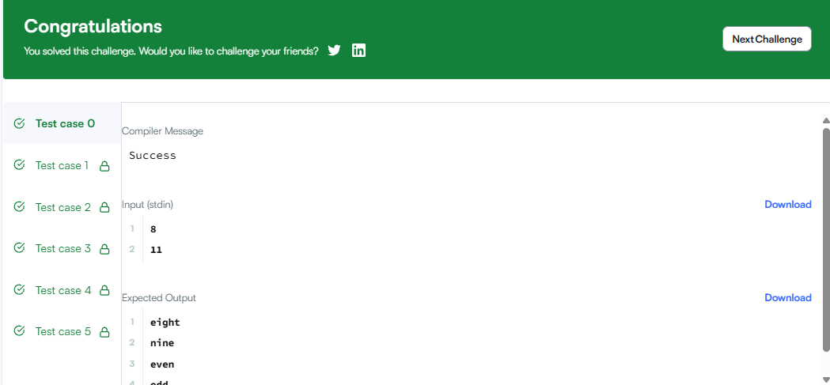
#include <stdio.h>
#include <string.h>
#include <math.h>
#include <stdlib.h>

int main()
{
int a, b;
scanf("%d\n%d", &a, &b);

char *words[] = {"one", "two", "three", "four",
"five", "six", "seven", "eight", "nine"};

for (int n = a; n <= b; n++) {
if (n >= 1 && n <= 9)
printf("%s\n", words[n - 1]);
else if (n % 2 == 0)
printf("even\n");
else
printf("odd\n");
}

return 0;
}

