Hackerrank Number Line Jumps
http://hackerrank.com/challenges/kangaroo/problem
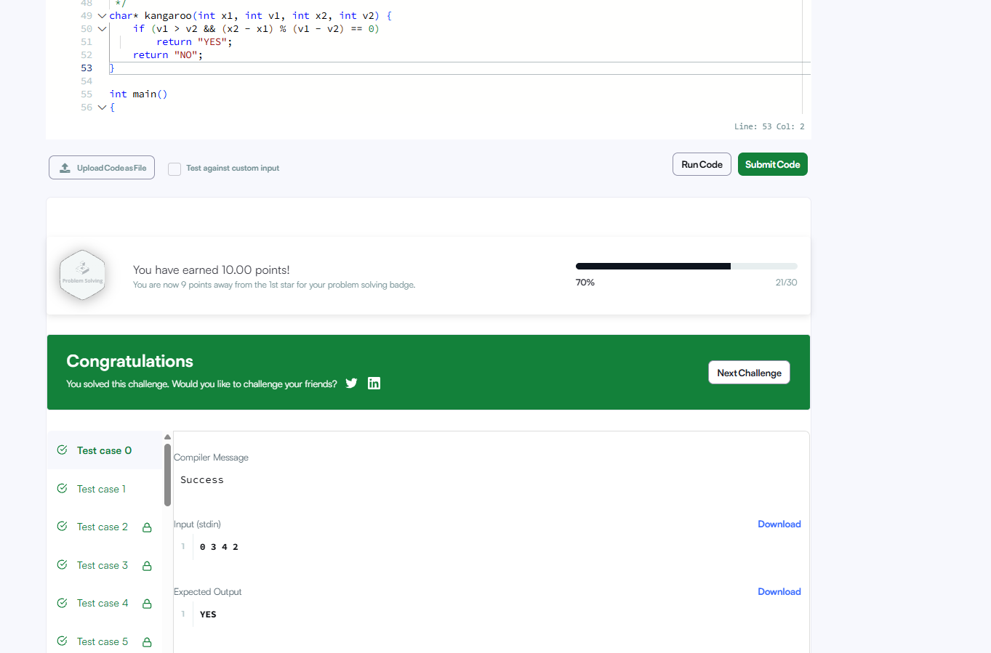
char* kangaroo(int x1, int v1, int x2, int v2) {
if (v1 > v2 && (x2 - x1) % (v1 - v2) == 0)
return "YES";
return "NO";
}

