Conditional Statements in C
https://www.hackerrank.com/challenges/conditional-statements-in-c/problem

NAVYA PANDEY
SEC G
26CSU296

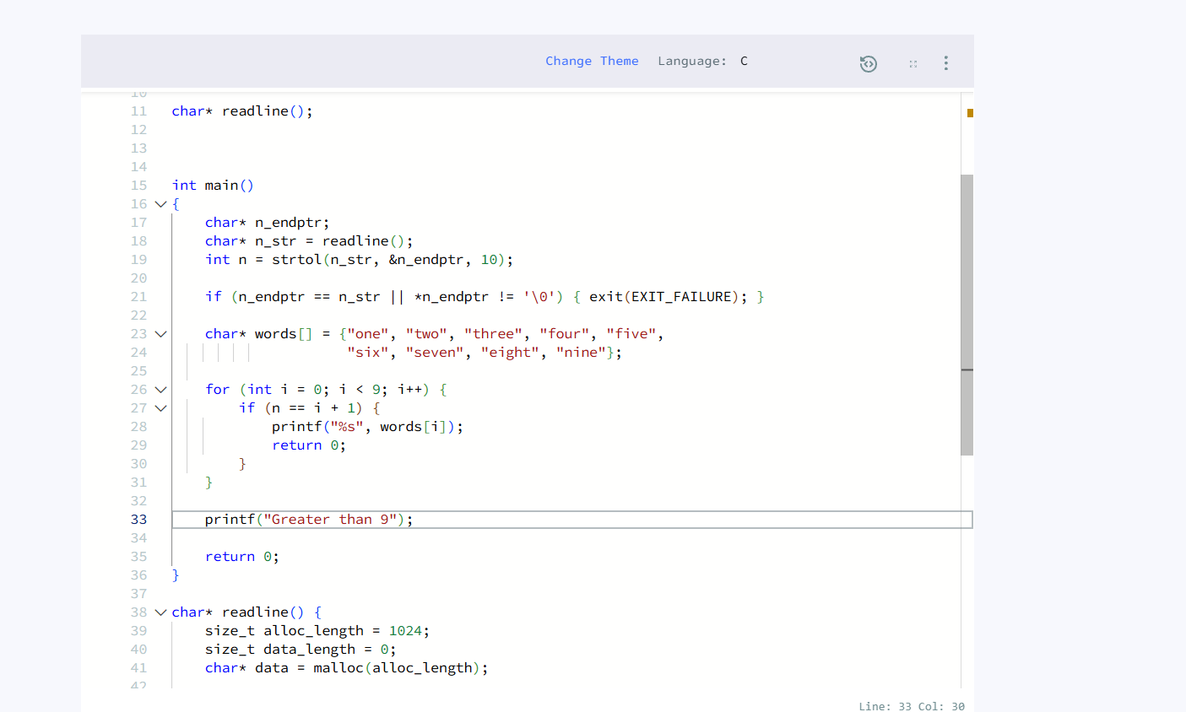
char* words[] = {"one", "two", "three", "four", "five",
"six", "seven", "eight", "nine"};

for (int i = 0; i < 9; i++) {
if (n == i + 1) {
printf("%s", words[i]);
return 0;
}
}

printf("Greater than 9");

