Hackerrank grading students
https://www.hackerrank.com/challenges/grading/problem
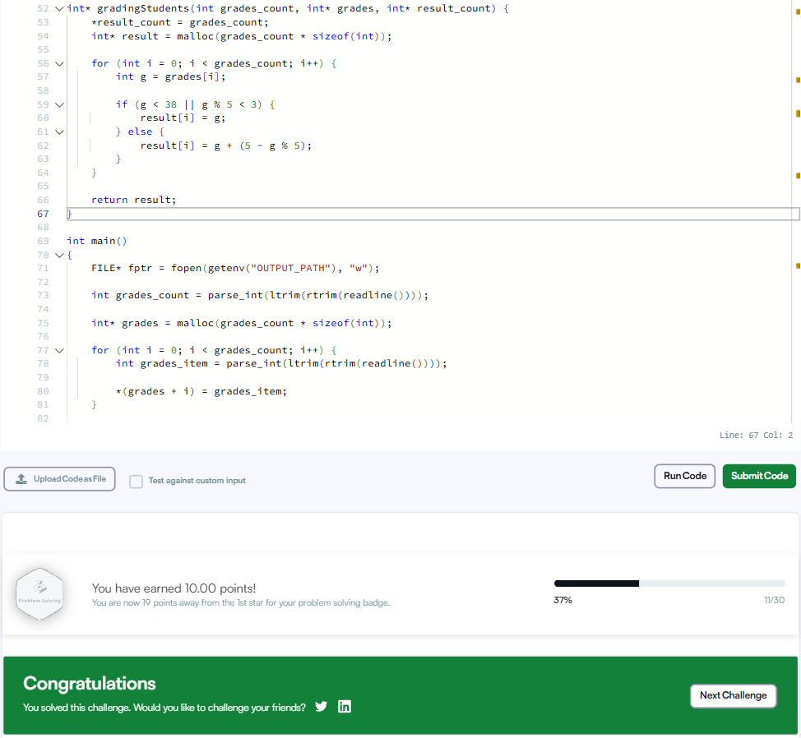
int* gradingStudents(int grades_count, int* grades, int* result_count) {
*result_count = grades_count;
int* result = malloc(grades_count * sizeof(int));

for (int i = 0; i < grades_count; i++) {
int g = grades[i];

if (g < 38 || g % 5 < 3) {
result[i] = g;
} else {
result[i] = g + (5 - g % 5);
}
}

return result;
}

