Hackerrank printing patterns using loops
https://www.hackerrank.com/challenges/printing-pattern-2/problem
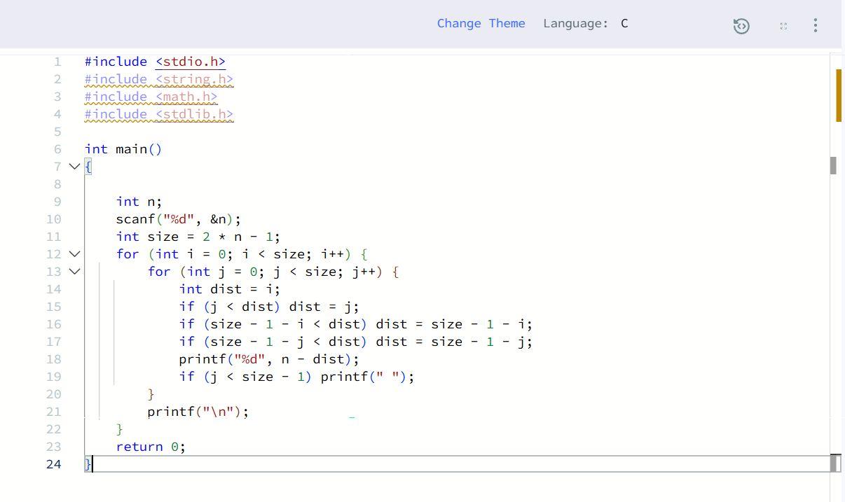
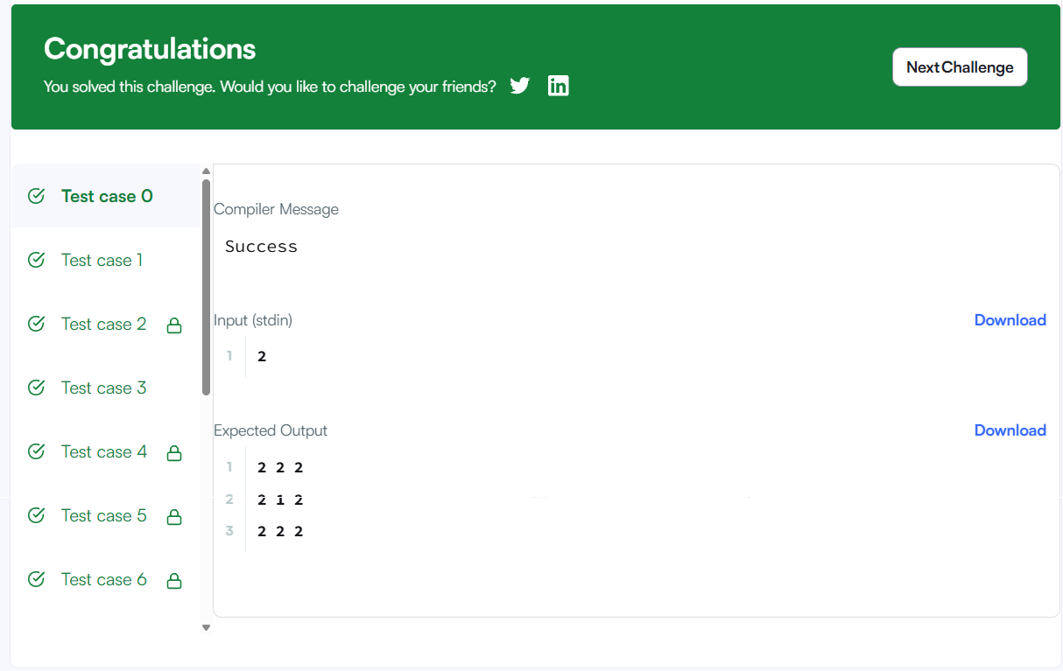
#include <stdio.h>
#include <string.h>
#include <math.h>
#include <stdlib.h>

int main()
{

int n;
scanf("%d", &n);
int size = 2 * n - 1;
for (int i = 0; i < size; i++) {
for (int j = 0; j < size; j++) {
int dist = i;
if (j < dist) dist = j;
if (size - 1 - i < dist) dist = size - 1 - i;
if (size - 1 - j < dist) dist = size - 1 - j;
printf("%d", n - dist);
if (j < size - 1) printf(" ");
}
printf("\n");
}
return 0;
}

