Hackerrank staircase
https://www.hackerrank.com/challenges/staircase/problem
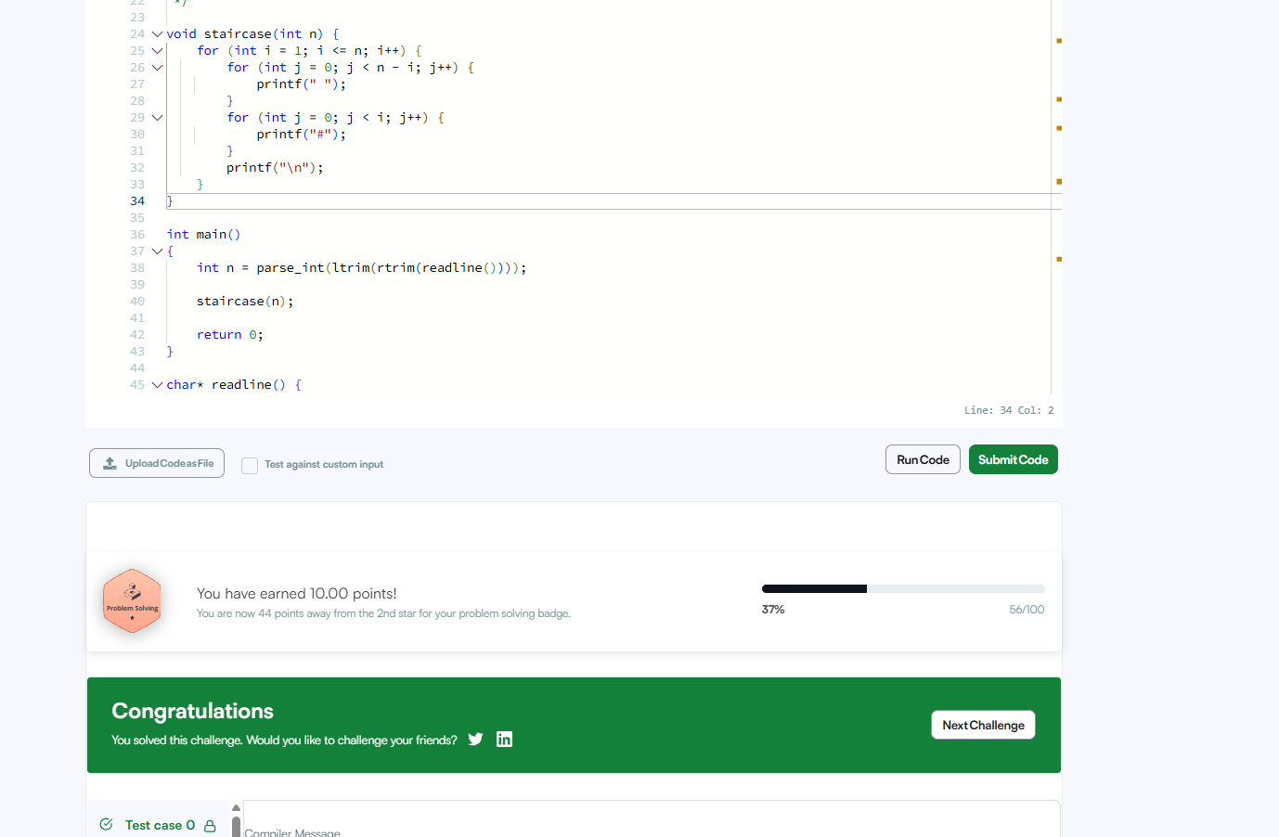
void staircase(int n) {
for (int i = 1; i <= n; i++) {
for (int j = 0; j < n - i; j++) {
printf(" ");
}
for (int j = 0; j < i; j++) {
printf("#");
}
printf("\n");
}
}

