1281. Subtract the Product and Sum of Digits of an Integer
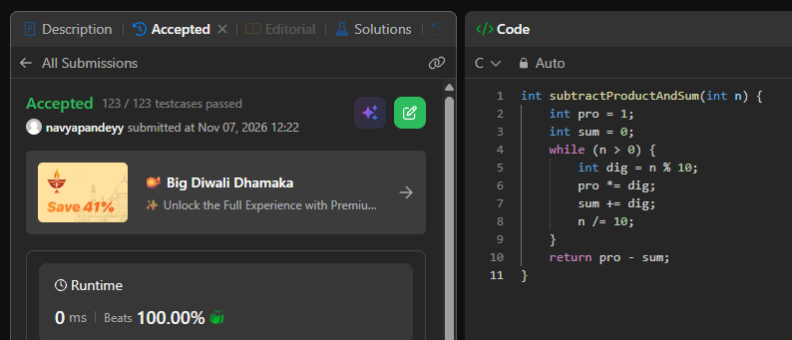
int subtractProductAndSum(int n) {
int pro = 1;
int sum = 0;
while (n > 0) {
int dig = n % 10;
pro *= dig;
sum += dig;
n /= 10;
}
return pro - sum;
}

