1523. Count Odd Numbers in an Interval Range
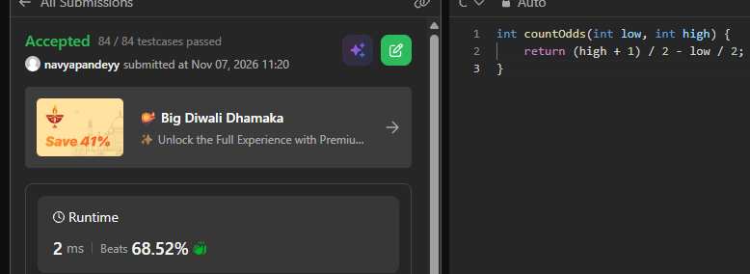
int countOdds(int low, int high) {
return (high + 1) / 2 - low / 2;
}

