2169. Count Operations to Obtain Zero
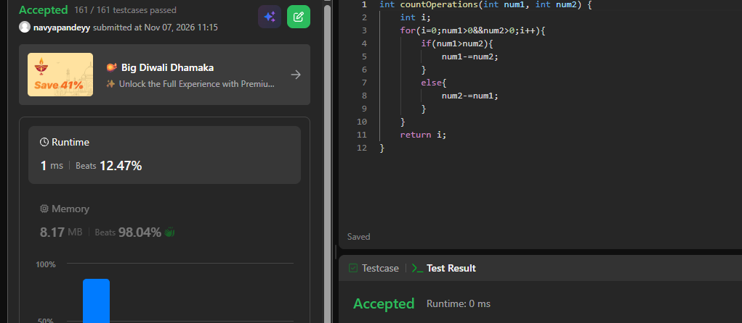
int countOperations(int num1, int num2) {
int i;
for(i=0;num1>0&&num2>0;i++){
if(num1>num2){
num1-=num2;
}
else{
num2-=num1;
}
}
return i;
}

