231. Power of Two
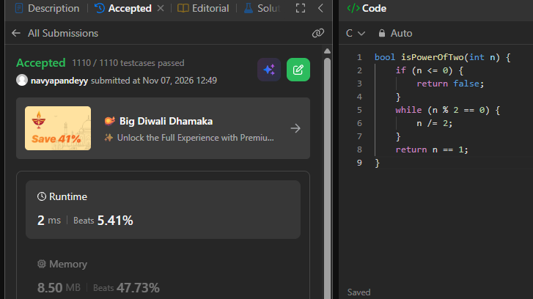
bool isPowerOfTwo(int n) {
if (n <= 0) {
return false;
}
while (n % 2 == 0) {
n /= 2;
}
return n == 1;
}

