2413. Smallest Even Multiple
NAVYA PANDEY
SEC G
26CSU296

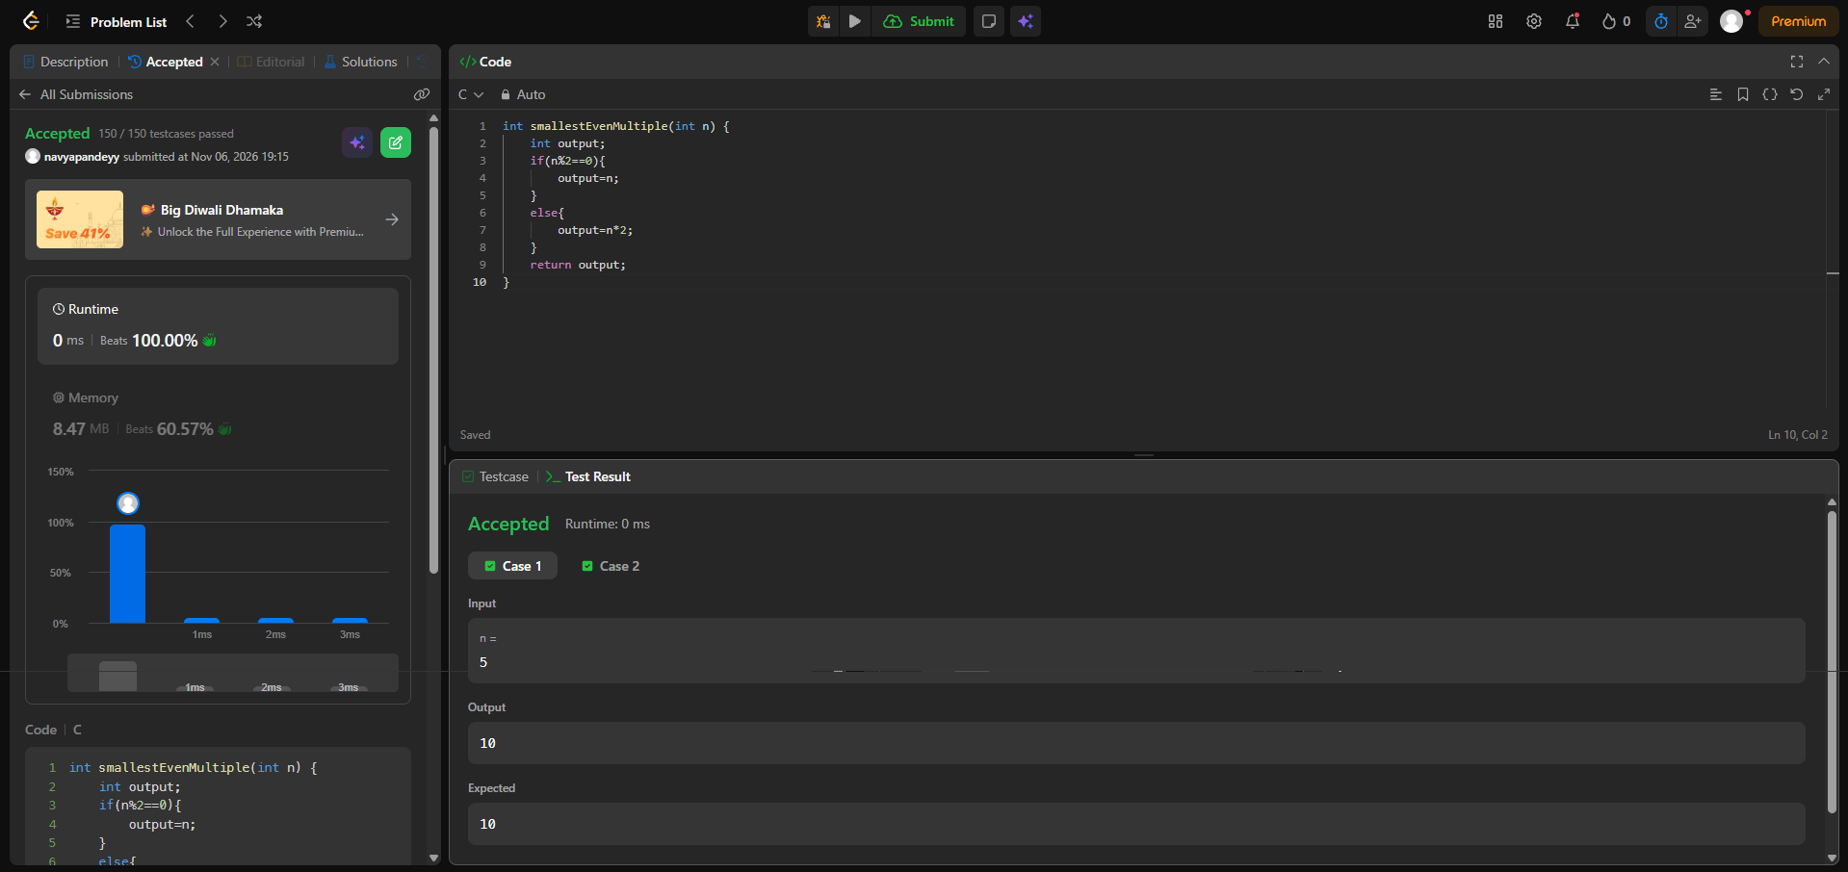
int smallestEvenMultiple(int n) {
int output;
if(n%2==0){
output=n;
}
else{
output=n*2;
}
return output;
}

