2520. Count the Digits That Divide a Number
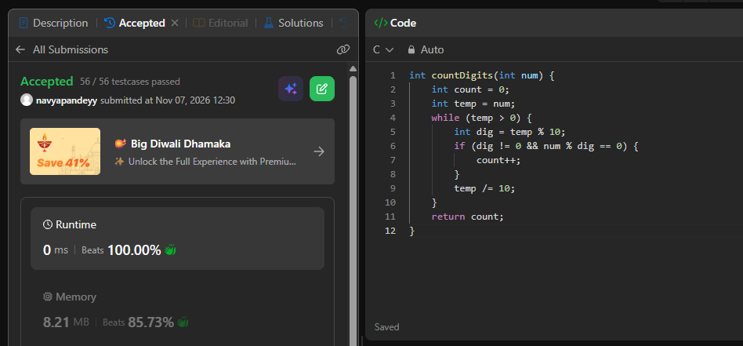
int countDigits(int num) {
int count = 0;
int temp = num;
while (temp > 0) {
int dig = temp % 10;
if (dig != 0 && num % dig == 0) {
count++;
}
temp /= 10;
}
return count;
}

