2651. Calculate Delayed Arrival Time
NAVYA PANDEY
SEC G
26CSU296
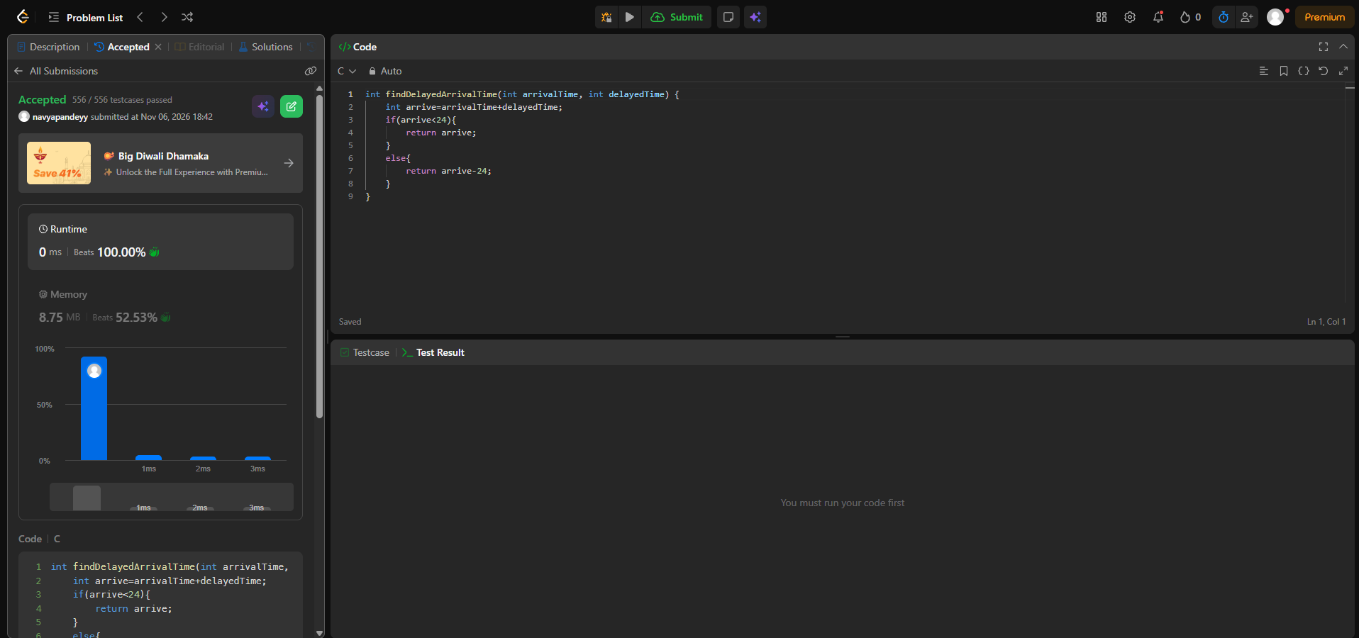
int findDelayedArrivalTime(int arrivalTime, int delayedTime) {
int arrive=arrivalTime+delayedTime;
if(arrive<24){
return arrive;
}
else{
return arrive-24;
}
}

