2739. Total Distance Traveled
NAVYA PANDEY
SEC G
26CSU296

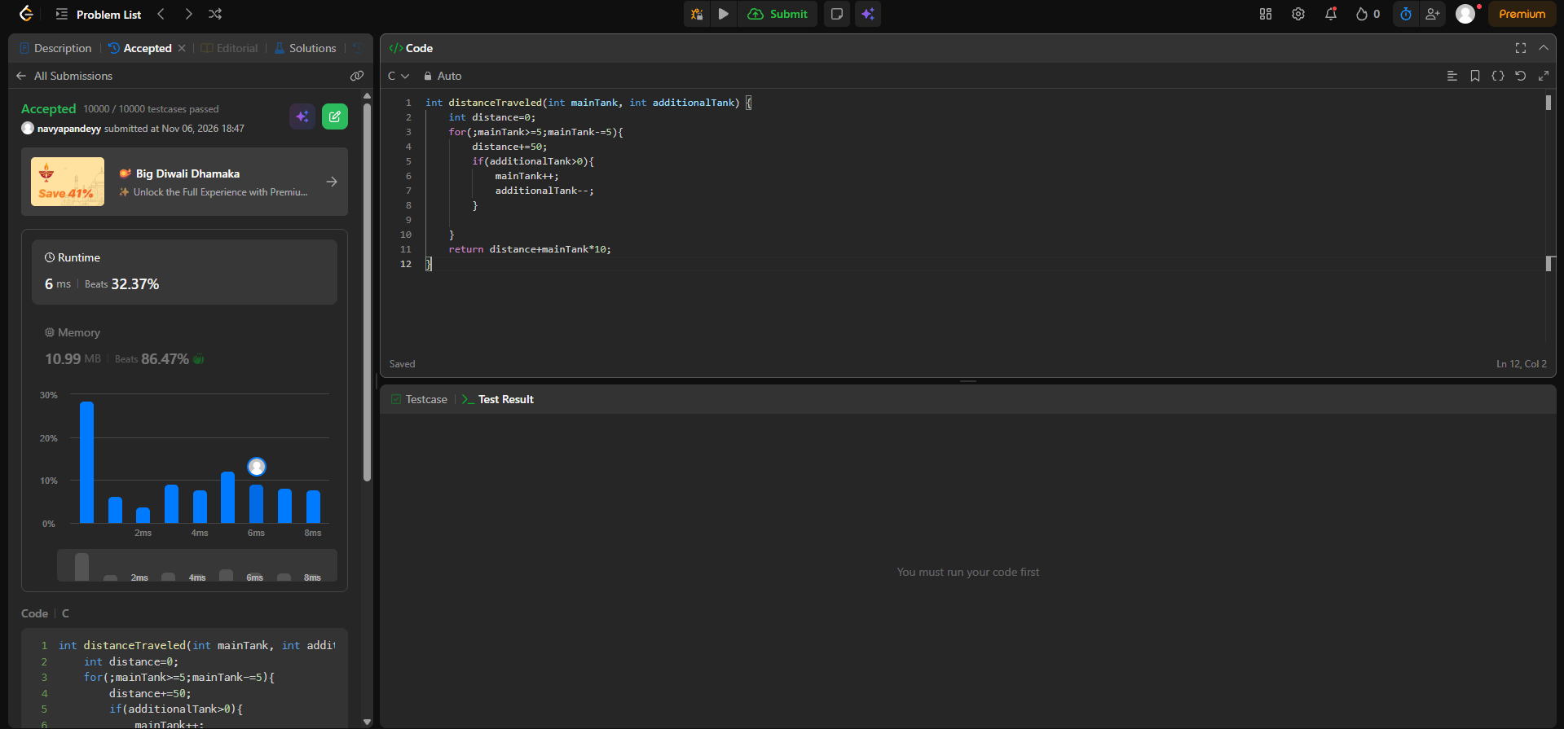
int distanceTraveled(int mainTank, int additionalTank) {
int distance=0;
for(;mainTank>=5;mainTank-=5){
distance+=50;
if(additionalTank>0){
mainTank++;
additionalTank--;
}

}
return distance+mainTank*10;
}

