326. Power of Three
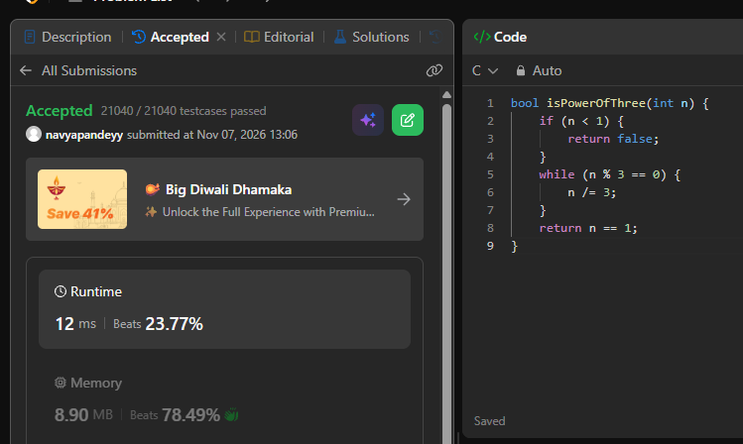
bool isPowerOfThree(int n) {
if (n < 1) {
return false;
}
while (n % 3 == 0) {
n /= 3;
}
return n == 1;
}

