Leetcode 507. Perfect Number
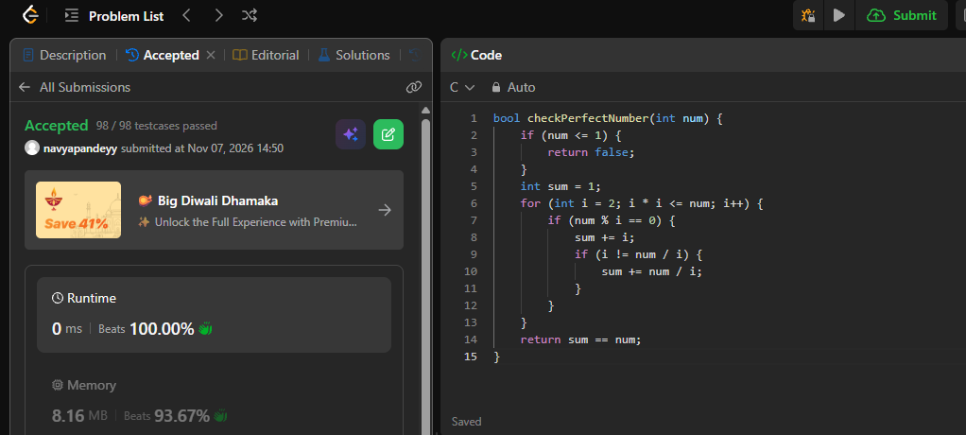
bool checkPerfectNumber(int num) {
if (num <= 1) {
return false;
}
int sum = 1;
for (int i = 2; i * i <= num; i++) {
if (num % i == 0) {
sum += i;
if (i != num / i) {
sum += num / i;
}
}
}
return sum == num;
}

