7. Reverse Integer
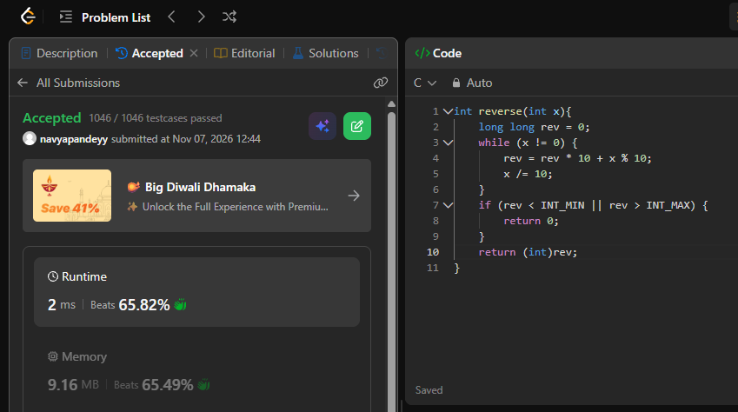
int reverse(int x){
long long rev = 0;
while (x != 0) {
rev = rev * 10 + x % 10;
x /= 10;
}
if (rev < INT_MIN || rev > INT_MAX) {
return 0;
}
return (int)rev;
}

