9. Palindrome Number
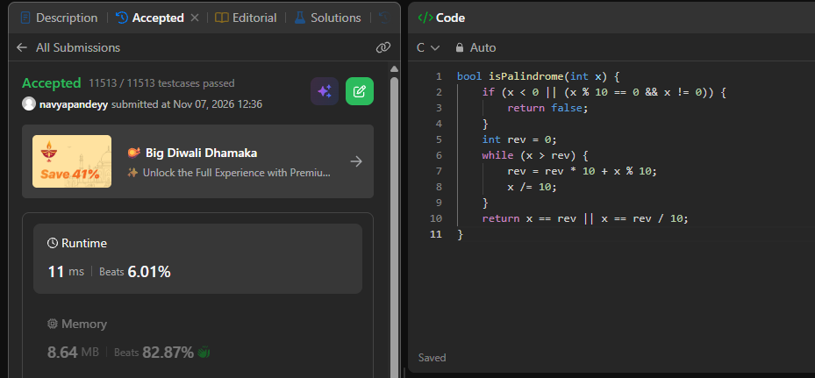
bool isPalindrome(int x) {
if (x < 0 || (x % 10 == 0 && x != 0)) {
return false;
}
int rev = 0;
while (x > rev) {
rev = rev * 10 + x % 10;
x /= 10;
}
return x == rev || x == rev / 10;
}

