Hands-on 1: Create an Angular Application
Objective: Create an Angular application named Student Course Portal and display a simple home page.
Commands Used:
ng new student-course-portal --routing --style=css
cd student-course-portal
ng serve
ng build
ng g c components/header
ng g c pages/home
ng g c pages/course-list
ng g c pages/student-profile

app.ts:
import { Component } from '@angular/core';
import { RouterOutlet } from '@angular/router';

import { Header } from './components/header/header';
import { Home } from './pages/home/home';

@Component({
selector: 'app-root',
standalone: true,
imports: [RouterOutlet, Header, Home],
templateUrl: './app.html',
styleUrl: './app.css'
})
export class App {}

app.html:
<app-header></app-header>

<app-home></app-home>

<router-outlet></router-outlet>

header.ts:
import { Component } from '@angular/core';

@Component({
selector: 'app-header',
standalone: true,
imports: [],
templateUrl: './header.html',
styleUrl: './header.css'
})
export class Header {}

header.html:
<nav>
<h2>Student Course Portal</h2>

<a href="#">Home</a> |

<a href="#">Courses</a> |

<a href="#">Profile</a>
</nav>

<hr>

home.ts:
import { Component } from '@angular/core';

@Component({
selector: 'app-home',
standalone: true,
imports: [],
templateUrl: './home.html',
styleUrl: './home.css'
})
export class Home {}

home.html:
<h1>Welcome to Student Course Portal</h1>

<p>
This portal helps students browse courses, enroll in courses,
and manage their profile.
</p>

<br>

<p><strong>Courses Available:</strong> 12</p>
<p><strong>Enrolled:</strong> 3</p>
<p><strong>GPA:</strong> 3.8</p>

Output:
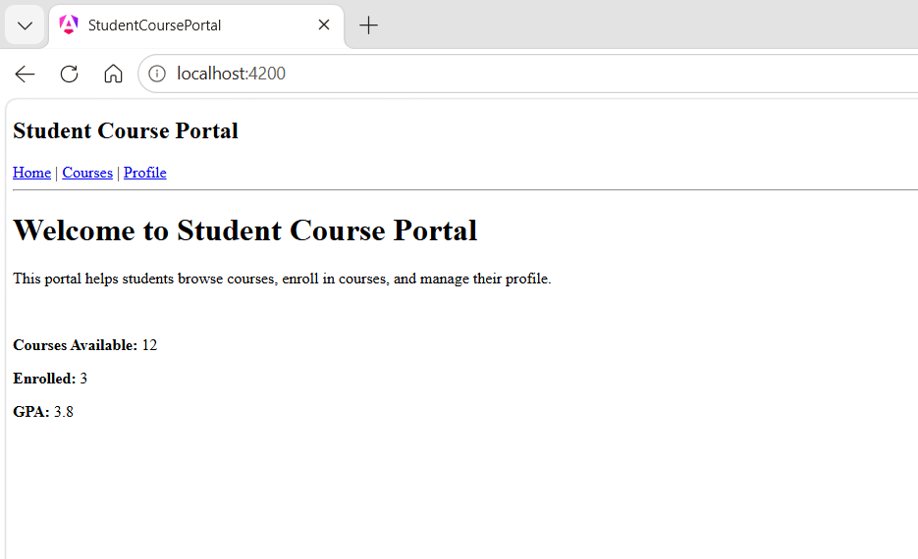

Hands-on 2: Routing in Angular
Objective: Implement routing to navigate between Home, Course List, and Student Profile pages.

app.routes.ts:
import { Routes } from '@angular/router';
import { Home } from './pages/home/home';
import { CourseList } from './pages/course-list/course-list';
import { StudentProfile } from './pages/student-profile/student-profile';

export const routes: Routes = [
{ path: '', component: Home },
{ path: 'courses', component: CourseList },
{ path: 'profile', component: StudentProfile }
];

header.ts:
import { Component } from '@angular/core';
import { RouterLink } from '@angular/router';

@Component({
selector: 'app-header',
standalone: true,
imports: [RouterLink],
templateUrl: './header.html',
styleUrl: './header.css'
})
export class Header {}

header.html:
<nav>
<h2>Student Course Portal</h2>

<a routerLink="/">Home</a> |
<a routerLink="/courses">Courses</a> |
<a routerLink="/profile">Profile</a>
</nav>

app.html:
<app-header></app-header>

<router-outlet></router-outlet>

course-list.html:
<h2>Available Courses</h2>

<ul>
<li>Angular</li>
<li>Java</li>
<li>Python</li>
<li>Spring Boot</li>
</ul>

student-profile.html:
<h2>Student Profile</h2>
<p><b>Name:</b> Rohitha </p>
<p><b>ID:</b> ST101</p>
<p><b>Department:</b> Computer Science</p>
<p><b>Semester:</b> 6</p>

Output:

