Hands-on 3: Create a Course Service and Display Data
Objective: Create an Angular application named Student Course Portal and display a simple home page.
Commands Used:
ng g s services/course
ng serve

course.ts:
import { Injectable } from '@angular/core';

@Injectable({
providedIn: 'root'
})
export class Course {

courses = [
{ id: 1, name: 'Angular', duration: '6 Weeks' },
{ id: 2, name: 'Java', duration: '8 Weeks' },
{ id: 3, name: 'Python', duration: '5 Weeks' },
{ id: 4, name: 'Spring Boot', duration: '7 Weeks' }
];

getCourses() {
return this.courses;
}
}

course-list.ts:
import { Component } from '@angular/core';
import { CommonModule } from '@angular/common';
import { Course } from '../../services/course';

@Component({
selector: 'app-course-list',
standalone: true,
imports: [CommonModule],
templateUrl: './course-list.html',
styleUrl: './course-list.css'
})
export class CourseList {

courses: any[] = [];

constructor(private courseService: Course) {
this.courses = this.courseService.getCourses();
}

}

course-list.html:
<h2>Available Courses</h2>

<table border="1">
<tr>
<th>ID</th>
<th>Course</th>
<th>Duration</th>
</tr>

<tr *ngFor="let c of courses">
<td>{{c.id}}</td>
<td>{{c.name}}</td>
<td>{{c.duration}}</td>
</tr>
</table>

Output:
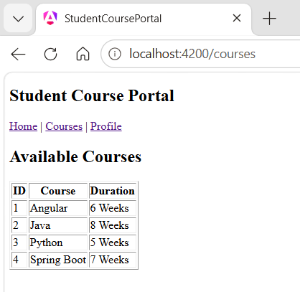
Hands-on 4: Create a Course Service and Display Data
Objective: Create a student registration form using Angular Forms.
Commands Used:
ng serve
app.config.ts:
import { ApplicationConfig } from '@angular/core';
import { provideRouter } from '@angular/router';

import { routes } from './app.routes';

export const appConfig: ApplicationConfig = {
providers: [
provideRouter(routes)
]
};

student-profile.ts:
import { Component } from '@angular/core';
import { FormsModule } from '@angular/forms';

@Component({
selector: 'app-student-profile',
standalone: true,
imports: [FormsModule],
templateUrl: './student-profile.html',
styleUrl: './student-profile.css'
})
export class StudentProfile {

student = {
name: '',
email: '',
course: ''
};

submitForm() {
alert('Student Registered Successfully');
}

}

student-profile.html:
<h2>Student Registration</h2>

<form (ngSubmit)="submitForm()">

<label>Name:</label><br>
<input type="text" [(ngModel)]="student.name" name="name"><br><br>

<label>Email:</label><br>
<input type="email" [(ngModel)]="student.email" name="email"><br><br>

<label>Course:</label><br>
<input type="text" [(ngModel)]="student.course" name="course"><br><br>

<button type="submit">Register</button>

</form>

Output:
