Hands-on 5: Reactive Forms – FormBuilder & FormGroup
Objective: Create a Reactive Enrollment Form using FormBuilder and ReactiveFormsModule with validation.
Commands Used:
ng g c pages/reactive-enrollment-form
ng serve
reactive-enrollment-form.ts:
import { Component } from '@angular/core';
import {
FormBuilder,
FormGroup,
ReactiveFormsModule,
Validators
} from '@angular/forms';

@Component({
selector: 'app-reactive-enrollment-form',
standalone: true,
imports: [ReactiveFormsModule],
templateUrl: './reactive-enrollment-form.html',
styleUrl: './reactive-enrollment-form.css'
})
export class ReactiveEnrollmentForm {

enrollForm: FormGroup;

constructor(private fb: FormBuilder) {

this.enrollForm = this.fb.group({
studentName: ['', [Validators.required, Validators.minLength(3)]],
studentEmail: ['', [Validators.required, Validators.email]],
courseId: ['', Validators.required],
preferredSemester: ['Odd', Validators.required],
agreeToTerms: [false, Validators.requiredTrue]
});

}
onSubmit() {
if (this.enrollForm.valid) {
console.log(this.enrollForm.value);
}
}
}

reactive-enrollment-form.ts:
<h2>Reactive Enrollment Form</h2>

<form [formGroup]="enrollForm" (ngSubmit)="onSubmit()">

<label>Name</label><br>
<input type="text" formControlName="studentName"><br><br>

<label>Email</label><br>
<input type="email" formControlName="studentEmail"><br><br>

<label>Course ID</label><br>
<input type="number" formControlName="courseId"><br><br>

<label>Semester</label><br>
<select formControlName="preferredSemester">
<option value="Odd">Odd</option>
<option value="Even">Even</option>
</select><br><br>

<label>
<input type="checkbox" formControlName="agreeToTerms">
Agree to Terms
</label>

<br><br>

<button type="submit" [disabled]="enrollForm.invalid">
Submit
</button>

</form>

Output:
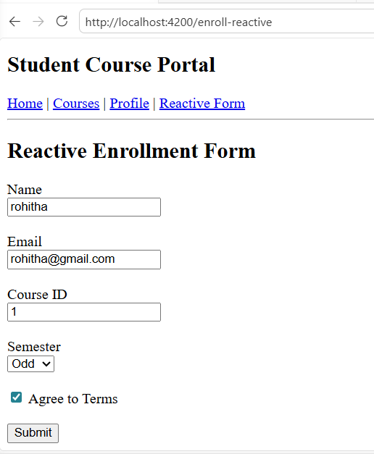

Hands-on 6: Services & Dependency Injection
Objective: Create a CourseService to store course details and use it in multiple components using Angular Dependency Injection.
Codes:
models/course.model.ts:
export interface Course {
id: number;
name: string;
code: string;
credits: number;
gradeStatus: 'passed' | 'failed' | 'pending';
}

services/course.ts:
import { Injectable } from '@angular/core';
import { Course } from '../models/course.model';

@Injectable({
providedIn: 'root'
})
export class CourseService {

private courses: Course[] = [
{
id: 1,
name: 'Angular',
code: 'ANG101',
credits: 4,
gradeStatus: 'passed'
},
{
id: 2,
name: 'Java',
code: 'JAVA102',
credits: 3,
gradeStatus: 'pending'
},
{
id: 3,
name: 'Python',
code: 'PY103',
credits: 4,
gradeStatus: 'passed'
},
{
id: 4,
name: 'React',
code: 'RE104',
credits: 3,
gradeStatus: 'failed'
},
{
id: 5,
name: 'Spring Boot',
code: 'SB105',
credits: 4,
gradeStatus: 'passed'
}
];

getCourses(): Course[] {
return this.courses;
}

getCourseById(id: number): Course | undefined {
return this.courses.find(course => course.id === id);
}

addCourse(course: Course): void {
this.courses.push(course);
}

}

course-list.ts:
import { Component } from '@angular/core';
import { CommonModule } from '@angular/common';
import { CourseService } from '../../services/course';
import { Course } from '../../models/course.model';

@Component({
selector: 'app-course-list',
standalone: true,
imports: [CommonModule],
templateUrl: './course-list.html',
styleUrl: './course-list.css'
})
export class CourseList {

courses: Course[] = [];

constructor(private courseService: CourseService) {
this.courses = this.courseService.getCourses();
}

}

course-list.html:
<h2>Available Courses</h2>

<table border="1">
<tr>
<th>ID</th>
<th>Name</th>
<th>Code</th>
<th>Credits</th>
<th>Status</th>
</tr>

<tr *ngFor="let c of courses">
<td>{{ c.id }}</td>
<td>{{ c.name }}</td>
<td>{{ c.code }}</td>
<td>{{ c.credits }}</td>
<td>{{ c.gradeStatus }}</td>
</tr>
</table>

home.ts:
import { Component } from '@angular/core';
import { CourseService } from '../../services/course';

@Component({
selector: 'app-home',
standalone: true,
imports: [],
templateUrl: './home.html',
styleUrl: './home.css'
})
export class Home {

totalCourses = 0;

constructor(private courseService: CourseService) {
this.totalCourses = this.courseService.getCourses().length;
}

}

home.html:
<h1>Welcome to Student Course Portal</h1>

<p>
This portal helps students browse courses,
enroll in courses, and manage their profile.
</p>

<p><b>Courses Available:</b> {{ totalCourses }}</p>
<p><b>Enrolled:</b> 3</p>
<p><b>GPA:</b> 3.8</p>

Output:

