Hands-on 7: Angular Routing – Guards, Lazy Loading & Route Parameters
Objective: Configure Angular Routing, implement Route Parameters, create a Course Detail page, and add Route Guards.
Codes:
app.routes.ts:
import { Routes } from '@angular/router';

import { Home } from './pages/home/home';
import { CourseList } from './pages/course-list/course-list';
import { StudentProfile } from './pages/student-profile/student-profile';
import { CourseDetail } from './pages/course-detail/course-detail';
import { NotFound } from './pages/not-found/not-found';
import { authGuard } from './guards/auth-guard';

export const routes: Routes = [
{ path: '', component: Home },

{ path: 'courses', component: CourseList },

{
path: 'courses/:id',
component: CourseDetail
},

{
path: 'profile',
component: StudentProfile,
canActivate: [authGuard]
},

{
path: '**',
component: NotFound
}
];

course-detail.ts:
import { Component } from '@angular/core';
import { ActivatedRoute } from '@angular/router';
import { CourseService } from '../../services/course';
import { Course } from '../../models/course.model';

@Component({
selector: 'app-course-detail',
standalone: true,
imports: [],
templateUrl: './course-detail.html',
styleUrl: './course-detail.css'
})
export class CourseDetail {

course?: Course;

constructor(
private route: ActivatedRoute,
private courseService: CourseService
) {

const id = Number(this.route.snapshot.paramMap.get('id'));

this.course = this.courseService.getCourseById(id);

}

}

course-detail.html:
<h2>Available Courses</h2>

<table border="1">

<tr>
<th>ID</th>
<th>Name</th>
<th>Code</th>
<th>Credits</th>
<th>Status</th>
</tr>

<tr *ngFor="let c of courses">

<td>
<a [routerLink]="['/courses', c.id]">
{{c.id}}
</a>
</td>

<td>{{c.name}}</td>

<td>{{c.code}}</td>

<td>{{c.credits}}</td>

<td>{{c.gradeStatus}}</td>

</tr>

</table>

auth-guard.ts:
import { CanActivateFn } from '@angular/router';

export const authGuard: CanActivateFn = () => {

const isLoggedIn = true;

return isLoggedIn;

};

not-found.html:
<h2>404 - Page Not Found</h2>

<p>The page you requested does not exist.</p>

course-list.html:
<h2>Available Courses</h2>

<table border="1">

<tr>
<th>ID</th>
<th>Name</th>
<th>Code</th>
<th>Credits</th>
<th>Status</th>
</tr>

<tr *ngFor="let c of courses">

<td>
<a [routerLink]="['/courses', c.id]">
{{c.id}}
</a>
</td>

<td>{{c.name}}</td>

<td>{{c.code}}</td>

<td>{{c.credits}}</td>

<td>{{c.gradeStatus}}</td>

</tr>

</table>

course-list.ts:
import { Component } from '@angular/core';
import { CommonModule } from '@angular/common';
import { RouterLink } from '@angular/router';
import { CourseService } from '../../services/course';
import { Course } from '../../models/course.model';

@Component({
selector: 'app-course-list',
standalone: true,
imports: [CommonModule, RouterLink],
templateUrl: './course-list.html',
styleUrl: './course-list.css'
})
export class CourseList {

courses: Course[] = [];

constructor(private courseService: CourseService) {
this.courses = this.courseService.getCourses();
}

}

Hands-on 7 – Task 2: Implement Routing, Route Guards and Lazy Loading in Student Course Portal

Objective: To secure the Student Course Portal using AuthGuard, configure routing for the Reactive Enrollment Form, and implement lazy loading for the Enrollment feature.
Commands Used:
ng generate service services/auth
ng generate guard guards/auth
ng serve
app.routes.ts:
import { Routes } from '@angular/router';

import { Home } from './pages/home/home';
import { CourseList } from './pages/course-list/course-list';
import { CourseDetail } from './pages/course-detail/course-detail';
import { StudentProfile } from './pages/student-profile/student-profile';
import { ReactiveEnrollmentForm } from './pages/reactive-enrollment-form/reactive-enrollment-form';
import { NotFound } from './pages/not-found/not-found';
import { authGuard } from './guards/auth-guard';

export const routes: Routes = [
{
path: '',
component: Home
},
{
path: 'courses',
component: CourseList
},
{
path: 'courses/:id',
component: CourseDetail
},
{
path: 'profile',
component: StudentProfile,
canActivate: [authGuard]
},
{
path: 'enroll',
component: ReactiveEnrollmentForm,
canActivate: [authGuard]
},
{
path: '**',
component: NotFound
}
];

auth-guard.ts:
import { inject } from '@angular/core';
import { CanActivateFn, Router } from '@angular/router';
import { AuthService } from '../services/auth';

export const authGuard: CanActivateFn = () => {

const auth = inject(AuthService);
const router = inject(Router);

if (auth.isLoggedIn) {
return true;
}

router.navigate(['/']);
return false;
};

app.config.ts:
import { ApplicationConfig } from '@angular/core';
import { provideRouter } from '@angular/router';

import { routes } from './app.routes';

export const appConfig: ApplicationConfig = {
providers: [
provideRouter(routes)
]
};

header.html:
<nav>
<h2>Student Course Portal</h2>

<a routerLink="/">Home</a> |
<a routerLink="/courses">Courses</a> |
<a routerLink="/profile">Profile</a> |
<a routerLink="/enroll">Reactive Form</a>
</nav>

<hr>

Output:
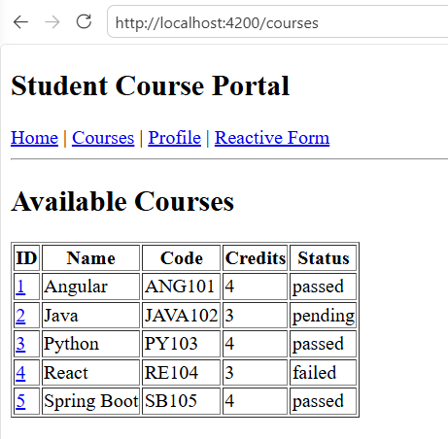

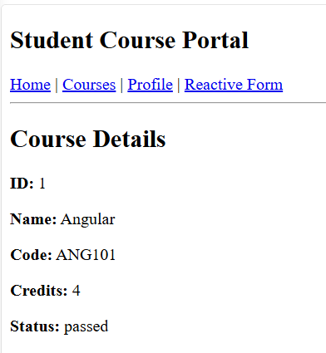

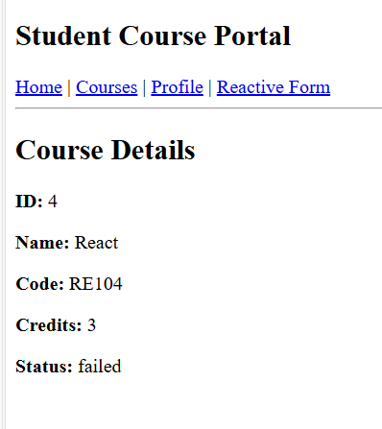

Hands-on 8: Reactive Forms – FormBuilder & FormGroup
Objective: Create a Reactive Enrollment Form using FormBuilder and ReactiveFormsModule with validation.
Commands Used:
ng generate component pages/reactive-enrollment-form
ng serve
reactive-enrollment-form.ts:
import { ComponentFixture, TestBed } from '@angular/core/testing';

import { ReactiveEnrollmentForm } from './reactive-enrollment-form';

describe('ReactiveEnrollmentForm', () => {
let component: ReactiveEnrollmentForm;
let fixture: ComponentFixture<ReactiveEnrollmentForm>;

beforeEach(async () => {
await TestBed.configureTestingModule({
imports: [ReactiveEnrollmentForm],
}).compileComponents();

fixture = TestBed.createComponent(ReactiveEnrollmentForm);
component = fixture.componentInstance;
await fixture.whenStable();
});

it('should create', () => {
expect(component).toBeTruthy();
});
});

reactive-enrollment-form.html:
<h2>Reactive Enrollment Form</h2>

<form [formGroup]="enrollForm" (ngSubmit)="onSubmit()">

<label>Name</label><br>
<input type="text" formControlName="studentName"><br><br>

<label>Email</label><br>
<input type="email" formControlName="studentEmail"><br><br>

<label>Course ID</label><br>
<input type="number" formControlName="courseId"><br><br>

<label>Semester</label><br>
<select formControlName="preferredSemester">
<option value="Odd">Odd</option>
<option value="Even">Even</option>
</select><br><br>

<label>
<input type="checkbox" formControlName="agreeToTerms">
Agree to Terms
</label>

<br><br>

<button type="submit" [disabled]="enrollForm.invalid">
Submit
</button>

</form>

Output:
