Lab 2: Web API using .NET Core with Swagger
Objective
To create an ASP.NET Core Web API with Swagger support, understand API documentation, test Web API endpoints using Swagger and Postman, and demonstrate the use of routing by customizing API endpoints through the Route attribute.
Commands Used
dotnet new webapi --use-controllers -n EmployeeAPI
cd EmployeeAPI
dotnet run
Code
Program.cs
using Microsoft.OpenApi.Models;
var builder = WebApplication.CreateBuilder(args);
// Add services
builder.Services.AddControllers();
builder.Services.AddEndpointsApiExplorer();
builder.Services.AddSwaggerGen(options =>
{
options.SwaggerDoc("v1", new OpenApiInfo
{
Title = "Employee API",
Version = "v1",
Description = "Swagger Demo",
Contact = new OpenApiContact
{
Name = "John Doe",
Email = "john@xyzmail.com"
}
});
});
var app = builder.Build();
if (app.Environment.IsDevelopment())
{
app.UseSwagger();
app.UseSwaggerUI(options =>
{
options.SwaggerEndpoint("/swagger/v1/swagger.json", "Employee API V1");
});
}
app.UseHttpsRedirection();
app.UseAuthorization();
app.MapControllers();
app.Run();
Employee.cs
namespace EmployeeAPI.Models;
public class Employee
{
public int Id { get; set; }
public string Name { get; set; }
public string Department { get; set; }
}
EmployeeController.cs
using Microsoft.AspNetCore.Mvc;
using EmployeeAPI.Models;

namespace EmployeeAPI.Controllers;
[ApiController]
[Route("api/Emp")]
public class EmployeeController : ControllerBase
{
static List<Employee> employees = new()
{
new Employee
{
Id = 1,
Name = "Harshitha",
Department = "IT"
},
new Employee
{
Id = 2,
Name = "Rahul",
Department = "HR"
}
};
// GET
[HttpGet]
public IActionResult GetEmployees()
{
return Ok(employees);
}
// GET BY ID
[HttpGet("{id}")]
public IActionResult GetEmployee(int id)
{
var employee = employees.FirstOrDefault(e => e.Id == id);
if (employee == null)
return NotFound();
return Ok(employee);
}
// POST
[HttpPost]
public IActionResult AddEmployee(Employee employee)
{
employees.Add(employee);
return Ok(employee);
}
// PUT
[HttpPut("{id}")]
public IActionResult UpdateEmployee(int id, Employee updatedEmployee)
{
var employee = employees.FirstOrDefault(e => e.Id == id);
if (employee == null)
return NotFound();
employee.Name = updatedEmployee.Name;
employee.Department = updatedEmployee.Department;
return Ok(employee);
}
// DELETE
[HttpDelete("{id}")]
public IActionResult DeleteEmployee(int id)
{
var employee = employees.FirstOrDefault(e => e.Id == id);
if (employee == null)
return NotFound();
employees.Remove(employee);
return Ok("Employee Deleted");
}
}

Output
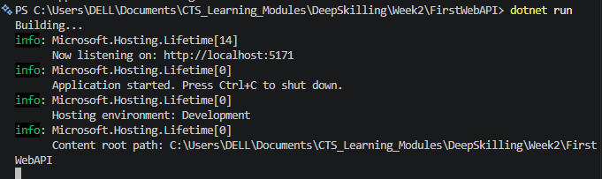
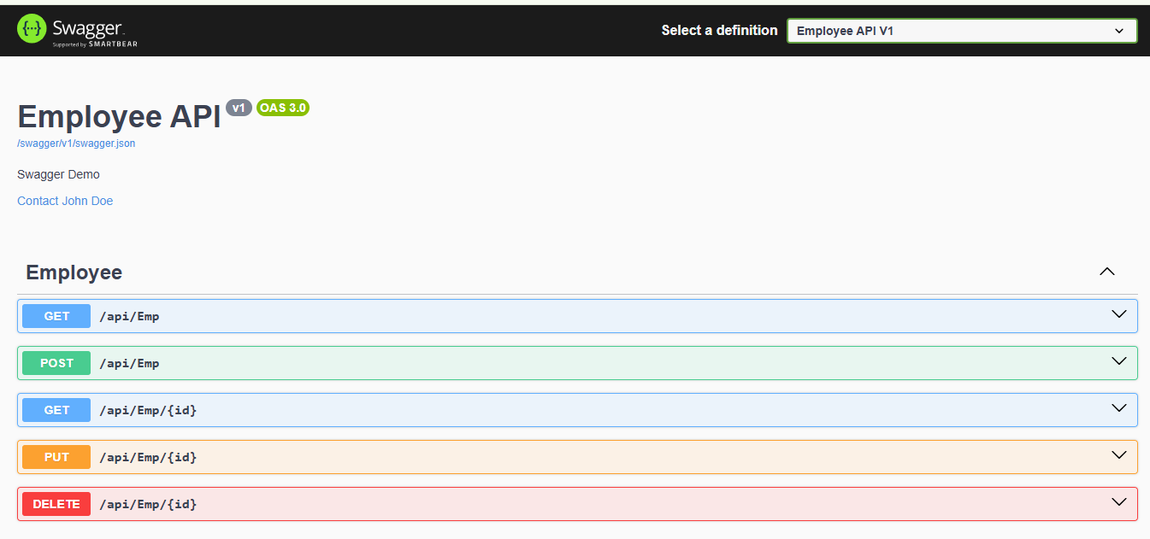
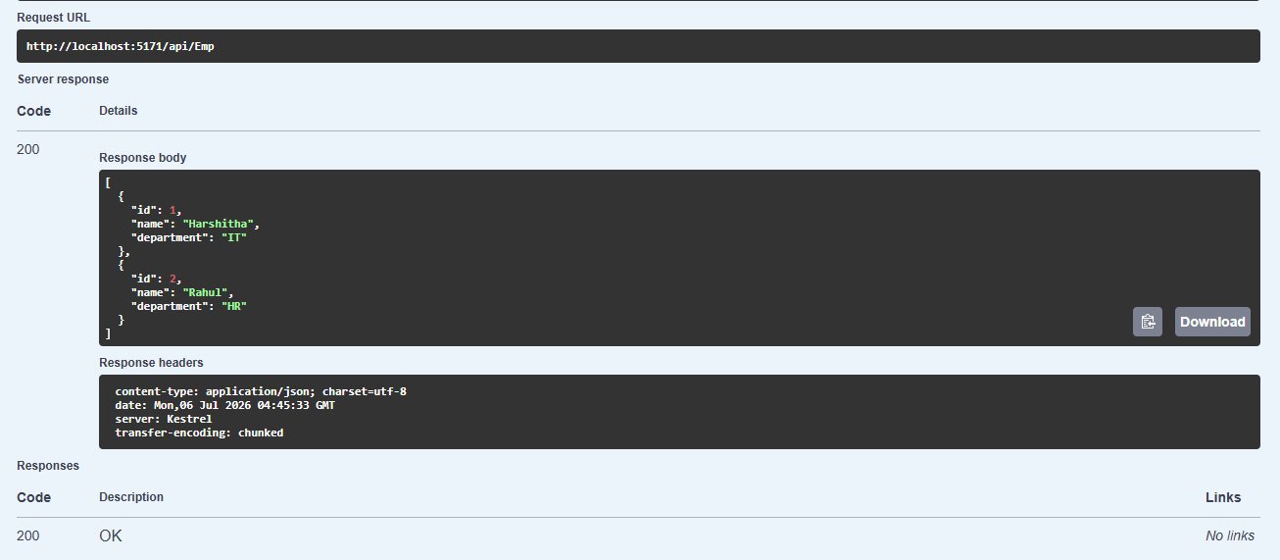
Result
Swagger was successfully configured in the ASP.NET Core Web API. The Employee API was tested using both Swagger UI and Postman. The GET endpoint returned the employee list successfully, and modifying the Route attribute from Employee to Emp changed the endpoint URL while still returning the expected response. This demonstrated API documentation, endpoint testing, and custom routing in ASP.NET Core Web API.

