Lab 4: Web API CRUD Operation (PUT)
Objective
To implement the HTTP PUT action method in an ASP.NET Core Web API to update employee information using the FromBody attribute, validate employee IDs, return appropriate BadRequest responses for invalid IDs, and test the API using Swagger and Postman.
Commands Used
dotnet run
Code
Program.cs
using FirstWebAPI.Filters;
using Microsoft.OpenApi.Models;
var builder = WebApplication.CreateBuilder(args);
builder.Services.AddControllers(options =>
{
options.Filters.Add<CustomExceptionFilter>();
});
builder.Services.AddEndpointsApiExplorer();
builder.Services.AddSwaggerGen(options =>
{
options.SwaggerDoc("v1", new OpenApiInfo
{
Title = "Employee API",
Version = "v1",
Description = "Employee Web API with Custom Filters"
});
});
var app = builder.Build();
app.UseSwagger();
app.UseSwaggerUI();
app.UseHttpsRedirection();
app.UseAuthorization();
app.MapControllers();
app.Run();
Employee.cs
namespace FirstWebAPI.Models;
public class Employee
{
public int Id { get; set; }
public string Name { get; set; }
public int Salary { get; set; }
public bool Permanent { get; set; }
public Department Department { get; set; }
public List<Skill> Skills { get; set; }
public DateTime DateOfBirth { get; set; }
}
Department.cs
namespace FirstWebAPI.Models;
public class Department
{
public int Id { get; set; }
public string Name { get; set; }
}
Skill.cs
namespace FirstWebAPI.Models;
public class Skill
{
public int Id { get; set; }
public string Name { get; set; }
}
EmployeeController.cs
using Microsoft.AspNetCore.Authorization;
using Microsoft.AspNetCore.Mvc;
using FirstWebAPI.Models;
namespace FirstWebAPI.Controllers;
[ApiController]
[Route("api/[controller]")]
public class EmployeeController : ControllerBase
{
private static List<Employee> employees = GetStandardEmployeeList();
private static List<Employee> GetStandardEmployeeList()
{
return new List<Employee>
{
new Employee
{
Id = 1,
Name = "Harshitha",
Salary = 50000,
Permanent = true,
Department = new Department
{
Id = 1,
Name = "IT"
},
Skills = new List<Skill>
{
new Skill
{
Id = 1,
Name = "C#"
},
new Skill
{
Id = 2,
Name = "ASP.NET Core"
}
},
DateOfBirth = new DateTime(2003, 5, 10)
},
new Employee
{
Id = 2,
Name = "Rahul",
Salary = 45000,
Permanent = false,
Department = new Department
{
Id = 2,
Name = "HR"
},
Skills = new List<Skill>
{
new Skill
{
Id = 3,
Name = "Communication"
}
},
DateOfBirth = new DateTime(2002, 8, 20)
}
};
}
// GET ALL
[AllowAnonymous]
[HttpGet]
[ProducesResponseType(StatusCodes.Status200OK)]
public ActionResult<List<Employee>> GetEmployees()
{
return Ok(employees);
}
// GET BY ID
[HttpGet("{id}")]
public ActionResult<Employee> GetEmployee(int id)
{
var employee = employees.FirstOrDefault(e => e.Id == id);
if (employee == null)
{
return NotFound();
}
return Ok(employee);
}
// POST
[HttpPost]
public ActionResult<Employee> AddEmployee([FromBody] Employee employee)
{
employees.Add(employee);
return Ok(employee);
}
// PUT
[HttpPut("{id}")]
public ActionResult<Employee> UpdateEmployee(int id, [FromBody] Employee updatedEmployee)
{
// Check for invalid id
if (id <= 0)
{
return BadRequest("Invalid employee id");
}
// Search employee
var employee = employees.FirstOrDefault(e => e.Id == id);
// Employee not found
if (employee == null)
{
return BadRequest("Invalid employee id");
}
// Update employee details
employee.Name = updatedEmployee.Name;
employee.Salary = updatedEmployee.Salary;
employee.Permanent = updatedEmployee.Permanent;
employee.Department = updatedEmployee.Department;
employee.Skills = updatedEmployee.Skills;
employee.DateOfBirth = updatedEmployee.DateOfBirth;
// Return updated employee
return Ok(employee);
}
}
Output
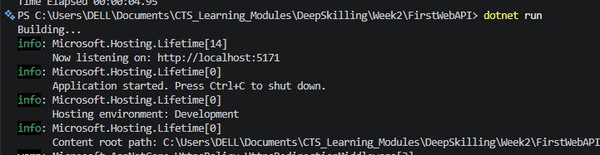
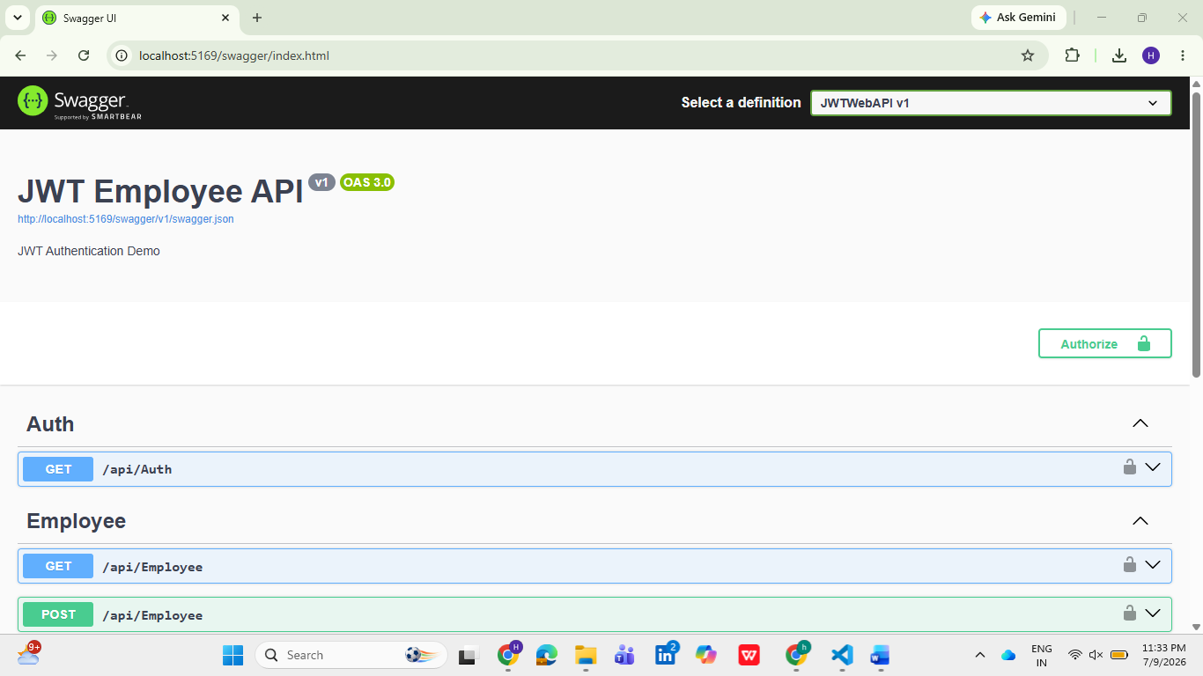
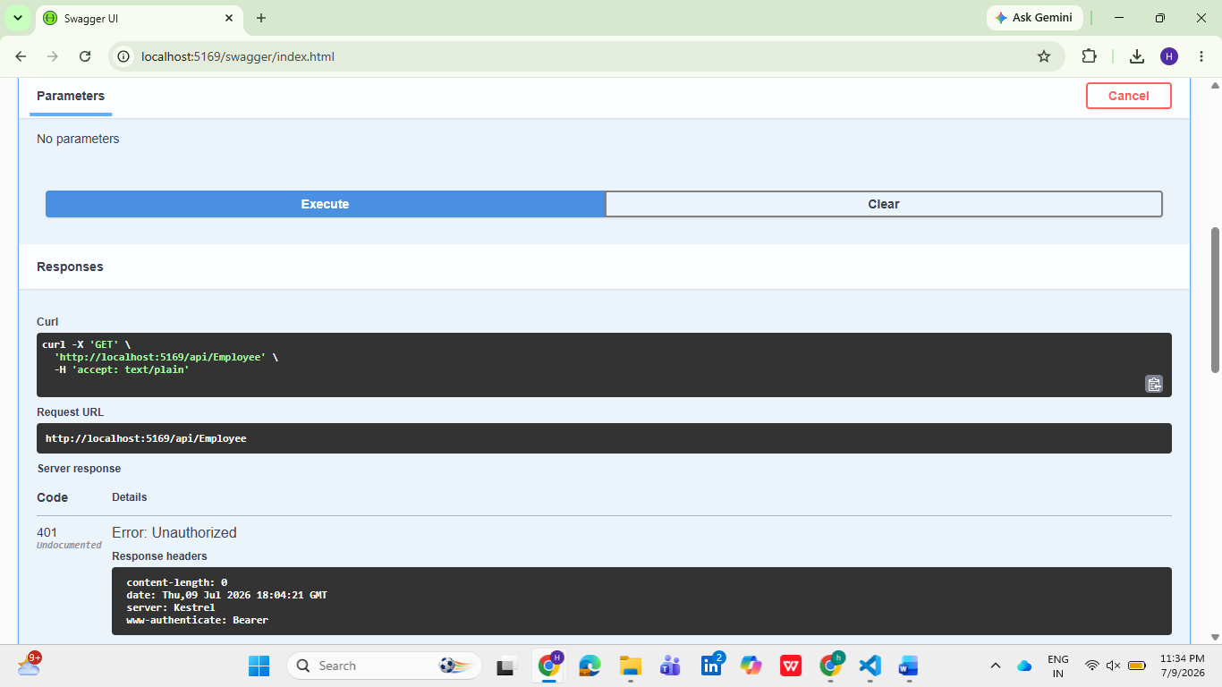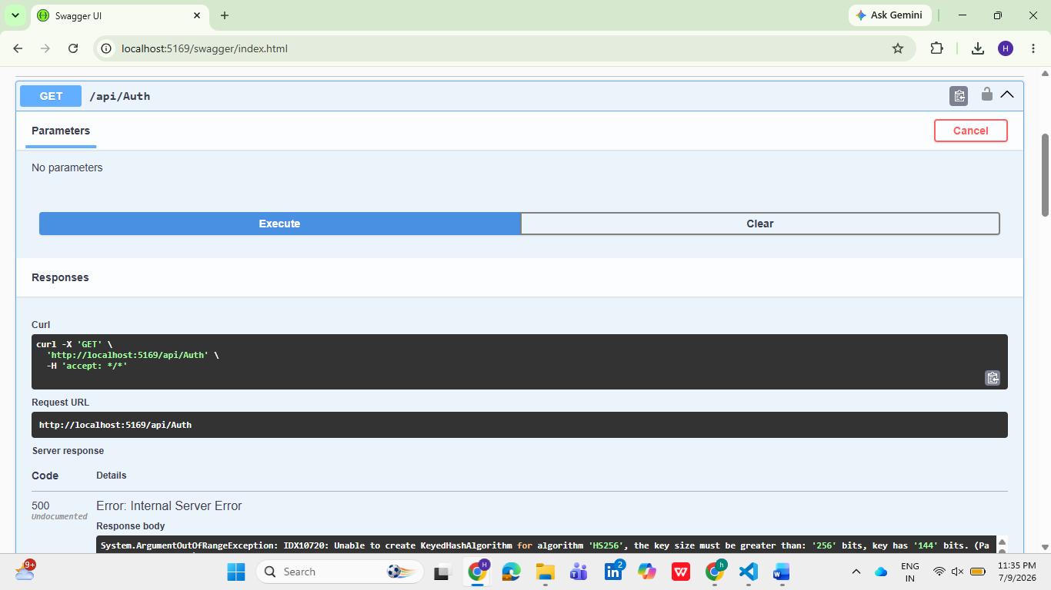
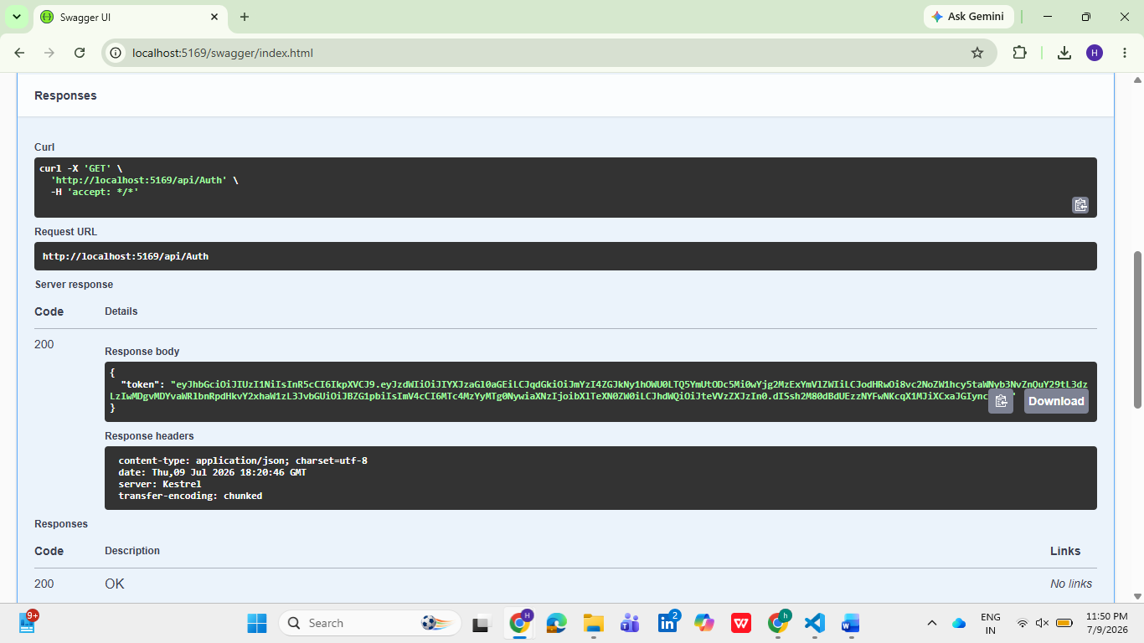
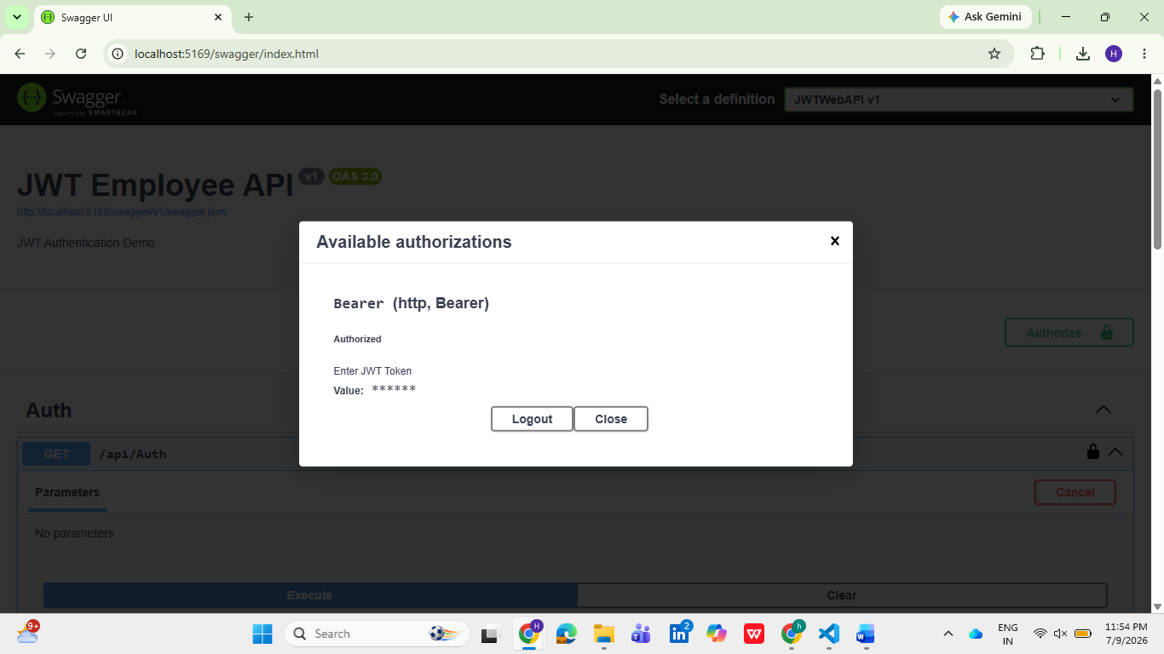
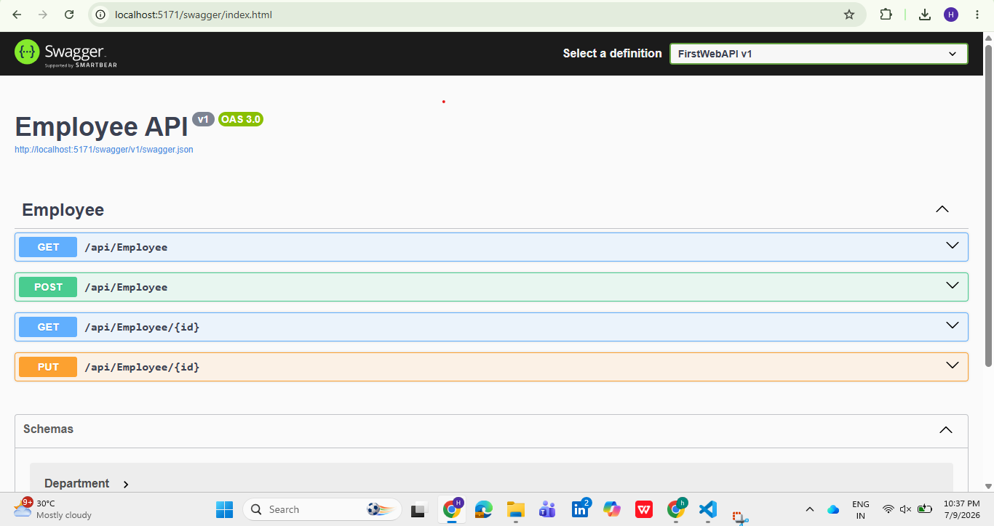
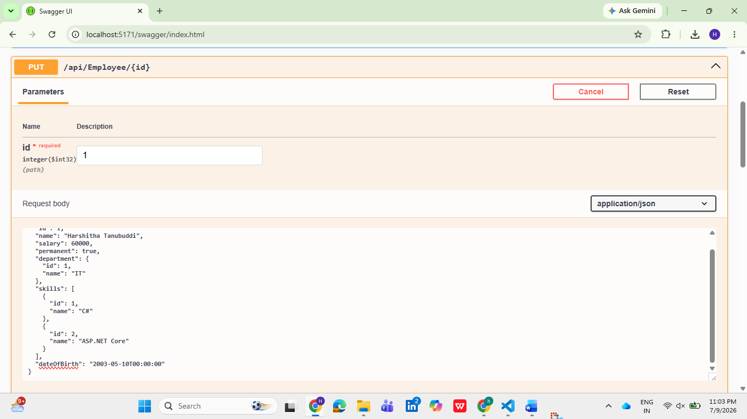
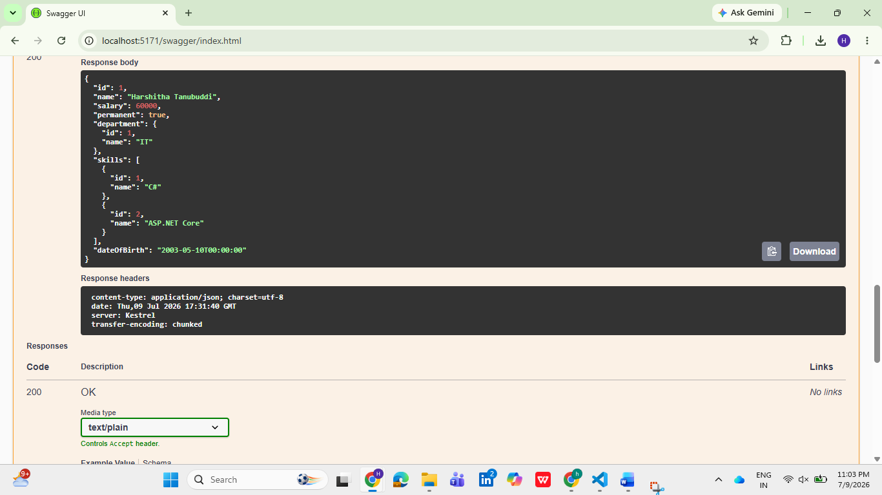
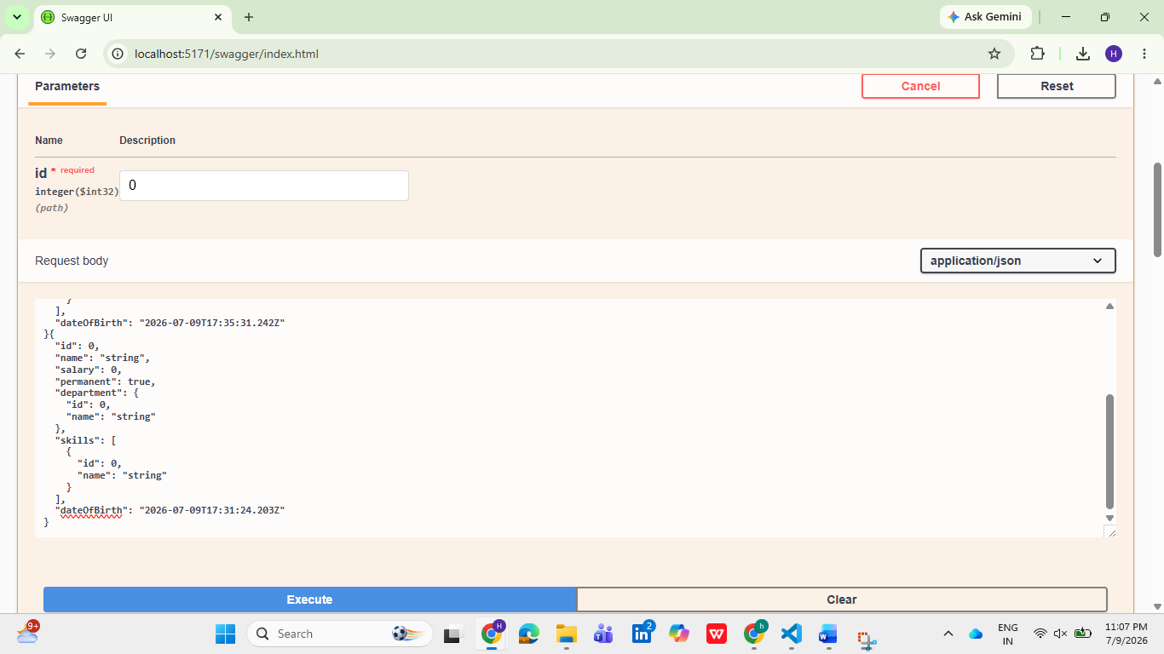
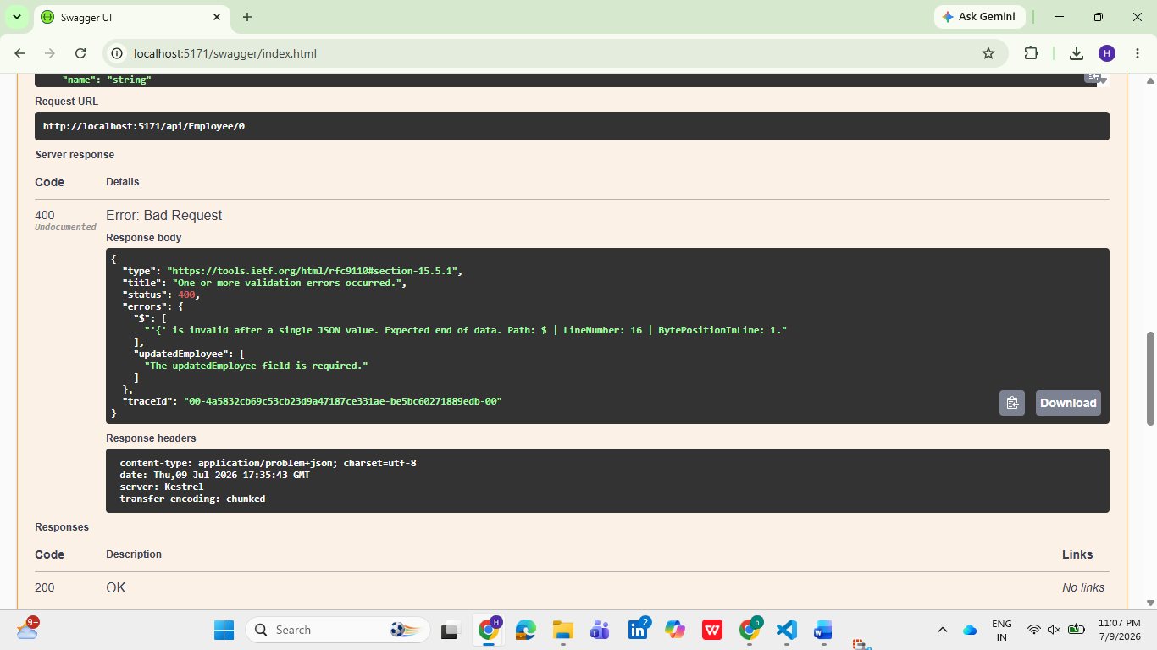
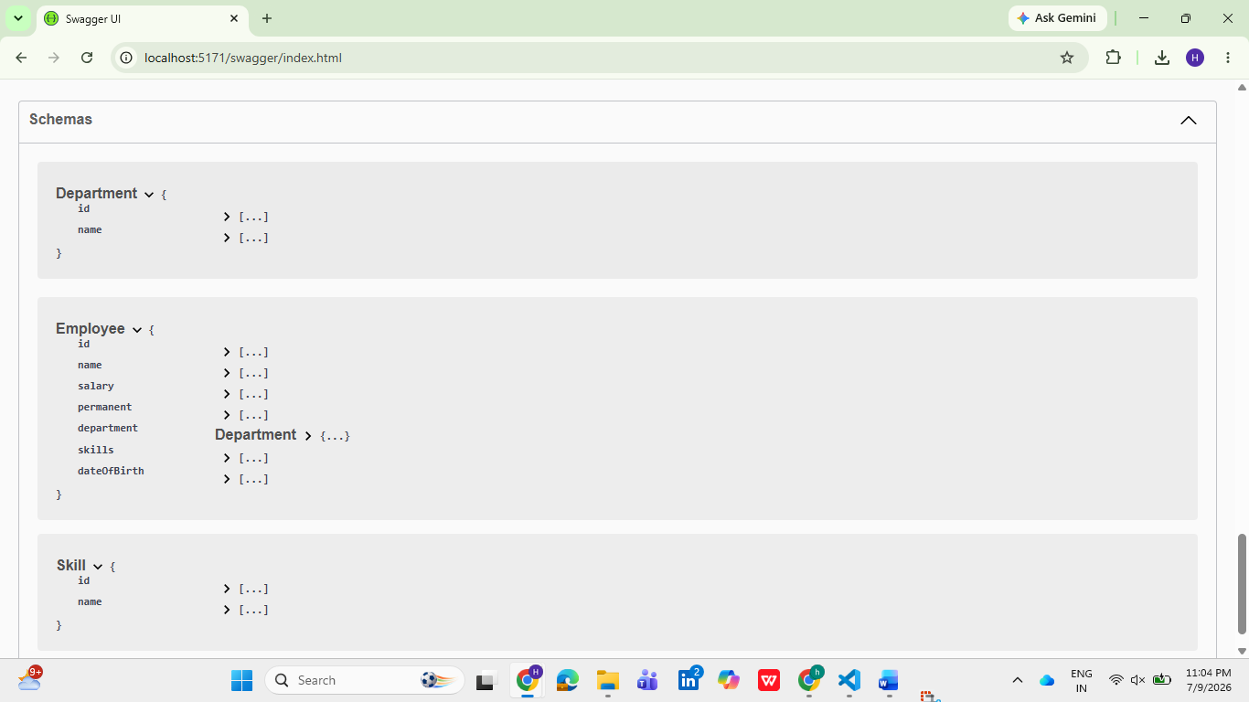
Result
The HTTP PUT action method was successfully implemented to update employee information using the FromBody attribute. Employee IDs were validated before updating the hardcoded employee list. Appropriate BadRequest responses were returned for invalid IDs, while valid requests updated and returned the modified employee record. The API was successfully tested using Swagger and Postman.

