Operating Systems
2520030137
SEC-5

WEEK-4

4. Write a C program where a parent process creates multiple child processes and synchronizes their completion using wait() and waitpid(). Compare the behavior of both functions.

Create a scenario where a child process becomes a zombie process. Investigate the process table and then modify the program to eliminate zombie processes using proper synchronization techniques.

Code

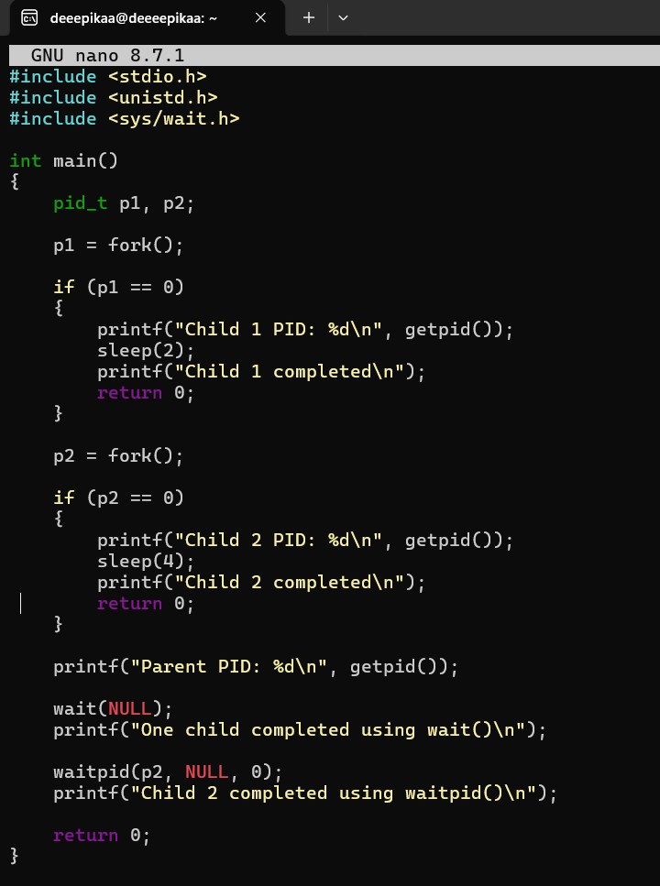

output : 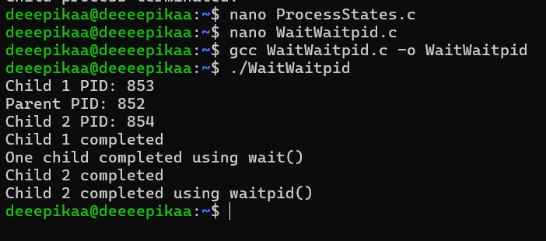
Part 2 — Create a Zombie Process
CODE –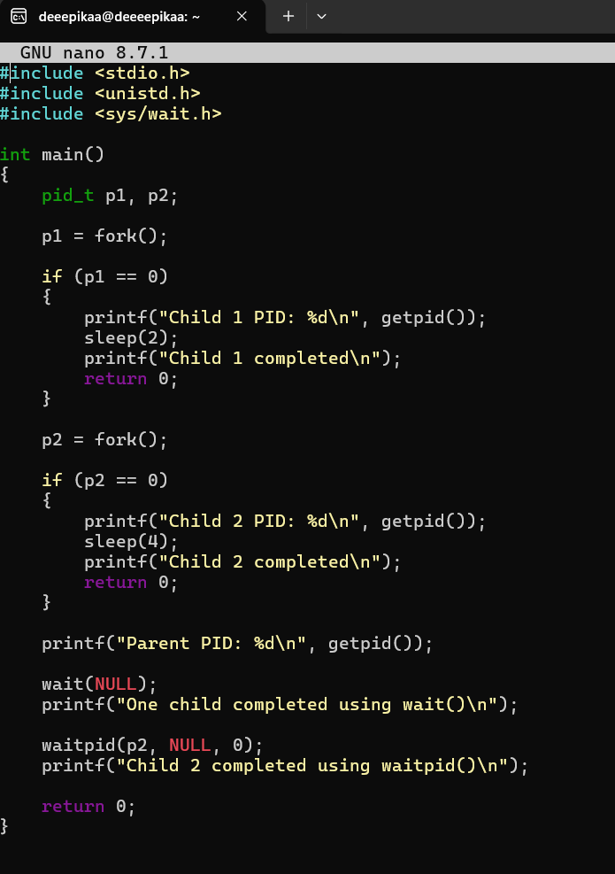

OUTPUT -