Operating Systems
2520030137
SEC-5

WEEK-5

5. Implement a producer-consumer communication system using anonymous pipes where the parent process generates data and the child process consumes it. Measure the communication efficiency.
Develop a program that executes the equivalent of the shell command: ls -l | grep ".c" using fork(), pipe(), dup2(), and exec() system calls.

Code
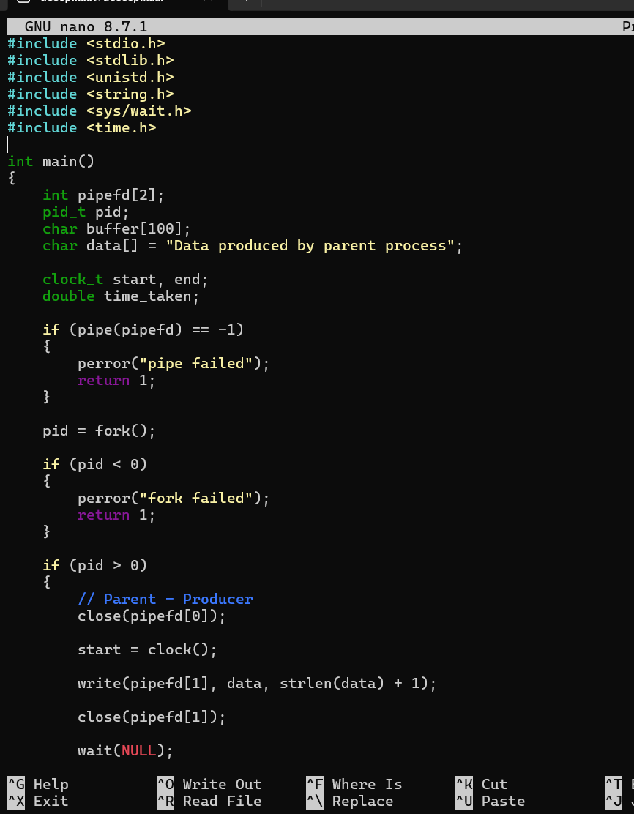
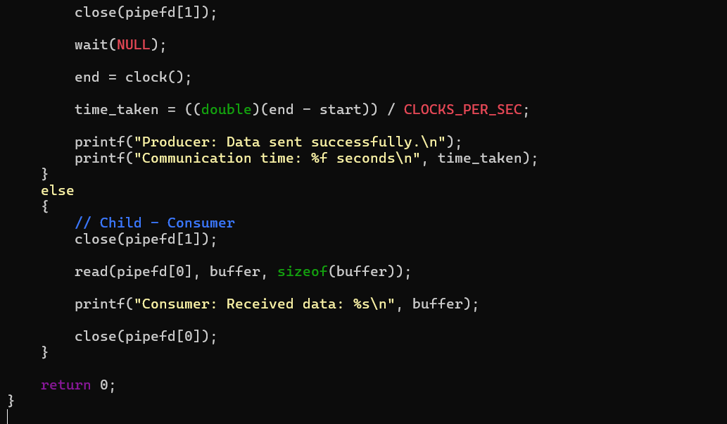
output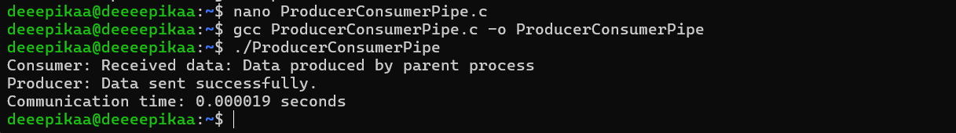
Part 2
CODE –
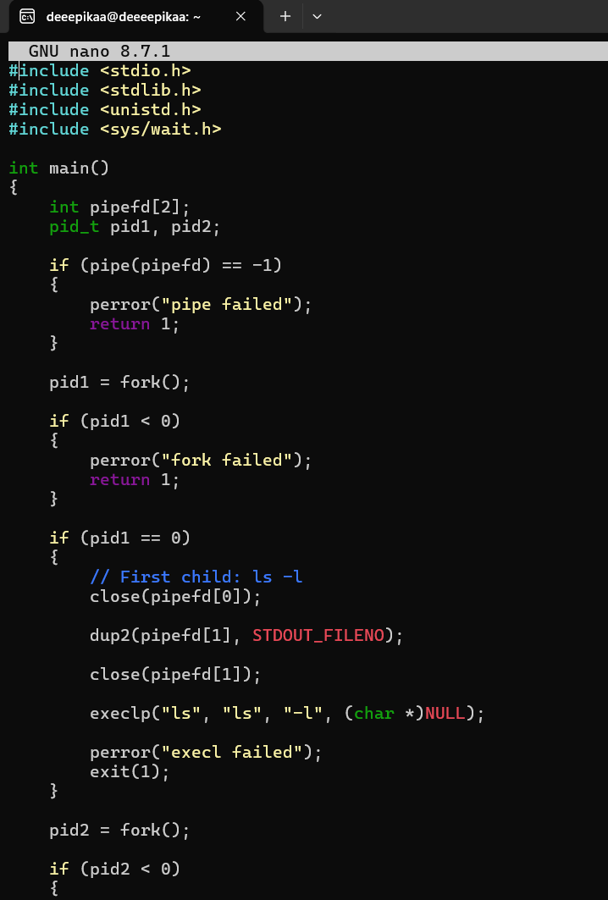
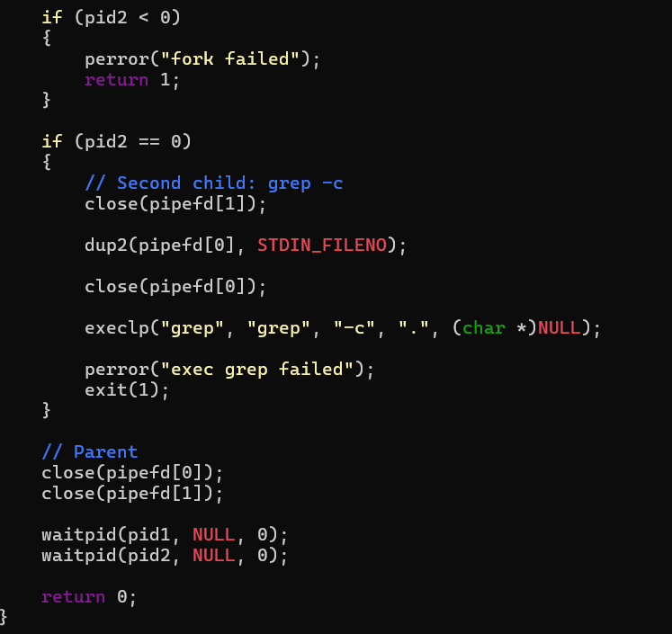
OUTPUT –
