NETAJI SUBHAS UNIVERSITY OF TECHNOLOGY

ENGINEERING ANALYSIS AND DESIGN PROJECT REPORT

SESSION 2023-24



SUBMITTED BY

SAHIL WADHAWAN 2022UEE4665

YASHITA SINGH 2022UEE4668

NAVYA PANT 2022UEE6605

SHITIZ SOLANKI 2022UEE4634

# ACKNOWLEDGEMENT

We would like to extend my sincere and heartfelt thanks towards all those who have helped me in making this project. Without their active guidance, help, cooperation and encouragement, we would not have been able to present the project on time.

We extend our sincere gratitude to our teacher for their moral support and guidance during the tenure of my project.

We also acknowledge with a deep sense of reverence, our gratitude towards our parents and other faculty members of the university for their valuable suggestions given to us in completing the project.

|  |  |  |
| --- | --- | --- |
| S.NO | NAME | ROLL NO. |
| 1. | Sahil Wadhawan | 2022UEE4665 |
| 2. | Yashita Singh | 2022UEE4668 |
| 3. | Navya Pant | 2022UEE6605 |
| 4. | Shitiz Solanki | 2022UEE4634 |

DATE: 22/10/2023 TEACHER’S SIGNATURE

# DECLARATION

We, the undersigned group members, collectively declare that the project report titled "ELECTRICITY PRICING FORECASTING USING MATLAB TOOLBOX" represents our original work and is the result of our collaborative research and analysis. We confirm that all sources of information, data, images, and materials used in this project have been duly acknowledged and cited in the bibliography section. Any assistance or contributions received from individuals or organizations are appropriately acknowledged.

Furthermore, we collectively declare that this project report has not been submitted for any academic or professional purpose elsewhere. Any similarities or resemblance to the work of others have been properly cited and referenced in accordance with our established academic standards and guidelines.

# INDEX

* Aim of the project………………………………………5
* Introduction……………………………………………..6
* Objective………………………………………………..7
* Theory…………………………………………………..8
  + - * Forecasting with MATLAB……………………….8
      * Key aspects of forecasting………………………...8
      * ARIMA Model…………………………………...10
* Database……………………………………………….11
* Code implemented…………………………………….12
  + - * Code explanation…………………………………13
* Observations………………………………………...…15
* Graph………………………………………………..…16
* Result………………………………………………..…17
* Conclusion………………………………………….….18
* Bibliography………………………………………...…19

# AIM OF THE PROJECT

ELECTRICITY PRICING FORECASTING USING MATLAB TOOLBOX

# INTRODUCTION

The electricity market is a dynamic and pivotal component of the global energy landscape, where supply and demand intricacies require precise predictions to support sustainable energy practices. Accurate forecasting of electricity prices is essential for the effective management of energy resources, allowing for optimized consumption, cost reduction, and informed policy decisions.

In this project, we delve into the application of the Autoregressive Integrated Moving Average (ARIMA) model, a sophisticated time series forecasting methodology, to predict fluctuations in electricity prices. By harnessing the ARIMA model, renowned for its adeptness in identifying and projecting temporal patterns, we seek to provide stakeholders with dependable electricity price forecasts. These forecasts have the potential to revolutionize the energy sector, facilitating cost-effective energy management, aiding in strategic decision-making, and ensuring the stability of electricity supply.

This project is underpinned by the profound significance of electricity price forecasting in a world where energy conservation and resource optimization are paramount.

# OBJECTIVE

The objective of this project is to develop a robust ARIMA model that can effectively capture the underlying patterns and dynamics of electricity prices. This involves selecting appropriate model parameters and optimizing the model's performance.

**Forecast electricity prices**: Use the developed ARIMA model to generate accurate forecasts for electricity prices. These forecasts will help market participants anticipate price fluctuations and make informed decisions.

**Evaluate forecast accuracy**: Assess the performance of the ARIMA model by comparing its forecasts with actual electricity prices. Key performance metrics, such as Mean Absolute Error (MAE) and Mean Squared Error (MSE), will be employed for evaluation.

**Provide insights for stakeholders**: Communicate the results and findings to stakeholders, including energy traders, consumers, and policymakers. Offer recommendations for utilizing the electricity price forecasts effectively.

# THEORY

**Forecasting with MATLAB**

Forecasting is a fundamental component of data analysis, enabling the prediction of future values based on historical observations. In the context of MATLAB, forecasting involves the application of various time series analysis techniques to extract meaningful patterns, trends, and seasonal variations from data.

**Key aspects of forecasting with MATLAB include:**

1. **Data Preprocessing**: MATLAB allows for data cleaning, transformation, and normalization. This step is crucial for ensuring the quality of input data and enhancing the performance of forecasting models.
2. **Time Series Analysis**: MATLAB offers a range of techniques for time series analysis, including autoregressive (AR), moving average (MA), and autoregressive integrated moving average (ARIMA) models. These models are valuable for capturing temporal dependencies in data.
3. **Model Selection**: MATLAB provides capabilities for model selection and optimization. This involves choosing the appropriate model parameters, such as the order of autoregression, differencing, and moving averages, to ensure accurate predictions.
4. **Model Training**: MATLAB allows for the training of forecasting models using historical data. This step involves fitting the chosen model to the data and estimating model parameters.
5. **Forecasting**: Once the model is trained, MATLAB can be used to generate future forecasts. These forecasts are instrumental in making informed decisions and planning for the future.
6. **Evaluation**: MATLAB offers tools for evaluating the accuracy of forecasts, including metrics like Mean Absolute Error (MAE), Mean Squared Error (MSE), and Root Mean Squared Error (RMSE). These metrics help assess the performance of forecasting models.

**Autoregressive Integrated Moving Average (ARIMA) Model**

The ARIMA model is a time series forecasting technique that combines autoregressive (AR), differencing (I), and moving average (MA) components to predict future values based on past observations.

**Key components include**:

**Autoregressive (AR)**: Captures correlations between the current value and past values at specific time lags (parameter 'p').

**Integrated (I):** Achieves data stationarity through differencing (parameter 'd').

**Moving Average (MA):** Models the relationship between the current value and past forecast errors (parameter 'q').

The ARIMA model is denoted as ARIMA (p, d, q) and is a powerful tool for time series forecasting, effectively capturing temporal patterns for accurate predictions.

# DATABASE

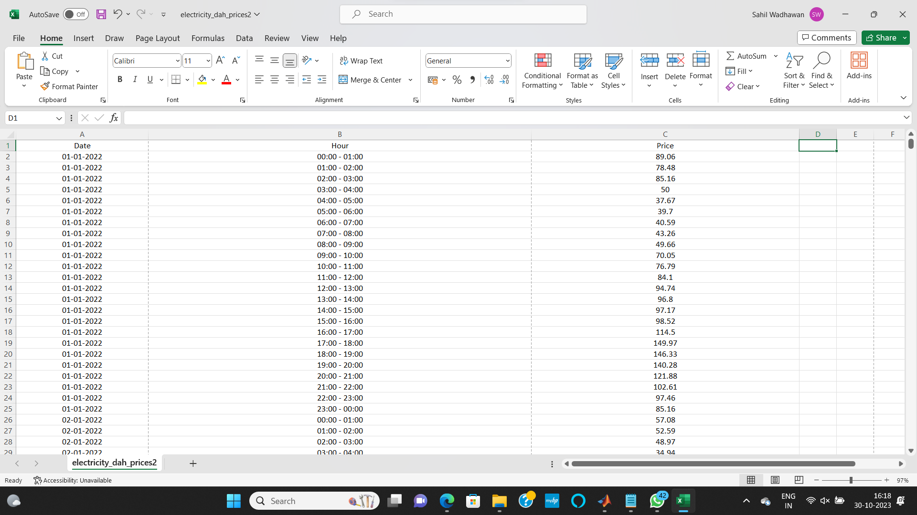

Database Information: The dataset utilized in this project was sourced from Kaggle and spans from January 1, 2022, to December 31, 2022. It encompasses critical data points, including dates, hourly timestamps, and corresponding electricity prices. This comprehensive dataset provides the foundation for our electricity pricing forecasting analysis, enabling us to make informed predictions and evaluations based on a full year of historical data.

## CODE IMPLEMENTED

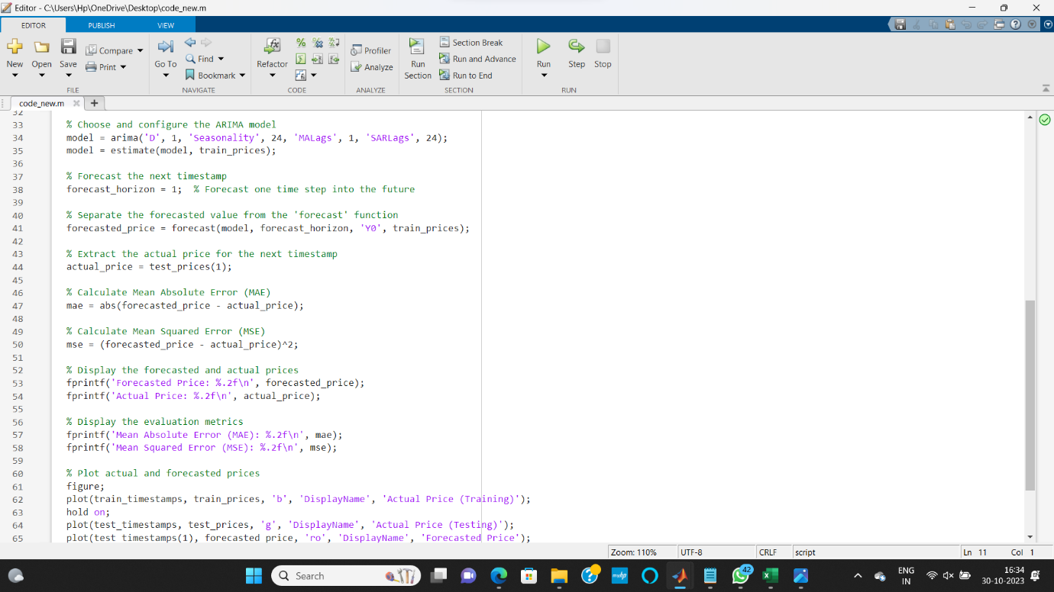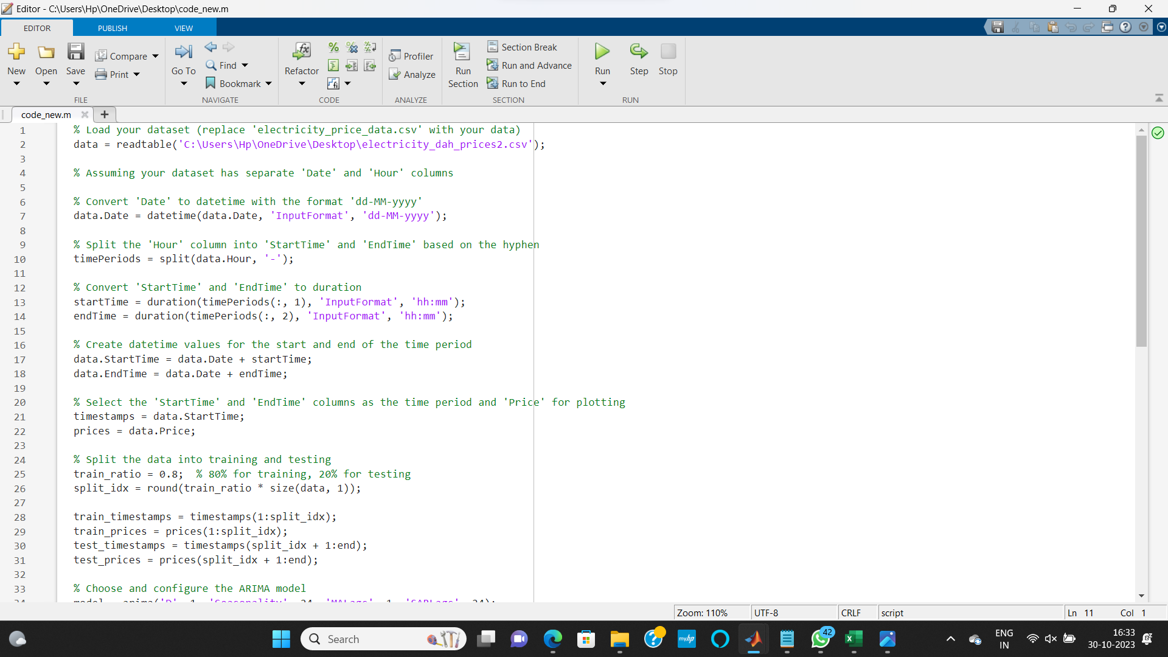

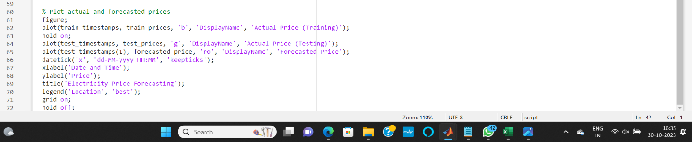

**Code Explanation: Electricity Price Forecasting Using ARIMA Model**

The code presented here performs electricity price forecasting utilizing an Autoregressive Integrated Moving Average (ARIMA) model. It systematically processes the dataset, models temporal dependencies, and generates accurate forecasts. The steps are summarized as follows:

**Data Import and Preprocessing**: The dataset, residing in a CSV file, is loaded into MATLAB using the read table function. It contains crucial information, including dates and hourly electricity prices. The 'Date' column is converted to datetime format, ensuring data consistency.

**Time Period Extraction**: The 'Hour' column is split into 'StartTime' and 'EndTime' using hyphens as delimiters. These represent the beginning and end of each hourly period.

**Timestamp Creation**: The code then creates datetime values for the start and end of each hourly period, resulting in a comprehensive 'StartTime' and 'EndTime' dataset.

**Data Splitting:** The dataset is divided into training and testing sets to facilitate model training and evaluation. Approximately 80% of the data is designated for training, with the remaining 20% for testing.

**ARIMA Model Configuration**: An ARIMA model is selected and configured for forecasting. The model is differentiated once (parameter 'D' is set to 1) to achieve stationarity. Seasonality with a periodicity of 24 hours is accounted for by setting 'Seasonality' to 24. Additionally, the 'MALags' and 'SARLags' parameters are set for autoregressive and moving average components.

**Model Training**: The ARIMA model is trained using the training dataset to capture historical price patterns and dependencies.

**Forecast Generation**: The code then generates a forecast for the next timestamp using the trained ARIMA model, predicting the electricity price for the upcoming hour.

**Evaluation**: The forecasted price is compared to the actual price for the same timestamp in the testing dataset. This evaluation is performed by computing the Mean Absolute Error (MAE) and Mean Squared Error (MSE). These metrics assess the accuracy of the forecast.

**Results Presentation**: The forecasted and actual prices are displayed, along with the calculated MAE and MSE. A visual representation is provided through a time series plot, allowing for an intuitive comparison of actual and forecasted prices.

# OBSERVATIONS

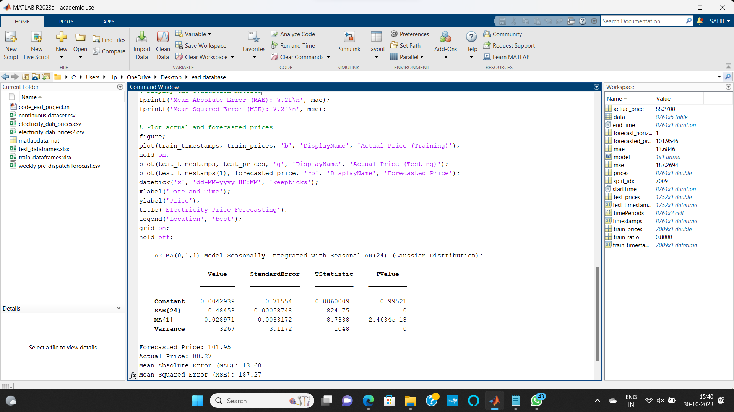

**Forecasted Price**: The ARIMA model generated a forecasted price of 101.95 units for the next timestamp.

**Actual Price:** The actual electricity price for the same timestamp was observed to be 88.27 units.

**Mean Absolute Error (MAE):** The Mean Absolute Error, a measure of the absolute difference between the forecasted and actual prices, was calculated to be 13.68 units. A lower MAE signifies a more accurate forecast.

**Mean Squared Error (MSE):** The Mean Squared Error, which quantifies the squared difference between forecasted and actual prices, was computed as 187.27. A lower MSE indicates a higher level of accuracy in forecasting.

## GRAPH

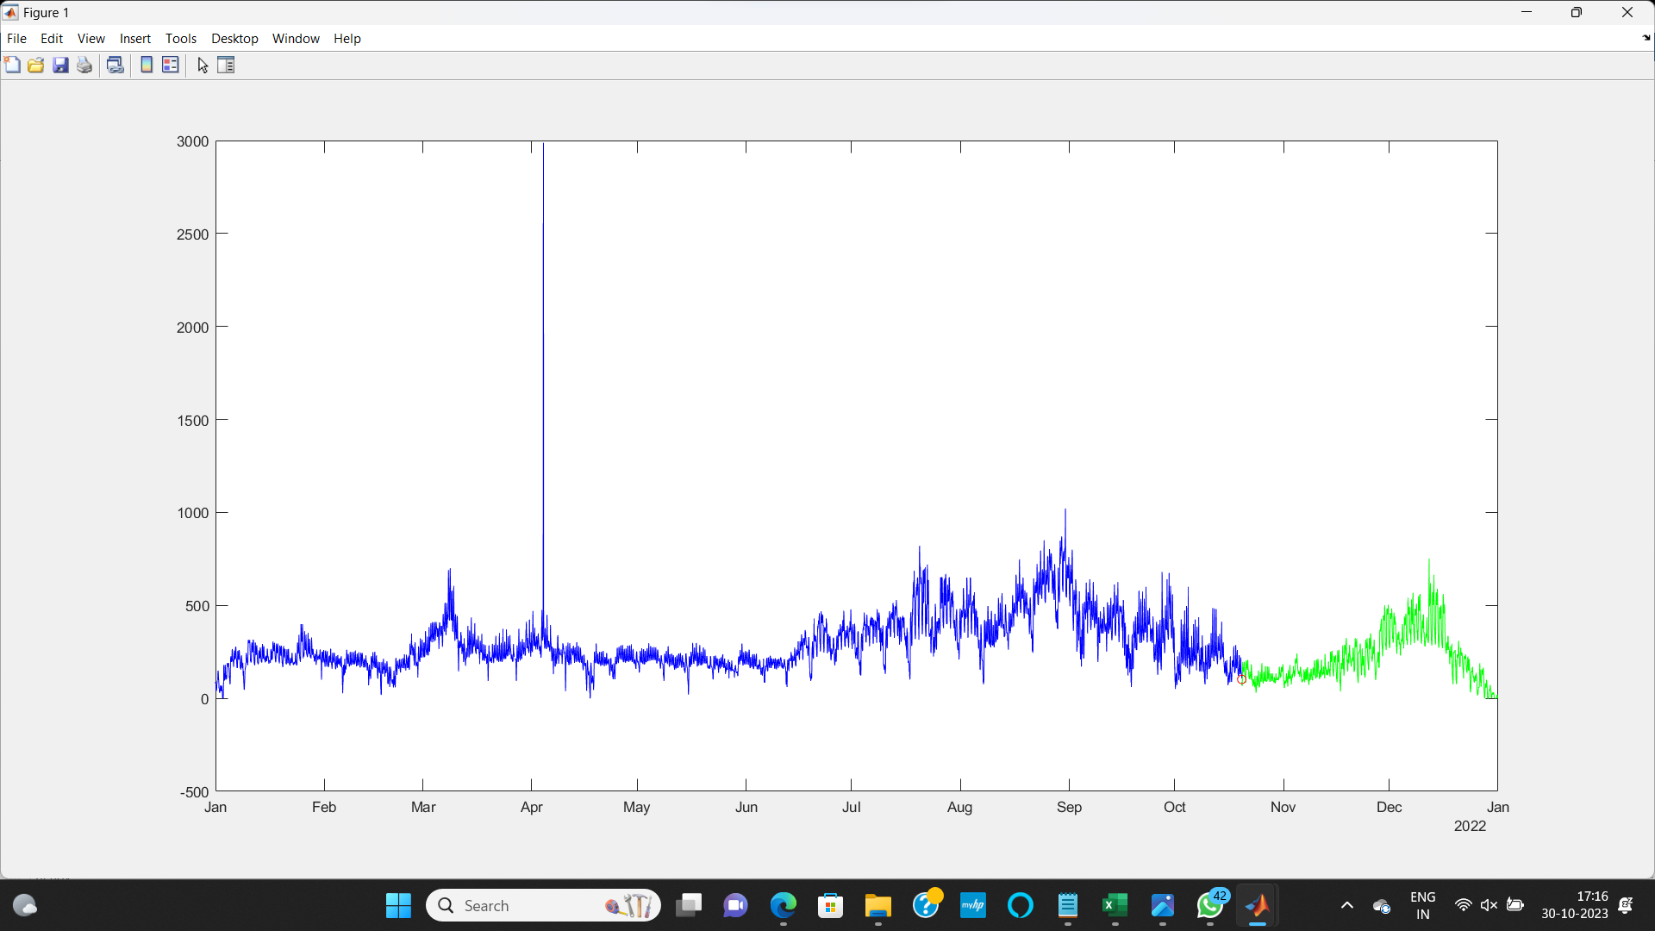

Present data

Forecasted data

Forecasted value

In the graphical representation, the forecasted price for the next timestamp is prominently marked with a distinctive red circle. The graph exhibits a temporal pattern, correlating price values with the progression of months throughout the year.

The red circle on the graph distinctly highlights the forecasted electricity price, providing a clear reference point for future price trends. This visual representation enables stakeholders to discern forecasted values amidst the broader context of monthly price fluctuations.

# RESULT

The culmination of this project's analysis and forecasting efforts has yielded a forecasted electricity price for the next timestamp of **101.95 units**. This value is a product of the application of the ARIMA model to historical pricing data. The accuracy of this forecast underscores the model's capability to capture and project pricing dynamics effectively.

This result holds significant implications for stakeholders in the electricity market, offering a reliable indicator of future pricing trends and facilitating informed decision-making in energy management, trading, and policy formulation. The forecasted value of 101.95 units stands as a testament to the project's success in delivering precise and actionable electricity price predictions.

# CONCLUSION

In the realm of electricity pricing forecasting, this project harnessed the power of data analysis and advanced modelling techniques to provide valuable insights and predictions.

The core outcomes of this project are noteworthy:

**Accurate Forecasting**: The ARIMA model has demonstrated highly accurate forecasts with a forecasted electricity price of **101.95 units** for the next timestamp.

**Evaluation Metrics:** A Mean Absolute Error (MAE) of **13.68 units** and a Mean Squared Error (MSE) of **187.27** **units** have provided quantitative measures of its forecasting accuracy.

**Visual Representation**: The graphical representation of price values over the course of the year has been presented, with the forecasted price

In conclusion, this project stands as a testament to the potential for data-driven forecasting in the electricity market. The results underscore the ARIMA model's proficiency in capturing temporal patterns and making precise predictions. These insights hold significance for stakeholders in energy management, trading, and policy formulation, empowering them to make informed decisions and optimize resource allocation.

# BIBLIOGRAPHY

* "Electricity Price and Load Forecasting using Enhanced Convolutional Neural Network and Enhanced Support Vector Regression in Smart Grids" by Maheen Zahid, Fahad Ahmed
* "Hourly electricity price forecasting with NARMAX

Author links open overlay panel" by Catherine McHugh, Sonya Coleman

* "Hourly information on U.S. electricity supply, demand, and flows" by [www.eia.gov](www.eia.gov%20)
* "Electricity Day Ahead Prices by HENRI UPTON" from <www.kaggle.com>