Day 4 – Doing Scrum – Sprint Simulation
Topics covered: Sprint Planning · Sprint Goal and Definition of Ready · Impediment Handling · Backlog Refinement · Sprint Review · Daily Stand-up for Distributed Teams

Set 2 – Airline Web Check-in – Blocked Dependency
Prepared by: Navyasree Programme: Hexaware Training Day: 4
Business Scenario | An airline's web check-in team is mid-sprint when the payment-gateway sandbox needed for the seat-upgrade story becomes unavailable.
Team and assumptions | Dev team of six: Ananya, Rohit, Divya (QA) in India (IST) and James, Emma, Oliver in London (GMT). Product Owner (PO): Karan. Scrum Master (SM): Neha.  Sprint length: 8 working days. Focus factor: 70% (the rest goes to ceremonies, support and reviews).  No past velocity is given, so the team uses the working calibration 1 story point ≈ 1 ideal focus person-day.  Jira numbers issues automatically (AWC-2, AWC-3 and so on). The team's own story IDs (AWC-201 and so on) are written at the start of each story title, and this document uses those IDs.  The outage is reported at the Day 4 stand-up. The plan below is the sprint commitment, with the blocked story handled as a known risk.

Task 1 – Team capacity and the number of points to commit
Capacity = team members × working days × focus factor.
Step | Calculation
Total person-days | 6 members × 8 days = 48 person-days
Focus (productive) person-days | 48 × 0.70 = 33.6 focus days
Capacity in story points | 33.6 focus days × 1 point per focus day = 33.6 points
Buffer for blocker, defects and support | About 10% of capacity ≈ 3.6 points
Points to commit | 30 story points (≈ 89% of capacity)

Why 30 and not 33? The gateway outage is a live risk. Committing the full 33.6 points would leave no room for rework or for the integration effort when the sandbox returns. Committing 30 keeps a small buffer and leaves the sprint honest.
Contingency: the payment-dependent part of the seat-upgrade story is about 3 points. If the sandbox is not back by Day 6, that slice moves to the next sprint and the commitment becomes 27 points, which is still inside capacity.
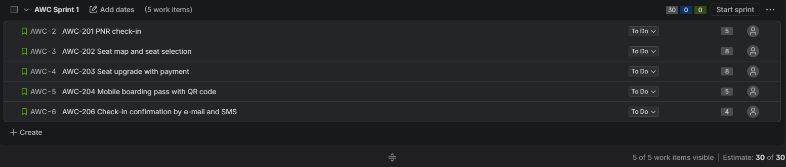
Figure 1: Jira backlog showing AWC Sprint 1 with the five selected stories and a 30-point commitment

Task 2 – Sprint Goal, selected stories and Definition of Ready
The PO's ordered backlog is pulled from the top until 30 points are reached.
ID | User story | Points | Sprint decision
AWC-201 | As a passenger, I can find my booking with a PNR and last name and start web check-in | 5 | ✔ Selected
AWC-202 | As a passenger, I can view the seat map and choose my seat | 8 | ✔ Selected
AWC-203 | As a passenger, I can pay to upgrade my seat (extra legroom / business) during check-in | 8 | ✔ Selected – at risk (payment sandbox down)
AWC-204 | As a passenger, I can get a mobile boarding pass with a QR code | 5 | ✔ Selected
AWC-206 | As a passenger, I receive a check-in confirmation by e-mail and SMS | 4 | ✔ Selected
AWC-205 | As a passenger, I can buy extra baggage during check-in | 5 | – Next sprint
AWC-207 | As a passenger, I can request special assistance (wheelchair, meal) | 3 | – Next sprint
AWC-208 | As a passenger, I can upload passport and visa details for international flights | 8 | – Next sprint
AWC-209 | As a group traveller, I can check in my whole group in one flow | 13 | – Next sprint (needs splitting)
AWC-210 | As a passenger, I get a check-in reminder 24 hours before departure | 3 | – Next sprint
 | Total selected for the sprint | 30 | = commitment

Sprint Goal: By Day 8, a passenger can check in online with a PNR, choose a seat and receive a mobile boarding pass and a confirmation message. The seat upgrade is demonstrated end to end against a contract-tested payment mock, so switching to the live gateway sandbox needs configuration changes only.

Definition of Ready check for each selected story
A story is Ready only when all six criteria are met: (1) clear value, written as a user story; (2) acceptance criteria written; (3) estimated by the team, 8 points or less; (4) dependencies available; (5) design or wireframe ready; (6) test data identified.
ID | 1. Clear value | 2. Acceptance criteria | 3. Estimated | 4. Dependencies available | 5. Design ready | Result
AWC-201 | ✔ | ✔ | ✔ 5 | ✔ | ✔ | Ready
AWC-202 | ✔ | ✔ | ✔ 8 | ✔ (seat API) | ✔ | Ready
AWC-203 | ✔ | ✔ | ✔ 8 | ✘ gateway sandbox down | ✔ | Conditionally ready: build on mock, test on live sandbox when it returns
AWC-204 | ✔ | ✔ | ✔ 5 | ✔ | ✔ | Ready
AWC-206 | ✔ | ✔ | ✔ 4 | ✔ (mail/SMS provider) | ✔ | Ready
Test data (criterion 6) is ready for all five stories: sample PNRs, flight inventory and test cards are in the QA data sheet. For AWC-203 the PO accepted the conditional Ready status because the mock follows the gateway's published API contract.

Task 3 – Impediment log and how the Scrum Master removes it

Impediment IMP-01: payment-gateway sandbox unavailable
ID / Date raised | IMP-01 / Day 4 daily stand-up (raised by Oliver, working on AWC-203)
Description | The payment-gateway sandbox returns HTTP 503 for all test calls. The vendor's status page shows "maintenance extended" with no end time. The seat-upgrade payment flow cannot be built against or tested on the real gateway.
Impact | AWC-203 (8 points, 27% of the commitment) cannot be completed or accepted as Done.  About 3 points of payment-dependent work and the payment failure-path tests (decline, timeout, refund) are blocked.  Sprint Goal at risk. Two developers lose focus time if the block continues beyond Day 5.
Owner | Neha (Scrum Master) owns removing the impediment. Emma owns the technical workaround.
Escalation path | Level 1 (now): SM raises a priority ticket with the gateway vendor support desk and asks for an ETA.  Level 2 (if no answer in 24 hours): SM escalates to the Engineering Manager, who contacts the vendor account manager.  Level 3 (if not fixed by Day 6 morning): SM and PO agree a scope decision: move the payment slice to the next sprint and keep the rest of the Sprint Goal.
Expected resolution | Vendor ETA: sandbox back within 2 working days (by Day 6 morning). Workaround ready by end of Day 5.
Status | Open – workaround in progress

Steps the Scrum Master takes to remove it
- Make it visible. Flag AWC-203 as blocked on the Jira board, create IMP-01 as an impediment issue linked to the story, and post it in the team channel so the PO and stakeholders see it the same day.
- Contact the owner of the problem. Raise the vendor ticket with the exact error, time stamps and business impact, and ask for a written ETA.
- Protect the team's focus. Agree with the team to carry on with unblocked work (AWC-201, 202, 204, 206) and not to wait idle.
- Unblock with a workaround. Emma builds a mock payment service from the gateway's API contract with success, decline and timeout responses. The story is developed and demonstrated against it.
- Time-box and escalate. Check the vendor reply at the next stand-up. Escalate to Level 2 after 24 hours and to Level 3 on Day 6 if the sandbox is still down.
- Close the loop. When the sandbox returns, run the integration tests on the live sandbox, update the log and tell the PO. Raise the dependency in the retrospective.

Impediment log
ID | Day | Impediment | Owner | Status | Next step / ETA
IMP-01 | 4 | Payment-gateway sandbox unavailable (HTTP 503) | Neha (SM) | Open | Vendor ETA Day 6 morning; mock ready end of Day 5
IMP-02 | 4 | No agreed test cases for payment failure paths without the real gateway | Divya (QA) | Open | Write cases from the vendor error-code list by Day 5
IMP-03 | 5 | Mock may not match the live gateway behaviour | Emma | Planned | Contract test when sandbox returns

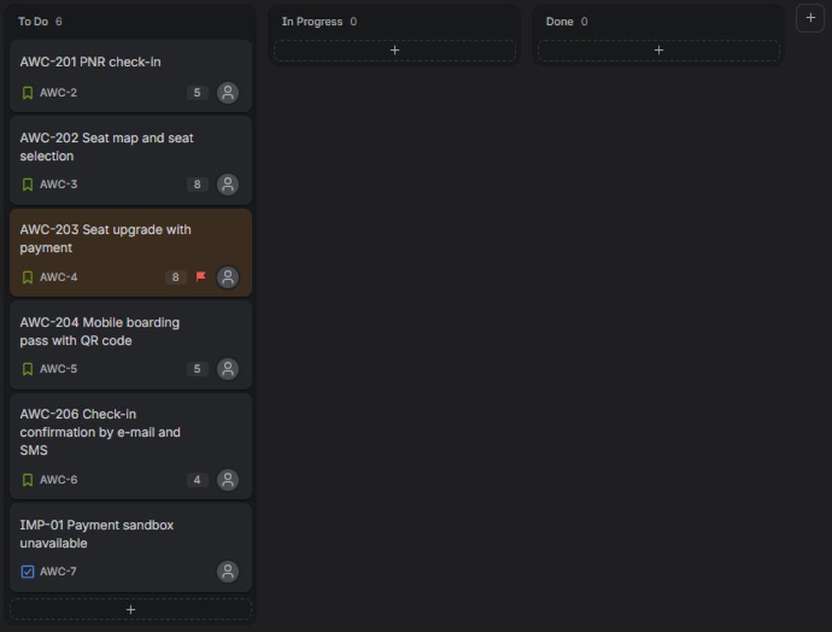
Figure 2: Jira board with AWC-203 flagged as blocked and the IMP-01 impediment task in the sprint

Task 4 – Refinement session on the next sprint's top five stories
Session | 60-minute backlog refinement on Day 5 (inside the 10% time the team keeps for refinement). Facilitator: Neha (SM). Decision-maker on content: Karan (PO). All six developers attend.
Method | Read the story, clarify acceptance criteria, estimate with planning poker (Fibonacci cards 1, 2, 3, 5, 8, 13, 21). Any story above 8 points is split before it enters a sprint.

ID | Story | Planning poker round 1 | Agreed | Outcome
AWC-205 | Extra baggage purchase | 3, 5, 5, 5, 8, 5 | 5 | Agreed after discussion. Needs the payment gateway, so it is flagged as a dependency.
AWC-207 | Special assistance request | 3, 3, 2, 3, 3, 5 | 3 | Agreed. Ready.
AWC-208 | Passport and visa upload | 8, 8, 5, 13, 8, 8 | 8 | Agreed. Largest story that can still stay whole.
AWC-209 | Group check-in | 13, 21, 13, 13, 21, 13 | 13 | Oversized. Split (see below).
AWC-210 | Check-in reminder | 2, 3, 3, 3, 2, 3 | 3 | Agreed. Ready.

Splitting the oversized story AWC-209 (13 points)
AWC-209 hides three different pieces of value, so it is split by workflow step, and each slice is something a passenger can use.
New ID | Slice | Re-estimate | Acceptance criterion (summary)
AWC-209a | Add up to 4 co-passengers from the same PNR to one check-in | 5 points | Given a PNR with 4 passengers, when the leader starts check-in, then all 4 appear and can be selected together.
AWC-209b | Seat-together allocation for the group | 5 points | Given adjacent free seats, when the group selects seats, then they are held together or the passenger is told why not.
AWC-209c | Download all group boarding passes as one bundle | 3 points | Given completed check-in, when the leader taps download, then one file with every boarding pass is produced.
 | Total after split | 13 points | Same scope, now three stories of 5 points or less
The top five now total 32 points (5 + 3 + 8 + 13 + 3), a little above a 30-point commitment. At sprint planning the PO can leave out AWC-210 or AWC-207 and the team will confirm the final number against the next sprint's real capacity.
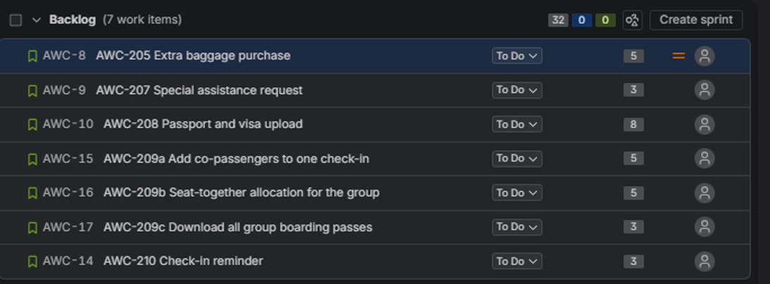
Figure 3: Jira backlog showing AWC-209 split into AWC-209a, 209b and 209c with story points (32 points in total)

Task 5 – Sprint Review agenda and demonstration script

Sprint Review agenda (60 minutes, end of Day 8)
Time | Item | Led by | Purpose
0–5 min | Welcome, Sprint Goal and attendees | Karan (PO) | Set context
5–10 min | Sprint summary: what is Done, what is not, and why | Karan (PO) | Transparency
10–40 min | Live demonstration of stories against acceptance criteria | Developers | Show working software
40–45 min | Payment-gateway impediment: impact, workaround, remaining risk | Neha (SM) | Honest status
45–55 min | Stakeholder feedback and questions | All | Inspect and adapt
55–60 min | Backlog outlook and next-sprint candidates (refined top five) | Karan (PO) | Agree next steps

Demonstration script
Rules: demo on the staging environment only, show working software and not slides, use prepared test data, and say clearly which items run on the mock. A recorded backup video is kept in case staging fails.
# | Story / presenter | Demo steps | Acceptance criterion checked | Expected result
1 | AWC-201 PNR check-in  Ananya | Open the web check-in page.  Enter PNR "AB12CD" and last name "Rao".  Then enter a wrong PNR. | Valid PNR shows the itinerary; invalid PNR shows a clear error without revealing booking data. | Itinerary appears in under 3 s; wrong PNR shows an error message.
2 | AWC-202 Seat selection  Rohit | Open the seat map for flight AI-101.  Pick seat 14C, then try an occupied seat. | Free seats are selectable; occupied seats are blocked; the choice is saved. | Seat 14C confirmed; occupied seat cannot be clicked.
3 | AWC-203 Seat upgrade  Emma | Choose an extra-legroom seat.  Pay with test card (success), then a declined test card.  State: "running on the payment mock". | Successful payment confirms the upgrade; a failed payment keeps the original seat and shows a retry message. | Success: upgraded seat + receipt. Decline: original seat kept, message shown.
4 | AWC-204 Boarding pass  Oliver | Complete check-in.  Open the mobile boarding pass and scan the QR code with the gate scanner app. | Boarding pass shows name, flight, seat and a valid QR code that scans correctly. | QR scan returns the right passenger record.
5 | AWC-206 Confirmation  James | Show the e-mail and SMS received after check-in. | Both messages arrive within 1 minute with the correct flight and seat. | E-mail and SMS received with correct details.

Items not demonstrated: live payment against the real gateway (sandbox unavailable). It is listed in the review as "ready for integration test" and is not counted as Done until the live-sandbox test passes.

Task 6 – Written (asynchronous) stand-up for two time zones, compared with a live stand-up

Set-up
Item | Agreement
Time zones | India team (Ananya, Rohit, Divya): IST. London team (James, Emma, Oliver): GMT. IST is 5½ hours ahead, so working hours overlap only from 09:00 to 13:00 GMT (14:30 to 18:30 IST).
Where | One thread per day in the team channel #awc-daily-standup. The SM opens the thread and pins the template.
When to post | Everyone posts by 10:00 in their own local time. Replies and questions are answered within 4 working hours.
Template | Yesterday – what I finished (story ID). Today – what I will finish. Blockers – use 🚩 and tag who can help. Decision needed – tag the PO or SM.
Scrum Master's role | Reads all updates at 13:00 GMT, writes a 3-line summary at the end of the thread, and calls a 15-minute live huddle in the overlap window only if a blocker needs discussion.

Written stand-up – Day 5 (sample thread)
Member | Yesterday | Today | Blockers / decisions
Ananya (IST) | Finished PNR lookup API and its unit tests (AWC-201). | Raise the pull request and fix review comments. | None.
Rohit (IST) | Seat-map component about 70% done (AWC-202). | Handle seat-conflict case when two users pick the same seat. | 🚩 Need the final seat-availability JSON format from @James.
Divya (IST, QA) | Wrote test cases for AWC-201 and AWC-202. | Run AWC-201 tests on staging. | 🚩 Cannot test payment failure paths for AWC-203 without a gateway (IMP-01, IMP-02).
James (GMT) | Built the seat-availability API (AWC-202). | Post the JSON sample by 10:30 GMT. | Decision needed from @Karan: seat-hold time 10 or 15 minutes?
Emma (GMT) | Built the mock payment service with success, decline and timeout responses (AWC-203). | Connect the seat-upgrade flow to the mock. | 🚩 Live sandbox still down (IMP-01). Vendor ticket raised, no ETA yet.
Oliver (GMT) | QR code generation for the boarding pass (AWC-204). | Boarding pass layout and PDF download. | None.
SM summary (Neha, 13:00 GMT): (1) IMP-01 stays open; Level 2 escalation goes out tomorrow morning if the vendor does not reply. (2) James will share the JSON sample, which unblocks Rohit. (3) Karan to answer the seat-hold question by end of day.

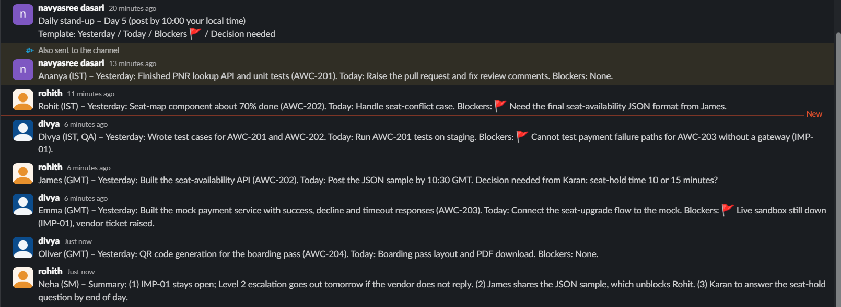
Figure 4: Slack thread in #awc-daily-standup showing the written stand-up posts (simulated team)

Comparison with a live stand-up
The live option here is one 15-minute video call at 09:30 GMT (15:00 IST), which is inside the overlap window.
Criterion | Written / asynchronous | Live (video call)
Time zone fairness | Fair: each person posts in their own morning. Nobody works outside normal hours. | Only fits the overlap. IST members join at 15:00, which breaks their afternoon focus; any other slot is unfair to one side.
Time cost | About 5 minutes to write and 5 to read, and the reading is flexible. | 15 minutes for all six at the same moment, plus waiting and late joiners.
Blocker visibility | Blockers are visible as soon as posted, but can be missed if nobody reads the thread. | Blockers are heard immediately and discussed on the spot.
Depth and clarity | Written updates are precise and searchable, but follow-up questions take hours. | Quick back-and-forth clears doubts in minutes, but updates can be vague.
Record and transparency | Permanent written record that the PO and stakeholders can read at any time. | No record unless someone takes notes.
Team connection | Weaker. Less chance to notice tone or stress. | Stronger. Faces and voices build trust.
Main risk | Copy-paste updates and silent blockers. | Turns into a status meeting and long problem-solving.

Conclusion: for a team split across IST and GMT, the written stand-up is the better daily default because it respects both time zones and leaves a record. It works best with a short live huddle in the overlap window, called by the SM only when a blocker such as IMP-01 needs a conversation, and with one live sync per week to keep the team connected.

Deliverables checklist
Deliverable | Where in this document
Impediment log | Task 3 (IMP-01 detail, removal steps, escalation path and log table)
Sprint plan | Task 1 (capacity and commitment) and Task 2 (Sprint Goal, selected stories, Definition of Ready); Task 4 (refined next-sprint backlog)
Review agenda | Task 5 (60-minute agenda and demonstration script against acceptance criteria)
Written async stand-up | Task 6 (set-up, Day 5 sample thread and comparison with a live stand-up)

