Day 3 – Agile and Scrum Foundations
Topics covered: Agile Overview · Scrum Roles, Events and Artifacts · User Stories, Backlog and Estimation

Set 3 – Hospital Appointment Booking Application
Prepared by: Navyasree Programme: Hexaware Training Day: 3
Business Scenario | A hospital group wants a mobile application for booking, rescheduling and cancelling doctor appointments, with reminder notifications.
Assumptions | The product is called MediBook. The name is chosen for this exercise.  The task names four epics: Booking, Rescheduling and Cancellation (kept together as one epic, as the task lists them), Reminders and Doctor Schedule Management.  Patients already have an account, so registration is out of scope. Payments are out of scope.  A patient can cancel or move an appointment up to 2 hours before it starts. Appointment slots are 15 minutes long.  Reminders are sent by SMS and e-mail 24 hours before the appointment.  No team details were supplied, so roles are described by title and not by person.  Story IDs (APT-101 and so on) are the team's own IDs. Jira numbers issues automatically, so the team ID is written at the start of each story title.

Task 1 – Vision statement and stakeholders

Vision statement
For patients who lose time on phone queues and crowded reception counters when they book, change or cancel a doctor's appointment, MediBook is a mobile app that lets them book, move or cancel an appointment in a few taps and reminds them before the visit.
Unlike calling the hospital front desk, our product shows live doctor availability across the hospital group and helps the hospital reduce missed appointments.

Stakeholders mapped to Scrum roles
Stakeholder | Interest in MediBook | Mapped to
Head of Patient Services (hospital group) | Owns the business result and decides what is built first. | Product Owner
Agile delivery lead | Coaches the team in Scrum, runs the events and removes blockers. | Scrum Master
Mobile and back-end developers, testers, UI designer | Build, test and deliver the app each sprint. | Developers
Patients and their families | Book, change and cancel quickly and get reminders. | Customer (end user)
Doctors | Publish working hours and leave, and see their day's appointments. | Customer (end user)
Reception staff | See free slots and help walk-in patients. | Customer (end user)
Compliance and data-protection officer | Patient data must stay private and secure. | Customer (business stakeholder). Their rules are included in the Definition of Ready and Done.

Task 2 – Epics and 14 user stories
Epic | Name | Goal
E1 | Booking | A patient can find a doctor and book a free slot.
E2 | Rescheduling and Cancellation | A patient can see, move or cancel an appointment, and reception can use freed slots.
E3 | Reminders | Patients are reminded so they do not miss appointments.
E4 | Doctor Schedule Management | Doctors control the hours and dates on which patients can book.

ID | Epic | User story (first draft)
APT-101 | E1 | As a patient, I want a good search experience for finding doctors, so that I can easily find the right doctor.
APT-102 | E1 | As a patient, I want to see a doctor's available time slots for a chosen date, so that I can pick a time that suits me.
APT-103 | E1 | As a patient, I want to book an available slot and receive a booking ID, so that I know my appointment is fixed.
APT-104 | E1 | As a patient, I want to book an appointment for a family member, so that I can arrange care for my parents or children.
APT-201 | E2 | As a patient, I want to see my upcoming appointments, so that I can manage them.
APT-202 | E2 | As a patient, I want to reschedule my appointment by cancelling it with the cancel feature and booking a new slot with the booking feature, so that I can change my visit.
APT-203 | E2 | As a patient, I want to cancel an appointment, so that the slot is released for someone else.
APT-204 | E2 | As a receptionist, I want a cancelled slot to show as available as soon as it is cancelled, so that I can offer it to a walk-in patient.
APT-301 | E3 | As a patient, I want to get a reminder at a suitable time before my appointment, so that I do not forget.
APT-302 | E3 | As a patient, I want to get an e-mail reminder using the same reminder service built for the SMS reminder, so that I have a second reminder.
APT-303 | E3 | As a patient, I want to turn reminders on or off in the app settings, so that I control how I am contacted.
APT-401 | E4 | As a doctor, I want to set my weekly working hours and slot length, so that patients can only book the times I work.
APT-402 | E4 | As a doctor, I want to block out dates when I am on leave, so that no new appointments are booked on those days.
APT-403 | E4 | As a doctor, I want to see my day's appointment list with patient names and reasons for the visit, so that I can prepare.

Task 3 – INVEST review and rewriting weak stories
Every story was checked against all six INVEST criteria. The task asks to rewrite stories that are not independent (I) or not testable (T). Five stories fail.
ID | I | N | V | E | S | T | Result
APT-101 | ✔ | ✔ | ✔ | ✔ | ✔ | ✘ | Fails T. "Good search experience" cannot be tested.
APT-102 | ✔ | ✔ | ✔ | ✔ | ✔ | ✔ | Passes all six criteria.
APT-103 | ✔ | ✔ | ✔ | ✔ | ✔ | ✔ | Passes all six criteria.
APT-104 | ✔ | ✔ | ✔ | ✔ | ✔ | ✔ | Passes all six criteria.
APT-201 | ✔ | ✔ | ✔ | ✔ | ✔ | ✔ | Passes all six criteria.
APT-202 | ✘ | ✔ | ✔ | ✔ | ✔ | ✔ | Fails I. It needs the cancel and booking stories to be built first.
APT-203 | ✔ | ✔ | ✔ | ✔ | ✔ | ✔ | Passes all six criteria.
APT-204 | ✘ | ✔ | ✔ | ✔ | ✔ | ✔ | Fails I. It depends on the cancel story (APT-203).
APT-301 | ✔ | ✔ | ✔ | ✔ | ✔ | ✘ | Fails T. "A suitable time" is not measurable.
APT-302 | ✘ | ✔ | ✔ | ✔ | ✔ | ✔ | Fails I. It depends on a service built in another story.
APT-303 | ✔ | ✔ | ✔ | ✔ | ✔ | ✔ | Passes all six criteria.
APT-401 | ✔ | ✔ | ✔ | ✔ | ✔ | ✔ | Passes all six criteria.
APT-402 | ✔ | ✔ | ✔ | ✔ | ✔ | ✔ | Passes all six criteria.
APT-403 | ✔ | ✔ | ✔ | ✔ | ✔ | ✔ | Passes all six criteria.

Rewritten stories
ID | Failed | Problem | Rewritten story
APT-101 | T | "Good search experience" has no pass or fail test. | As a patient, I want to search doctors by specialty and hospital location and see results within 2 seconds, showing name, specialty, hospital and fee, so that I can choose a doctor quickly.
APT-202 | I | It is built from two other stories, so it cannot be built or tested alone. | As a patient, I want to move my appointment to another free slot of the same doctor in one step, so that my old slot is released and the new slot is held for me.
APT-204 | I | It depends on the cancel story, so it cannot be tested until APT-203 is done. | As a receptionist, I want to see the list of free slots for a doctor today, so that I can offer a free slot to a walk-in patient.
APT-301 | T | "A suitable time" cannot be checked. | As a patient, I want to receive an SMS 24 hours before my appointment showing the doctor, date, time and hospital, so that I do not miss it.
APT-302 | I | It depends on a reminder service built in another story. | As a patient, I want to receive an e-mail 24 hours before my appointment showing the doctor, date, time and hospital, so that I do not miss it.
The rewritten stories are used for the rest of this document. Stories that passed are unchanged.

Task 4 – Acceptance criteria for booking and cancellation
Scenarios marked (Negative) cover failures. The required "slot already taken" case is APT-103, scenario 2.

APT-103 – Book an available slot and get a booking ID
Scenario | Given | When | Then
1. Successful booking | A logged-in patient is viewing a free 10:30 slot with Dr Rao for tomorrow | They select the slot and tap Confirm | The appointment is saved, the slot shows as booked, a booking ID is displayed and an SMS confirmation is sent.
2. Slot already taken (Negative) | Two patients are viewing the same 10:30 slot and the first patient has already confirmed it | The second patient taps Confirm | No booking is created. The message "Sorry, this slot has just been taken. Please choose another" is shown, and the slot list refreshes to show only free slots for the same doctor and date.
3. Clash with own appointment (Negative) | The patient already has an appointment at 10:30 with another doctor | They try to book a 10:30 slot | The booking is blocked and a message explains that they already have an appointment at that time.

APT-104 – Book an appointment for a family member
Scenario | Given | When | Then
1. Booking for a family member | The patient has added "Ravi (father)" to their profile | They book a free slot and choose Ravi as the patient | The appointment shows Ravi's name, and the booking ID and confirmation go to the account holder.
2. Missing member details (Negative) | The patient has chosen "Book for someone else" and left the name empty | They tap Continue | The message "Please enter the patient's name and age" is shown and the booking does not continue.

APT-203 – Cancel an appointment
Scenario | Given | When | Then
1. Successful cancellation | The patient has a booked appointment tomorrow at 10:30 | They tap Cancel and confirm | The status changes to Cancelled, the slot is released for other patients and an SMS confirmation is sent.
2. Too late to cancel (Negative) | The appointment starts in 1 hour, which is inside the 2-hour limit | The patient taps Cancel | The message "Appointments cannot be cancelled within 2 hours. Please call the hospital" is shown and the appointment stays Booked.
3. Keep the appointment | The patient is on the cancel confirmation screen | They tap Keep appointment | Nothing changes and the appointment stays Booked.

APT-204 – See today's free slots for a doctor (reception)
Scenario | Given | When | Then
1. Free slots shown | Dr Rao has 3 free slots and 5 booked slots today | The receptionist opens today's free slot list | The 3 free slots are listed with their times and the booked slots are not shown.
2. Doctor on leave (Negative) | Dr Rao is marked on leave today | The receptionist opens the free slot list | The message "Doctor is on leave today" is shown and no slots are listed.

Task 5 – Business value versus effort, Planning Poker and story points

Business value, effort and the reference story
Business value is scored from 1 (low) to 5 (high) by the Product Owner. Effort is the story point estimate from Planning Poker (cards 1, 2, 3, 5, 8, 13). Reference story: APT-102 View a doctor's available slots = 3 points. It is well understood and every other story is compared with it.
ID | Story | Value | Points | Reason for the points (compared with APT-102)
APT-101 | Search doctors | 5 | 3 | One search screen over doctor data. Similar to 102.
APT-102 | View free slots | 5 | 3 | Reference story.
APT-103 | Book a slot | 5 | 5 | The slot must be locked so two patients cannot book it, then saved and confirmed.
APT-104 | Book for family member | 3 | 3 | Adds a person choice and a small form to the booking flow.
APT-201 | My upcoming appointments | 4 | 2 | A simple list of the patient's own appointments.
APT-202 | Move an appointment | 4 | 5 | Releases the old slot and holds the new one together, with the same clash checks as booking.
APT-203 | Cancel an appointment | 5 | 3 | Status change, slot release, 2-hour limit and an SMS.
APT-204 | Today's free slots (reception) | 3 | 2 | A read-only list of free slots that reuses the slot data.
APT-301 | SMS reminder | 5 | 5 | A scheduled job and an SMS provider connection. See the discussion below.
APT-302 | E-mail reminder | 3 | 3 | A scheduled e-mail with its own template.
APT-303 | Reminder on or off | 2 | 2 | One saved setting that is checked before sending.
APT-401 | Doctor weekly hours | 5 | 5 | Creates the slot calendar from weekly hours and slot length. See the discussion below.
APT-402 | Doctor leave dates | 4 | 3 | Blocks a date range and hides those slots.
APT-403 | Doctor's day list | 3 | 3 | A list of the day's appointments with patient name and reason.
 | Total backlog size |  | 47

Planning Poker round
The Developers each pick a card in secret and all cards are shown together. If the numbers differ, the highest and the lowest voters explain their reasons and the team votes again until they agree.
Story | Round 1 votes | Round 2 votes | Discussion
APT-301 SMS reminder | 3, 5, 5, 5, 8 | 5, 5, 5, 5, 5 | The voter with 3 thought a scheduled job is quick. The voter with 8 pointed out that the SMS provider connection, failed sends and time zones add work. The team agreed on 5.
APT-401 Doctor weekly hours | 3, 5, 5, 8, 8 | 5, 5, 5, 5, 5 | The voters with 8 worried about overlapping working hours and changing the slot length later. The team agreed that changing slot length later is out of this story, so they settled on 5.
The votes above are a sample of how the discussion is recorded.

How a story point differs from an hour
Aspect | Story point | Hour
What it measures | The relative size of the work: effort, complexity and uncertainty, compared with a reference story. | A fixed amount of clock time.
Depends on who does it | No. A story is 5 points whoever builds it. | Yes. A senior and a new joiner take different hours.
How reliable it is | Quick to agree and stays steady over time. | Looks exact, but is often wrong for new work.
Used for | Velocity and forecasting how many sprints the backlog needs. | Timesheets and task plans.
Example: APT-103 (Book a slot) is 5 points because it is bigger than the reference story APT-102 (3 points) and has locking to handle. One developer may need 6 hours for it and another 14 hours, but the story is still 5 points. After a few sprints the team sees how many points it finishes in a sprint (its velocity) and can forecast from that. The backlog is 47 points. If the velocity is about 18 points per sprint (an assumption, as none was given), that is about 3 sprints.

Prioritised backlog
The order uses business value first, then effort, then dependencies (doctors' hours must exist before patients can book). High priority stories make up the first usable release: find a doctor, book, view and cancel, get an SMS reminder, and publish working hours. Medium priority stories improve it. Low priority stories can wait.
Rank | ID | Story | Epic | Value | Points | Value ÷ points | Priority | Running total
1 | APT-401 | Set doctor weekly hours | E4 | 5 | 5 | 1.0 | High | 5
2 | APT-101 | Search doctors | E1 | 5 | 3 | 1.7 | High | 8
3 | APT-102 | View free slots | E1 | 5 | 3 | 1.7 | High | 11
4 | APT-103 | Book a slot | E1 | 5 | 5 | 1.0 | High | 16
5 | APT-201 | My upcoming appointments | E2 | 4 | 2 | 2.0 | High | 18
6 | APT-203 | Cancel an appointment | E2 | 5 | 3 | 1.7 | High | 21
7 | APT-301 | SMS reminder | E3 | 5 | 5 | 1.0 | High | 26
8 | APT-202 | Move an appointment | E2 | 4 | 5 | 0.8 | Medium | 31
9 | APT-402 | Doctor leave dates | E4 | 4 | 3 | 1.3 | Medium | 34
10 | APT-104 | Book for family member | E1 | 3 | 3 | 1.0 | Medium | 37
11 | APT-204 | Today's free slots (reception) | E2 | 3 | 2 | 1.5 | Medium | 39
12 | APT-302 | E-mail reminder | E3 | 3 | 3 | 1.0 | Low | 42
13 | APT-403 | Doctor's day list | E4 | 3 | 3 | 1.0 | Low | 45
14 | APT-303 | Reminder on or off | E3 | 2 | 2 | 1.0 | Low | 47
 |  | Total |  |  | 47
Points per epic: E1 Booking = 14, E2 Rescheduling and Cancellation = 12, E3 Reminders = 10, E4 Doctor Schedule Management = 11 (total 47).

Task 6 – Backlog in JIRA, Definition of Ready and Definition of Done

How the backlog was published in JIRA
- A Scrum project named "MediBook" was created in Jira.
- The four epics were created: Booking, Rescheduling and Cancellation, Reminders and Doctor Schedule Management.
- The 14 stories were created with their team ID in the title, linked to their epic, given story points and ordered by the rank in Task 5.
- The board has four states: To Do, In Progress, In Review and Done.
- Sprint 1 holds the top five stories (18 points) with the Sprint Goal: "A patient can find a doctor, see free slots, book an appointment and view it in the app."

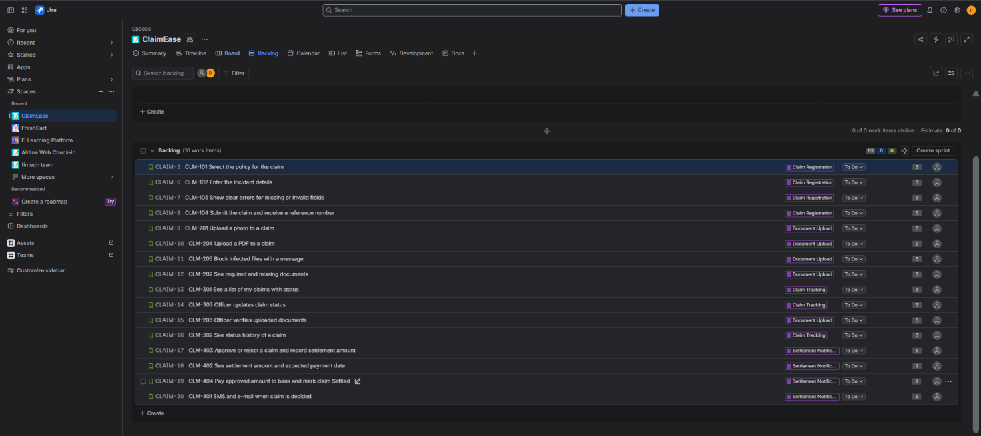
Figure 1: Jira Backlog view with epics, stories and story points
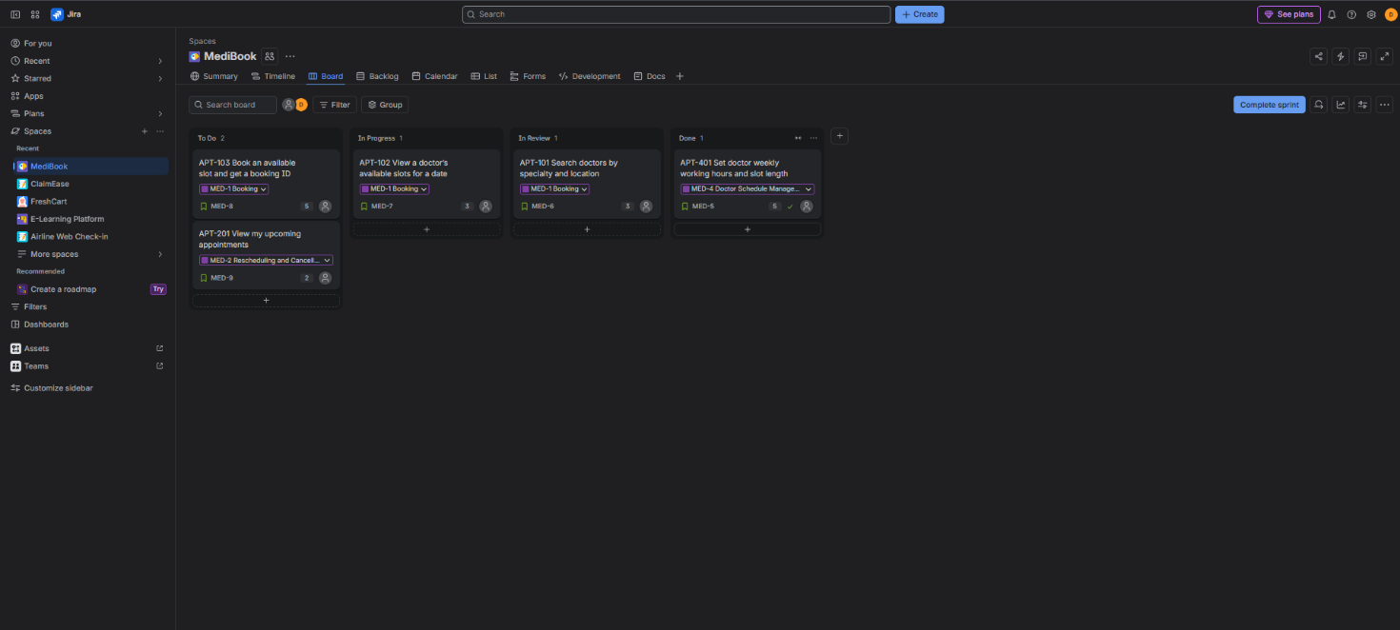
Figure 2: Jira board with Sprint 1

Definition of Ready (DoR) checklist
A story is ready for sprint planning only when all of these are true:
# | Criterion
1 | The story is written as As a / I want / so that, and it passes the INVEST checklist.
2 | Acceptance criteria are written in Given / When / Then form, including at least one negative scenario.
3 | The Developers have estimated it with Planning Poker, and it is 8 points or less.
4 | The Product Owner has prioritised it and agrees the business value.
5 | Dependencies are known and available (for example, the SMS provider test account and the doctor schedule data).
6 | Screen designs for the mobile app exist where the story has a user interface.
7 | Open questions are answered, and any patient-data privacy rule that applies is identified.

Definition of Done (DoD) checklist
A story is done only when all of these are true. Partly done work does not move to the Done column.
# | Criterion
1 | The code is written, follows the coding standard and the pull request is reviewed and approved by a second developer.
2 | Unit tests are written and pass, and new code has at least 80% test coverage.
3 | Every acceptance criterion is tested and passes, including the negative scenarios (for example, slot already taken).
4 | There are no open critical or major defects for the story.
5 | The code is merged, built and deployed to the test environment, and the regression tests still pass.
6 | Patient data is protected: it is encrypted in storage and in transit, and no patient details appear in logs.
7 | The feature works on the latest Android and iOS test devices.
8 | Documentation is updated, and the Product Owner has reviewed the story in a demo and accepted it. Only then does the card move to Done.

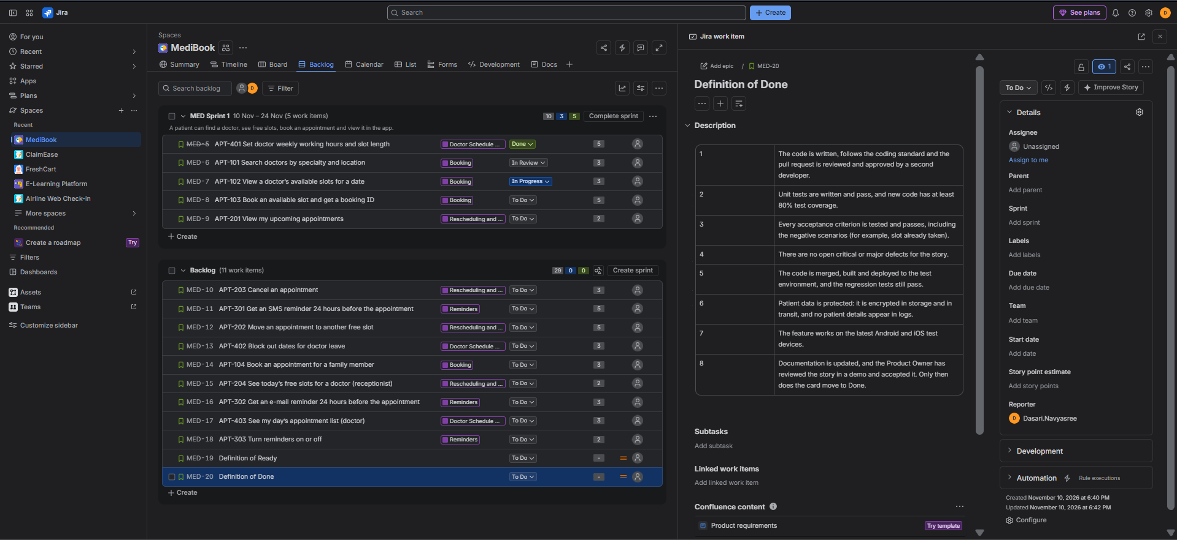
Figure 3.1: Definition of Ready recorded in Jira
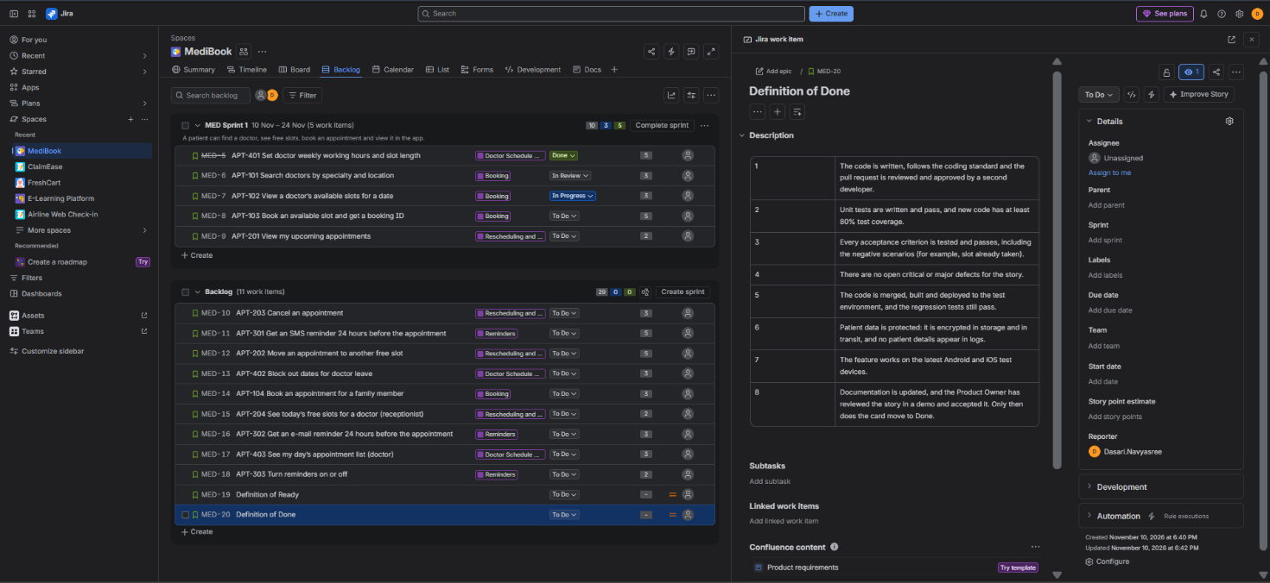
Figure 3: Definition of Done recorded in Jira

Deliverables checklist
- Prioritised backlog – Task 5, Prioritised backlog table.
- JIRA board screenshot – Figures 1 and 2.
- DoR and DoD checklist – Task 6, with Figure 3 as the Jira record.

