Day 3 – Agile and Scrum Foundations
Topics covered: Agile Overview · Scrum Roles, Events and Artifacts · User Stories, Backlog and Estimation

Set 1 – Online Grocery Delivery Application
Prepared by: Navyasree Programme: Hexaware Training Day: 3
Business Scenario | A regional supermarket chain is launching a grocery ordering and home-delivery application. Management wants an estimated, prioritised backlog before the first sprint begins.
Assumptions | The product is called FreshCart, and the Jira project key is GRO. Both names are chosen for this exercise.  No team details were supplied, so roles are described by title (Product Owner, Scrum Master, Developers) and not by person.  Customers pay in rupees (₹) using UPI, cards or net banking, and they log in with a mobile number and OTP.  Story points use the Fibonacci scale (1, 2, 3, 5, 8, 13) and are agreed by the Developers using Planning Poker.  Story IDs (GRO-101 and so on) are the team's own IDs. Jira will number the issues automatically, so the IDs are written at the start of each story title.

Task 1 – Product vision and Scrum roles

Product vision statement
For busy households in our region who want fresh groceries without a trip to the store, FreshCart is a mobile and web grocery application that delivers a chosen basket to the door in a time slot the customer picks.
Unlike general delivery marketplaces, our product is backed by the supermarket's own stock and prices, so what the customer sees is in stock and priced as on the shelf.
The statement follows the standard vision template (For, who, is a, that, unlike, our product). It states who the customer is, the need, the product and what makes it different.

The three Scrum roles and one anti-pattern for each
Role | Responsibility | In FreshCart | Anti-pattern and the better practice
Product Owner (PO) | Owns the product vision and the Product Backlog. Orders it by value and makes sure the team understands each item. | A category or e-commerce manager from the supermarket who decides what customers get first (for example, checkout before coupons). | Anti-pattern: the proxy PO. The PO has no authority and must ask management for every decision, so the team waits days for an answer.  Better: one empowered PO who decides priorities and is available to the team daily.
Scrum Master (SM) | Coaches the team and the organisation in Scrum, runs the events when needed and removes impediments. | Helps the team protect the sprint, for example by chasing a missing payment-gateway test account. | Anti-pattern: the SM as project manager. The SM assigns tasks, demands status reports and decides how the work is done.  Better: a servant-leader who coaches and removes blockers, while the team decides how to work.
Developers | Self-managing, cross-functional people who build a usable, tested Increment each sprint. | App developers, back-end developers, testers and a UI designer who together deliver a story to Done. | Anti-pattern: silos and hand-offs. Developers finish coding and "throw it over the wall" to testers in the last two days, or wait for a manager to assign tasks.  Better: the team plans together, tests from the start and pulls work themselves.

Task 2 – Epics and 12 user stories
Four epics cover the full customer journey from finding a product to receiving the order. Each epic is broken into three user stories, giving 12 stories in the format As a / I want / so that.
Epic | Name | Goal
E1 | Browse and Search | The customer can find the right products quickly.
E2 | Cart and Checkout | The customer can collect items, apply an offer and pay securely.
E3 | Delivery and Tracking | The customer chooses when the order arrives and knows where it is.
E4 | Customer Account and Orders | The customer can log in, keep their details and repeat past orders.

ID | Epic | User story (first draft)
GRO-101 | E1 | As a shopper, I want to browse products by category (fruits, vegetables, dairy, staples), so that I can find what I need without typing.
GRO-102 | E1 | As a shopper, I want the search to be fast and user-friendly, so that I can find products easily.
GRO-103 | E1 | As a shopper, I want to see a product's photo, price, pack size and stock status, so that I can decide whether to buy it.
GRO-201 | E2 | As a shopper, I want to add, change and remove items in my cart and see the running total, so that I can control my basket before paying.
GRO-202 | E2 | As a shopper, I want to apply a coupon code to my cart, so that I can get the discount offered by the store.
GRO-203 | E2 | As a shopper, I want to pay for my order online using UPI, cards or net banking and receive a confirmation, so that I can complete my purchase.
GRO-301 | E3 | As a shopper, I want to pick a delivery slot at checkout, so that the order arrives when I am at home.
GRO-302 | E3 | As a shopper, I want to track my order live on a map, so that I know exactly when it will arrive.
GRO-303 | E3 | As a shopper, I want to get a notification when my order status changes, so that I do not need to keep checking the app.
GRO-401 | E4 | As a new customer, I want to register and log in with my mobile number and an OTP, so that I can place orders without remembering a password.
GRO-402 | E4 | As a customer, I want to save my delivery addresses, so that I do not retype them for every order.
GRO-403 | E4 | As a customer, I want to see my past orders and reorder them in one tap, so that my regular shopping takes less time.

Task 3 – INVEST check and rewriting weak stories
Letter | Meaning | Question asked of each story
I – Independent | Can be built and delivered on its own | Can the team build it without waiting for another story?
N – Negotiable | Details can be discussed | Does the story leave room for discussion instead of fixing the solution?
V – Valuable | Gives value to a user or the business | Is the "so that" benefit clear?
E – Estimable | The team can size it | Does the team know enough to estimate it?
S – Small | Fits inside one sprint | Can one or two developers finish it in a few days?
T – Testable | Can be proven done | Can we write a clear pass or fail test for it?

ID | I | N | V | E | S | T | Result
GRO-101 | ✔ | ✔ | ✔ | ✔ | ✔ | ✔ | Passes all six criteria.
GRO-102 | ✔ | ✔ | ✔ | ✔ | ✔ | ✘ | Fails T. "Fast" and "user-friendly" cannot be tested.
GRO-103 | ✔ | ✔ | ✔ | ✔ | ✔ | ✔ | Passes all six criteria.
GRO-201 | ✔ | ✔ | ✔ | ✔ | ✔ | ✔ | Passes all six criteria.
GRO-202 | ✔ | ✔ | ✔ | ✔ | ✔ | ✔ | Passes all six criteria.
GRO-203 | ✔ | ✔ | ✔ | ✔ | ✘ | ✔ | Fails S. Three payment methods plus confirmation are too big for one story.
GRO-301 | ✔ | ✔ | ✔ | ✔ | ✔ | ✔ | Passes all six criteria.
GRO-302 | ✔ | ✔ | ✔ | ✘ | ✘ | ✔ | Fails E and S. Live map needs a rider app and a map service that are not chosen yet.
GRO-303 | ✔ | ✔ | ✔ | ✔ | ✔ | ✔ | Passes all six criteria.
GRO-401 | ✔ | ✔ | ✔ | ✔ | ✔ | ✔ | Passes all six criteria.
GRO-402 | ✔ | ✔ | ✔ | ✔ | ✔ | ✔ | Passes all six criteria.
GRO-403 | ✔ | ✔ | ✔ | ✔ | ✔ | ✔ | Passes all six criteria.
Three stories fail the checklist: GRO-102, GRO-203 and GRO-302. They are rewritten below. The rewritten versions are used for the rest of this document.
ID | Problem found | Rewritten story
GRO-102 | Not testable. "Fast" and "easy" have no measure, so nobody can say if the story is done. | As a shopper, I want to search products by name and see matching results within 2 seconds, so that I can find items quickly.
GRO-203 | Too big. UPI, cards and net banking are three integrations in one story, so it cannot finish in one sprint. | As a shopper, I want to pay for my order using UPI and see an order confirmation, so that I can complete checkout securely.  Card and net-banking payments are split into a new later story (GRO-204).
GRO-302 | Not estimable and too big. A live map depends on a rider app and a map provider that have not been decided. | As a shopper, I want to see my order's status (Packed, Out for delivery, Delivered) with an estimated arrival time, so that I know when to be home.  The live map is split into a new later story (GRO-304).

Task 4 – Acceptance criteria (Given / When / Then)
Acceptance criteria are written for five stories. Every story has a positive scenario, and the scenarios marked (Negative) cover what happens when something goes wrong.

GRO-401 – Register and log in with mobile number and OTP
Scenario | Given | When | Then
1. Successful login | A customer is on the login screen and has entered a valid mobile number | They enter the correct 6-digit OTP received by SMS within 5 minutes | They are logged in and see the home screen. A new number gets an account created automatically.
2. Wrong OTP (Negative) | A customer has requested an OTP | They enter an incorrect OTP | The message "Incorrect OTP, please try again" is shown and the customer stays on the OTP screen. After three wrong tries, the OTP is blocked for 15 minutes.

GRO-102 – Search products by name
Scenario | Given | When | Then
1. Matching results | The catalogue contains "Basmati Rice 1 kg" | The shopper searches for "rice" | Products with "rice" in the name are shown within 2 seconds, each with photo, price and pack size.
2. No results (Negative) | The catalogue has no product named "xyzabc" | The shopper searches for "xyzabc" | The message "No products found for xyzabc" is shown, with links to the main categories.

GRO-201 – Manage items in the cart
Scenario | Given | When | Then
1. Add an item | The shopper is viewing an in-stock product | They tap Add | The item appears in the cart with quantity 1 and the cart total is updated.
2. Change quantity | The cart has Milk 500 ml at ₹30 with quantity 1 | The shopper increases the quantity to 3 | The line total shows ₹90 and the cart total is updated.
3. Stock limit (Negative) | Only 5 packs of an item are in stock | The shopper tries to set the quantity to 6 | The quantity stays at 5 and the message "Only 5 available" is shown.

GRO-203 – Pay with UPI and see confirmation
Scenario | Given | When | Then
1. Successful payment | The cart total is ₹450 and a delivery slot is selected | The shopper pays with UPI and approves the request in their UPI app | The payment is marked successful, an order number is created and a confirmation is shown and sent by SMS.
2. Failed payment (Negative) | The shopper is on the payment step | The UPI payment fails or is declined | No order is created, the cart is kept as it was, and the message "Payment failed" is shown with the options Retry or Choose another method.

GRO-302 – See order status and estimated arrival
Scenario | Given | When | Then
1. Status update | A customer has placed an order | The store marks the order as Packed | The order screen shows the status Packed with the time of the update.
2. Estimated arrival | The order status is Out for delivery | The customer opens the order screen | The screen shows the status and an estimated arrival window, for example 6:00 to 7:00 PM.
3. Delay (Negative) | The order is still on the way after the estimated window ends | The customer opens the order screen | The status shows "Running late" with a new estimated arrival time.

Task 5 – MoSCoW, story points and Planning Poker

Reference story and Planning Poker
Reference story: GRO-101 Browse products by category = 3 points. It was chosen because the team understands it well: it lists categories from the catalogue and shows the products in a grid. It has no external integration and low risk, and it is neither trivial nor large. Every other story is compared with it ("is this bigger or smaller than browsing by category, and by how much?").
Each Developer picks a Fibonacci card (1, 2, 3, 5, 8, 13) in secret and all cards are shown together. If the numbers differ, the highest and the lowest voters explain their reasons and the team votes again until they agree. A sample round is shown below for the biggest story.
Story | Round 1 votes | Round 2 votes | What the discussion found
GRO-203 Pay with UPI | 5, 8, 8, 8, 13 | 8, 8, 8, 8, 8 | The voter with 13 pointed out the security checks and failure handling. The voter with 5 had assumed the gateway SDK does most of the work. After discussion the team agreed on 8.

Estimates and reasons
ID | Story | Points | Reason (compared with GRO-101)
GRO-101 | Browse by category | 3 | Reference story. Well understood, no integration, low risk.
GRO-102 | Search by name | 5 | More than 101: needs a search query, empty-result handling and the 2-second target.
GRO-103 | Product details | 2 | Simpler than 101: shows data for one product that the catalogue already holds.
GRO-201 | Manage cart | 5 | Add, change, remove, running total, stock-limit checks and a cart that is saved.
GRO-202 | Apply coupon | 3 | Rules to check (valid, expired, minimum order) but only one new screen field. Similar to 101.
GRO-203 | Pay with UPI | 8 | Largest story: payment gateway, security, success and failure handling, order creation and SMS. High uncertainty.
GRO-301 | Delivery slot | 5 | Slots per store, capacity limits and cut-off times need store data.
GRO-302 | Order status and ETA | 3 | Shows status values on one screen with an estimated time. No map.
GRO-303 | Status notifications | 3 | Uses the existing SMS/push service, but has several status events to cover.
GRO-401 | OTP register and login | 5 | SMS provider, OTP expiry and retry limits, and automatic account creation.
GRO-402 | Saved addresses | 3 | Simple add, edit and delete form with validation. Similar to 101.
GRO-403 | Order history and reorder | 5 | A history list, plus reorder must check current price and stock and touch the cart.
 | Total | 50

MoSCoW prioritisation
Category | Stories | Points | Why
Must have | GRO-401, 101, 102, 103, 201, 402, 301, 203 | 36 | Without these a customer cannot log in, find products, order, pay and choose a delivery time. The launch fails without them.
Should have | GRO-302, 403 | 8 | Important and expected, but the first release still works without them for a short time.
Could have | GRO-303 | 3 | Useful. Customers can check the status in the app, so notifications can wait.
Won't have (this release) | GRO-202, and the split-off GRO-204 (card and net banking) and GRO-304 (live map) | 3 | A marketing feature and later improvements. They are agreed with the PO to wait for a later release.

Prioritised product backlog
The backlog is ordered by MoSCoW category first, and inside a category by dependency (for example, a customer must log in and save an address before a slot and payment make sense).
Rank | ID | Story | Epic | MoSCoW | Points | Cumulative points
1 | GRO-401 | Register and log in with OTP | E4 | Must | 5 | 5
2 | GRO-101 | Browse products by category | E1 | Must | 3 | 8
3 | GRO-102 | Search products by name | E1 | Must | 5 | 13
4 | GRO-103 | View product details | E1 | Must | 2 | 15
5 | GRO-201 | Manage items in the cart | E2 | Must | 5 | 20
6 | GRO-402 | Save delivery addresses | E4 | Must | 3 | 23
7 | GRO-301 | Pick a delivery slot | E3 | Must | 5 | 28
8 | GRO-203 | Pay with UPI and get confirmation | E2 | Must | 8 | 36
9 | GRO-302 | See order status and ETA | E3 | Should | 3 | 39
10 | GRO-403 | Order history and reorder | E4 | Should | 5 | 44
11 | GRO-303 | Order status notifications | E3 | Could | 3 | 47
12 | GRO-202 | Apply a coupon code | E2 | Won't (this release) | 3 | 50
 |  | Total |  |  | 50
Points per epic: E1 = 10, E2 = 16, E3 = 11, E4 = 13 (total 50).

Task 6 – JIRA board with Definition of Ready and Definition of Done

How the board was set up
- A Scrum project named "FreshCart" (key GRO) was created in Jira.
- The four epics (E1 to E4) were created and given different colours.
- The 12 stories were created with their text, linked to their epic, given story points and ordered in the Backlog by the rank in Task 5. The MoSCoW category is stored as a label (Must, Should, Could, Wont).
- The board columns are To Do, In Progress, In Testing and Done. A card moves to Done only when it meets the Definition of Done below.
- The Definition of Ready and the Definition of Done are written as a team agreement and linked from the project.

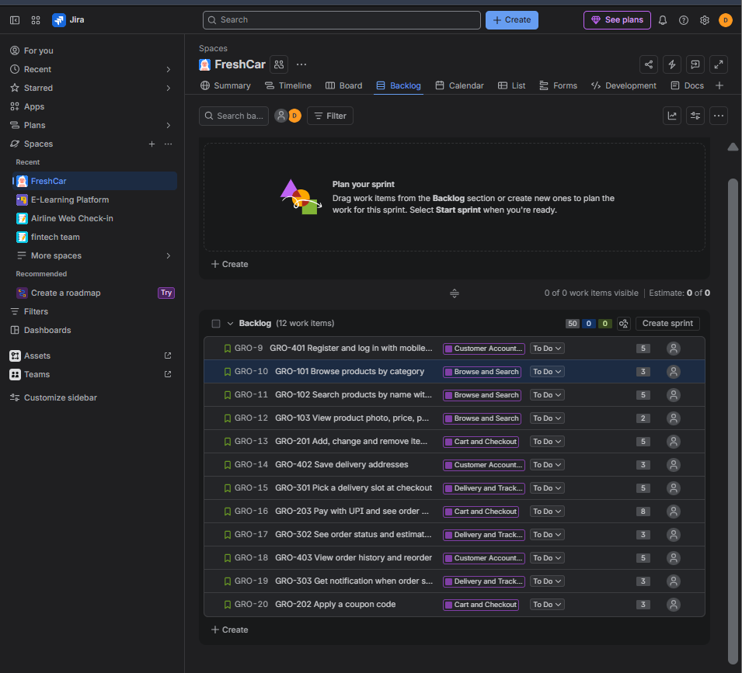
Figure 1: Jira Backlog view with epics, stories and story points
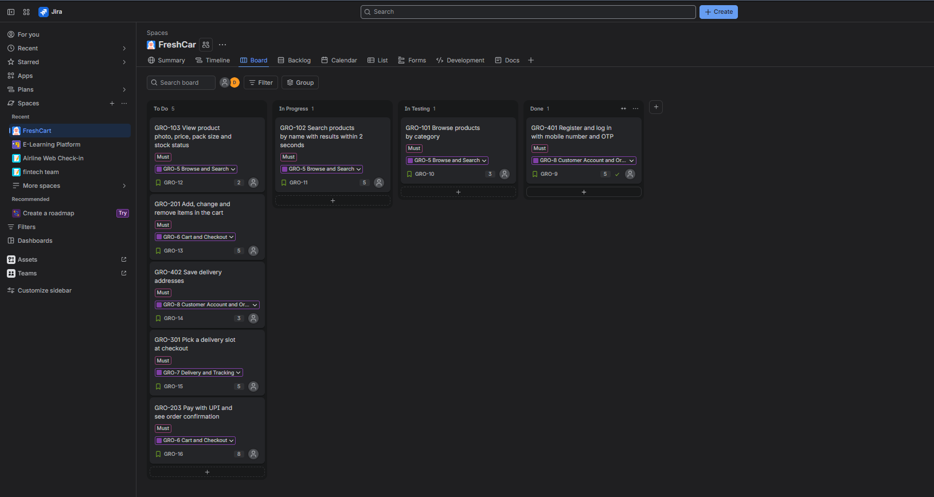
Figure 2: Jira board with the Sprint 1 stories

Definition of Ready (DoR)
A story is ready to be taken into sprint planning only when all of these are true:
# | Criterion
1 | The story is written as As a / I want / so that, and it passes the INVEST checklist.
2 | Acceptance criteria are written in Given / When / Then form, including at least one negative scenario.
3 | The Developers have estimated it with Planning Poker, and it is 8 points or less.
4 | The Product Owner has set its priority and agrees the "so that" value.
5 | Dependencies are known and available (for example, the payment gateway test account and the SMS provider).
6 | Screen designs or mock-ups exist where the story has a user interface.
7 | Open questions have been answered by the Product Owner.

Definition of Done (DoD)
A story is done only when all of these are true. Partly done work does not move to the Done column.
# | Criterion
1 | The code is written, follows the coding standard and is peer reviewed.
2 | Unit tests are written and pass.
3 | Every acceptance criterion of the story has been tested and passes.
4 | There are no open critical or major defects for the story.
5 | The code is merged, built and deployed to the test environment, and regression tests still pass.
6 | Security and performance targets of the story are met (for example, search results within 2 seconds, and no card or UPI details stored by the app).
7 | Documentation is updated (API notes and release notes).
8 | The Product Owner has reviewed the story and accepted it.

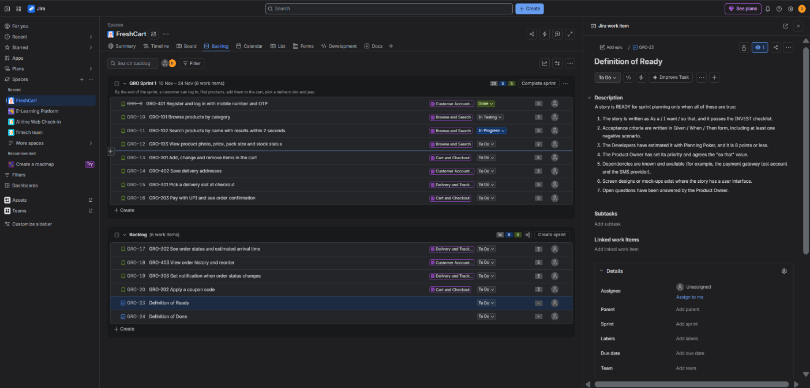
Figure 3: Definition of ready recorded in Jira
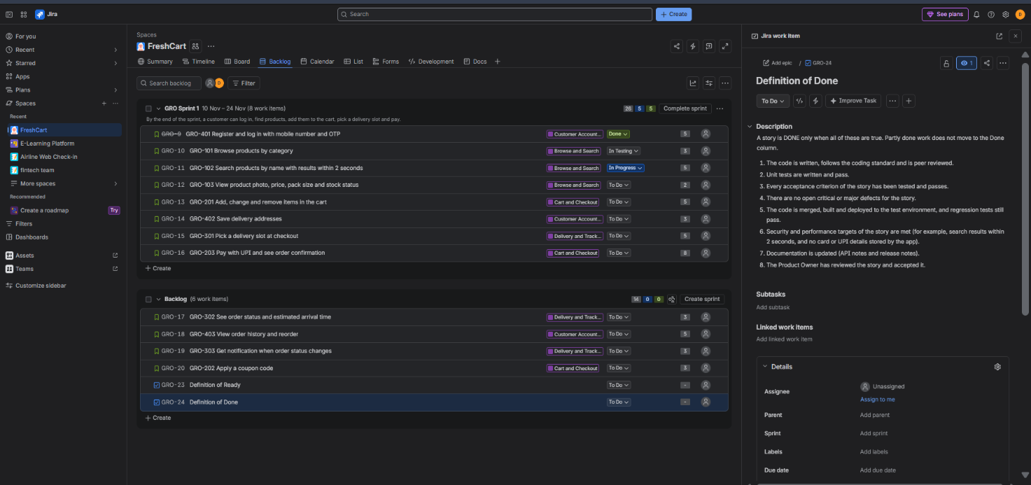
Figure 3: Definition of done recorded in Jira

Deliverables checklist
- Screenshot of the Jira board and backlog – Figures 1 and 2.
- Backlog table with story, priority and points – Task 5, Prioritised product backlog.
- DoR/DoD document – Task 6, with Figure 3 as the Jira record.

