Day 4 – Doing Scrum – Sprint Simulation
Topics covered: Sprint Planning · Scope Change Handling · Daily Stand-up and Impediments · Velocity · Retrospective · Definition of Done and Automation

Set 3 – E-Learning Platform – Scope Change Handling
Prepared by: Navyasree Programme: Hexaware Training Day: 4
Business Scenario | An e-learning company's team is on day 6 of a 10-day sprint when the Product Owner asks for a 'certificate download' feature for an upcoming launch.
Team and assumptions | Dev team of five: Meena, Suresh, Kavya, Imran (tech lead), Tara. Product Owner (PO): Rahul. Scrum Master (SM): Lakshmi.  Team velocity is 30 story points per 10-day sprint, so about 3 points per sprint day.  No backlog was supplied with the task, so a sample backlog of an e-learning platform is used (Task 1).  Jira numbers issues automatically (ELP-2, ELP-3 and so on). The team's own story IDs (ELP-301 and so on) are written at the start of each story title, and this document uses those IDs.  A story counts toward velocity only when it fully meets the Definition of Done.

Task 1 – Sprint plan and Sprint Goal
The team's velocity is 30 points, so the sprint forecast is 30 points. The PO's ordered backlog is pulled from the top until 30 points are reached, and the team does not stretch beyond the forecast.
ID | User story | Points | Sprint 1 decision
ELP-301 | As a learner, I can register and log in with e-mail or Google | 5 | ✔ Selected
ELP-302 | As a learner, I can browse and search the course catalogue | 5 | ✔ Selected
ELP-303 | As a learner, I can enrol in a free or paid course | 8 | ✔ Selected
ELP-304 | As a learner, I can watch video lessons and resume where I stopped | 8 | ✔ Selected
ELP-306 | As a learner, I can see my progress on a dashboard | 4 | ✔ Selected
ELP-305 | As a learner, I can take a quiz after each module with auto-scoring | 5 | – Next (would take the sprint to 35)
ELP-307 | As a learner, I can post in a discussion forum for each course | 8 | –
ELP-308 | As a learner, I can rate and review a course | 3 | –
ELP-309 | As a learner, I get e-mail reminders for unfinished courses | 2 | –
ELP-310 | As a learner, I get a polished mobile-responsive layout | 5 | –
 | Total selected for the sprint | 30 | = velocity

Sprint Goal: By Day 10, a new learner can register, find a course, enrol in it and watch its video lessons with progress saved, on a stable staging build that is ready for the launch demo, and every selected story meets the Definition of Done.

Why this goal: it describes the first complete learner journey the launch needs. It does not depend on any single story, so a small change inside the sprint can happen without changing the goal.
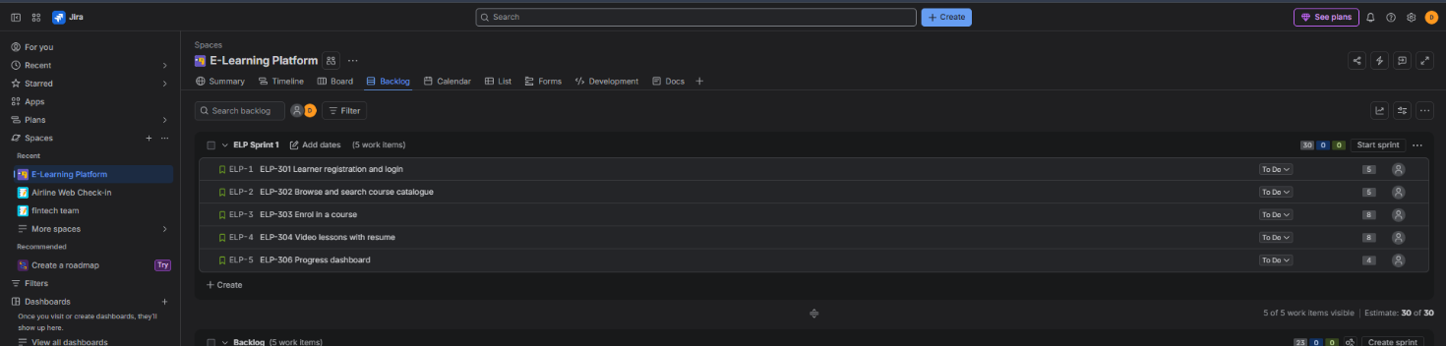
Figure 1: Jira backlog showing the sprint with five selected stories and a 30-point commitment

Task 2 – Impact of the 'certificate download' request on the sprint

Where the sprint stands on Day 6
ID | Story | Points | % complete | Remaining effort (points)
ELP-301 | Registration and login | 5 | 100% (Done) | 0
ELP-302 | Course catalogue | 5 | 100% (Done) | 0
ELP-303 | Enrol in a course | 8 | 60% | 3.2
ELP-304 | Video lessons | 8 | 50% | 4.0
ELP-306 | Progress dashboard | 4 | 0% (not started) | 4.0
 | Total | 30 |  | 11.2

Capacity left: 4 sprint days remain (Days 7 to 10), which is 4 ÷ 10 × 30 = 12 points of capacity. Remaining committed effort is 11.2 points, so the buffer is only 0.8 points. The sprint is already nearly full.

The new request
After a short refinement with the developers, ELP-311 Certificate download is estimated at 4 points: generate a PDF certificate with the learner's name, course title, completion date and a verification code, and add a download button on the course-completion screen.

Options considered
Option | Effect on the sprint | Decision
A. Add it and remove nothing | Remaining effort becomes 11.2 + 4 = 15.2 points against 12 of capacity: overcommitted by 3.2 points. Quality or the Sprint Goal would suffer. | Rejected
B. Swap: add ELP-311 and move ELP-306 out | ELP-306 (4 points, not started) goes back to the top of the backlog. Remaining effort stays 11.2 points, so the sprint stays at 30 points with the same 0.8 buffer. | Chosen
C. Say no, certificates go to the next sprint | Sprint untouched, but the launch needs the feature, so the business value is delayed. | Fallback if the swap is not accepted
D. Cancel the sprint | Only allowed if the Sprint Goal becomes obsolete. It has not. | Rejected

Question | Answer
What can be swapped out | ELP-306 Progress dashboard (4 points). It has not started, so no work is wasted. It is not needed for the Sprint Goal. The certificate only needs a "course completed" flag, which ELP-304 already records when all lessons are finished, so the dependency is covered.
What must wait | ELP-306 (dashboard), and the extras around certificates: e-mailing the certificate, sharing to LinkedIn, instructor-designed templates. These stay in the backlog for the next sprint, with ELP-306 at the top.
How the Sprint Goal is protected | The Sprint Goal (register, find, enrol, watch) does not change. Certificates are added without touching the stories that deliver it.  The rule is "nothing comes in unless something goes out", so the sprint stays at 30 points.  Only the smallest version of the certificate is built: a PDF with a download button.  The Definition of Done stays the same for ELP-311. It is not shortened to save time.  If ELP-311 is at risk on Day 8, it is the first item dropped, not the Sprint Goal stories. The PO and SM review this at the Day 8 stand-up.
Who decides | PO (Rahul) decides the swap and the new order. Developers estimate the 4 points and confirm it fits. SM (Lakshmi) facilitates the discussion, protects the team from extra scope and records the change. The sponsor is informed through the PO.

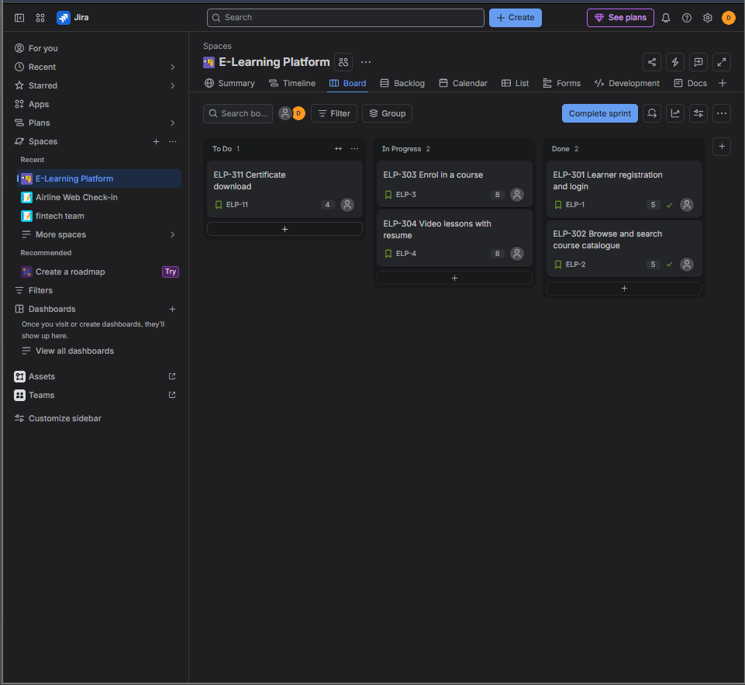
Figure 2: Jira board on Day 6 after the change: ELP-311 added to the sprint, ELP-306 moved back to the backlog

Task 3 – Stand-up statements: developer blocked on a missing API contract
Day 7 stand-up. Kavya has started ELP-311 and needs data from the course-completion API, but the platform team has not shared the contract.
Part | Developer statement – Kavya
Yesterday | I finished the certificate PDF template with sample data (name, course, date, verification code) for ELP-311.
Today | I planned to connect the download button to the course-completion API and test with a real completed course.
Impediment | I am blocked: the contract for the course-completion API (endpoint, fields, authentication and error codes) has not been shared. I have been guessing the JSON structure. I need it by 12:00 today, or the story will not finish by Day 10. This affects ELP-311 (4 points).

Scrum Master's follow-up action (Lakshmi)
# | Action | Owner | When
1 | Log the impediment (IMP-01: course-completion API contract missing) with its impact on ELP-311, and flag the story on the board. | Lakshmi (SM) | Right after stand-up
2 | Contact the API owner (platform lead) and ask for a draft contract (OpenAPI/Swagger file) by 12:00. | Lakshmi | Within 15 minutes
3 | Set up a 15-minute call between Kavya and the API owner to agree fields and error codes, then record the agreed contract. | Lakshmi, Kavya | Before 14:00
4 | Meanwhile Kavya builds against a mock service based on the draft contract, so she keeps working. | Kavya | Today
5 | If there is no contract by end of day, escalate to the Engineering Manager and tell the PO that ELP-311 is at risk. | Lakshmi | End of Day 7
6 | Raise "API contracts must exist before a story starts" in the retrospective. | Lakshmi | Retrospective

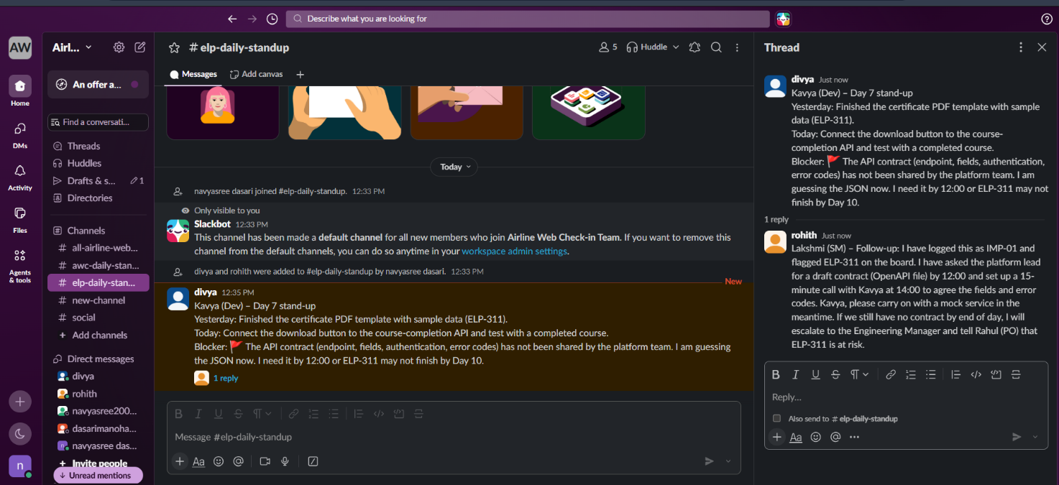
Figure 3: Slack thread in #elp-daily-standup: the blocked stand-up update and the Scrum Master follow-up (simulated team)

Task 4 – Velocity calculation with a partially done story
Completed-points table at the end of Day 10:
ID | Story | Points | Status at sprint end | Meets DoD? | Points counted
ELP-301 | Registration and login | 5 | Done | Yes | 5
ELP-302 | Course catalogue | 5 | Done | Yes | 5
ELP-303 | Enrol in a course | 8 | Done | Yes | 8
ELP-311 | Certificate download | 4 | Done | Yes | 4
ELP-304 | Video lessons | 8 | 80% done | No | 0
ELP-306 | Progress dashboard | 4 | Moved out on Day 6 | – | –
 | Sprint velocity |  |  |  | 22

Velocity = 5 + 5 + 8 + 4 = 22 story points. The forecast was 30, so the team completed 22 ÷ 30 = 73% of its forecast.

How the partially done story (ELP-304, 80% done) is counted
- It counts as 0 points this sprint. Velocity only counts stories that fully meet the Definition of Done. Work that is "almost done" cannot be released, tested by users or demonstrated as finished, and it carries hidden risk.
- The 80% is still useful information, but it is not velocity. About 6.4 points of effort were spent. It is shown in the sprint review and the burndown, and it tells the team the story was too big.
- What happens next: ELP-304 returns to the top of the backlog. The team re-estimates only the remaining work (for example 2 points) and that remaining piece is counted in the sprint where it is finished. Some teams credit the full 8 points when the story is finally Done instead. Either method is fine as long as the team agrees on it beforehand and applies it every time.
- Why not count 80%: if partial credit were allowed, velocity would be inflated, the next forecast would be too high, and the team would overcommit again.
Forecast for the next sprint: using the average of the last two sprints, (30 + 22) ÷ 2 = 26 points, which is a safer commitment than 30.
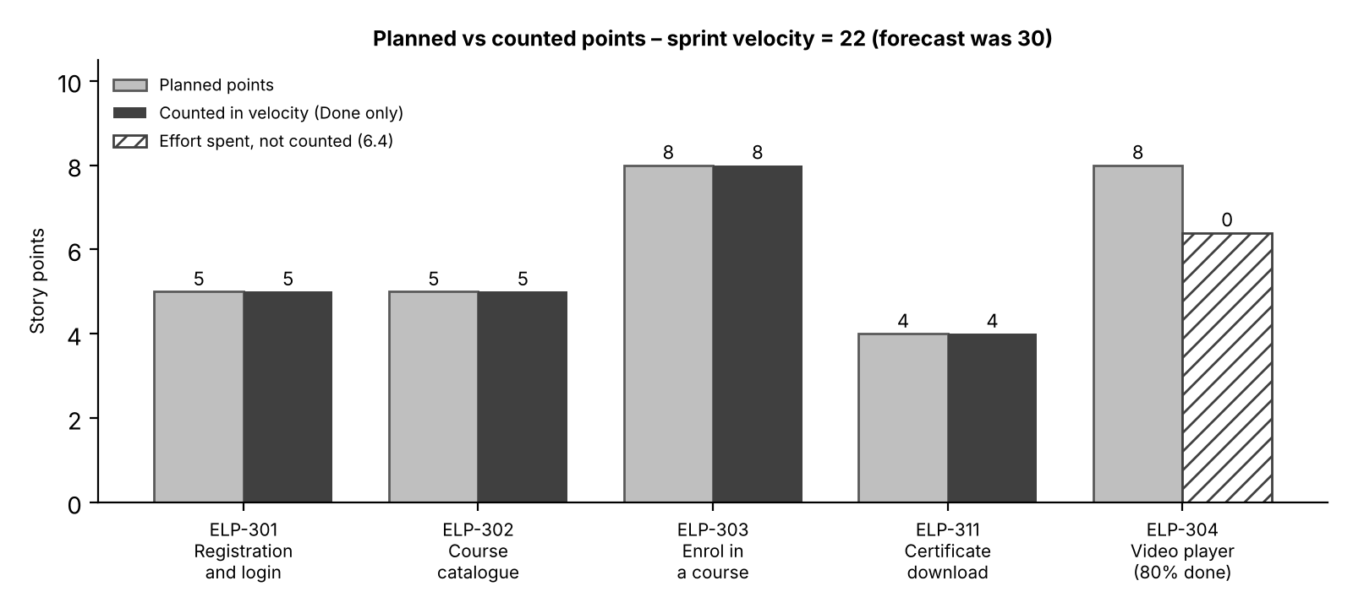
Figure 4: Planned versus counted story points for the sprint

Task 5 – Retrospective: Start – Stop – Continue

How the retrospective was facilitated (60 minutes)
Time | Activity | Output
0–5 min | Set the stage: purpose, working agreement ("focus on the process, not people"). | Safe space
5–15 min | Silent writing: everyone adds notes to Start, Stop and Continue. | Notes on the board
15–25 min | Group similar notes and vote with 3 dots each. | Top themes
25–50 min | Discuss the top three themes and find causes (for example, why ELP-304 ended at 80%). | Shared understanding
50–60 min | Turn themes into SMART action items with owners and dates. | 3 action items

Start | Stop | Continue
• Agreeing API contracts before a story enters the sprint.  • Slicing stories to 5 points or less.  • Starting testing in the first half of the sprint. | • Accepting mid-sprint requests without removing something.  • Working on all stories in parallel (too much work in progress).  • Leaving testing and review to the last two days. | • Daily written updates of blockers in the channel.  • Swapping scope with the PO instead of overloading the sprint.  • Pairing on difficult parts and demonstrating early.

Three SMART action items
# | Action (Specific and Measurable) | Success measure | Owner | Due (Time-bound)
1 | Add "API contract available and agreed" to the Definition of Ready, and check it for every story at planning. | 100% of stories with an API dependency have a contract at planning; zero API blockers in the next sprint. | Imran with Lakshmi | Before next sprint planning
2 | Introduce a scope-change rule: any new request needs a PO decision and an equal removal, and is logged on the board. | Zero mid-sprint additions without a matching removal; every change logged. | Rahul (PO) | Effective now; reviewed at next retrospective
3 | Slice stories to 5 points or less at refinement and finish each story before starting another (maximum 3 stories in progress). | No story above 5 points in the next sprint; at least 90% of committed points Done; no story ends the sprint partly done. | Whole team, led by Meena | Refinement on Day 8 of the next sprint
SMART check: each action is Specific (clear change), Measurable (a number to check), Achievable (within the team's control), Relevant (tied to what went wrong this sprint: the API blocker, the scope swap and the 80% story) and Time-bound (has a date).

Task 6 – How automation supports the Definition of Done
The Definition of Done (DoD) is the team's shared checklist for "finished". Automation turns that checklist into checks that run on every code change, so "Done" is decided by facts and not by opinion. A story is either green on the pipeline or it is not Done, which also stops stories from drifting into "80% done".
Automation | What it checks | DoD criterion it supports | Example tools
Unit tests | Each function behaves as expected (for ELP-311: the certificate shows the right name, course and date). Coverage of new code is measured. | Code is tested and acceptance criteria are met; no regressions. | Jest, JUnit, PyTest
Linting and static analysis | Code style, common bugs, security issues and secrets left in code. | Code meets standards and has no critical issues. | ESLint, SonarQube
CI/CD pipeline | On every commit: builds the code, runs lint and tests, deploys to staging, and blocks the merge if any step fails. | The build is green and the story is deployable and ready to demo. | Jenkins, GitHub Actions

- Fast feedback: a developer learns within minutes that something broke, not on Day 9.
- Consistency: the same checks run for every story and every developer, so the DoD is applied fairly.
- Protects the Sprint Goal: when a scope change like ELP-311 arrives, the pipeline checks the new work against the same standard, so speed does not lower quality.
- Frees the team: manual effort moves to exploratory testing and review instead of repeated checks.
Automation supports the DoD but does not replace it: human items such as PO acceptance and updated documentation still need a person.

Deliverables checklist
Deliverable | Where in this document
Sprint plan | Task 1 (30-point plan, Sprint Goal and selected stories)
Change-impact note | Task 2 (Day 6 status, options, swap decision and Sprint Goal protection); Task 3 (blocked stand-up and Scrum Master follow-up)
Velocity calculation | Task 4 (completed-points table, velocity of 22 and treatment of the 80% story)
Retrospective actions | Task 5 (Start-Stop-Continue and three SMART actions); Task 6 (automation and the Definition of Done)

