PROGRAMMING CASE STUDIES
Python problem solving with algorithms, flowcharts, pseudocode, code, and sample runs
Introductory Python Programming

How to use this document
This collection presents ten programming case studies as practical exercises in input validation, selection, loops, strings, collections, and numeric calculations. Each study contains a problem statement, objectives, assumptions, algorithm, text flowchart, pseudocode, Python source code, sample test cases and expected console output, and a conclusion. The rules are explicitly stated so the examples can be run and assessed consistently.
Flowcharts are written as arrow sequences to keep them editable in Word. Sample outputs are expected-output examples, not images captured from a live terminal. Save a source block as a separate .py file to run it. Illustrative formats and thresholds should be replaced with official requirements when applicable.

Contents
1. Advanced Numeric Pattern Generator
2. Password Policy Validation Engine
3. Student Email and Identifier Validation
4. Text Compression Using Character Runs
5. Repeated Word and Phrase Detection
6. Nested Loop Calendar Generator
7. Bus Passenger Occupancy Simulation
8. Food Waste Monitoring System
9. Tuple-Based Product Catalogue Audit
10. Fuel Consumption and Route Comparison

Case Study 1: Advanced Numeric Pattern Generator

Problem statement
Create a menu-driven program that prints a numeric pattern selected by the user. It accepts a pattern type and positive row count, validates both, and prints a centered pyramid, increasing triangle, or repeated-row triangle.

Objectives
- Practice nested loops and formatted output.
- Use selection logic to choose a pattern.
- Reject invalid choices and row counts.

Assumptions
- Rows are 1–20.
- Pyramid values ascend then descend; digits wrap after 9.
- One pattern is generated per run.

Algorithm
- Show menu
- read and validate choice and row count
- use nested loops to print each row
- stop after the final row.

Flowchart
Start → Show menu → Read choice and rows → Valid? → Generate rows with nested loops → Display → End

Pseudocode
BEGIN
DISPLAY menu; INPUT choice, rows
IF choice not in 1..3 OR rows not in 1..20: DISPLAY error; STOP
FOR i=1 TO rows: print selected pattern row
END FOR
END

Python source code
size = int(input("Enter an odd size (3 or more): "))
if size < 3 or size % 2 == 0:
print("Please enter an odd number of at least 3.")
else:
middle = size // 2
# Top half, including the middle row
for row in range(middle + 1):
spaces = middle - row
inside = 2 * row -
if row == 0:
print(" " * spaces + "*")
else:
print(" " * spaces + "*" + " " * inside + "*")

# Bottom half
for row in range(middle - 1, -1, -1):
spaces = middle - row
inside = 2 * row - 1

if row == 0:
print(" " * spaces + "*")
else:
print(" " * spaces + "*" + " " * inside + "*")

Test cases and sample output
Case A: choice 1, rows 4
1
1 2 1
1 2 3 2 1
1 2 3 4 3 2 1
Case B: choice 2, rows 3 → rows: 1 / 1 2 / 1 2 3
Case C: choice 0 → Error: invalid choice or row count.

Conclusion
Nested loops and input validation produce three common numeric patterns; more pattern choices can be added.
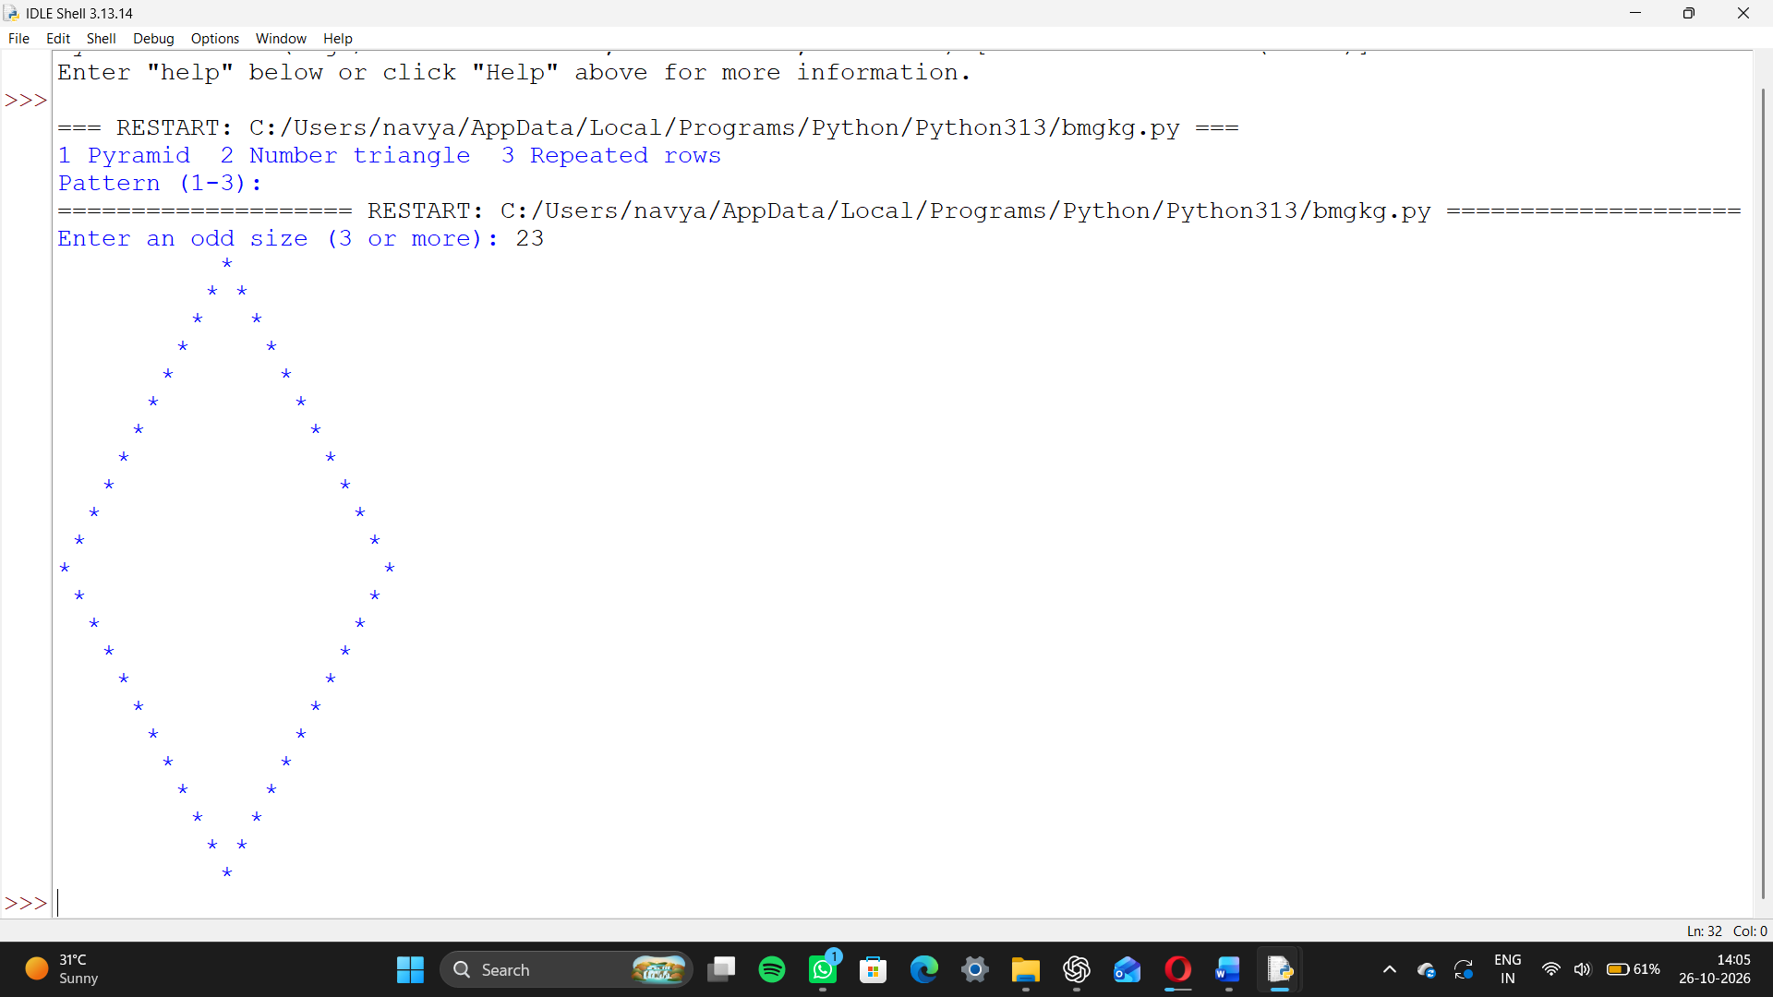

Case Study 2: Password Policy Validation Engine

Problem statement
Build a command-line validator that checks a password against a stated policy and lists every failed requirement.

Objectives
- Apply string inspection and boolean conditions.
- Give feedback for multiple policy failures.
- Do not display the password in results.

Assumptions
- At least 8 characters; one uppercase, lowercase, digit, and one of !@#$%^&*.
- Whitespace is not allowed.
- This learning example does not check leaked-password databases or estimate real-world strength.

Algorithm
- Read password securely
- check each rule independently
- collect failures
- report success or failed rules.

Flowchart
Start → Read password → Evaluate rules → Failures? → List failures or success → End

Pseudocode
BEGIN
INPUT password securely; failures=[]
CHECK length, upper, lower, digit, symbol, whitespace
APPEND each failure
IF failures empty: valid ELSE list failures
END

Python source code:

password = input("Enter a password: ")

if len(password) < 8:

print("Password must have at least 8 characters.")

if not any(letter.isdigit() for letter in password):

print("Password must contain a number.")

if not any(letter.isupper() for letter in password):

print("Password must contain an uppercase letter.")

if "password" in password.lower():

print("Password must not contain the word 'password'.")

if ( len(password) >= 8

and any(letter.isdigit() for letter in password)

and any(letter.isupper() for letter in password)

and "password" not in password.lower)

print("Password is valid.")Test cases and sample output
Input: Abcdef1! → Password meets the stated policy.
Input: abc → Invalid: at least 8 characters, one uppercase letter, one digit, one allowed symbol.
Input: Abcdef 1! → Invalid because whitespace is present.

Conclusion
The validator checks independent rules without echoing the secret. Production systems also need established authentication controls and secure storage.

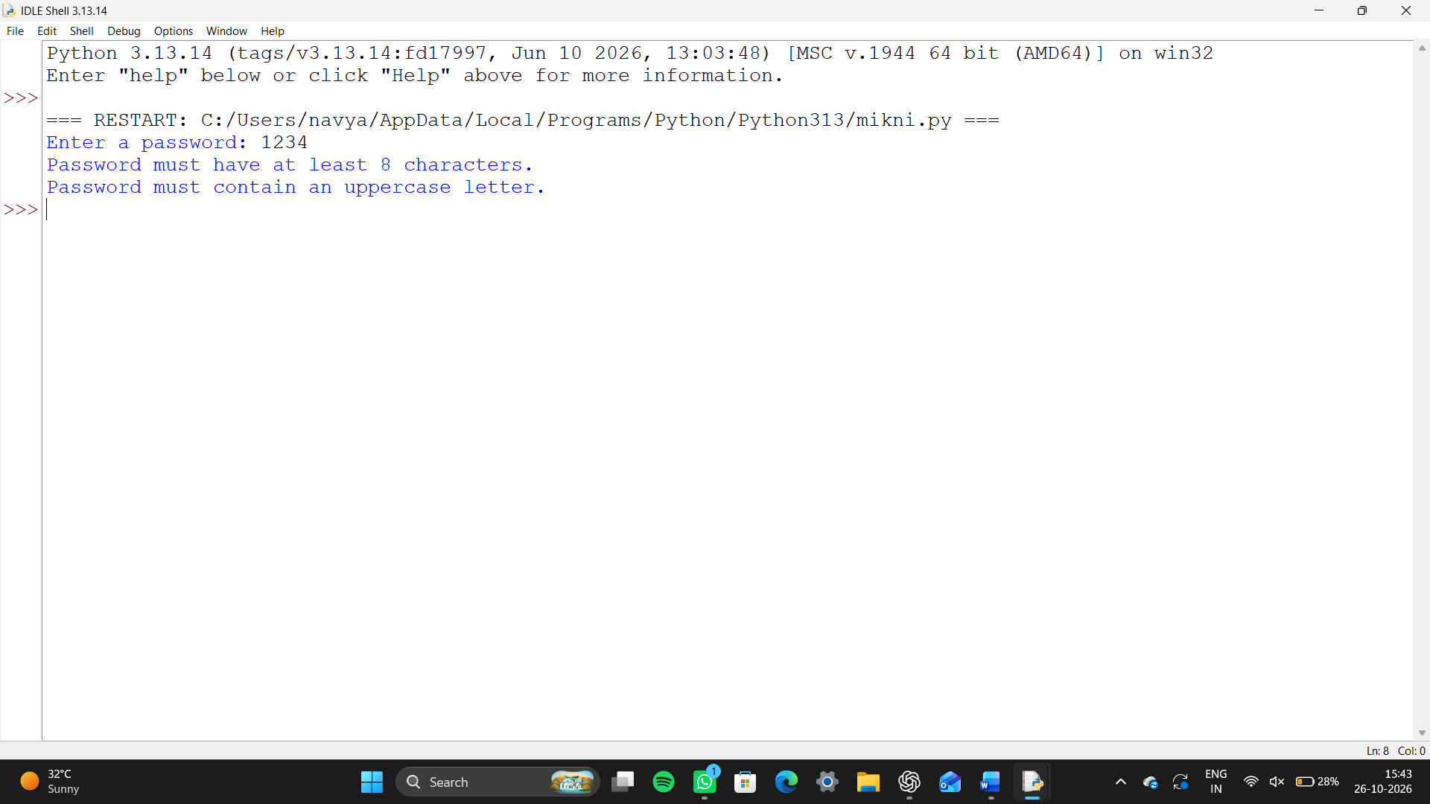

Case Study 3: Student Email and Identifier Validation

Problem statement
Check a student identifier and institutional email against explicit formats before accepting a student record.

Objectives
- Use string methods and regular expressions.
- Reject malformed identifiers and emails.
- Report field-specific errors.

Assumptions
- ID is two uppercase letters plus six digits, e.g. CS123456.
- Email uses local-part@students.example.edu with no spaces.
- Format checks do not verify enrollment or mailbox ownership.

Algorithm
- Read ID and email
- match ID and email patterns
- report invalid fields or accept record.

Flowchart
Start → Read ID/email → Validate ID → Validate email → Both valid? → Accept or report errors → End

Pseudocode
BEGIN
INPUT student_id, email
id_ok = ^[A-Z]{2}[0-9]{6}$
email_ok = local-part@students.example.edu
IF both: accepted ELSE field errors
END

Python source code
email = input("Enter email: ")
student_id = input("Enter student ID: ")
if "@" in email and "." in email:
print("Email looks correct.")
else:
print("Email is incorrect.")
if student_id.startswith("STU") and len(student_id) == 7:
print("Student ID looks correct.")
else:
print("Student ID is incorrect.")

Test cases and sample output
CS123456 and ana.lee@students.example.edu → Student record format accepted.
cs123 and ana@gmail.com → ID and email format errors.
AB123456 and sam@students.example.edu → accepted.

Conclusion
The validator enforces a clear format. Institutions should replace the illustrative rules and verify identity against authoritative systems
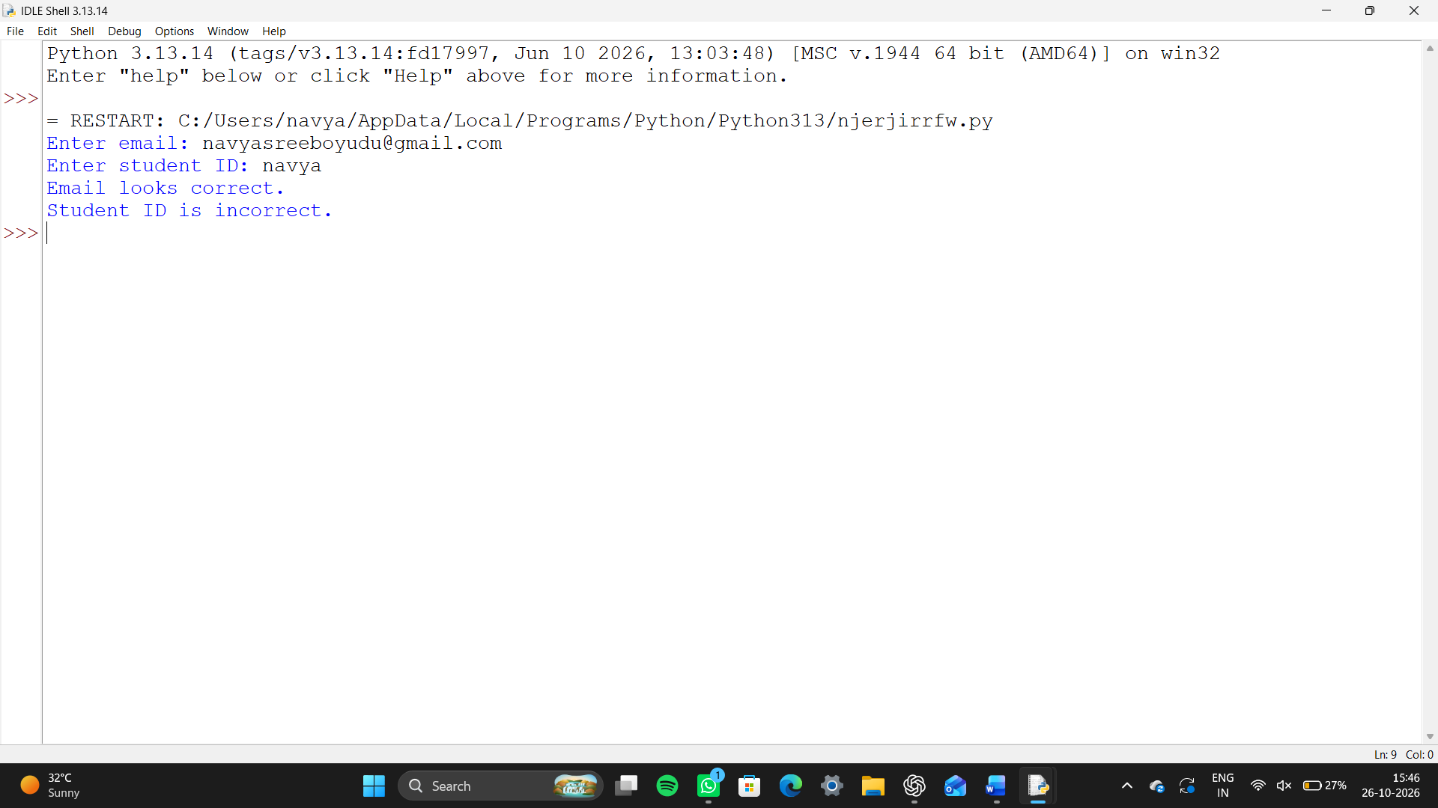
.

Case Study 4: Text Compression Using Character Runs

Problem statement
Implement run-length encoding by replacing each consecutive character run with that character and its count.

Objectives
- Traverse text and identify adjacent runs.
- Encode each run with its length.
- Recognize that simple run-length encoding may enlarge some inputs.

Assumptions
- Input is a line; case, spaces, and punctuation are preserved.
- Each character is followed by its count, including one.
- This simple output needs escaping for digits in a production format.

Algorithm
- Read text
- handle empty input
- track current character and count
- save on changes
- append final run.

Flowchart
Start → Read line → Track current run → Scan characters → Change? save run/reset → Save final run → Display → End

Pseudocode
BEGIN
INPUT text; IF empty: output empty
current=first; count=1
FOR each next char: increment if same, else append run and reset
append final run; DISPLAY
END

Python source code
text = input("Enter text: ")
encoded = ""
i = 0
while i < len(text):
count = 1
while i + 1 < len(text) and text[i] == text[i + 1]:
count = count + 1
i = i + 1
encoded = encoded + text[i] + str(count)
i = i + 1
print("Encoded text:", encoded)
if len(encoded) < len(text):
print("Encoding saves space.")
else:
print("Encoding does not save space.")

Test cases and sample output
Input: AAAAABB → Encoded: A5B2
Input: Hello → Encoded: H1e1l2o1
Empty input → Encoded: (empty)

Conclusion
The one-pass encoder compresses adjacent repeated characters and works best when input contains long runs.
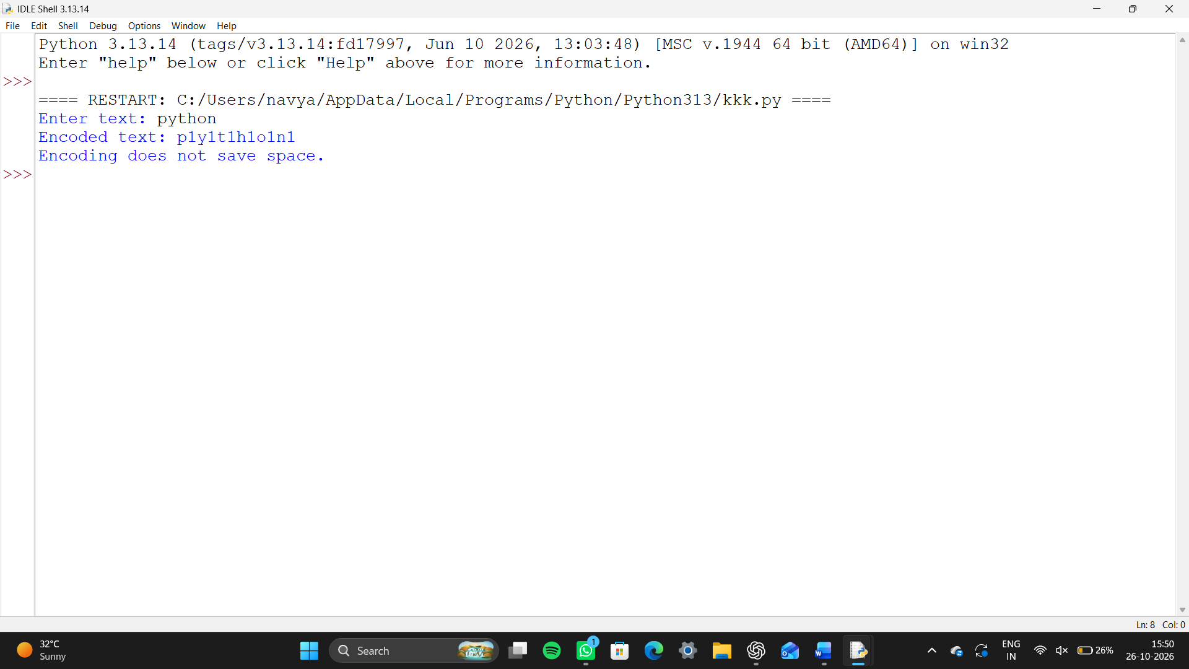

Case Study 5: Repeated Word and Phrase Detection

Problem statement
Analyze text for words and adjacent two-word phrases that occur more than once, ignoring case and punctuation.

Objectives
- Tokenize text into words.
- Count repeated terms with a dictionary.
- Report repeated items in alphabetical order.

Assumptions
- Words contain letters and may include internal apostrophes.
- Comparison is case-insensitive.
- Phrases are adjacent two-word sequences; punctuation is not a token.

Algorithm
- Read text
- extract lowercase words
- count words and adjacent pairs
- filter counts above one
- display sorted results.

Flowchart
Start → Read text → Normalize/tokenize → Count words and adjacent pairs → Filter repeats → Display → End

Pseudocode
BEGIN
INPUT text; words=lowercase tokens
COUNT each word and adjacent pair
DISPLAY entries whose count>1 in sorted order
END

Python source code
text = input("Enter a sentence: ")
words = text.lower().split()
for word in words:
if words.count(word) > 1:
print(word, "is repeated")

Test cases and sample output
Input: Go, go now; go now!
Repeated words: {'go': 3, 'now': 2}
Repeated adjacent phrases: {'go now': 2}
Input: one two three → no repeats.

Conclusion
Normalized tokens and frequency counters find repeated words and adjacent phrases. The simple tokenizer is not full linguistic analysis.
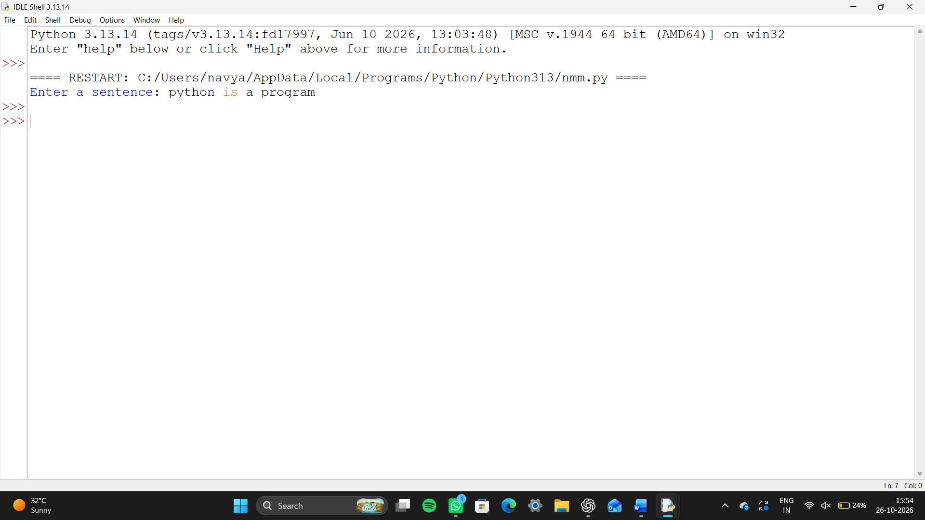

Case Study 6: Nested Loop Calendar Generator

Problem statement
Generate a monthly calendar grid for a given month length and first weekday using nested loops and seven weekday columns.

Objectives
- Practice nested loops and calendar arithmetic.
- Align dates under weekday headings.
- Validate the supplied month length and weekday.

Assumptions
- User supplies day count and first weekday (0=Monday to 6=Sunday).
- Leap years are not calculated; user supplies 28 or 29 for February.
- Calendar starts Monday.

Algorithm
- Read day count and weekday
- validate
- print headings
- use six rows and seven columns
- calculate each date position and display blanks outside the month.

Flowchart
Start → Input days/first weekday → Validate → Print headings → Nested row/column loops → Calendar → End

Pseudocode
BEGIN
INPUT days (28..31), first (0..6)
PRINT weekday header
FOR row=0..5, FOR col=0..6
day=row*7+col-first+1; print day if in range else blank
END

Python source code
days = int(input("Enter number of days (28, 29, 30, or 31): "))
start = int(input("Enter starting weekday (Monday=0 to Sunday=6): "))
print("Mon Tue Wed Thu Fri Sat Sun")
# Print spaces before the first day
for i in range(start):
print(" ", end="")
# Print the days
for day in range(1, days + 1):
print(day, end=" ")
if (start + day) % 7 == 0:
print()

Test cases and sample output
Input days=31, first=3 → first row: blank Mon-Wed, 1 Thu, 2 Fri, 3 Sat, 4 Sun; final date 31.
first=7 → Invalid month length or weekday.

Conclusion
Nested loops construct a clear seven-column grid. A real calendar should derive month length and weekday from a date library.
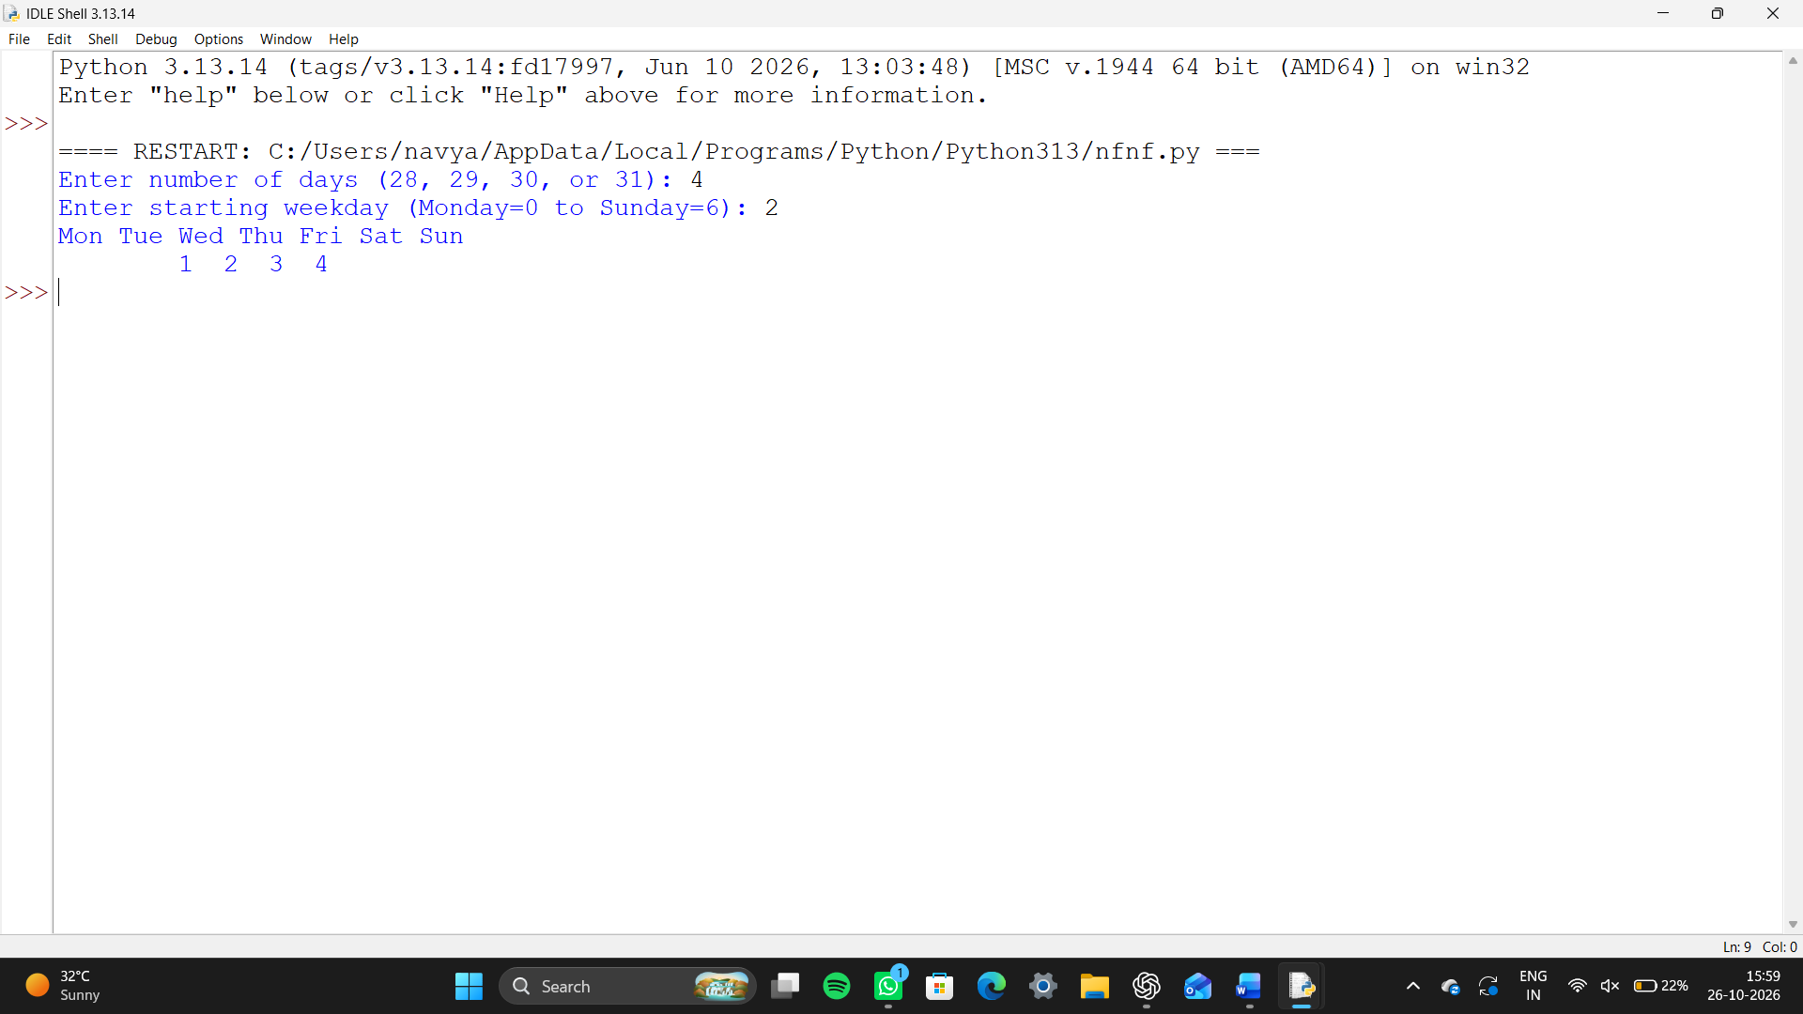

Case Study 7: Bus Passenger Occupancy Simulation

Problem statement
Simulate passenger occupancy at each bus stop by recording boarders and alighters, updating the count, and checking capacity.

Objectives
- Track a changing passenger count.
- Prevent alighting above current occupancy.
- Report capacity violations and route summary.

Assumptions
- Bus begins empty and has positive fixed capacity and stop count.
- Boarding and alighting counts are nonnegative integers.
- Impossible alighting input is rejected.

Algorithm
- Read capacity and number of stops
- at each stop read counts
- validate
- update occupancy
- report status
- summarize maximum and final occupancy.

Flowchart
Start → Input capacity/stops → Read board/alight per stop → Validate → Update occupancy → Check capacity → Summary → End

Pseudocode
BEGIN
occupancy=0; maximum=0
FOR each stop: INPUT board, alight
IF alight>occupancy: report invalid; STOP
occupancy=occupancy-alight+board; update maximum
DISPLAY status; after loop DISPLAY summary
END

Python source code
capacity = int(input("Enter bus capacity: "))
passengers = 0
for stop in range(1, 4):
boarding = int(input("How many board? "))
alighting = int(input("How many get off? "))
passengers = passengers + boarding - alighting
print("Passengers on bus:", passengers)
if passengers > capacity:
print("Capacity exceeded")

Test cases and sample output
Capacity 40; events (20,0), (10,5), (20,10) → occupancy 20, 25, 35; maximum 35; final 35.
Occupancy 4, alighting 5 → Invalid: more passengers alight than are aboard.

Conclusion
The simulation tracks occupancy and flags capacity excesses. Operational use requires reliable counts and safe boarding procedures.
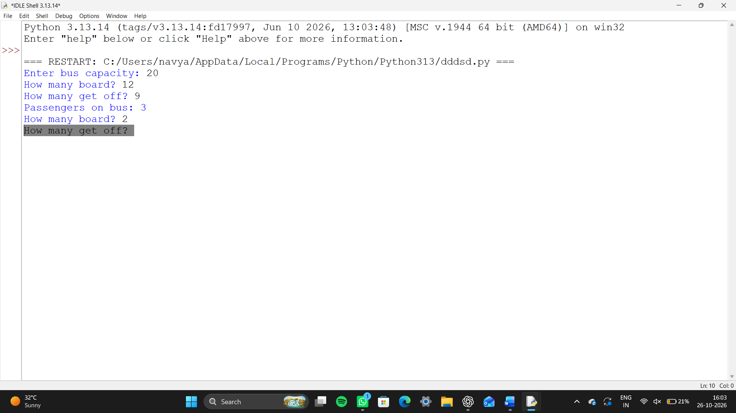

Case Study 8: Food Waste Monitoring System

Problem statement
Record prepared and discarded food quantities by day, calculate waste percentages, and flag days above a threshold.

Objectives
- Collect and validate daily quantities.
- Calculate daily and overall waste rates.
- Highlight days above the threshold.

Assumptions
- Quantities use nonnegative kilograms; waste cannot exceed preparation.
- Threshold is 0–100 percent.
- A fixed number of days is entered at runtime.

Algorithm
- Read days and threshold
- for each day read quantities
- validate
- calculate and report daily rate
- total quantities
- report overall rate.

Flowchart
Start → Input days/threshold → Daily quantities → Validate → Calculate rate → Threshold exceeded? → Report totals → End

Pseudocode
BEGIN
total_prepared=0; total_wasted=0
FOR each day: INPUT prepared,wasted; require 0<=wasted<=prepared
rate=100*wasted/prepared (or 0 if prepared=0)
DISPLAY rate/status; accumulate totals
DISPLAY overall rate
END

Python source code
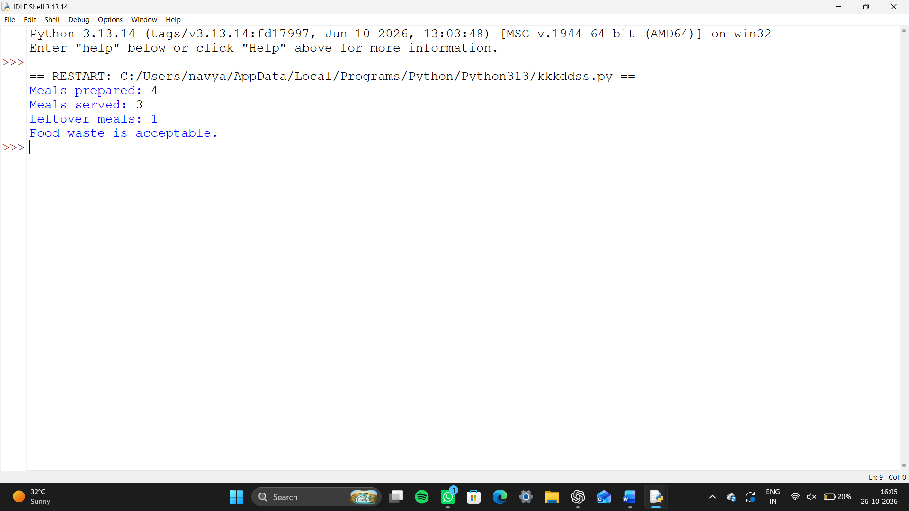 prepared = int(input("Meals prepared: "))
served = int(input("Meals served: "))
leftovers = prepared - served
print("Leftover meals:", leftovers)
if leftovers > 2:
print("Too much food was wasted.")
else:
print("Food waste is acceptable.")

Test cases and sample output
Threshold 20%; day amounts (10,1), (8,2) → 10.0% OK; 25.0% REVIEW.
Totals: 18.0 kg prepared, 3.0 kg wasted; overall 16.7%.
Wasted greater than prepared → error.

Conclusion
The monitor converts daily quantities into comparable rates and review flags. Consistent weighing and clear food categories are needed for useful measurements.

Case Study 9: Tuple-Based Product Catalogue Audit

Problem statement
Audit a small tuple-based product catalogue for duplicate IDs, missing names, and invalid prices.

Objectives
- Use immutable tuple records.
- Detect duplicate identifiers with a set.
- Report issues without silently changing records.

Assumptions
- Record format is (product_id, name, price).
- ID and name are nonempty strings; price is numeric and positive.
- Sample catalogue is embedded in source.

Algorithm
- Load tuple records
- track IDs
- check required fields, price, and duplicate IDs
- print each record result.

Flowchart
Start → Load tuples → Initialize ID set → Validate each record → Report issues → End

Pseudocode
BEGIN
seen_ids=empty set
FOR each (id,name,price): check fields and uniqueness; collect issues
DISPLAY valid/issues; add nonempty ID to set
END

Python source code
products = (
("P01", 10, 5), # ID, price, stock
("P02", 20, 2)
)
for product in products:
print("Product:", product[0])
print("Inventory value:", product[1] * product[2])
if product[2] < 3:
print("Order more stock")

Conclusion
Tuples provide compact records and a set makes duplicate checks easy. A production audit should validate data at ingestion and preserve an audit trail.
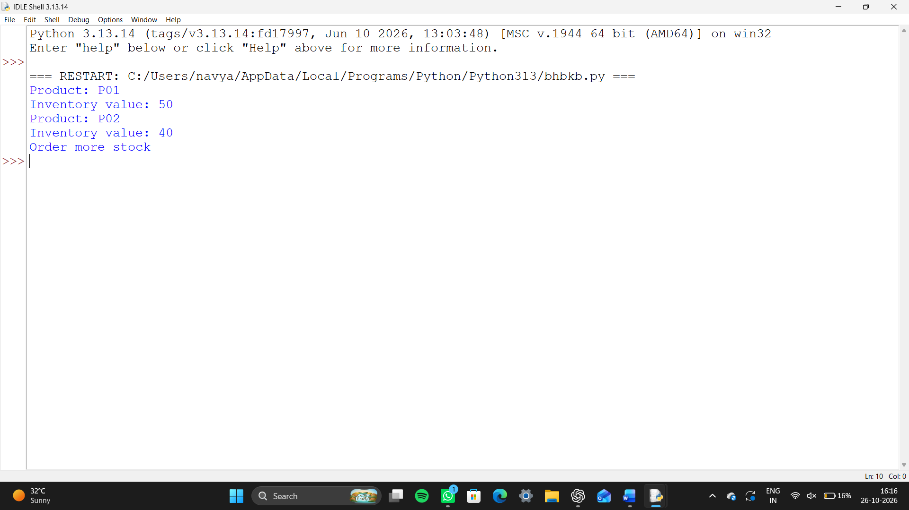

Case study 10: fuel Consumption and Route Comparison

Problem statement
Compare two routes using distance and fuel consumed, calculate km/L, estimate fuel for a planned trip, and identify the more efficient route.

Objectives
- Use consistent units and calculations.
- Handle invalid or zero fuel values.
- Summarize route comparison clearly.

Assumptions
- Distances are positive kilometres and fuel amounts are positive litres.
- Same vehicle and comparable conditions are assumed.
- Planned trip distance is positive; cost is not included.

Algorithm
- Read both routes and planned distance
- validate positive values
- calculate km/L and estimated trip litres
- compare efficiencies.

Flowchart
Start → Input route distances/fuel and trip length → Validate → Calculate km/L → Estimate trip litres → Compare → Display → End

Pseudocode
BEGIN
INPUT d1,f1,d2,f2,trip; require each >0
e1=d1/f1; e2=d2/f2
estimate1=trip/e1; estimate2=trip/e2
DISPLAY estimates and higher economy
END

Python source code
distance = float(input("Enter journey distance in km: "))
mileage = float(input("Enter vehicle mileage in km per litre: "))
fuel_price = float(input("Enter fuel price per litre: "))
reserve = float(input("Enter extra fuel reserve in litres: "))

fuel_needed = distance / mileage
total_fuel = fuel_needed + reserve
cost = total_fuel * fuel_price

print("Fuel needed:", total_fuel, "litres")
print("Journey cost:", cost)

Test cases and sample output
Route A 120 km / 8 L = 15 km/L; Route B 150 km / 12 L = 12.5 km/L.
For 300 km: A estimate 20.00 L; B estimate 24.00 L; Route A more efficient.
Fuel=0 → Error: Value must be greater than zero.

Conclusion
The comparison uses km/L consistently and estimates trip fuel from observed economy. Traffic, load, vehicle condition, and driving style affect actual consumption.
