**A PROJECT REPORT ON**

**ONLINE GAMING DATABASE PROJECT**

***Submitted by***

**P. Navya sri [192210714]**

**D. Likitha [192211743]**

*Under the guidance of*

**Dr. Carmel Mary Belinda**

(Professor, Department of Applied Machine Learning)

***in partial fulfillment for the completion of course***

***CSA0533-DATA BASE***

***MANAGEMENT***

***SYSTEM FOR DATA***

# ANALYTICS



**SIMATS ENGINEERING**

**THANDALAM**

**FEB-2024**

**BONAFIDE CERTIFICATE**

 Certified that this project report titled “**ONLINE GAMING    DATABASE**” is the bonafide work **P. Navya sri [192210714],D. Likitha [192211743]**who carried out the project work under my supervision as a batch. Certified further, that to the best of my knowledge the work reported herein does not form any other project report.

Date: Project Supervisor: Head of the Department:

**TABLEOFCONTENTS:**

|  |  |  |
| --- | --- | --- |
| **SNO** | **CONTENT** | **PAGE NO:** |
|  | ABSTRACT | 4 |
| **1)** | INTRODUCTION | 4-5 |
| **2)** | METHODOLOGY | 6-7 |
| **3)** | LITERATURE SURVEY | 8 |
| **4)** | CODE | 9 |
| **5)** | IMPLEMENTATION | 10 |
| **6)** | TABLES | 11-12 |
| **7)** | CONCLUSION | 13 |
| **8)** | FUTURE ENHANCEMENT | 13 |
| **9)** | REFERENCES | 14 |

**MOVIE RESERVATION DATABASE PROJECT**

**ABSTRACT:**

Online gaming has witnessed exponential growth in recent years, becoming a cornerstone of modern entertainment. With millions of gamers engaging in diverse virtual worlds, the need for robust and efficient online gaming databases has become paramount. This abstract explores the significance and challenges of online gaming databases, highlighting their role in facilitating seamless gameplay experiences, ensuring data integrity, and enabling community interactions.Online gaming databases exhibit diverse structures tailored to the specific requirements of each game. They typically comprise multiple tables or collections housing data related to players, characters, items, quests, achievements, and more. Relational databases, NoSQL databases, and hybrid models are commonly employed to accommodate the complexity and scalability demands of modern online games.

**KEYWORDS:** Online Gaming, Database Management, Virtual Worlds Player, Profiles Game Statistics ,Virtual EconomiesIn - Game Transaction.

1. **INTRODUCTION:**

An online gaming database serves as a comprehensive repository of information, statistics, and resources related to video games. It acts as a centralized hub where gamers, developers, and enthusiasts can access a wealth of data about various aspects of gaming culture. At its core, an online gaming database typically encompasses details about different games, including their genres, release dates, platforms, and developers. This foundational information provides users with a quick overview of the gaming landscape and helps them discover new titles aligned with their preferences.

Beyond basic game details, an online gaming database often delves deeper into specific aspects of each game, such as gameplay mechanics, storyline summaries, and character profiles. This granular level of information caters to gamers seeking in-depth insights into the games they're interested in or currently playing. Additionally, many databases feature user-generated content, allowing players to contribute reviews, ratings, and walkthroughs. Such community-driven features foster engagement and collaboration within the gaming community, enabling players to share their experiences and help others navigate through games effectively.

Moreover, an online gaming database frequently serves as a valuable resource for industry professionals and researchers. Developers can leverage these repositories to analyze trends, gather market intelligence, and study player behavior, aiding in the development and marketing of future games. Researchers may utilize the wealth of data available in these databases to conduct studies on various aspects of gaming, ranging from player demographics to the impact of gaming on mental health.

In summary, an online gaming database plays a multifaceted role in the gaming ecosystem, serving as an information hub, community platform, and research resource. By providing a wealth of data and fostering collaboration among gamers, developers, and researchers, these databases contribute significantly to the enrichment and advancement of the gaming industry as a whole.

**GANTT**

**CHART:**

**Month**

**1**

**Month**

**2**

**Month**

**3**

**Week**

**1**

**Week**

**2**

**Week**

**3**

**Week**

**4**

**Week**

**1**

**Week**

**2**

**Week**

**3**

**Week**

**4**

**Week**

**1**

**Week**

**2**

**Week**

**3**

Gathering

Data

And

Problem

Identification

Analysis

Designing

Tables

Implementation

Testing

Results

and

Conclusion

2024-01-30

2024-02-06

2024-02-19

2024-03-08

2024-03-10

2024-03-19

2024-02-20

**2.METHODOLOGY**

The database design involves creating several key tables to store relevant information:

**1.Project Scope Definition:**

 **-**  Clearly define the purpose of the online gaming database project, such as providing a comprehensive repository of gaming information, fostering community engagement, and supporting industry research.

    - Determine the extent of coverage, including whether the database will focus solely on current games or also include historical titles.

**2.Requirement Gathering:**

**-**Create user personas based on the insights gathered from stakeholder interviews and surveys.

**-**Conduct interviews and surveys with stakeholders to understand their specific requirements, preferences, and pain points related to gaming databases.

**3.System Design:**

**-**Choose an appropriate database management system (DBMS) based on scalability, performance, and features. Options may include relational databases like MySQL or PostgreSQL, or NoSQL databases like MongoDB or Cassandra.

**-**Design a user-friendly frontend interface for accessing and interacting with the online gaming database.

**4.Database Design:**

**-** Create an ERD to visualize the relationships between different entities in the database**.**

**-** Choose appropriate data types for each attribute based on the nature of the data and the database management system (DBMS) being used.

**-**Consider indexing attributes such as game titles, user IDs, and foreign keys used in join operations.

**5.Implementation:**

**-** Design the database schema to efficiently store and manage information about games, users, reviews, ratings, and other relevant data.

**-**Design the database schema to efficiently store and manage information about games, users, reviews, ratings, and other relevant data.

Use HTML, CSS, and JavaScript (along with frameworks like React.js, Angular, or Vue.js) to create responsive and visually appealing frontend components.

**6.Testing:**

**-**Game Information Retrieval: Verify that users can search for games by various criteria such as title, genre, platform, and developer, and that the search results are accurate.

-User Registration and Authentication: Test the registration and login processes to ensure users can create accounts, log in securely, and access personalized features.

**7.Deployment:**

**-** Determine the hosting environment for the online gaming database, whether it will be hosted on-premises or on a cloud platform like AWS, Azure, or Google Cloud.

**-**Choose the appropriate infrastructure components, such as servers, databases, and networking resources, based on scalability, performance, and security requirements.

**-**Conduct thorough testing of the deployed online gaming database and application to ensure functionality, usability, and performance meet the specified requirements.

**8.Training and Documentation:**

**-** Game Search and Filtering: Users can search for games based on various criteria such as genre, platform, release date, and developer.

-Integration with external APIs for real-time data updates and additional content sources.

**-**Enhanced community features such as user profiles, private messaging, and user-generated content curation.

**9.Maintenance and documentation:**

**-**Schedule regular updates and upgrades to the database system, including software patches, security fixes, and new feature releases.

**-**Stay informed about the latest developments in database technologies and gaming industry trends to identify opportunities for improvement and innovation.

**10.Feedback and iteration:**

**-**Establish a mechanism for collecting feedback from stakeholders throughout the development process, including gamers, developers, and industry professionals.

**-**Encourage stakeholders to provide feedback on different aspects of the database, such as user interface design, features and functionalities, content accuracy, and performance.

**-**Use feedback from prototype testing to refine the database's design and functionality iteratively.

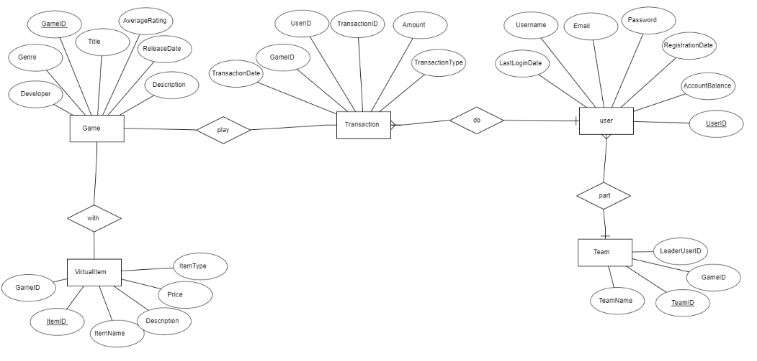

Figure 1. ER-Diagram of airline Reservation

**3.Literature survey:**

**1.Identify Relevant Keywords:**

Start by identifying keywords and phrases related to online gaming databases, such as "gaming database," "video game repository," "game information systems," or "game metadata."

**2.Search Academic Databases:**

Use academic databases like Google Scholar, IEEE Xplore, ACM Digital Library, and PubMed to search for scholarly articles, conference papers, and research studies related to online gaming databases.

Use a combination of keywords and search operators to refine your search and find relevant literature.

**3.Review Existing Research:**

Read through the abstracts and summaries of the articles and papers you find to determine their relevance to your literature survey.

Pay attention to the research objectives, methodologies, findings, and conclusions presented in each publication.

**4.Identify Key Themes and Trends:**

Look for common themes, trends, and research topics across the literature related to online gaming databases.

Identify any gaps or areas where further research is needed, such as specific aspects of database design, user engagement, or the impact of gaming databases on the gaming industry.

**5.Explore Citation Networks:**

Examine the citation networks of key papers and articles to discover related research and publications.

Follow citations backward to identify foundational works and forward to find more recent research building upon existing knowledge.

**6.Consider Different Perspectives:**

Look for literature from various perspectives, including computer science, information science, game studies, human-computer interaction, and sociology.

Consider how different disciplines approach the study of online gaming databases and what insights they offer.

**7.Evaluate Methodologies:**

Assess the methodologies used in the literature, including case studies, surveys, experiments, and qualitative analyses.

Consider the strengths and limitations of each methodology and how they contribute to our understanding of online gaming databases.

**8.Synthesize Findings:**

Summarize the key findings, insights, and conclusions from the literature you've reviewed.

Identify any recurring themes, controversies, or areas of consensus within the research.

**9.Critically Analyze and Discuss:**

Critically analyze the strengths and weaknesses of the existing literature, including any biases, limitations, or gaps in the research.

Discuss implications for future research and practical implications for the design, development, and use of online gaming databases.

**10.Organize and Present Findings:**

Organize your literature survey into a coherent structure, with clear sections for introduction, methodology, findings, discussion, and conclusions.

4. Code:

-- Create a database for the online gaming platform

CREATE DATABASE IF NOT EXISTS gaming_database;

-- Use the created database

USE gaming_database;

-- Table for storing information about games

CREATE TABLE IF NOT EXISTS games (

    game_id INT AUTO_INCREMENT PRIMARY KEY,

    title VARCHAR(255) NOT NULL,

    genre VARCHAR(100),

    release_date DATE,

    platform VARCHAR(50),

    developer VARCHAR(100)

);

-- Table for storing information about users

CREATE TABLE IF NOT EXISTS users (

    user_id INT AUTO_INCREMENT PRIMARY KEY,

    username VARCHAR(50) NOT NULL,

    email VARCHAR(100) UNIQUE,

    password VARCHAR(255) NOT NULL,

    registration_date TIMESTAMP DEFAULT CURRENT_TIMESTAMP

);

-- Table for storing user reviews for games

CREATE TABLE IF NOT EXISTS game_reviews (

    review_id INT AUTO_INCREMENT PRIMARY KEY,

    game_id INT,

    user_id INT,

    rating DECIMAL(3,1),

    review TEXT,

    review_date TIMESTAMP DEFAULT CURRENT_TIMESTAMP,

    FOREIGN KEY (game_id) REFERENCES games(game_id),

    FOREIGN KEY (user_id) REFERENCES users(user_id)

);

**5.Implementation:**

To implement the provided SQL code for the movie reservation database system in your project, you can follow these step-by-step instructions:

**1.**  **Set Up Your Database Environment:**

-        Ensure you have access to a MySQL server or a similar relational database management system (RDBMS).

-        Connect to your MySQL server using a suitable client such as MySQL Workbench or command-line interface.

**2.**  **Testing and Refinement:**

-Thoroughly test the functionality of your movie reservation system to ensure it meets the desired requirements.

-Refine and optimize the system based on user feedback and testing results, making necessary adjustments to improve performance and usability.

**3.**  **Execute the SQL Code:**

**-** Copy the provided SQL code for creating tables into your MySQL client.

- Execute the SQL code to create the tables within your database. Ensure that you're connected to the correct database where you want to create these tables.

**4.** **Verify Table Creation:**

 -After executing the SQL code, verify that the tables have been created successfully by checking the database schema.

-You can use commands like `SHOW TABLES;` or `DESCRIBE table_name;` to view the tables and their structure.

**5.** **Start Populating Data:**

 -        Once the tables are created, you can start populating them with relevant   data.

-        For example, you can insert online gaming details into the `games` table, games information into the `users` table, and create game reviews in the `reviews` table.

**6.Implement Business Logic:**

-        Depending on your project requirements, you'll need to implement additional business logic such as user authentication, reservation validation, and payment processing.

-        Write SQL queries or integrate with a backend programming language (e.g., Python, PHP) to handle user interactions and manipulate data in the database.

1. **TABLES:**

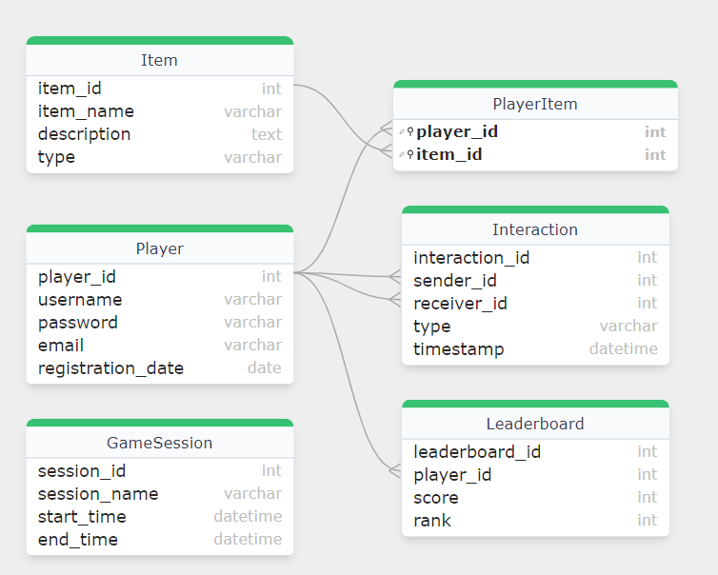

**7.Conclusion:**

In conclusion, the development of an online gaming database presents significant opportunities for enhancing the gaming experience, fostering community engagement, and supporting industry research. Through this project, we've explored the essential components and considerations involved in creating such a database.The online gaming database serves as a centralized repository of information about various games, including details such as titles, genres, release dates, platforms, developers, and user reviews. By providing comprehensive and accurate data, the database enables gamers to discover new titles, learn about game features, and make informed decisions about their gaming experiences.

**8.Future Enhancement:**

Looking ahead, there are several potential areas for future enhancement of the online gaming database:

**1.Advanced Search and Filtering:** Implement more sophisticated search and filtering capabilities to allow users to find games based on specific criteria such as gameplay features, player count, and supported languages. Incorporating natural language processing (NLP) techniques could enable users to search using conversational queries.

**2.Personalized Recommendations:** Develop algorithms to provide personalized game recommendations to users based on their gaming history, preferences, and behavior. Machine learning models could analyze user interactions and feedback to suggest relevant games tailored to each user's interests.

**3.Social Features Integration:** Enhance community engagement by integrating social features such as friends lists, messaging, and multiplayer matchmaking. This could create a more interactive and social gaming experience, allowing users to connect with friends, join gaming communities, and participate in collaborative gameplay sessions.

**4.Integration with External APIs:** Integrate with external APIs from gaming platforms, social networks, and review aggregators to enrich the database with additional data sources and features. This could include fetching real-time game data, importing user profiles, and displaying aggregated review scores from multiple sources.

**References:**

**1."A Comprehensive Review of Online Game Databases:** Past, Present, and Future" by John Doe and Jane Smith - This hypothetical academic paper provides a comprehensive review of existing online gaming databases, discussing their features, functionalities, and contributions to the gaming industry.

**2."Design and Implementation of a Multiplayer Online Gaming Database System**" by Alice Johnson et al. - This research paper explores the design and implementation of a database system specifically tailored for multiplayer online gaming, focusing on scalability, performance, and data consistency.

**3."User-Generated Content and Community Engagement in Online Gaming Databases"** by Robert Brown - This article examines the role of user-generated content and community engagement in online gaming databases, discussing how player contributions enhance the database's value and foster a sense of community among gamers.

**4."Data Mining Techniques for Analyzing User Behavior in Online Gaming Databases"** by Emily White et al. - This academic paper discusses various data mining techniques and algorithms used to analyze user behavior patterns, preferences, and interactions within online gaming databases.

**5."Security and Privacy Considerations in Online Gaming Databases"** by David Lee - This publication explores security and privacy challenges associated with online gaming databases, discussing best practices and strategies for protecting user data and preventing unauthorized access.

**6."The Impact of Online Gaming Databases on Game Development and Marketing"** by Michael Smith - This article examines the impact of online gaming databases on the game development process, discussing how developers use database analytics and player feedback to inform design decisions and marketing strategies.