Full Stack Development Project Documentation
India's Agricultural Crop Production Analysis

1. Introduction
Project Title: India's Agricultural Crop Production Analysis (1997-2021)
Team ID:
Team Members and Roles:
- Navyasri Meruga — Team Lead
- Megha Sai Vardhan Chodavarapu
- Mohammad Nasreen
- Santosh Kakani
- Gudavalli Sumanth

2. Project Overview

Purpose
This project analyzes and visualizes India's agricultural crop production data spanning 1997 to 2021. It was originally scoped as a Tableau-based dashboard project and has been recreated as a fully Python-based solution, allowing the same insights to be explored without any BI software license. The goal is to help three types of stakeholders — a small-scale farmer, a government policy analyst, and an agribusiness investor — make data-driven decisions about crop selection, regional productivity, and investment opportunities.

Features
- Interactive Streamlit dashboard with sidebar filters for Crop Year range, State, Crop, and Season, applied live across every chart and KPI.
- Overview tab showing key metrics (Total Production, Total Area, Average Yield, Crops Tracked), production trend over time, production by season, top 10 crops by production, regional (state-wise) distribution, and a crop-vs-decade production heatmap.
- Scenario 1 — Farmer view: seasonal crop trends and best-performing crops by state (by yield) to help reduce risk and maximize yield.
- Scenario 2 — Policy Analyst view: states ranked by average yield (lowest first) to flag intervention candidates, and long-term national production trend.
- Scenario 3 — Investor view: crop CAGR (1997-2021), emerging crops by recent growth, and states with consistent, low-risk production growth.
- A complete data pipeline: synthetic dataset generation, preprocessing/cleaning (missing values, duplicates, invalid rows), analysis functions, and static chart exports.
- A Jupyter notebook for exploratory data analysis (EDA).

3. Architecture

Frontend
The frontend is built with Streamlit rather than React, since the project was re-scoped from Tableau to a pure-Python stack. The dashboard (dashboard/app.py) renders the sidebar filters, KPI metric cards, and four tabs (Overview, Scenario 1: Farmer, Scenario 2: Policy Analyst, Scenario 3: Investor). Charts are rendered using Plotly Express for interactivity (line charts, donut/pie charts, bar charts, heatmaps, and area charts).

Backend
There is no separate Node.js/Express.js server. Backend-equivalent logic lives in Python modules under src/:
- generate_data.py — builds the synthetic dataset that mirrors the structure of the real Kaggle "Crop Production in India" dataset (State_Name, District_Name, Crop_Year, Season, Crop, Area, Production).
- data_preprocessing.py — cleans the raw dataset: trims whitespace, normalizes text case, removes duplicates and invalid rows, imputes missing values, and derives Yield (t/ha) and Decade columns.
- data_analysis.py — houses all analytical functions used by the dashboard, organized around the three stakeholder scenarios (Farmer, Policy Analyst, Investor).
- visualizations.py — generates the static PNG chart set saved under outputs/charts/.
Streamlit's @st.cache_data is used to cache the loaded dataset so repeated filter changes don't reload data from disk.

Database
No database server (e.g., MongoDB) is used. Data is stored as flat CSV files:
- data/crop_production.csv — the raw (synthetic) dataset.
- data/crop_production_clean.csv — the cleaned dataset produced by data_preprocessing.py, which is what the dashboard and analysis functions read from.
Schema (columns): State_Name, District_Name, Crop_Year, Season, Crop, Area, Production, with Yield and Decade added during cleaning. The project's README notes that a real Kaggle CSV with matching column names can be dropped in to replace the synthetic data without any code changes.

4. Setup Instructions

Prerequisites
- Python 3.x
- pip
- Recommended: a virtual environment (venv)
Python package dependencies (requirements.txt): pandas, numpy, matplotlib, seaborn, streamlit, plotly, jupyter.

Installation
- 1. Create and activate a virtual environment: python -m venv venv, then source venv/bin/activate (Windows: venv\Scripts\activate).
- 2. Install dependencies: pip install -r requirements.txt
- 3. Generate the dataset: python src/generate_data.py
- 4. Clean the dataset: python src/data_preprocessing.py
- 5. (Optional) Generate static charts: python src/visualizations.py

5. Folder Structure

Client (Dashboard)
Since the frontend is a Streamlit app rather than a React client, the equivalent folder is dashboard/, containing app.py — the single-file interactive dashboard that renders the sidebar, KPIs, and all four tabs.

Server (Source & Data)
The Node.js-equivalent backend logic and data live under src/ (data generation, preprocessing, analysis, visualization) and data/ (raw and cleaned CSVs). Overall structure:
- india-crop-analysis/
  - data/ — crop_production.csv, crop_production_clean.csv
  - src/ — generate_data.py, data_preprocessing.py, data_analysis.py, visualizations.py
  - dashboard/ — app.py
  - notebooks/ — EDA.ipynb
  - outputs/charts/ — generated PNG charts
  - requirements.txt, README.md

6. Running the Application
Commands to run the project locally:
- Generate & clean data (one-time setup): python src/generate_data.py followed by python src/data_preprocessing.py
- Start the dashboard: streamlit run dashboard/app.py
- This opens a browser tab at http://localhost:8501 with the full interactive dashboard.
- Explore the EDA notebook: jupyter notebook notebooks/EDA.ipynb

7. API Documentation
This project does not expose a REST/HTTP API — there is no Express.js server. Instead, the "API" surface is a set of internal Python functions in src/data_analysis.py that the Streamlit dashboard calls directly. Key functions include:
Function | Purpose | Example Output
load_clean(path) | Loads the cleaned CSV into a DataFrame | DataFrame of all crop records
top_crops_by_production(df, n) | Top N crops by total production | Ranked series, e.g. Rice, Wheat, Sugarcane...
seasonal_trends(df) | Aggregates Area, Production, Avg. Yield by season | Table: Whole Year, Rabi, Kharif, Winter, Autumn
best_crops_for_state(df, state, n) | Best-yielding crops for a chosen state | Top 5 crops by yield for e.g. Andhra Pradesh
state_yield_ranking(df) | States ranked by average yield (lowest first) | Rajasthan, Haryana, ... Maharashtra
yearly_production_trend(df) | Total production grouped by Crop_Year | Time series 1997-2021
crop_growth_rate(df) | CAGR (1997-2021) per crop | e.g. Soybean, Potato, Onion highest CAGR
emerging_crops(df) | Crops with the strongest recent growth | Wheat, Banana, Soybean, Coconut...
consistent_growth_states(df) | States with steady, low-risk production growth | Ranked list of states

8. Authentication
The dashboard is a local/self-hosted Streamlit application (also deployable to Streamlit Community Cloud) and does not implement user authentication, login sessions, or tokens. There is no concept of user accounts — all filters and views are available to anyone who opens the app URL. If authentication were required for a future deployment, it would need to be added separately (e.g., via Streamlit's authentication components or a reverse proxy).

9. User Interface
The screenshots below showcase the dashboard's key views and features.
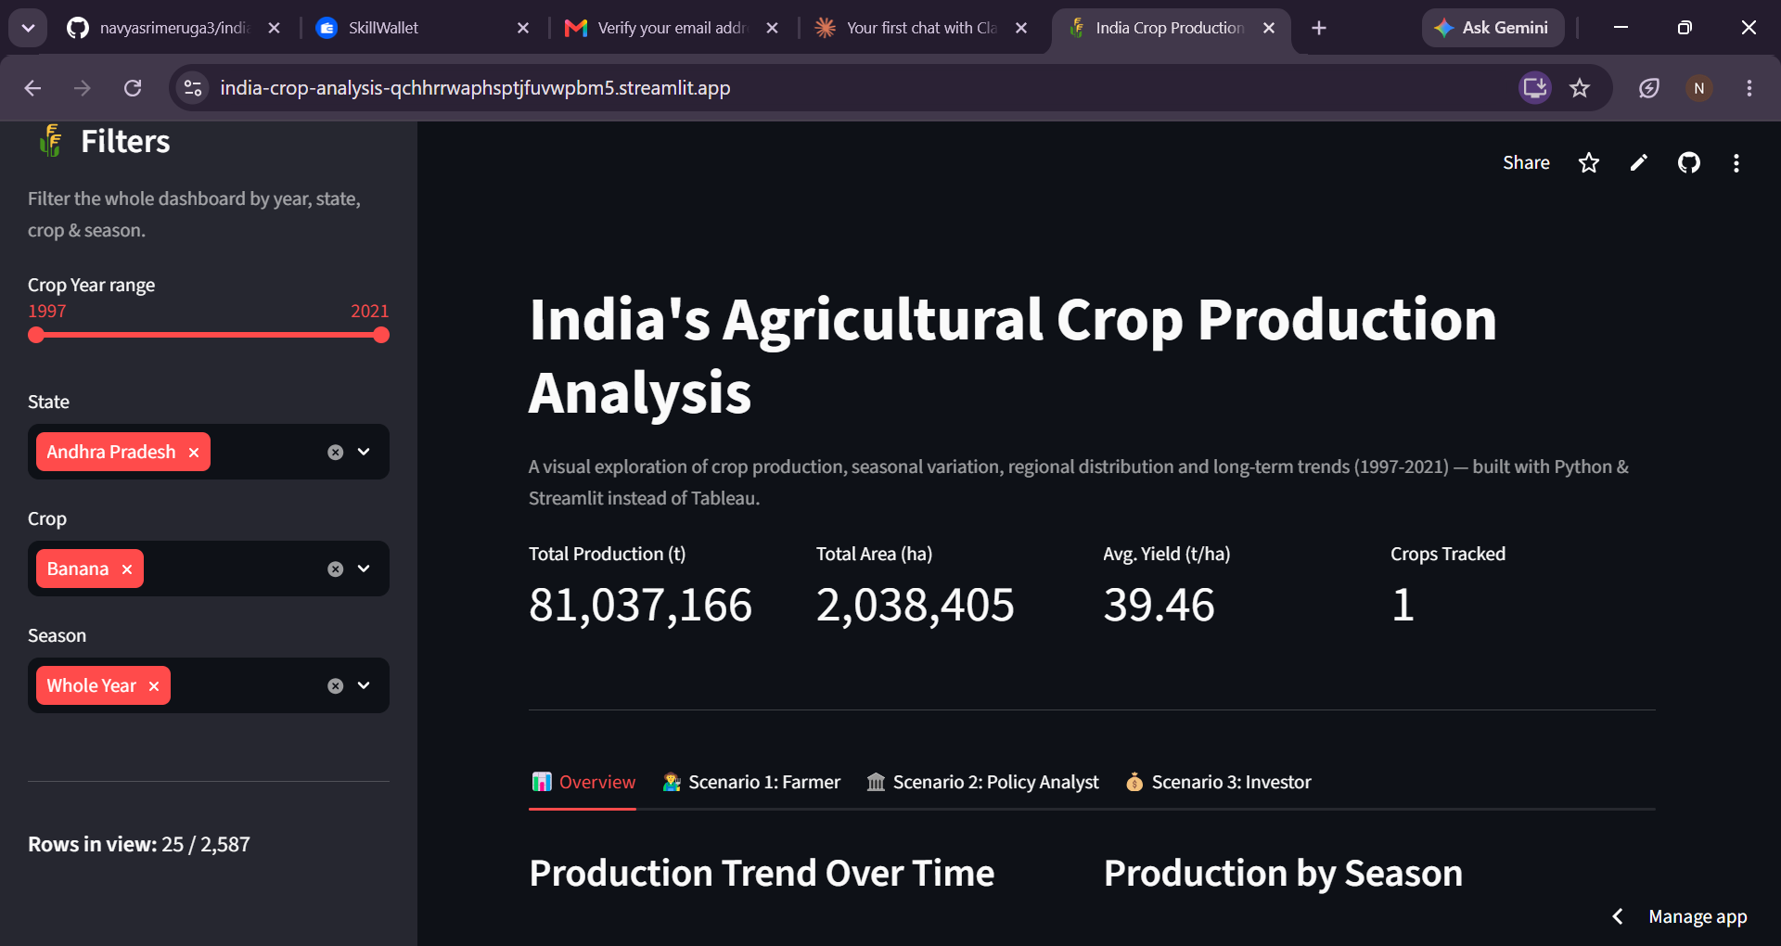
Overview tab — landing page with filters, KPIs (Total Production, Total Area, Avg. Yield, Crops Tracked), and scenario tabs.
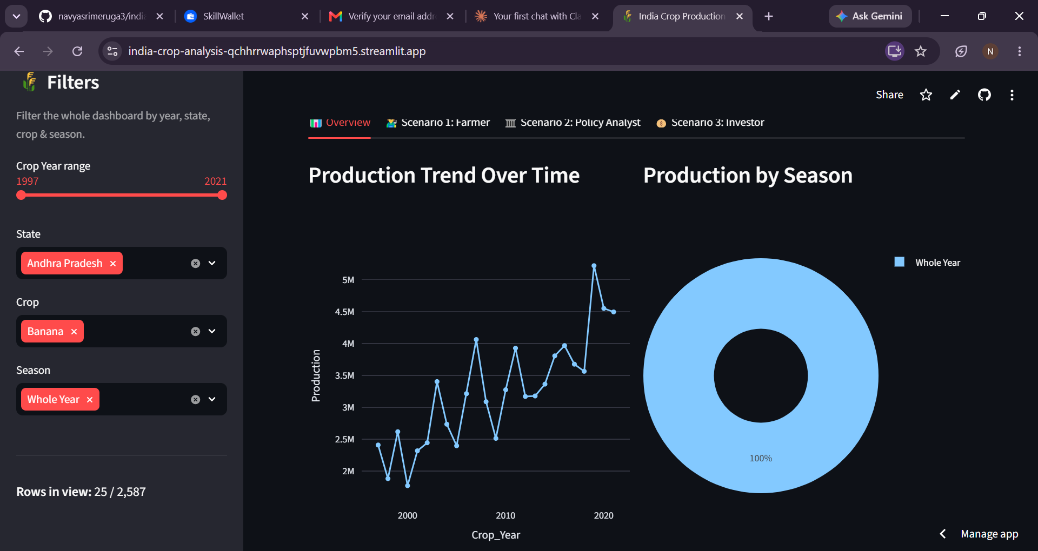
Production Trend Over Time (line chart) and Production by Season (donut chart).
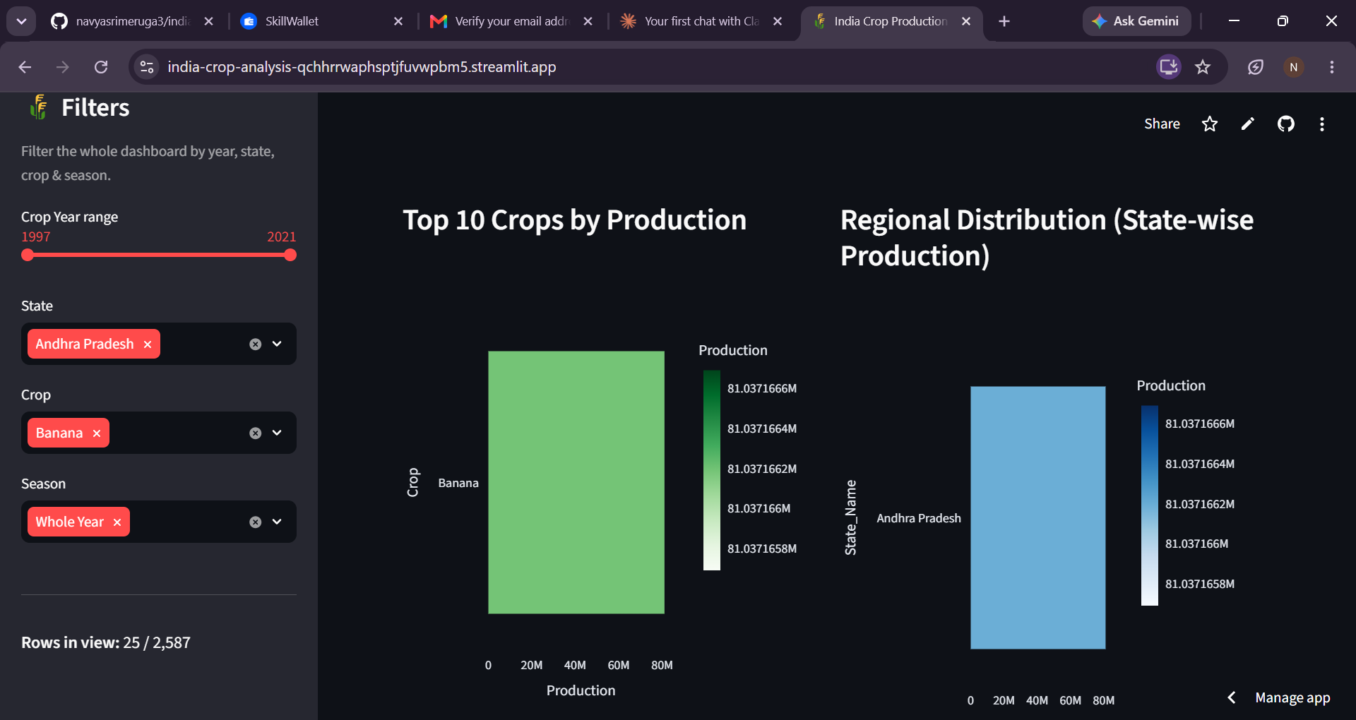
Top 10 Crops by Production and Regional Distribution (State-wise Production).
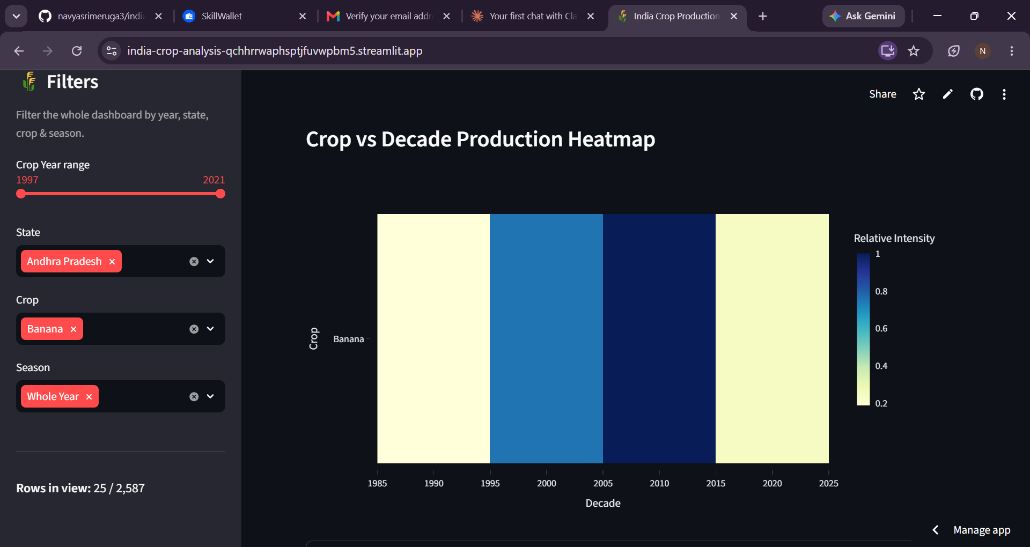
Crop vs Decade Production Heatmap.
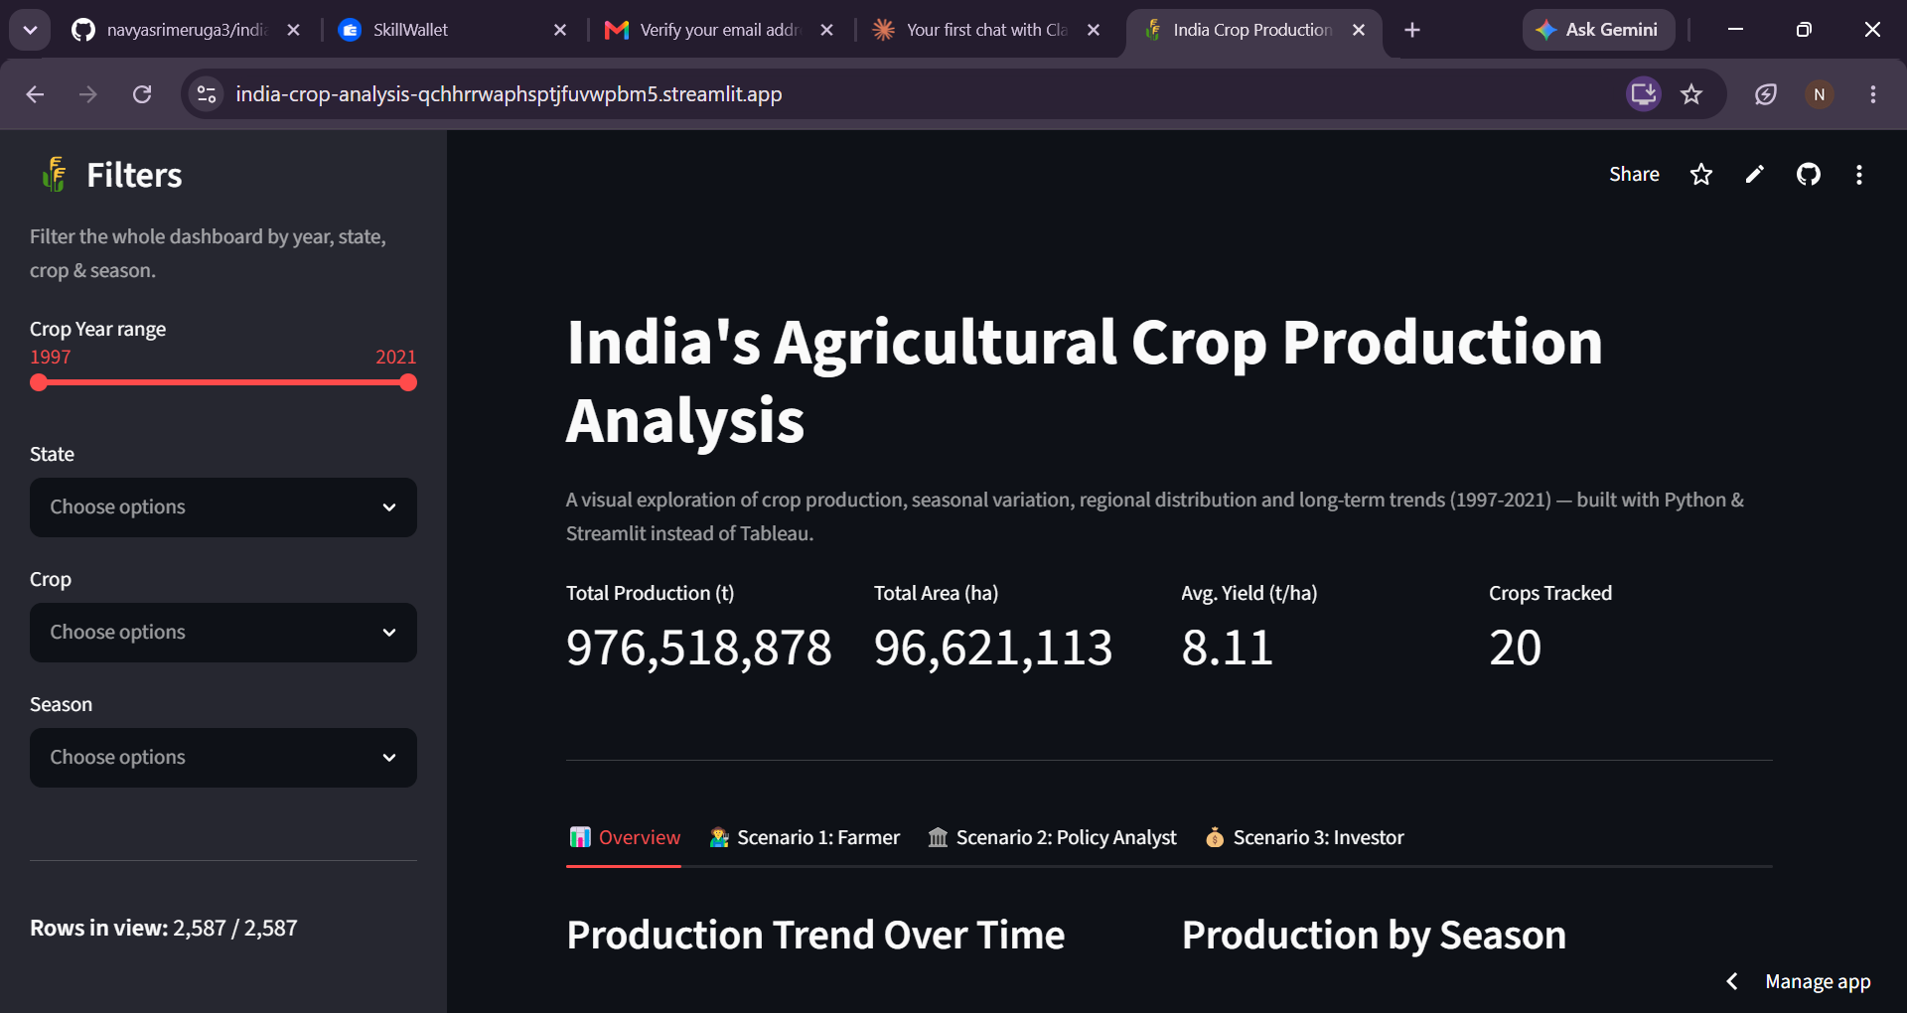
Overview tab with filters cleared, showing all rows in view (2,587 / 2,587).
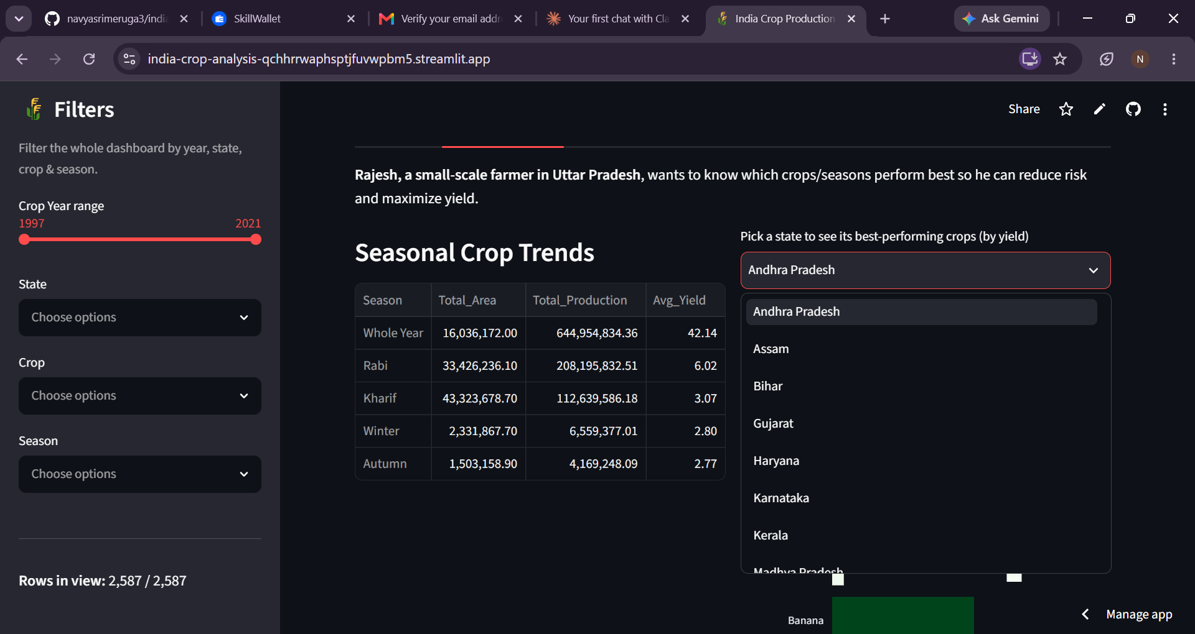
Scenario 1: Farmer — Seasonal Crop Trends table and best-performing crops by state selector.
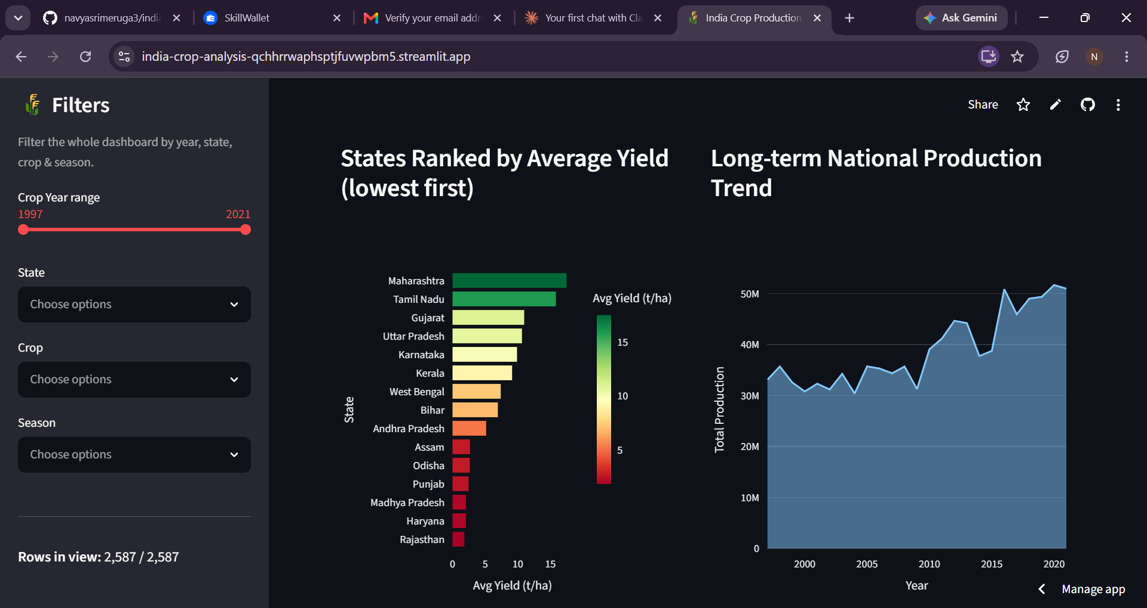
Scenario 2: Policy Analyst — States Ranked by Average Yield and Long-term National Production Trend.
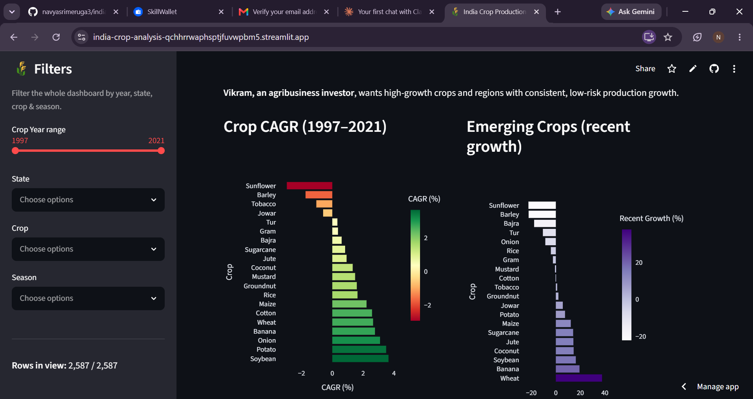
Scenario 3: Investor — Crop CAGR (1997-2021) and Emerging Crops by recent growth.

10. Testing
Testing was performed manually by running each pipeline stage (data generation, preprocessing, analysis, visualization) and verifying the outputs, as well as by interacting with every dashboard filter, tab, and chart in the browser to confirm the KPIs and visuals update correctly. No automated unit test suite (e.g., pytest) is currently included in the repository.

11. Screenshots or Demo
Screenshots are provided in Section 9 (User Interface) above.
GitHub Link:
Demo Link: https://india-crop-analysis-qchhrrwaphsptjfuvwpbm5.streamlit.app

12. Known Issues
- The dataset used is synthetically generated (not official government statistics) because no internet/dataset download was available while building the project; figures should not be cited as real agricultural statistics.
- No automated test suite is currently included.
- No authentication/authorization layer exists, so the dashboard is openly accessible to anyone with the URL.

13. Future Enhancements
- Replace the synthetic dataset with the real Kaggle "Crop Production in India" dataset (the pipeline already supports this by dropping in a CSV with matching column names).
- Add automated tests (e.g., pytest) for the data preprocessing and analysis functions.
- Add user authentication for restricted/private deployments.
- Expand scenario analysis with predictive modeling (e.g., forecasting future production trends).
- Add district-level drill-down in addition to state-level analysis.

