Project Documentation:
Create a Local Folder – Project Name
Sub Folders – data – raw | cleaned > python > powerbi > sql > tableau > images > docs

Create a Repository in GitHub (Chrome) – Project Name
Make it:
- Public
- Add README
- Add .gitignore → Python
- Add MIT License
Clone the repository in your Local GitHub Desktop – choose the path (same above folder)
After cloning, your folder should now contain:
- .git
- README.md
- .gitignore
- LICENSE along with your folders.

Open Project in VS Code – File > Open Folder > above project folder
You should now see:
- data
- sql
- python
- powerbi
- tableau
- README.md inside VS Code Explorer

Paste the Dataset inside the Project Folder > data > raw
- In VS Code, to ignore large datasets – Open .gitignore > Go to the bottom & add:
# Ignore raw datasets
data/raw/*.csv
# Ignore large files
*.zip
*.7z
*.parquet

Ctrl+5 – save file

- In GitHub Desktop:
Right-click each CSV file (datasets) listed under Changes > select ‘Ignore this file’
After this: Changes tab should mostly disappear, except maybe .gitignore.

In GitHub Desktop:
Summary: Initial project structure setup
Then click: Commit to main
Then: Push origin
This uploads your project structure to GitHub properly.

My SQL Workbench:
- Double Click: Local instance MySQL80
- Click SQL+ (new SQL tab)
- CREATE DATABASE project_name;
- Right-click on this database & Set as Default Schema

Note: Raw CSV → Python Cleaning → SQL Import → Analytics

In VS Code, inside python > create a new file > data_inspection.ipynb
Install extensions, if asked
Code+ > print("Python notebook is working")
Virtual Environment:
Click Top Right Python Version - Python 3.14.4 > select .venv OR
Create Python Environment > choose .venv > select Python 3.14.4 Base Interpreter
Open Terminal in VS Code > top menu New Terminal > Power Shell
- py -m venv .venv > .venv\Scripts\activate > Set-ExecutionPolicy -Scope Process -ExecutionPolicy Bypass > Y > .venv\Scripts\activate
- pip install pandas numpy matplotlib
- pip install pandas openpyxl jupyter
- pip install pandas > python -m pip install pandas > pip install openpyxl > python -m pip install openpyxl
Restart Kernel
- import pandas as pd
- df = pd.read_csv(r'../data/Raw/Dataset Dec 2019.csv') // import dataset
- df.head()
- df.info()
- df.describe()S
- df.columns
- df.shape // how many rows, columns, datatypes we have
- df['event_type'].value_counts() // huge drop between viewing & purchasing
- df.isnull().sum() // missing values, data quality issue

- df['user_id'].nunique() // actual customers
- customer segmentation
- retention analysis
- repeat purchase analysis
- cohort analysis

- df['product_id'].nunique() // product details
- category analysis
- product affinity
- top sellers
- conversion ranking
- inventory/revenue style insights

What business questions can I answer?
- Which brands convert best?
- Which categories have the highest abandonment?
- Which users purchase repeatedly?
- Which sessions lead to conversion?
- What products drive revenue?

Data Cleaning:
- df['event_time'] = pd.to_datetime(df['event_time'])
- df.info() // check if the datatype is changed
- Which hours have highest purchases?
- Which days show highest abandonment?
- How does conversion trend over time?

- Markdown+ # Initial Data Exploration
This notebook explores customer behaviour data from an e-commerce platform to understand:
- customer activity
- purchase behaviour
- cart abandonment
- retention patterns

- Code+ > df['event_type'].value_counts()
- To see in %: df['event_type'].value_counts(normalize=True) * 100
- df.duplicated().sum() // Are these true duplicates or legitimate repeated events?
- df['user_session'].nunique() // how many browsing sessions
- purchases = df[df['event_type'] == 'purchase'] // filtered dataframe
- purchases.head()

- duplicates = df[df.duplicated()]
- duplicates.head()
- duplicates.shape
- duplicates.sample(10)
- duplicates.sort_values(by=['user_id']).head(20) // gives only duplicate rows (B)
- df[df.duplicated(keep=False)].sort_values(by=['user_id']).head(20) // this gives duplicate + original rows (B + A)

Same timestamp, same product, same user, same session, same everything - Those are safe to delete
- df = df.drop_duplicates()
- df.shape
- df.duplicated().sum()
// how many rows reduced? Are the duplicates count zero?

Null Analysis:
We delete data when:
- the missing values make the row unusable // price = null | user_id = null
- OR the row damages analysis quality
- OR the missingness is tiny and safe to remove

- df.isnull().sum()
- in %: (df.isnull().sum() / len(df)) * 100
- Investigate the missing columns: df[df['brand'].isnull()].head(10)
- Do you need a brand for every row of analysis?
- Check whether purchases have a missing brand
- purchase_null_brand = df[(df['event_type'] == 'purchase') & (df['brand'].isnull())]
- purchase_null_brand.shape
- if Yes, then fill it - df['brand']=df['brand'].fillna('Unknown Brand')
- Check: df[‘brand’].isnull().sum()
- If you want to Reverse it: df['brand'] = df['brand'].replace('Unknown Category', np.nan) // this needs > import numpy as np
Check other missing columns: Category_Code
- df['category_code'].value_counts() // doesn’t include null value count
- df['category_code'].value_counts(dropna=False) // gives count of Null Values too

- Let's fill the category_code for purchase orders:

- purchase_category_null=df[(df['event_type']=='purchase') & (df['category_code'].isnull())]
- purchase_category_null.shape

- Fill It:
- Syntax: df.loc[condition, ‘column’] = value
- df.loc[(df['event_type'] == 'purchase') & (df['category_code'].isnull()), 'category_code'] = 'Unknown'
- Check 1: df[(df['event_type']=='purchase') & (df['category_code'].isnull())].shape
- Check 2: df['category_code'].value_counts(dropna=False)

Check if Price is negative:
- df.groupby('event_type')['price'].agg(['mean', 'min', 'max'])
- Check how many negatives exist: df[df['price'] < 0].shape
- Inspect: df[df['price'] < 0].head(10)
- Delete: df = df[df['price'] >= 0]
- Check: df[df['price']<0].shape | df.shape – 17 rows should be deleted from main dfS

Inspect Highest Priced Products:
- df.sort_values(by=‘price’, ascending=False).head(20)

Inspect Unique Users for each Event Type:
- df['event_type'].value_counts() // gives all event types
- df['event_type'].value_counts(normalize=True)*100 // in %
- df.groupby('event_type')['user_id'].nunique()
This tells us: Only a small fraction of users who viewed products actually purchased
# Viewer-to-Purchase Conversion Rate:
- view_users = df[df['event_type']=='view']['user_id'].nunique()
- purchase_users = df[df['event_type']=='purchase']['user_id'].nunique()
- view_users
- purchase_users
- purchase_users / view_users * 100

# Calculate Mean, Median & Range:
- df.groupby('event_type')['price'].agg(['count','mean','median','min','max'])
- df.groupby('event_type')['price'].sum()

- Count - How many events occurred? / Lots of people view products / Fewer add to cart / Even fewer purchase
- Mean - people VIEW cost on average $12.64 but BUY cost on average $5.05
- People seem to look at expensive products but buy cheaper products.
- Median - mean = 12.64 / median = 5.22 - Most products are cheap, a few very expensive products are pulling the average upward - This is called a right-skewed distribution.
- Sum - Views are not revenue. / A user can view a product 100 times and buy nothing. / Only purchases represent actual sales.
- Products viewed by customers had a significantly higher average price ($12.64) than products ultimately purchased ($5.05). The large gap between mean and median prices suggests a right-skewed price distribution, indicating that a relatively small number of high-priced products attract substantial browsing activity while lower-priced products account for most purchases.

Brand Analysis:
- df.groupby('brand')['price'].agg(['count','mean'])
- df.groupby('brand')['price'].agg(['count','mean']).sort_values(by='count',ascending=False).head(20)
- df['product_id'].nunique()
- The count is counting rows/events, not products. It could be views/carts/purchases all combined.
- Unique product count is less, hence proved!
"How many unique customers interacted with each brand?"
That's usually more valuable than counting events because one customer can generate hundreds of events.
- df.groupby('brand')['user_id'].nunique()
- df.groupby('brand')['user_id'].nunique().sort_values(ascending=False).head(20)
- "How many distinct people showed interest in this brand?”
- "Unknown Brand" has become the largest brand in the dataset.

User Funnel Analysis:
- df.groupby('event_type')['user_id'].nunique() // Uniques Users in each event_type
- df['user_id'].nunique() // Total Unique Users
- The same user can belong to: View users, Cart users, Purchase users simultaneously.
- This is a concept called overlapping populations.

Large files cannot be stored in GitHub, so to ignore it before saving:
create/update .gitignore

# datasets
data/raw/*.csv
data/cleaned/*.csv

# virtual environment
.venv/
venv.venv/

# notebook checkpoints
.ipynb_checkpoints/

# Save the Cleaned Dataset
- df.to_csv('../data/cleaned/dec_cleaned_dataset.csv',index=False)
- df.shape
- Raw Dataset: 3.5M | Cleaned Dataset: 3.3M

Raw Data
↓
Python Cleaning
↓
SQL Business Analysis
↓
Power BI Dashboard
↓
GitHub Portfolio & Insights
SQL Workbench:
Create a new SQL File (01_data_import) (Save it inside the project’s sql folder)
- create database customer_retention_db;
Schemas -> select the above database -> right click -> set as default schema
Right click on the database -> Table Data Import Wizard -> select the path for cleaned dataset
Finish Import
- use customer_retention_db;
- select count(*) from dec_cleaned_dataset;
it should give the result 3.3M – then import is rightly done
if it is not imported properly the drop table & load data again
- drop table dec_cleaned_dataset;

Other method to import data:
In SQL Workbench –
- SHOW VARIABLES LIKE 'local_infile'; // result: OFF
- SELECT VERSION(); // result: 8.0.45
- SHOW VARIABLES LIKE 'secure_file_priv'; // result: C:\ProgramData\MySQL\MySQL Server 8.0\Uploads\
Now, copy the cleaned dataset & paste it in the above path.
Now, create tables manually:
- use customer_retention_db;
- create table dec_cleaned_dataset (
event_time datetime,
event_type varchar(50),
product_id bigint,
category_id bigint,
category_code varchar(255),
brand varchar(255),
price decimal(10,2),
user_id bigint,
user_session varchar(255));
- show tables;

- LOAD DATA INFILE
'C:/ProgramData/MySQL/MySQL Server 8.0/Uploads/dec_cleaned_dataset.csv'
INTO TABLE dec_cleaned_dataset
FIELDS TERMINATED BY ','
ENCLOSED BY '"'
LINES TERMINATED BY '\n'
IGNORE 1 ROWS;

- select count(*) from dec_cleaned_dataset;

SQL Analysis:
Create a new .sql file (02_exploratory_analysis) - save it in the project’s sql folder
- use customer_retention_db;
- select count(*) from dec_cleaned_dataset;

/* Total Rows */
- select * from dec_cleaned_dataset;
- select * from dec_cleaned_dataset limit 10;
- select count(*) as total_rows from dec_cleaned_dataset;

/* Unique Users */
- select user_id from dec_cleaned_dataset;
- select count(user_id) from dec_cleaned_dataset;
- select count(distinct user_id) from dec_cleaned_dataset;
- select count(distinct user_id) as unique_users from dec_cleaned_dataset;

/* Total Event Types */
- select event_type from dec_cleaned_dataset;
- select event_type, count(*) from dec_cleaned_dataset group by event_type;
- select event_type, count(*) from dec_cleaned_dataset group by event_type order by count(*) desc;
- select event_type, count(*) as total_events from dec_cleaned_dataset group by event_type order by total_events desc;
- Everything is matching our Python cleaned dataset

Create a new .sql file (03_customer_funnel_analysis) - save it in the project’s sql folder
One user can generate hundreds of event_types. How many unique users:
1. Viewed products?
2. Added products to cart?
3. Purchased products?
- select count(distinct user_id) from dec_cleaned_dataset;
- select count(distinct case when event_type='view' then user_id end) as unique_viewers,
count(distinct case when event_type='cart' then user_id end) as unique_cart,
count(distinct case when event_type='purchase' then user_id end) as unique_purchase from dec_cleaned_dataset;

Total unique users in dataset = 370,154
View users = 358,212 //Almost everyone interacted through a view event first
View → Cart Conversion = Cart/View*100 | Cart → Purchase Conversion | View → Purchase Conversion
- select count(distinct case when event_type='cart' then user_id end)/count(distinct case when event_type='view' then user_id end)*100 as view_to_cart_pct from dec_cleaned_dataset;

- select round(count(distinct case when event_type='cart' then user_id end)/count(distinct case when event_type='view' then user_id end)*100 ,2) as view_to_cart_pct,
round(count(distinct case when event_type='purchase' then user_id end)/count(distinct case when event_type='cart' then user_id end)*100 ,2) as cart_to_purch_pct,
round(count(distinct case when event_type='purchase' then user_id end)/count(distinct case when event_type='view' then user_id end)*100 ,2) as view_to_purch_pct
from dec_cleaned_dataset;

This is a user-related conversion, so we used distinct. How many unique users purchased at least once?
Out of every 100 users who viewed products, about 23 added something to their cart.
Out of every 100 users who added products to their cart, about 31 completed a purchase.
Only about 7 out of every 100 viewers became customers.
Businesses care far more about customer counts because conversion rates are calculated using people, not clicks.

/* Top Brands by Purchases */
Which brands are causing purchases? | Which brands get lots of views but no sales? | Which products convert best?

Now we don’t have to use distinct bcz 1 user might purchase 2 times from the same brand.
- select brand, count(event_type='purchase') as purchases from dec_cleaned_dataset
group by brand order by count(event_type='purchase') desc;
event_type='purchase' gives TRUE OR FALSE, which is a NON-NULL value and count() counts it all, so it's not the correct code.
/* To prove the code is wrong */
- select count(*) as total_rows, count(event_type='purchase') as wrong_pur_count from dec_cleaned_dataset; ------------------ gives the same result
CORRECT CODE:
- select brand, count(*) as purchases from dec_cleaned_dataset where event_type='purchase' group by brand order by count(*) desc;
#BRAND generated the highest number of purchase events among identifiable brands, suggesting strong customer demand and conversion performance relative to competitors.

/* Top Brands by REVENUE */
- select brand, sum(price) as revenue from dec_cleaned_dataset group by brand order by revenue desc;
- select brand, sum(price) as revenue from dec_cleaned_dataset where event_type='purchase'
group by brand order by revenue desc;
#BRAND is not just popular—it also generates strong revenue. It is No.1 in both criterias: revenue & count
#BRAND – count is less but revenue is more, which means, products are higher-priced.
A significant proportion of revenue comes from products with missing brand information ("Unknown Brand"), limiting brand-level analysis and indicating a potential data-quality issue.

Average Purchase Value by Brand:
- select brand, round(avg(price), 2) as avg_pur_value from dec_cleaned_dataset
where event_type='purchase' group by brand order by avg_pur_value desc;
- select brand, count(*) as total_purchases, round(avg(price), 2) as avg_pur_value from dec_cleaned_dataset where event_type='purchase' group by brand order by avg_pur_value desc;
These brands have a decent number of purchases and high average values: Reliable findings
High average + tiny sample size = weak evidence
- select brand, count(*) as total_purchases, round(sum(price), 2) as revenue, round(avg(price), 2) as avg_pur_value from dec_cleaned_dataset where event_type='purchase' group by brand having count(*)>50 order by revenue desc;
The HAVING COUNT(*) >= 50 removes brands with very few purchases and focuses on brands that actually matter.
Revenue Percentage:
- select brand, count(*) as total_purchases, round(sum(price), 2) as revenue, round(avg(price), 2) as avg_pur_value,
round(sum(price)/sum(sum(price)) over()*100, 2) as revenue_pct from dec_cleaned_dataset
where event_type='purchase' group by brand having count(*)>50 order by revenue desc;
------------------Commit to GitHub--------------------
Create a new .sql file - 04_customer_retention_metrics.sql / save in the project’s sql folder.
Analysis 1: Repeat Customers
Find customers who purchased more than once.
- select user_id, count(*) as total_purchases from dec_cleaned_dataset where event_type='purchase' group by user_id having count(*)>1 order by total_purchases desc;
How many repeat buyers exist?
Who are the most loyal customers?

Analysis 2: Purchase Frequency Distribution
Query 1:
Customer → Number of Purchases
Query 2:
Number of Purchases → Number of Customers

- select purchases as no_of_purchases, count(*) as no_of_customers from
(select user_id, count(*) as purchases from dec_cleaned_dataset
where event_type='purchase' group by user_id order by count(*) desc) t
group by no_of_purchases order by no_of_purchases desc;

Analysis 3: Top Categories by Revenue
Which product categories make the most money?
- select category_code, sum(price) as revenue from dec_cleaned_dataset where event_type='purchase' group by category_code order by revenue desc;

Analysis 4: Top Categories by Purchases
Which categories are most popular?
- select category_code, count(*) as purchases from dec_cleaned_dataset
where event_type='purchase' group by category_code order by purchases desc;

Analysis 5: Revenue by Month
- select date(event_time) as order_date, sum(price) as revenue from dec_cleaned_dataset
where event_type='purchase' group by date(event_time) order by order_date desc;

Analysis 6: Peak Purchase Hours
When do customers buy the most?
- select hour(event_time) as purchase_hour, sum(price) as revenue from dec_cleaned_dataset
where event_type='purchase' group by hour(event_time) order by purchase_hour desc;

Create a new .sql file - 05_customer_segmentation.sql, save it in the project’s sql folder.
Top Customers by Revenue - VIP Customers
- select user_id, sum(price) as total_revenue from dec_cleaned_dataset where event_type='purchase' group by user_id order by total_revenue desc;

- select user_id, count(*) as total_purchases, sum(price) as total_revenue from dec_cleaned_dataset where event_type='purchase' group by user_id order by total_revenue desc;

Customer Segments - Customers with High Value / Medium Value / Low Value
- select user_id, sum(price) as customer_revenue from dec_cleaned_dataset
where event_type='purchase' group by user_id;

- select min(customer_revenue) as min_revenue, avg(customer_revenue) as avg_revenue, max(customer_revenue) as max_revenue from(
select user_id, sum(price) as customer_revenue from dec_cleaned_dataset
where event_type='purchase' group by user_id) t;

The average is only 42, but the top customer is 1526. That means a small number of customers contribute a large amount of revenue.
- select case
when customer_revenue < 10 then "0-10"
when customer_revenue < 25 then "10-25"
when customer_revenue < 50 then '25-50'
when customer_revenue < 100 then '50-100'
when customer_revenue < 250 then '100-250'
when customer_revenue < 500 then '250-500'
when customer_revenue < 1000 then '500-1000'
else '1000+' end as revenue_band, count(*) as customers from (
select user_id, sum(price) as customer_revenue from dec_cleaned_dataset
where event_type='purchase' group by user_id) t
group by revenue_band order by customers desc;

The vast majority of customers spend less than $100.
Total ≈ 25,613 customers.
254 customers spent more than $250.
254 / 25613 = 0.99%
Only the top 1% are spending more than $250.

- select user_id, count(*) as total_purchases, sum(price) as total_revenue,
case when sum(price)>=250 then "High Value"
when sum(price)>=100 then "Medium Value"
else "Low Value" end as Customer_segment
from dec_cleaned_dataset
where event_type='purchase' group by user_id order by total_revenue desc;

Segment Summary - How many customers belong to each segment
- select user_id,
case when sum(price)>=250 then "High Value"
when sum(price)>=100 then "Medium Value"
else "Low Value" end as Customer_segment
from dec_cleaned_dataset
where event_type='purchase' group by user_id;

- select customer_segment, count(*) as customers from (
select user_id,
case when sum(price)>=250 then "High Value"
when sum(price)>=100 then "Medium Value"
else "Low Value" end as Customer_segment
from dec_cleaned_dataset
where event_type='purchase' group by user_id) t
group by customer_segment order by customers desc;

Approximately 94% of customers are low spenders, around 6% are medium-value customers, and only 1% belong to the high-value segment.

Instead of only counting customers, let's measure how much revenue each segment contributes.
/* Revenue contributed by each Segment */

- select user_id, sum(price) as customer_revenue,
case when sum(price) >= 250 then "High Value"
when sum(price) >=100 then "Medium Value"
else "Low Value"
end as customer_segment
from dec_cleaned_dataset where event_type='purchase' group by user_id;

- select customer_segment, count(*) as customers, sum(customer_revenue) as total_revenue, avg(customer_revenue) as avg_revenue
from (
select user_id, sum(price) as customer_revenue,
case when sum(price) >= 250 then "High Value"
when sum(price) >=100 then "Medium Value"
else "Low Value"
end as customer_segment
from dec_cleaned_dataset where event_type='purchase' group by user_id) t
group by customer_segment;

Average Revenue per Customer - How much does an average customer spend?
- select user_id, sum(price) as customer_revenue from dec_cleaned_dataset
where event_type='purchase' group by user_id;

- select round(avg(customer_revenue),2) as avg_cust_revenue from (
select user_id, sum(price) as customer_revenue from dec_cleaned_dataset
where event_type='purchase' group by user_id) t;
Approximately 94% of customers are low spenders, around 6% are medium-value customers, and only 1% belong to the high-value segment.

/* Repeat Customer Rate */
- select count(*) as repeat_customers from (
select user_id, count(*) from dec_cleaned_dataset
where event_type='purchase' group by user_id having count(*)>1) t;

/* Total Purchasing Customers */
- select count(distinct user_id) as total_customers
from dec_cleaned_dataset where event_type='purchase';

/* What percentage of customers came back and bought again? */
- select (
select count(*) as repeat_customers from (
select user_id, count(*) from dec_cleaned_dataset
where event_type='purchase' group by user_id having count(*)>1) t
) / (
select count(distinct user_id) as total_customers
from dec_cleaned_dataset where event_type='purchase'
) * 100 as repeat_customer_rate

Formula:
Repeat Customers
----------------------------------- ×100
Total Purchasing Customers

22,700
---------
25,613
= 88.63% - Nearly 9 out of every 10 purchasing customers returned to make another purchase.

New file - 06_sales_trend_analysis.sql
/* 1. Daily Revenue Trend - How did Revenue change day by day */
- select date(event_time) as sales_date, count(*) as purchases, sum(price) as revenue
from dec_cleaned_dataset where event_type='purchase'
group by date(event_time) order by sales_date;

/* 2. Hourly Sales Trend */
- select hour(event_time) as hour_of_day, count(*) as purchases, sum(price) as revenue
from dec_cleaned_dataset where event_type='purchase'
group by hour(event_time) order by hour_of_day;

/* 3. Weekday Analysis - Which day performs the best? */
- select dayname(event_time) as weekday, count(*) as purchases, sum(price) as revenue
from dec_cleaned_dataset where event_type='purchase'
group by dayname(event_time);

/* 4. Weekend vs Weekday */
- select event_time, dayname(event_time) as day_name, dayofweek(event_time) as day_number from dec_cleaned_dataset
order by event_time desc;

- select case when dayofweek(event_time) in (1,7)
then "Weekend"
else "Weekday" end as day_type,
count(*) as purchases, sum(price) as revenue
from dec_cleaned_dataset where event_type='purchase'
group by day_type;

/* 5. Peak Shopping Hours */
- select hour(event_time) as purchase_hour, count(*) as purchases, sum(price) as tot_revenue, avg(price) as avg_revenue
from dec_cleaned_dataset where event_type='purchase'
group by purchase_hour order by purchase_hour;

New file - 07_cohort_analysis.sql
/* 1. First Purchase Date */
select user_id, min(date(event_time)) as first_purchase
from dec_cleaned_dataset where event_type='purchase' group by user_id;

/* 2. Purchase Days per Customer */
select user_id, count(distinct date(event_time)) as active_purchase_days
from dec_cleaned_dataset where event_type='purchase' group by user_id order by active_purchase_days desc;

/* 3. Customers Purchasing on Multiple Days */
select count(*) as repeat_day_customers from (
select user_id, count(distinct date(event_time)) as active_purchase_days
from dec_cleaned_dataset where event_type='purchase' group by user_id having active_purchase_days>1) t;

/* 4. Distribution of Purchase Days */
select active_purchase_days, count(*) as customers from (
select user_id, count(distinct date(event_time)) as active_purchase_days
from dec_cleaned_dataset where event_type='purchase'
group by user_id)t
group by active_purchase_days;

Power BI:
Save in the project’s Power BI folder - customer_retention_dashboard.pbix
Get Data – Text/CSV – dec_cleaned_data.csv – Transform Data
- Check all the data types of the columns
- Check the row/column count
- Goto VIEW – enable Column distribution/ quality & profile (you will see nulls / errors/ missing values immediately)
- Close & Apply

Power BI has 4 major parts:
┌─────────────────────┐
│ Power Query │
│ (Data Cleaning) │
└─────────────────────┘
↓
┌─────────────────────┐
│ Data Model │
│ Relationships │
└─────────────────────┘
↓
┌─────────────────────┐
│ DAX │
│ Calculations │
└─────────────────────┘
↓
┌─────────────────────┐
│ Visualizations │
│ Dashboard │
└─────────────────────┘

Calculates every row, creating a new column – CALCULATED COLUMN
Calculates only when needed, doesn’t create a new column – MEASURE

Report View – Modeling – New Measure
Total Revenue = SUM(dec_cleaned_dataset[price])
Total Purchases = CALCULATE(COUNTROWS(dec_cleaned_dataset), dec_cleaned_dataset[event_type] = "purchase")
Total Customers = CALCULATE( DISTINCTCOUNT(dec_cleaned_dataset[user_id]),
dec_cleaned_dataset[event_type] = "purchase")
For Clustered Bar Chart: You can apply FILTER
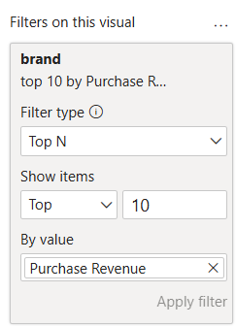

Edit Interactions : If you don’t want the Cards to be interactive
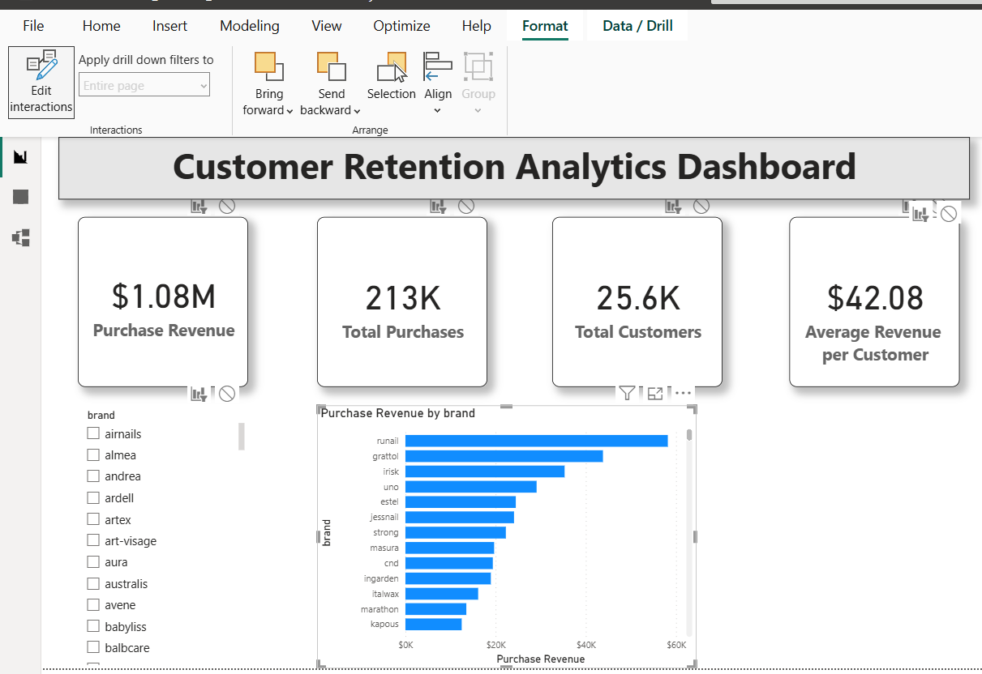

Measure:
Repeat Customers = COUNTROWS(FILTER(VALUES(dec_cleaned_dataset[user_id]), CALCULATE(COUNTROWS(dec_cleaned_dataset),dec_cleaned_dataset[event_type]="purchase")>1))
In DAX we're expressing the same business logic differently:
- Get unique customers (VALUES)
- Check each customer (FILTER)
- Keep those with more than one purchase (CALCULATE)
- Count them (COUNTROWS)

VALUES(dec_cleaned_dataset[user_id])
What does it do?
It creates a list like
101
102
103
104
... Only unique customers.

FILTER(...)
Now Power BI asks:
"For every customer...
should I keep them?"
It starts checking.
Customer 101
↓
Purchased twice?
Yes
↓
Keep.
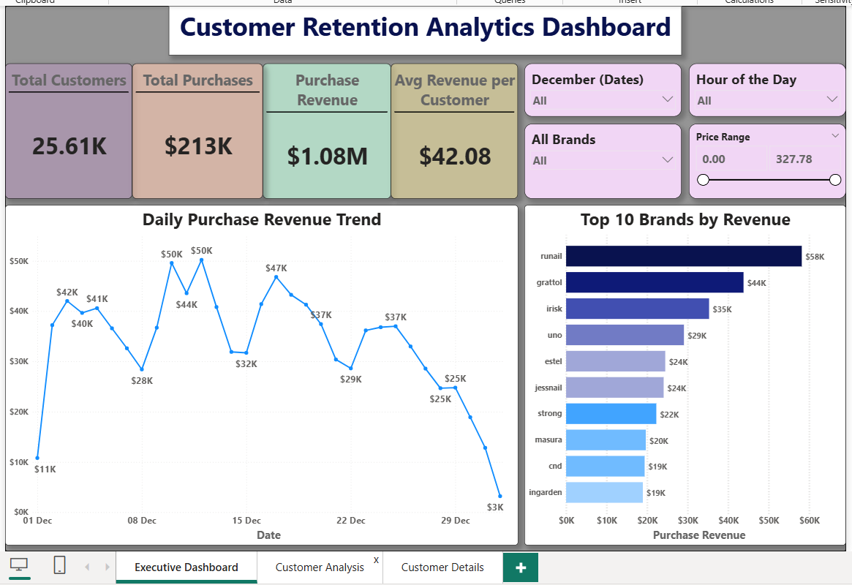

Your current table has 334,409 transaction rows, but what we actually need is 25,613 unique customers.
Instead of repeating "High Value" hundreds of times for the same customer, we'll create a Customer Summary table with one row per customer.
That table will look like this:
user_id | Total Revenue | Total Purchases | Customer Segment
12345 | 38.45 | 5 | Low
67890 | 142.10 | 18 | Medium
98765 | 487.32 | 63 | High
Then every customer appears exactly once.
Modeling → New Table
In Power BI, SUMMARIZE is a DAX function used to group data and perform aggregate calculations. It outputs a new summary table.
The basic syntax is:
SUMMARIZE ( <table>, <groupBy_columnName>, [groupBy_columnName], ["<newColumnName>", <expression>] )

- Customer Summary = SUMMARIZE (
FILTER(dec_cleaned_dataset, dec_cleaned_dataset[event_type]="purchase"),
dec_cleaned_dataset[user_id],"Total Revenue", sum(dec_cleaned_dataset[price]),
"Total Purchases", COUNTROWS(dec_cleaned_dataset))

You just learned one of the most common DAX patterns:
- FILTER() = SQL WHERE
- SUMMARIZE() = SQL GROUP BY

Customer Segmentation:
Add New Column in the new table:
- Customer Segment = SWITCH(TRUE(), [Total Revenue]>=250, "High Value", [Total Revenue]>=100, "Medium Value", "Low Value")

Instead of showing only repeat customers, we want to compare both groups.
Create a New Column –
- Customer Type = SWITCH( TRUE(), [Total Purchases] > 1, "Repeat Customer",
"One-time Customer")

Set Up Page:
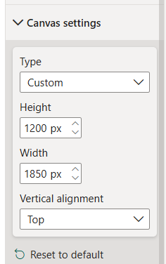
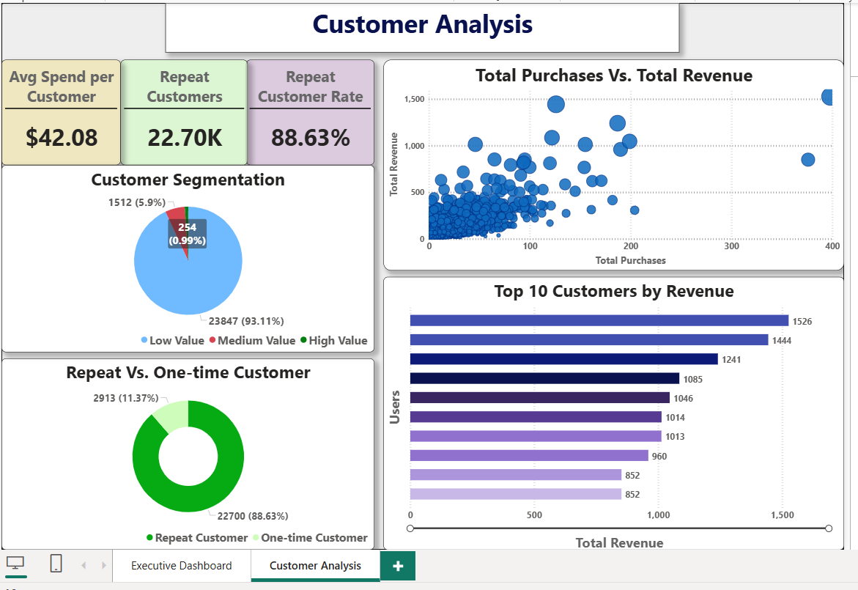

Add Tooltips –
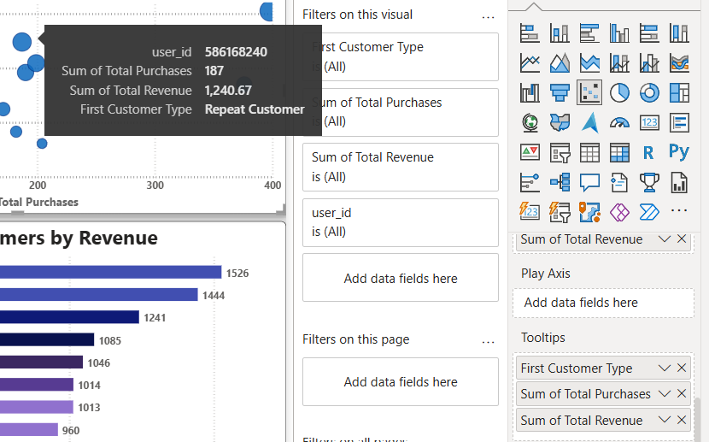

Drill-Through:
Click on a blank area of the page - Add drill-through fields here
Customer Summary[user_id]
Now go back to your Customer Analysis page.
On the Top 10 Customers by Revenue chart:
- Right-click one of the bars.
- You should see:
Drill through
→ Customer Details
- Click Customer Details.
Now Power BI will open this page filtered for that one customer, and your cards will display only that customer's information.
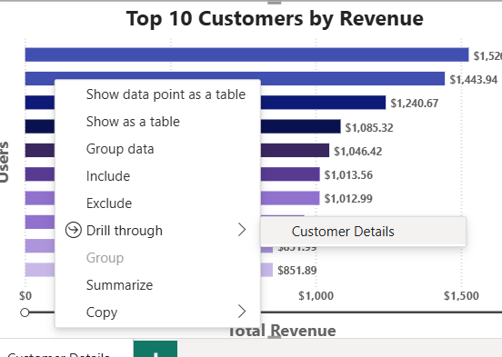

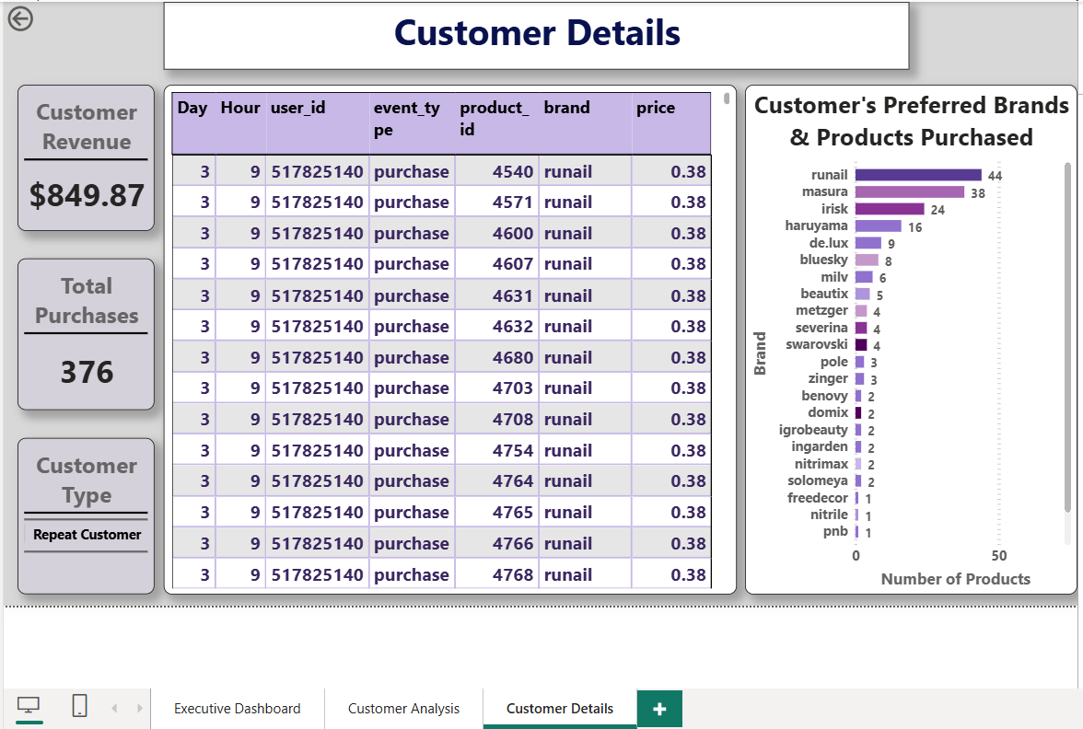

Business Insights:
Key Findings
- Revenue exceeded $1.08M.
- Repeat customer rate was 88.63%.
- Top-performing brand generated approximately $58K in revenue.
- Highest purchasing activity occurred during late evening hours.
- Revenue gradually declined toward the end of December.
Recommendations
- Strengthen loyalty initiatives for repeat customers.
- Schedule promotions during peak purchasing hours.
- Prioritise inventory for top-performing brands.
- Investigate end-of-month sales decline.

